Progressive Writing Practice
Core principle: pupils develop their ability to write through the understanding of the basic grammatical concepts.
Foundation: once pupils have learnt what a noun (including common and proper nouns) and a verb is, the should be able to compose their initial ‘directed’ simple (single clause) sentences (subject + verb + object). Example, John ate rice or Sam play football, or Sam is playing football. This particular structure appears to work for the past and the present continuous. Note also the introduction of ‘is’ (helping verb) in the continuous scenario.
A new progressive sentence structure, noun +verb + proposition + object. Sam ate in school. A new structure, noun + verb + proposition + object, Sam ate in school. A new structure, noun + verb + proposition + determiner + object, Sam ate in a school. Teaching reinforcement, what is the difference between eating in a school and in the school? New structure, noun (subject) + verb + noun + proposition + noun = Sam is playing football in school.
Creating a writing composition (story) from this sentence
Start with the question. Assuming this was a story, would it be the beginning, middle or the end?
Assuming this was the middle, what is needed to make the story complete?
We nee to know what happened before Sam ate in school and what happened after he ate.
Note: if pupils have not learnt paragraphs then they must write these as individual sentences. Teachers must discourage pupils forming the wrong habit of randomly groping sentences together in a pretend paragraph.
PWP builds on daily with this practice, pupils will change the subject of their writing each day.
When a new grammatical term is learned, the sentence structure is extended accordingly.
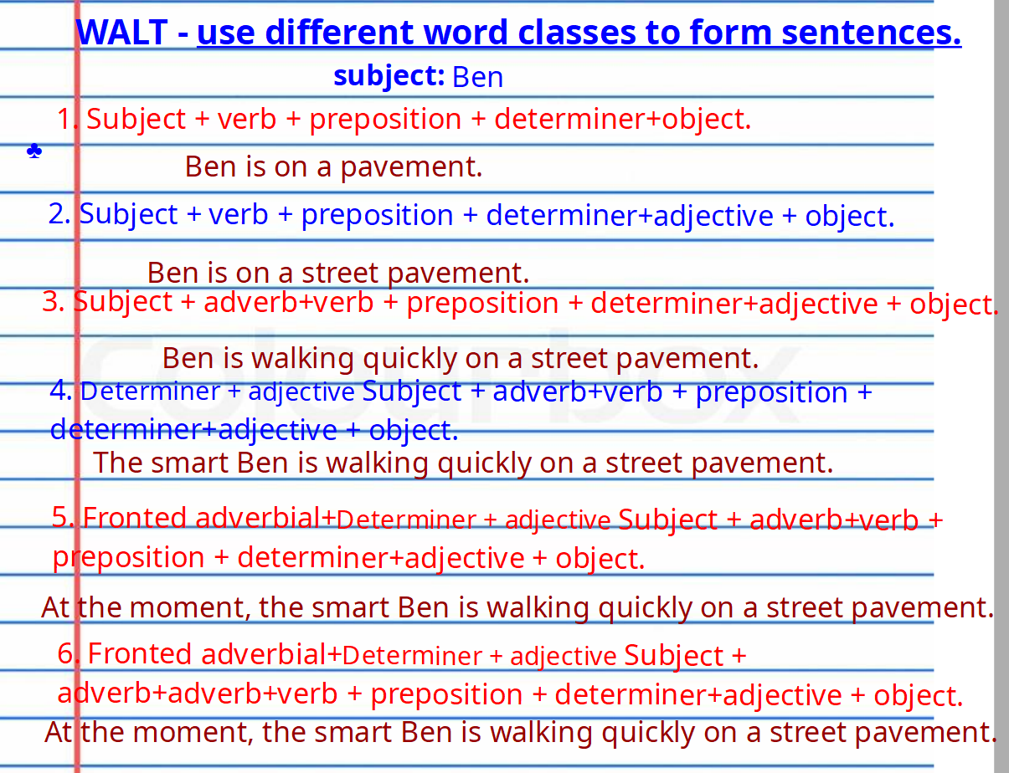
Notice noun and phrasal verbs are introduced at this early stage.
From here the next sentence structure will introduce compound sentences and pupils should have the opportunity to compose these types of sentences by various permutations.
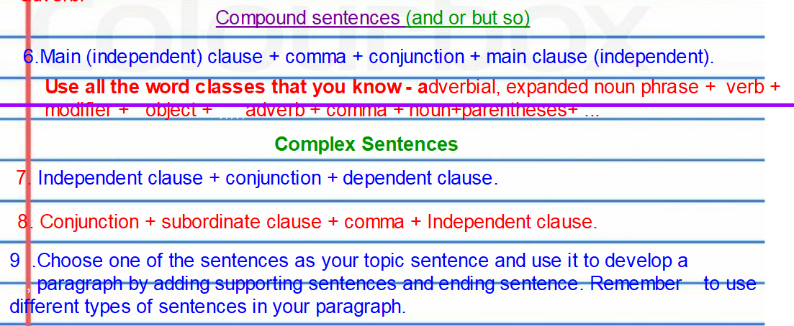

After compound and complex sentences, the next is a multiclause/phrase sentences. Example: last night, the sickly Ben, who has not been to school, sat lonely in a dilapidated shed but his family did not notice that he was alone outside.
The compositions at the end of the structured progressive writing also becomes progressively complex.

