Developer notes – bug fixes
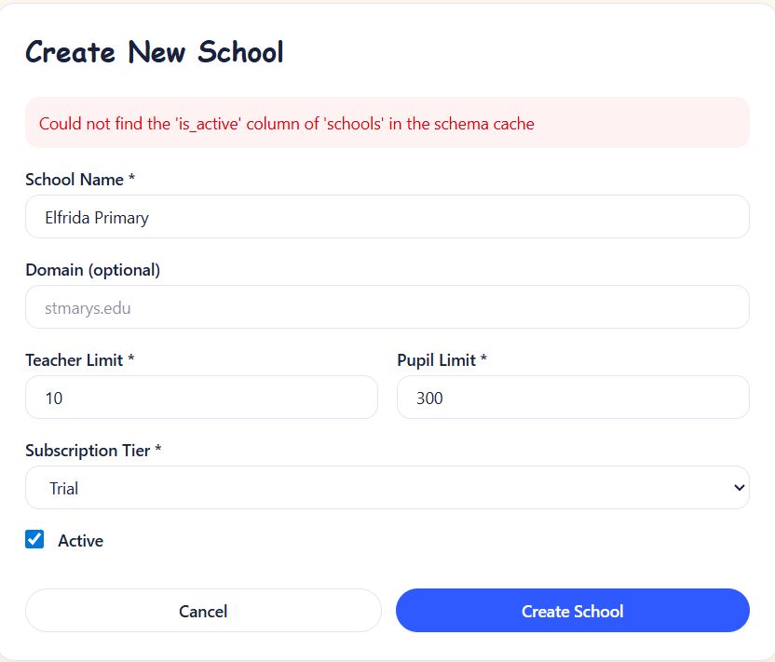 | Trying to create a new school from admin dashboard returned this error.
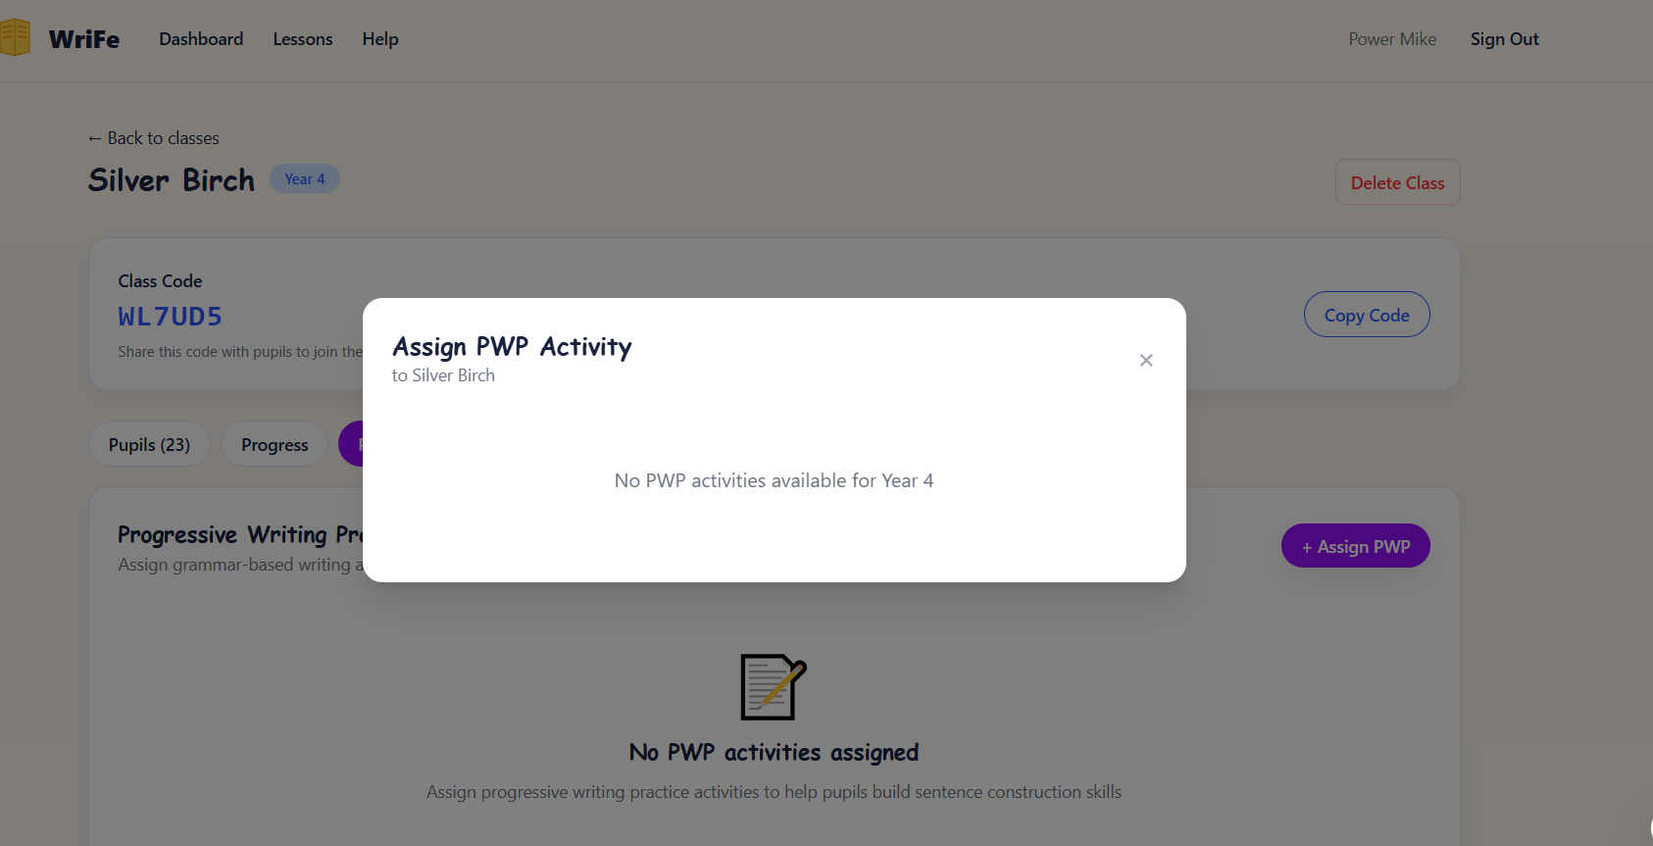 | Teacher not able to assign PWP
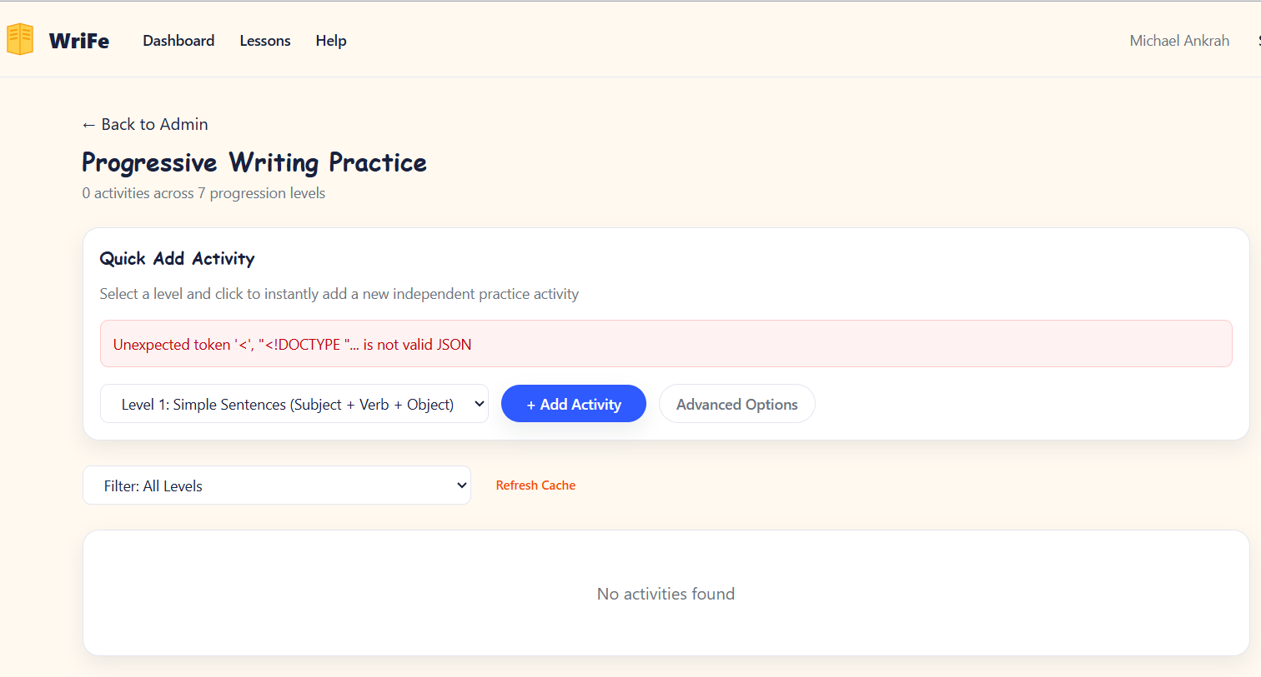 | Unable to access the PWP assignment page on Admin dashboard.
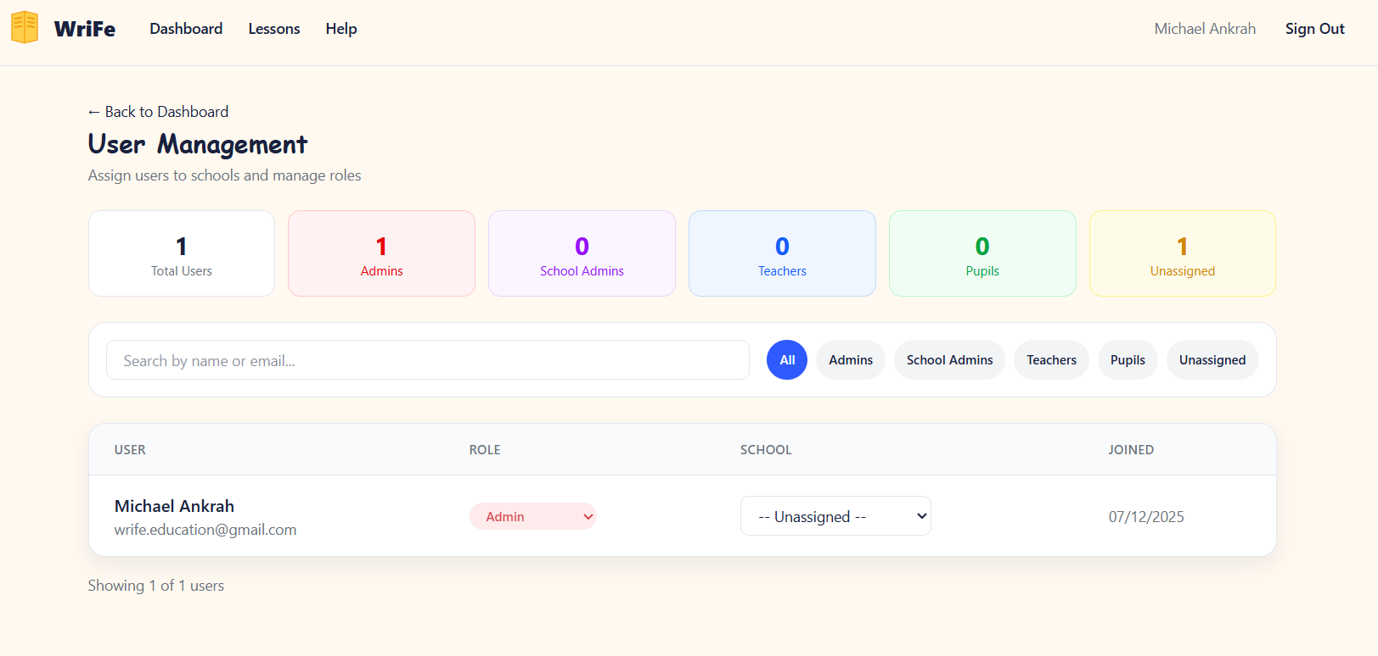 | Manage user interface on Admin dashboard is not fetching the actual numbers. There are more than 1 teacher registered and I have 23 pupils signed up but the user management is not picking these numbers up.
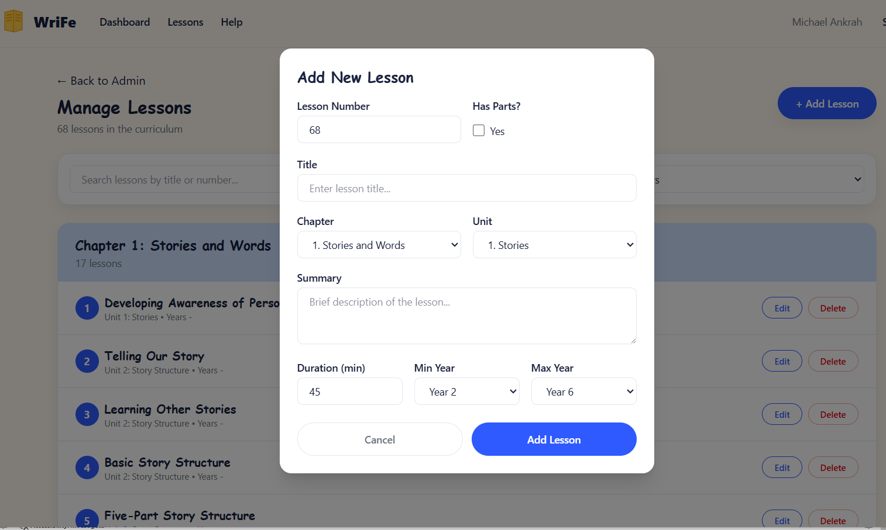 | Question: Does adding a new lesson (Teacher guide, Lesson presentation, Interactive Practice, Worksheets, Assessment Package and Progress Tracker) automatically overwrites the existing files? Set it up for the admin to upload new lesson components (8 files) from this page.  I want add new lesson to result in Admin adding new lesson files. The lessons of WriFe are already set.

