Instructions for installing and using GaussHomogFWM, plotter3Da, and associated Graphical User Interface files into Matlab R13 (KAM 1/5/03 v.1)

NOTE: GaussHomogFWM has been replaced by a DOVE routine that allows for inhomogeneous broadening. The new routine uses a different electric field envelope function (without the 2 in the exponential’s denominator).

GaussHomogFWM creates x,y,z files of simulated spectra containing one DOVE feature, one CARS peak associated with the DOVE peak, one CARS peak to which the spectrum is scaled to, one alternate CARS feature, one SIVE feature resonant with wbg along the w2 axis, and background. Upon running the GUI file, the user can input resonance frequencies and linewidths for all of these processes minus background, and amplitudes for all processes, as well as specify laser pulse widths, delays, x,y,z spectra parameters, file I/O, and additional parameters. All features are assumed to be homogeneously broadened for this program. After computing, the x,y,z files can be plotted using plotter3da. Plotter3da is a variant of NJC’s “plotter3d” program – the original program is incompatible with R13.

To install the files to run in Matlab:
- Copy the folder containing all relevant Matlab files (as well as these instructions) into appropriate location.
- Include a path to the new location in Matlab using “Set Path”.
- To run GaussHomogFWM, type “frontpanel” on Matlab prompt.
- To run plotter3da, type “plotter3da” at Matlab prompt.

To use GaussHomogFWM:

There are several sections in which the user applies information.

Major input parameters: pulsewidth, delay, and non-linear parameters
On the left side of the front panel are three boxes. The first two boxes contain input boxes for the resonance frequencies, linewidths (HWHM), and amplitudes (A coefficients) for all the processes. The A coefficients stem from polarization equations, of which the following are examples:

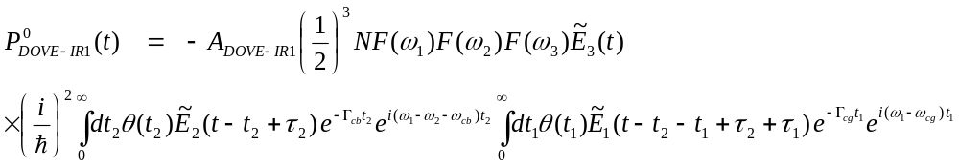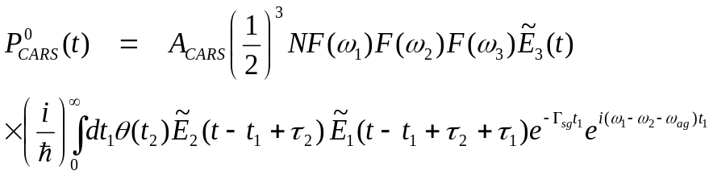

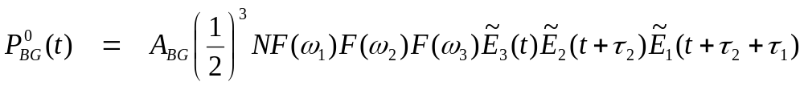All third-order nonlinear equations contain a factor of (1/hbar)³. Depending on the dimensionality of the nonlinear process, different amounts of (1/hbar) are included in its A coefficient. DOVE A coefficients will be an hbar’s order of magnitude smaller than the reference CARS coefficient, and the background will an hbar’s order higher.
The bottom box contains the pulse parameters used in the experiment. The pulses are assumed to be Gaussian of the following form

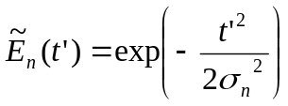
The user inputs the values for σ and the delays between the pulses. Pulse 1 refers to w1, the higher frequency IR pulse, pulse 2 refers to the lower frequency IR pulse w2, and pulse 3 refers to the pump pulse w3.

Spectrum and output file parameters
Much of the inner controls are important for the format of the output x,y,z files. Once specified for a given simulation, they generally need not be changed. However, these controls are the most confusing and so need to be discussed.

w1beginning, w1end, w2beginning, w2end, w2spacing,w3 -- parameters to specify the beginning and ending x(w1) and y(w2) data points of the spectrum, as well as the frequency of the pump pulse. w2spacing refers to the spacing between data points along w2. It differs from the spacing along w1, which is governed by the resolution obtained through the FFT algorithms applied for each direction. By increasing the spacing along w2, the computation time is faster. The user can choose an optimal computation time by comparing the quality of the output spectra with decrease in spacing along w2.
upper limit of time integral, delta t – the two parameters that ultimately govern the resolution in w1 and w2 as well as the Nyquist frequency. The resolution and Nyquist frequencies are given by
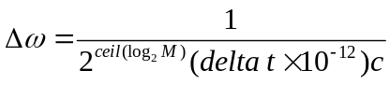

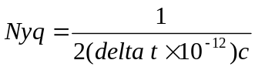

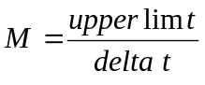

The ceiling function is used to make the next higher power of 2, useful for the FFT algorithm. The computer zero-pads only to the next higher power to keep computation to a minimum. This means that small changes in either or both of these two values will not change the computation time. The Nyquist frequency must be more than twice the difference between the DOVE center frequency and the more extreme of w1beginning or w1end (or w2beginning or w2end).
delta t of final integral – the final time integral for all features is over the pump pulse. For short temporal pulses, this value needs to be small, whereas it can be on the order of the pump pulse itself for near-cw simulation.

frequency domain spectra – for spectra to simulate near-cw lasers, use upperlimt values of ~ 50 psec and delta t values near 0.1 psec, and set σ no smaller than 10 psec. delta t of final integral can be set to sig(w3) .

time domain spectra – Set delta t of final integral to 0.2-0.4 ps for 0.6 psec sig(w3).

sample conc., ref. conc., solv.(bg) conc., alt. conc. – concentrations of the analyte used for DOVE, reference for CARS, solvent for background FWM, and of the material creating the alternate CARS feature, respectively.

OUTPUT FILE – defines where the x,y,z (and p files) are saved to. You may specify a path to save to as part of the input.

Additional parameters
Most of the rest of the parameters left on the front panel are straightforward. All files must be specified regardless of whether or not they are needed for the simulation. Hotband inputs can be used if a single Lorentzian hotband is viewable in 1D spectra. The ratio of the A coefficients, specified in Ratio(hotband/main), will be related to the product of the two square roots of the ratio of intensities in the 1D spectra.

LOAD PARAMETERS— loads the p file in the path specified. A useful starting point for simulating CS₂ picosecond data is “testp.txt”.

To use plotter3da:
The x,y,z files created in GaussHomogFWM, as well as the experimental spectra can be plotted. The x,y,z files must be tab delimited ASCII format.

Mapping Method – select “start at zero” for colormapped plots such as “pcolor” when you want the colormap to use the value zero as its first color in its cycle. Select “direct” when you wish to start the colormap at the minimum value in the z data.

Interpolated Spacing – For Matlab to plot a decent figure, the x,y,z data must be interpolated before plotting. This is particularly important when the data in one dimension is spaced much differently than in the other. Specify the final spacing (in wavenumbers) for the x,y data for linear type interpolation for the z data.

