**Data Files needed for this Case Problem: ms_euler_txt.html, 2 CSS files, 2 PNG files, 1 TXT file**

**Math Strings**Professor Lauren Coe of the Mathematics Department of Coastal University in Anderson, South Carolina, is one of the founders of Math Strings, a website containing articles and course materials for high school and college math instructors. She has written a series of biographies of famous mathematicians for the website and would like you to use that content in a web page. You’ll create the first one in this exercise. [Figure 1-47](javascript://) shows a preview of the page you’ll create, which profiles the mathematician Leonhard Euler.

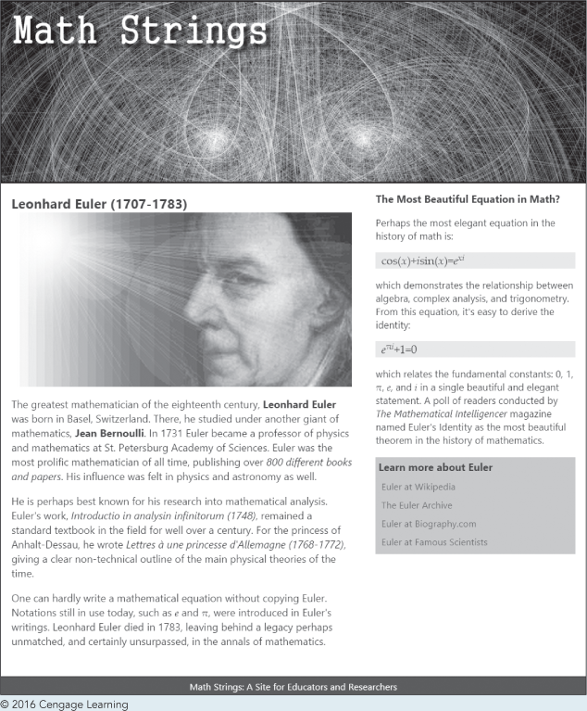

1. 1

Using your editor, open the **ms_euler_txt.html** file from the html01 ► case2 folder. Enter ***your name*** and ***the date*** in the comment section of the file, and save it as **ms_euler.html**.

1. 2

Add the following to the document head:

* 1. Set the character encoding of the file to **utf-8.**
  2. Add the following search keywords: **math, Euler, pi**, and **geometry.**
  3. Set the title of the document to **Leonhard Euler (1707-1783).**
  4. Link the document to the ms_base.css and ms_layout.css style sheet files.

1. 3

Add a header, article, aside, nav, and footer element to the document body.

1. 4

Within the body header, insert an inline image for the ms_logo.png file with the alternate text **Math Strings.**

1. 5

Go to the **ms_pages.txt** file in your text editor and copy the text of the main article (located in the first section of the file), including the title. Then, go to the **ms_euler.html** file in your HTML editor and paste the copied text into the article element.

1. 6

Within the article element, make the following markup changes:

* 1. Mark the text *Leonhard Euler (1707-1783)* as an h1 heading.
  2. Mark the three paragraphs of the article content using the p element.
  3. In the first paragraph, mark the names *Leonhard Euler* and *Jean Bernoulli* as strong text. Mark the phrase *800 different books and papers* as emphasized text.
  4. In the second paragraph mark the works *Introductio in analysin infinitorum (1748)* and *Lettres à une princesse d’Allemagne (1768-1772)* as citations. Insert the à character using the character reference **&agrave;**.
  5. In the third paragraph, mark the mathematical symbols *e* and π using the var (variable) element. Insert the π character by replacing [pi] with the &pi; character reference.

1. 7

Return to the **ms_pages.txt** in your text editor and copy the text of the second section containing information about Euler’s Equation, the most beautiful equation in math. Then, go to the ms_euler.html file in your HTML editor and paste the copied text into the aside element.

1. 8

Within the aside element, add the following markup:

* 1. Mark the title *The Most Beautiful Equation in Math?* as an h1 heading.
  2. Mark the two equations in the pasted text using the code element. Mark the three other text groups as paragraphs.
  3. Throughout the text of the aside element, mark *x, i, e, xi*, and *pi* using the var element, replacing [pi] from the pasted text with the character reference **&pi;**.
  4. Use the sup element in the following equations to mark *xi* and *πi* as superscripts:  
     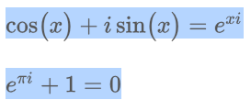
  5. Mark the text *The Mathematical Intelligencer* as a citation.

1. 9

Return to the **ms_pages.txt** file in your text editor and copy the text of the third section listing more ways to learn about Euler. Then, go to the **ms_euler.html** file in your HTML editor and paste the copied text into the nav element.

1. 10

Within the nav element, add the following markup:

* 1. Mark the title *Learn more about Euler* as an h1 heading.
  2. Mark the four Euler websites as an unordered list.
  3. Change the text of the Euler websites to hypertext links pointing to the following URLs:

*Euler at Wikipedia* linked to *http://en.wikipedia.org/wiki/Leonhard_Euler*

*The Euler Archive* linked to *http://eulerarchive.maa.org/*

*Euler at* *Biography.com* linked to *http://www.biography.com/people/leonhard-euler-21342391*

*Euler at Famous Scientists* linked to *http://www.famousscientists.org/leonhard-euler*

1. 11

Within the footer element, insert the text **Math Strings: A Site for Educators and Researchers.**

1. 12

Save your changes to the file and open the **ms_euler.html file** in your browser. Verify that the equations in the sidebar match the ones shown in [Figure 1-47](javascript://) and that all occurrences of the [pi] character have been replaced with π. Click the four links in the navigation list and verify that your browser opens the websites.