A comprehensive analysis of natural sequence variation within the Arabidopsis thaliana nuclear auxin signaling pathway using an accessible web application

2018-07-10

Table of Contents

knitr::opts_chunk$set(warning = FALSE, message = FALSE, echo = FALSE, collapse = TRUE, comment = "#>", tidy = TRUE, cache = TRUE, cache.lazy = FALSE, out.width = "90%", fig.height=4, fig.width=7, out.extra='style="margin: auto; display: block; padding-top: 15px;"')  
  
#devtools::install_github("wrightrc/r1001genomes", ref = "auxin-natural-variation")  
library(ape)  
library(r1001genomes)  
library(DT)  
library(tidyverse)  
library(magrittr)  
library(RColorBrewer)  
library(ggpmisc)  
library(ggthemes)  
library(ggseqlogo)  
library(ggtree)  
library(reticulate)  
library(scales)  
library(viridis)  
library(ips)  
library(knitr)  
  
#use_python(python = "/usr/local/bin/python")

# List of working titles

* A comprehensive analysis of natural sequence variation within the Arabidopsis thaliana nuclear auxin signaling pathway
* **Add your suggestions**

# Abstract

* Motivating, high level statement
* Statement defining the cutting edge of your research area
* A statement of the form: “However, it remains unclear …” that defines what problem you are  
  addressing.
* A statement of the form:“Here, we …” that concisely states your contribution.
* A series of 3?5 statement about your results.
* A concluding statement.

# Intro

The first genome sequence of *Arabidopsis thaliana* facilitated rapid advancement of plant biology through molecular genetics. Since this initial genome, massive scaling of sequencing technology has allowed a pioneering group to survey the global genomic variation in natural *Arabidopsis thaliana* populations. This valuable population genetics resource has led to several associations of genetic loci with phenotypic traits and provided insights into how selective pressure has and is influencing the evolution of plant genomes. Outside of genome-wide studies however, this valuable dataset has seen little use. Natural genomic variation also provides a set of feasible functional variation at the gene, gene family and gene network level that may provide insight into the function and evolution of genes, families and networks. Here, we present a web application and R-package through which plant molecular biologists with little-to-no bioinformatics experience can make use of this rich dataset of genetic variation to formulate hypotheses as to the sequence/function/phenotype relationships determined by the gene, family, or network of their interest. We demonstrate the utility of this tool through comprehensive analysis and identification of potential functional variation in the nuclear auxin signaling pathway.

This application allows easy access to 1. lists of missense polymorphisms to facilitate biochemical assays of variant effects (Starita et al., 2017), 2. family-wise alignments of variants to facilitate de novo functional domain identification (Melamed, Young, Miller, & Fields, 2015), 3. lists of accessions containing missense (or any type of) polymorphisms to facilitate segregation analysis and measurment of the distribution of variant effects on phenotype (Park et al., 2017), 4. as well as the study of gene and network evolution (**???**; Delker et al., 2010).

Here, we have utilized this tool to analyze the genetic variation in the nuclear auxin signaling pathway and formulate hypotheses regarding the functional implications of this variation and the evolution of the genes and gene families in this pathway. Our analysis also provided further confirmation of much of the existing knowledge of these genes demonstrating the validity of this approach.

# Results

## *TIR1/AFB* genes

Auxin acts by binding to receptors that in turn target co-repressors for degradation. Auxin receptors (six in the model plant *Arabidopsis thaliana*) evolved through gene duplication and diversification early in the history of vascular plants (**???**). The rate of co-repressor degradation is determined by the identity of both the receptor and co-repressor (**???**), and this rate sets the pace of lateral root development (**???**).

Although it is unclear what unique roles each receptor plays in growth and development, a number of studies have pointed out differences in the ways the six different receptors in A. thaliana differ in biochemical function and expression domain(Dharmasiri et al., 2005; Parry et al., 2009; Prigge et al., 2016). Although TIR1/AFBs are expressed ubiquitously in A. thaliana tissues, TIR1, AFB2, and AFB3 have been shown to accumulate in the shoot and root meristems and leaf tissues, with slightly different expression patterns for TIR1 (**???**). Additionally, the expression of AFB5 is stronly circadian-regulated (**???**) and AFB3 is more highly expressed in the roots in the presence of nitrate, allowing increased lateral root formation (**???**), suggesting more broad environmental regulation of this gene family may exist. Functionally, all members of this family have been shown to bind auxin and Aux/IAA proteins. However, AFB1 has drastically reduced ability to assemble into an SCF complex, due to the substitution E8K in its F-box domain, preventing it from inducing degradation of Aux/IAAs(**???**). This lack of complexation may allow observed high ubiquitous AFB1 accumulation (**???**). Higher order mutants in the family containing *afb1* mutants suggest that *AFB1* has a moderate positive effect on auxin signaling. Additionally, AFB4 and AFB5 have been shown to preferentially and functionally bind the synthetic auxin picloram, while other family members preferentially bind indole-3-acetic acid (**???**). Interestingly, the strength and rate with which TIR1/AFBs are able to bind and mark Aux/IAAs for degradation are variable (**???**; Calderón Villalobos et al., n.d.). AFB2 induced the degradation of certain Aux/IAA proteins at a faster rate than TIR1, suggesting some functional specificity has arisen since the initial duplication between the *TIR1/AFB1* and *AFB2/AFB3* clades.

(ref:TIR1_AFB_div_stats)

#> [1] "new genes:"  
#> character(0)

|  |  |  |  |  |  |  |
| --- | --- | --- | --- | --- | --- | --- |
| **transcript** | **symbol** | **πN** | **πS** | **πN/πS** | **π coding** | **π transcript** |
| TIR1 | AT3G62980.1 | 0.000082 | 0.000267 | 0.308748 | 0.000350 | 0.001312 |
| AFB1 | AT4G03190.1 | 0.000156 | 0.000627 | 0.248598 | 0.000783 | 0.001320 |
| AFB2 | AT3G26810.1 | 0.000225 | 0.001275 | 0.176109 | 0.001500 | 0.003224 |
| AFB3 | AT1G12820.1 | 0.000353 | 0.000470 | 0.750053 | 0.000823 | 0.001868 |
| AFB4 | AT4G24390.1 | 0.000853 | 0.002208 | 0.386292 | 0.003060 | 0.004496 |
| AFB5 | AT5G49980.1 | 0.000199 | 0.001666 | 0.119402 | 0.001865 | 0.003393 |
| COI1 | AT2G39940.1 | 0.000255 | 0.001768 | 0.144011 | 0.002019 | 0.002351 |

Examining the natural sequence variation across the *AFB* family revealed that *TIR1* and *AFB1* both had very low nonsynonymous diversity, hinting at their likely functional importance and bringing in to question the inconclusive role of *AFB1* in auxin signaling. *AFB3* and *AFB4* had higher nonsynonymous diversity, while their sister genes, *AFB2* and *AFB5* were more conserved. This matches our current understanding of *AFB3* as playing a minor role in the auxin signaling pathway and *AFB4* perhaps undergoing pseudogenization.

Although most known functional regions are highly conserved in *AFB1*, there is a nonsynonymous polymorphism in the oligomerization domain, only found in the Can-0 accession. Mutations in this domain of *TIR1* frequently have a semidominant effect on root phenotypes (Dezfulian et al., 2016; Wright, Zahler, Gerben, & Nemhauser, 2017). Characterization of this accession may identify potential *AFB1* phenotypes and may also test the hypothesis that AFB1 functions through oligomerization with other TIR1/AFBs.

#> Determining distance matrix based on shared 5-mers:  
#>   
 |   
 | | 0%  
 |   
 |================== | 28%  
 |   
 |================================== | 52%  
 |   
 |============================================== | 71%  
 |   
 |======================================================= | 85%  
 |   
 |============================================================== | 95%  
 |   
 |=================================================================| 100%  
#>   
#> Time difference of 0.01 secs  
#>   
#> Clustering into groups by similarity:  
#>   
 |   
 | | 0%  
 |   
 |================== | 28%  
 |   
 |================================== | 52%  
 |   
 |============================================== | 71%  
 |   
 |======================================================= | 85%  
 |   
 |============================================================== | 95%  
 |   
 |=================================================================| 100%  
#>   
#> Time difference of 0.01 secs  
#>   
#> Aligning Sequences:  
#>   
 |   
 | | 0%  
 |   
 |========== | 16%  
 |   
 |===================== | 33%  
 |   
 |================================ | 50%  
 |   
 |=========================================== | 66%  
 |   
 |====================================================== | 83%  
 |   
 |=================================================================| 100%  
#>   
#> Time difference of 0.24 secs  
#>   
#> Iteration 1 of 2:  
#>   
#> Determining distance matrix based on alignment:  
#>   
 |   
 | | 0%  
 |   
 |================== | 28%  
 |   
 |================================== | 52%  
 |   
 |============================================== | 71%  
 |   
 |======================================================= | 85%  
 |   
 |============================================================== | 95%  
 |   
 |=================================================================| 100%  
#>   
#> Time difference of 0 secs  
#>   
#> Reclustering into groups by similarity:  
#>   
 |   
 | | 0%  
 |   
 |================== | 28%  
 |   
 |================================== | 52%  
 |   
 |============================================== | 71%  
 |   
 |======================================================= | 85%  
 |   
 |============================================================== | 95%  
 |   
 |=================================================================| 100%  
#>   
#> Time difference of 0 secs  
#>   
#> Realigning Sequences:  
#>   
 |   
 | | 0%  
 |   
 |=================================================================| 100%  
#>   
#> Time difference of 0.01 secs  
#>   
#> Alignment converged - skipping remaining iteration.

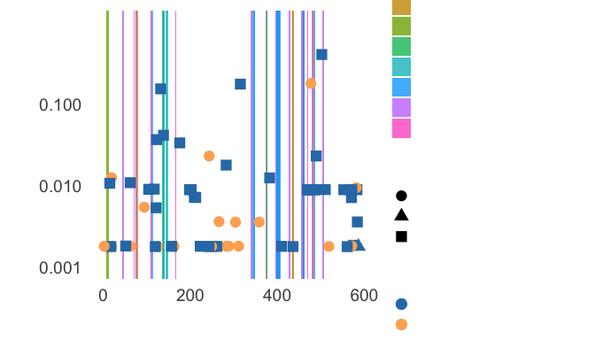

The AFB4 and AFB5 receptors have an N-terminal extension prior to the F-box domains. This extension had very high nonsynonymous diversity(Fig. 4), suggesting that this extension does not play an important functional role in these proteins. Additionally, two frameshift variants and one stop-gained variant were observed in *AFB4* supporting its pseudogenization.

(ref:AFB_F-box_align) Alignment of A. thaliana TIR1/AFB F-box domains showing variants. Cyan marks the F-box binding domain. Yellow, green, and magenta, mark missense and synonymous, synonymous only, and missense only variant locations respectively. Yellow squared E’s show Cul1-interacting residues, differing in AFB1.

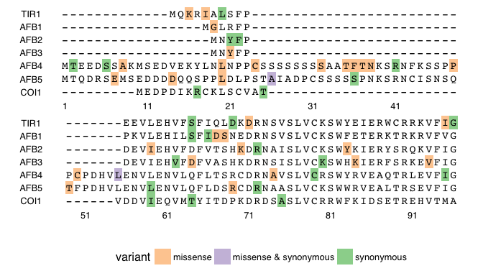

(ref:AFB_F-box_align)

Calderón Villalobos, L. I. A., Lee, S., De Oliveira, C., Ivetac, A., Brandt, W., Armitage, L., … Estelle, M. (n.d.). A combinatorial TIR1/AFB-Aux/IAA co-receptor system for differential sensing of auxin. *Nat Chem Biol*, *8*(5), 477–85. <https://doi.org/10.1038/nchembio.926>

Delker, C., Pöschl, Y., Raschke, A., Ullrich, K., Ettingshausen, S., Hauptmann, V., … Quint, M. (2010). Natural Variation of Transcriptional Auxin Response Networks in Arabidopsis thaliana. *The Plant Cell*, *22*(7), 2184–2200. <https://doi.org/10.1105/tpc.110.073957>

Dezfulian, M. H., Jalili, E., Roberto, D. K. A., Moss, B. L., Khoo, K., Nemhauser, J. L., & Crosby, W. L. (2016). Oligomerization of SCF TIR1 Is Essential for Aux/IAA Degradation and Auxin Signaling in Arabidopsis. *PLOS Genet*, *12*(9), e1006301. <https://doi.org/10.1371/journal.pgen.1006301>

Dharmasiri, N., Dharmasiri, S., Weijers, D., Lechner, E., Yamada, M., Hobbie, L., … Estelle, M. (2005). Plant Development Is Regulated by a Family of Auxin Receptor F Box Proteins. *Developmental Cell*, *9*(1), 109–119. <https://doi.org/10.1016/j.devcel.2005.05.014>

Melamed, D., Young, D. L., Miller, C. R., & Fields, S. (2015). Combining Natural Sequence Variation with High Throughput Mutational Data to Reveal Protein Interaction Sites. *PLoS Genet*, *11*(2), e1004918. <https://doi.org/10.1371/journal.pgen.1004918>

Park, B., Rutter, M. T., Fenster, C. B., Symonds, V. V., Ungerer, M. C., & Townsend, J. P. (2017). Distributions of Mutational Effects and the Estimation of Directional Selection in Divergent Lineages of Arabidopsis thaliana. *Genetics*, *206*(4), 2105–2117. <https://doi.org/10.1534/genetics.116.199190>

Parry, G., Calderon-Villalobos, L. I., Prigge, M., Peret, B., Dharmasiri, S., Itoh, H., … Estelle, M. (2009). Complex regulation of the TIR1/AFB family of auxin receptors. *Proceedings of the National Academy of Sciences*, *106*(52), 22540–22545. <https://doi.org/10.1073/pnas.0911967106>

Prigge, M. J., Greenham, K., Zhang, Y., Santner, A., Castillejo, C., Mutka, A. M., … Estelle, M. (2016). The Arabidopsis Auxin Receptor F-Box Proteins AFB4 and AFB5 Are Required for Response to the Synthetic Auxin Picloram. *G3: Genes|Genomes|Genetics*, *6*(5), 1383–1390. <https://doi.org/10.1534/g3.115.025585>

Starita, L. M., Ahituv, N., Dunham, M. J., Kitzman, J. O., Roth, F. P., Seelig, G., … Fowler, D. M. (2017). Variant Interpretation: Functional Assays to the Rescue. *The American Journal of Human Genetics*, *101*(3), 315–325. <https://doi.org/10.1016/j.ajhg.2017.07.014>

Wright, R. C., Zahler, M. L., Gerben, S. R., & Nemhauser, J. L. (2017). Insights into the Evolution and Function of Auxin Signaling F-Box Proteins in Arabidopsis thaliana Through Synthetic Analysis of Natural Variants. *Genetics*, *207*(2), 583–591. <https://doi.org/10.1534/genetics.117.300092>