Regulatory Compliance Knowledge Graph
Concept note: an ontology-based approach to regulatory impact assessment
RCAI&A · November 2026 · Internal

1. Purpose
When a regulation changes, the bank needs to know quickly and defensibly which obligations, policies, procedures and controls are affected, who owns them, and where it may be exposed. Today that answer is assembled by hand, alert by alert, across several systems.
This note sets out a different approach: a knowledge graph built on a shared ontology that connects every regulatory alert to the bank's obligations, policies, procedures, risks and controls, with the evidence for each connection.

2. The problem today
- The information exists but is disconnected. Regulatory alerts arrive in Rapid2. Regulations, summaries and obligations sit in RegMap. Policies and procedures sit in GPPS. Risks, control standards and the controls actually operated sit in Helios. Each system holds only part of the chain, and each uses its own identifiers and language.
- The critical links are missing. No system records which section of a policy implements a given obligation, which procedure step carries it out, or which control actually meets it. These are exactly the links an impact assessment needs, so they are rebuilt manually every time, from searching and expert memory.
- Slow, inconsistent and hard to evidence. A single alert can touch dozens of obligations and hundreds of controls. Assessments take time, vary between assessors, and are hard to trace back to source text for audit, MRM or regulators.
- No view of the whole. Because the pieces are not connected, it is hard to see the knock-on effect of a change (its blast radius) or to spot obligations that no control covers at all.

3. What happens when an alert lands
Each regulatory alert goes through the same five steps, mirroring the journey shown on the explorer's Live data tab. Steps 1 to 4 standardise and enrich the alert; step 5 assesses its impact.
- Alert received. The regulatory development arrives from the horizon-scanning feed (Rapid2) with its reference, title, summary and update text.
- Applicability. Is the development relevant to HSBC in this jurisdiction? Alerts that do not apply stop here, so effort goes only where it matters.
- Categorisation. The alert is classified by type (for example regulatory development, consultation, news, or fine and enforcement), which sets how it is handled.
- Contextualisation (machine learning). The alert is tagged with its location, risk steward, theme, risk taxonomy (L1 to L3), line of business and legal entity. These tags place it in the bank's own language and steer the impact search.
- Impact assessment (AI). Using the knowledge graph, AI links the alert to the regulations, obligations, policies, procedures, risks and controls it touches. An independent AI judge confirms each link, every link carries its evidence, and the result is an evidenced draft for SME review.

4. The concept: one connected map of regulation to control
An ontology is a shared, agreed model of the things that matter in regulatory compliance (alert, regulation, obligation, policy, procedure, risk, control standard, live control and gap) and of how they relate: an obligation is implemented by a policy section, satisfied by a control standard, and performed by a live control. The ontology is the blueprint; the knowledge graph is that blueprint filled with the bank's real records.
Because everything is connected, any question becomes a matter of following links: from an alert down to the controls it affects, or from a control back up to every regulation that depends on it. The model is independent of any one tool or process.

5. How the bank's artefacts connect
The relationships are those defined in the ontology model (the Map tab of the explorer). Each system already connects records within its own area; the bridges between areas are built by AI and confirmed by an independent judge.
- Regulatory source (RegMap, system). A Regulation Summary is partOfRegulation a Regulation; a Regulatory Obligation is derivedFromSummary a summary. RegMap also records that an obligation givesRiseTo a Library Risk.
- Policy and procedure (GPPS, system). A Procedure implementsPolicy a Policy, and policy and procedure sections map to the Library Controls that deliver them.
- Risk and control (Helios, system). A Library Risk is mitigatedBy Library Controls, and each Control Instance is an instanceOf exactly one Library Control.
- AI-built bridges (confirmed by the judge). A policy requirement implementsObligation; an obligation governsActivity in a procedure; a Library Control and a Control Instance each satisfies the obligation. A Regulatory Alert's change affectsSummary / affectsObligation, impactsPolicyRequirement and impactsControl.
- Gaps (rule). A Gap sits onRequirement for an obligation with no confirmed control, a control that is not operated, or only partial cover.
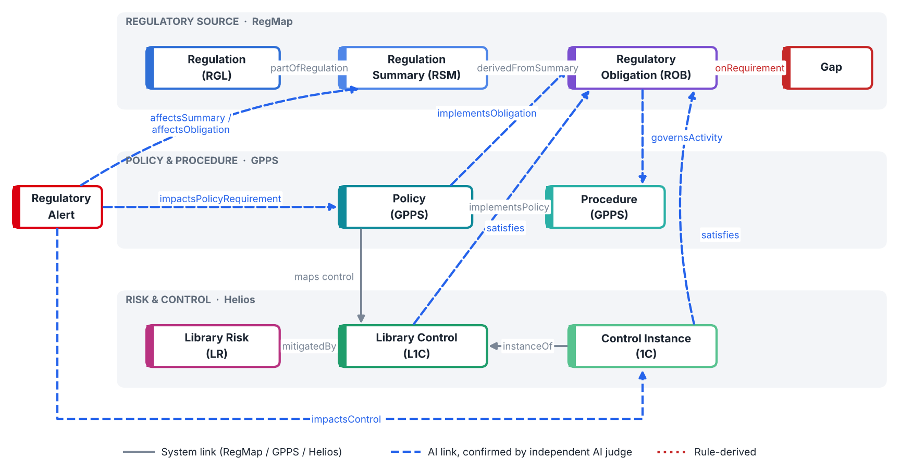

6. How it works
- Bring the sources together. Records from Rapid2, RegMap, GPPS and Helios are loaded with the links those systems already hold, current versions only.
- AI builds the missing links. A large language model reads the full texts of an obligation and a candidate policy section, procedure or control, and decides whether they genuinely connect. It must quote the exact supporting words from both texts, give a score and explain its reasoning. Candidates are proposed from the systems' own mappings, shared risk taxonomy and text search, so the AI chooses from realistic options rather than guessing.
- An independent AI judge checks every link. A second model reviews each proposed link as an assurance reviewer, looking for errors such as a generic theme or a mismatch in business or jurisdiction. Only links the judge confirms, with verified quotes, are treated as facts; everything else is kept, clearly labelled, for audit. The judge is itself tested with deliberately wrong links, which it reliably rejects.
- Rules flag the gaps. From the confirmed links, simple rules identify obligations with no control, controls that exist on paper but have no live instance, and controls that only partly cover an obligation. Each becomes a gap finding for review.
- Built to global standards, with a full audit trail. The model is published in W3C standards (OWL, SKOS, PROV-O) and aligned to FIBO; governance rules are checked automatically on every refresh. Every AI link keeps its evidence, reasoning, model run and review status.

7. What it enables for the business
- Faster, consistent impact assessment. For a new regulatory alert, the graph shows within minutes the obligations, policies, procedures and controls affected, each with its supporting evidence and a "change required" or "review" flag. Assessors start from a complete, evidenced draft instead of a blank page.
- Blast radius. Before a policy, control or process changes, see everything that depends on it: the obligations it serves, the regulations behind them and the alerts that have touched it.
- Control coverage and gaps. A prioritised view of obligations with no confirmed control, or with controls that are not operated, so remediation effort goes where the exposure is.
- Traceability and audit readiness. Every link can be traced from alert to control and back, with the source text, the reasoning and the review trail, which supports internal audit, MRM and regulatory scrutiny.
- Question answering in plain language. A chatbot answers questions over the graph, such as "which procedures does this new rule affect?", and cites the records and evidence it used.
- Reusable and scalable. The same model and method can be run for other jurisdictions and extended to new data sources from one configuration, building a bank-wide picture over time.

