*Session-02*

* *What is Repository?*
* *Repo it is used to store the source code of the project*
* *For every repo one URL will be generated.*
* *Source code and document of the file can be store.*
* *For every project one repository will be created and every repo will be having one url*
* [*https://github.com/writeds-dev/node-js.git*](https://github.com/writeds-dev/node-js.git)
* *We can create two types of repository*
* *Public repo // anyone can see but you will see who will modify.*
* *Private repo // no one can see and no one can modify*
* *Project team member will connect with repository they will connect with the url and they can connect with the url*
* *Git architecture -:*

***Git init***

Git hub

***Git add***

Git commit git push

Local

Repository

Staging area

Working tree

Central / remote

* 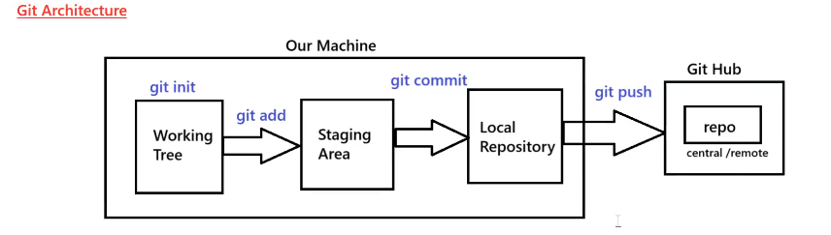What is central repo?
* *In GitHub where we have created our repository*
* What is working tree?
* *from where we can perform our action like add the files*
* *git init ()*
* What is staging area?
* Staging area represent which file you want to commit that commit file will go the local repo.
* *git add ()*
* *Git commit () --- sending the changes and storing the changes from our system to the remote system.*
* What is local repository?
* *It will create the file in the local system.*
* *git push ()*
* Some of the issue that can be come -:

