**Business Requirements Document**

**Customized self-serve link for DLMS Channel**

Sep 14, 2020

Version 1.0

|  |
| --- |
| Statement of Confidentiality  This document contains information that is proprietary and confidential to Axis Bank, which shall not be disclosed outside Axis Bank, transmitted, or duplicated, used in whole or in part for any purpose other than its intended purpose. Any use or disclosure in whole or in part of this information without explicit written permission of Axis Bank is prohibited.  © 2020, Axis Bank Ltd. |

**Purpose of document**

The purpose of Business Requirement Document (BRD) is to collate business requirements for the system to be developed or changes to be made in an existing system.

**Document Version:**

|  |  |  |  |  |  |  |
| --- | --- | --- | --- | --- | --- | --- |
| Date | Version | Status | Author(s) | Reviewer | Department | Notes |
| 18-08-2020 | 1.0 | Draft | Amit Prasad | Shefali Dixit | CXT | <New functionality> |
| 14-09-2020 | 1.0 | Draft | Amit Prasad | Shefali Dixit | CXT | Technical specifications mentioned |
| 28-09-2020 | 1.0 | Draft | Amit Prasad | Shefali Dixit | CXT | Updated BRD as per the meeting held on 24th Sep |

Contents

1. Background: 3

1.1 : Key Project Drivers 3

1.2 : Change Management 4

2. Cost Benefit Details 4

3. Description of Requirements 5

4. Risks, Assumptions, Issues, Dependencies (RAID) 17

5. Acceptance Criteria 17

6. Signoff 17

7. Glossary – 18

*<Right click on the above table and click on update entire table in case of any change in section names below>*

# Background:

*<Mention brief summary of the project - narrative containing a more detailed explanation of the project’s goals and objectives, the definition of the business needs and problems to be addressed – Block of text >*

# : Key Project Drivers

*<Select the applicable business driver & mention the remarks>*

|  |  |  |
| --- | --- | --- |
| Key Project Drivers | User Selection (Yes/No) | Justify/Quantify –Remarks *(Wherever applicable)* |
| Business Need | <Select> |  |
| Technology Need *(Upgrade/Enhancement)* | <Select> |  |
| Process/Customer Experience Enhancement | Yes | Self-serve link will be customized for allowing customers to change address and send it back to DLMS. This will be used extensively during 1st delivery attempt gets failed. |
| Regulatory/Compliance/Legal requirement | <Select> |  |
| Change Type *(New application / Enhancements/Upgrade)* | <Select> |  |
| Customer Segments / end users that will be served by this initiative *(internal/external)* | <Select> |  |

# : Change Management

|  |  |  |
| --- | --- | --- |
| Parameters | User Selection (Yes/No) | Remarks *(Wherever applicable)* |
| Does this change require PMC/CMC approval? | Yes |  |
| If PMC/CMC is required. Are the approvals in place? | Yes | CMC/PQ./19-20/251 |

# 2. Cost Benefit Details

*< Select the parameters which are applicable for your project. E.g. post implementation of this project if the bank is able to save Rs 2 Cr then Select “Yes” for the parameter – “Cost Reduction” and mention “2 Cr” in the Justify/Quantify column>*

|  |  |  |
| --- | --- | --- |
| Parameters | User Selection (Yes/No) | Justify/Quantify –Remarks *(Wherever applicable)* |
| Cost Reduction | <Select> |  |
| Generating Revenue for the bank (Per year) | <Select> |  |
| Efforts/Hours Reduction (Per day- across team) | <Select> |  |
| Risk Reduction | <Select> |  |
| TAT (Turn Around Time) reduction | <Select> |  |
| Regulatory/Compliance/Legal requirement | <Select> |  |
| Customer delight   * *Little value to the customer(s)* * *Some value* * *A lot of value to customer* * *Essential/critical to customer(s)* | <Select> |  |
| Expected Project Delivery date   * *Has to be delivered in the next 6+ months* * *Has to be delivered in the next 4-6 months* * *Has to be delivered in the next 2-4 months* * *Has to be delivered in the next 0-2 months* | <Select> |  |
| Requirement Type/ Emerging From *\* Is it a mandate from SVP & above?* | <Select> |  |

# 3. Description of Requirements

**AS IS:** Self-serve link is medium through which address can be updated in core system. However there is no reverse feed of the updated address to DLMS (when the same is triggered from DLMS post failed delivery attempt)

*<Brief description of the existing process/functionality/ issue>*

**TO BE:** In the proposed process, self-serve link will send the reverse feed (new address) to Newgen container and DLMS on the basis of channel id. If channel id corresponds to Newgen then reverse feed will be sent to Newgen and if it corresponds to DLMS then reverse feed will be sent to DLMS.

*<Brief description of the desired process/functionality/High-level solution>*

1. **Functional Requirements**

|  |  |  |
| --- | --- | --- |
| Sr No. | ID | Detailed description of the Functional Requirement |
| 1 | BR1 | **Self-serve link modification for DLMS**   * DLMS triggers self-serve link to customer if the card delivery fails to customer. * DLMS calls self-serve link API with below inputs parameters   1. **Input parameters which are passed to self-serve link’s -generateShortLink( ) API from DLMS:** Unique reference number (AWB), Channel ID, Cust Id and Product Identifier (for CC and DC). Unique reference number is to be generated by DLMS to track the entire request and response * Post clicking on the link, customer will be asked to authenticate himself/herself as defined in Branch of Future journey * Post authentication, customer is shown the option through which he wants to change his communication address with respect to the deliverable.   Customer can change his address only on the basis of EKYC Aadhhar based authentication (which is an instant updation). *Document upload part (Voter ID and Driving license) shouldn’t be visible to customer.*   * **Customer chooses eKYC Aadhaar authentication based address change method:**    1. **If Product Identifier is CC (passed on from DLMS as an input argument)**   **Gist:** In this post successful EKYC authentication, the new address (es) gets updated in CTL in STP manner through MDM services. Also, a reverse feed of the updated **communication address (preferred mailing address), along with the AWB number** is sent back to DLMS. DLMS will provide an API basis which the updated address and other details are sent back from Digi-serve to DLMS. Customer journey is as below  ***Case 1*** *: Customer chooses to go with* ***Aadhaar address*** *and enters his* ***Work address***   * + 1. Post successful EKYC authentication the Aadhaar address will be fetched from UIDAI and is shown to customer.     2. Customer selects Aadhaar address as his preferred address for delivery. Customer clicks on “Use Aadhaar address for card delivery” button.        - Customer is asked if he wants to update this address (Aadhaar’s address) for all his existing relationships as well. A check-box is given to capture his consent.        - If customer selects the check-box, then address should be updated across all his relationships (as his communication address) using MDM services.        - If customer doesn’t select the check-box then the address should be updated only on CTL (as his resident address).     3. Customer is asked if he also wants to update his Work address (this will be non-mandatory field). Customer enters his Work address and clicks on “Confirm Work Address” button.     4. Post that, customer will be asked to re-confirm the card delivery address. Customer will be shown both Resident and Work address. A check-box will be given (for both Resident and Work address) to select the delivery address.        - Customer can choose only one address as his mailing address. This address will be passed on to DLMS as Preferred mailing address of the customer (post address update using MDM). Customer clicks on **Submit** button     5. Post click on Submit, both Work and Resident address gets updated in CTL using MDM services. Post successful response from MDM, DLMS API is called with preferred mailing address and AWB number.   **Mailing flag in CTL is also set True for the Preferred mailing address**   * If customer has chosen to update all his existing relationships (Loan/Savings/Credit Cards) then Aadhaar address will be replicated across all core systems using MDM services. * Post successful updation across all the core systems or CTL, the mailing address (as selected by customer in step IV, will be sent back to DLMS as Preferred mailing address of the customer).   **Case 2:** *Customer chooses to go with* ***Aadhaar address*** *and skips his* ***Work address***   1. Post successful EKYC authentication the Aadhaar address will be fetched from UIDAI and is shown to customer. 2. Customer selects Aadhaar address as his preferred address for delivery. Customer clicks on “Use Aadhaar address for card delivery” button.    * Customer is asked if he wants to update this address (Aadhaar’s address) for all his existing relationships as well. A check-box is given to capture his consent.    * If customer selects the check-box, then address should be updated across all his relationships (as his communication address) using MDM services.    * If customer doesn’t select the check-box then the address should be updated only on CTL (as his resident address). 3. Customer is asked if he also wants to update his Work address (this will be non-mandatory field). Customer enters his Work address and clicks on “Skip” button. 4. Post that, customer will be shown the card delivery address (Resident Address). Customer clicks on Proceed button. 5. Post click on Submit, Resident address gets updated in CTL using MDM services. Post successful response from MDM, DLMS API is called with preferred mailing address and AWB number.   **Mailing flag in CTL is also set True for the Preferred mailing address**   * If customer has chosen to update all his existing relationships (Loan/Savings/Credit Cards) then Aadhaar address will be replicated across all core systems using MDM services. * Post successful updation across all the core systems or CTL, the mailing address (Resident Address) will be sent back to DLMS as Preferred mailing address of the customer)   **Case 3:** *Customer chooses to go with* ***self-declared address*** *and enters his* ***Work address***   1. Post successful EKYC authentication the Aadhaar address will be fetched from UIDAI and is shown to customer. 2. Customer selects Aadhaar address as his preferred address for delivery. Customer clicks on “Enter different address for card delivery” button. 3. Customer is asked to enter his self-declared address. Customer clicks on Proceed button.    * Customer is asked if he wants to update this address (Self-declared address) for all his existing relationships as well. A check-box is given to capture his consent.    * If customer selects the check-box, then address should be updated across all his relationships (as his communication address) using MDM services. In this case Aadhaar address will become permanent address in Finacle    * If customer doesn’t select the check-box then the address should be updated only on CTL (as his resident address). 4. Customer is asked if he also wants to update his Work address (this will be non-mandatory field). Customer enters his Work address and clicks on “Confirm Work Address” button. 5. Post that, customer will be asked to re-confirm the card delivery address. Customer will be shown both Resident (self-declared address) and Work address. A check-box will be given (for both Resident and Work address) to select the delivery address.    * Customer can choose only one address as his mailing address. This address will be passed on to DLMS as Preferred mailing address of the customer. Customer clicks on Submit button 6. Post click on Submit, both Work and Resident (self-declared address) address gets updated in CTL using MDM services. Post successful response from MDM, DLMS API is called with preferred mailing address and AWB number.   **Mailing flag in CTL is also set True for the Preferred mailing address**   * If customer has chosen to update all his existing relationships (Loan/Savings/Credit Cards) then self-declared address will be replicated across all core systems using MDM services. In this case, Aadhaar address is stored as Permanent address in Finacle * Post successful updation across all the core systems (or CTL), the mailing address (as selected by customer in step V, will be sent back to DLMS as Preferred mailing address of the customer)   **Case 4:** *Customer chooses to go with* ***self-declared address*** *and skips his* ***Work address***   1. Post successful EKYC authentication the Aadhaar address will be fetched from UIDAI and is shown to customer. 2. Customer selects Aadhaar address as his preferred address for delivery. Customer clicks on “Enter different address for card delivery” button. 3. Customer is asked to enter his self-declared address. Customer clicks on Proceed button.    * Customer is asked if he wants to update this address (Self-declared address) for all his existing relationships as well. A check-box is given to capture his consent.    * If customer selects the check-box, then address should be updated across all his relationships (as his communication address) using MDM services. In this case Aadhaar address will become permanent address in Finacle    * If customer doesn’t select the check-box then the address should be updated only on CTL (as his resident address). 4. Customer is asked if he also wants to update his Work address (this will be non-mandatory field). Customer enters his Work address and clicks on “Skip” button.    * Post that, customer will be shown the card delivery address (Resident Address- Self declared address). Customer clicks on Proceed button. 5. Post click on Submit, Resident address gets updated in CTL using MDM services. Post successful response from MDM, DLMS API is called with preferred mailing address and AWB number.   **Mailing flag in CTL is also set True for the Preferred mailing address**   * If customer has chosen to update all his existing relationships (Loan/Savings/Credit Cards) then self-declared address will be replicated across all core systems using MDM services. In this case, Aadhaar address is stored as Permanent address in Finacle * Post successful updation across all the core systems or CTL, the mailing address (as selected by customer in step IV, will be sent back to DLMS as Preferred mailing address of the customer)   1. **If Product Identifier is DC (passed on from DLMS as an input argument)**   **Case 1:** *Customer chooses to go ahead with Aadhaar address*   1. Post successful EKYC authentication the Aadhaar address will be fetched from UIDAI and is shown to customer. 2. Customer selects Aadhaar address as his preferred address for delivery. Customer clicks on “Use Aadhaar address for card delivery” button.    * Customer is asked if he wants to update this address (Aadhaar address) for all his existing relationships as well. A check-box is given to capture his consent.    * If customer selects the check-box, then address should be updated across all his relationships (as his communication address) using MDM services.    * If customer doesn’t select the check-box then the address should be updated only on Finacle (as his communication address). 3. Post clicking the button, Aadhaar address (fetched from UIDAI) will get updated in Finacle as customer’s communication address via MDM services.    * If customer has chosen to update all his relationships then the address gets replicated across all relationships using MDM services. 4. On successful updation of address in Finacle or all core systems (as per choice of customer), DLMS API is called and Aadhaar address, AWB number and Cust Id is sent back to DLMS. 5. DLMS API will provide the Reason code (Success/Failure) along with the Cust Id and AWB number   **Case 1:** *Customer chooses to go ahead with Self-declared address*   1. Post successful EKYC authentication the Aadhaar address will be fetched from UIDAI and is shown to customer. 2. Customer clicks on “Enter different address for card delivery” button. 3. Customer is asked to enter his self-declared address. Customer clicks on Proceed button.    * Customer is asked if he wants to update this address (self-declared address) for all his existing relationships as well. A check-box is given to capture his consent.    * If customer selects the check-box, then address should be updated across all his relationships (as his communication address) using MDM services.    * If customer doesn’t select the check-box then the address should be updated only on Finacle (as his communication address). 4. On the click of Proceed button, self-declared address (entered above) will get updated in Finacle as customer’s communication address and Aadhaar Address (fetched from UIDAI) will get updated as Permanent address via MDM services.    * If customer has chosen to update the address across multiple relationships then the same should happen post click on Proceed. 5. On successful updation of address across Finacle or other core systems (as per choice of customer), DLMS API is called and Self-declared address, AWB number and Cust Id is sent back to DLMS. 6. DLMS API, will provide the Reason code (Success/Failure) along with the Cust Id and AWB number |
| - | - | For Input/Output parameters and mapping document: Refer this excel sheet. |
| 2 | BR 2 | * In case of DLMS API failure (post address updation in core systems) : * A response code will be shared by DLMS (if it’s an data issue or server side issue)   + Digiserv will try to re-attempt calling the DLMS API 3 times. Post that the response code (received from DLMS) is updated in Digiserv application database.   + A report will be fetched by BIU at the EOD to facilitate manual intervention * In case of MDM service failure/exception   + - A message will be shown on screen: Customer should be able to use link till the address gets successfully updated in core system(s) before the link expiry.   *Dear Customer, we are currently not able to process your request because of a technical issue. Please try again later. However, you can also change your address using IB/MB (Insta Services) and Phone banking channel.*  No SR is to be raised for address change in case of MDM failures. |
|  |  |  |

1. **Dashboard/Report/MIS Requirements**

|  |  |  |
| --- | --- | --- |
| Sr No. | ID | Detailed description of the Dashboard/Report/MIS Requirement |
| 1 | MIS 1 |  |
| 2 | MIS 2 | < Mention the individual requirement in detail> |
| ..10 | ..MIS 10 | < Mention the individual requirement in detail> |

1. **Diagrams/ Wireframes/ Flowcharts/Prototype screens**

*<*[*www.draw.io*](http://www.draw.io) *accessible on any browser can be used for creating drag & drop flowcharts etc.>*

*<Flowchart>*

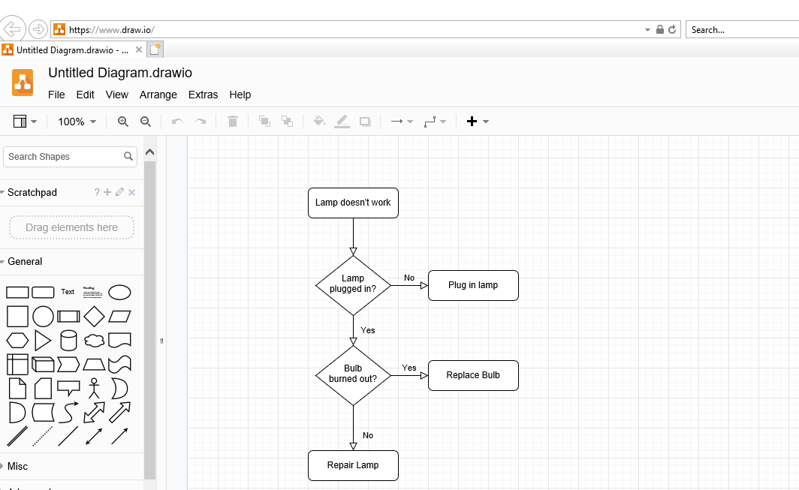

*<Wireframe/Mock-up 1>*

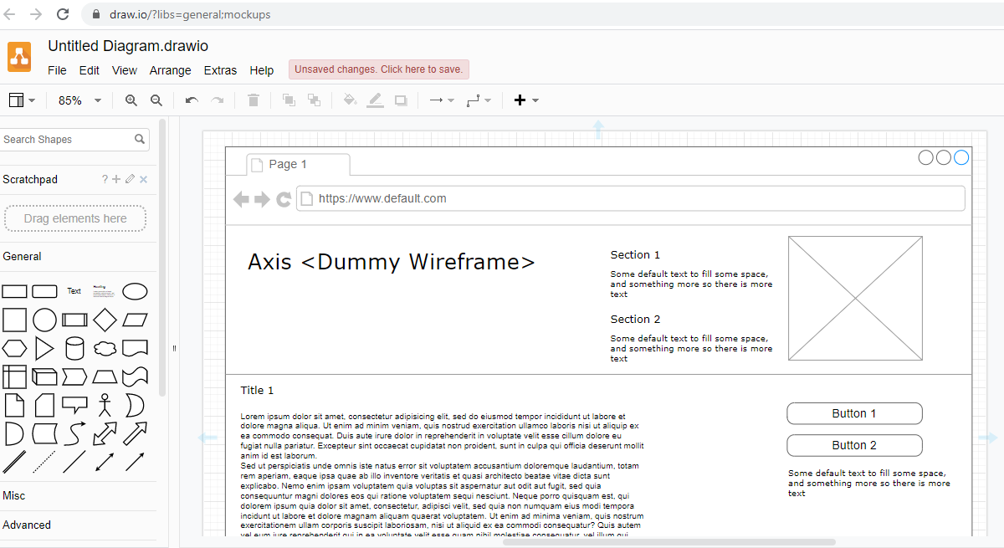

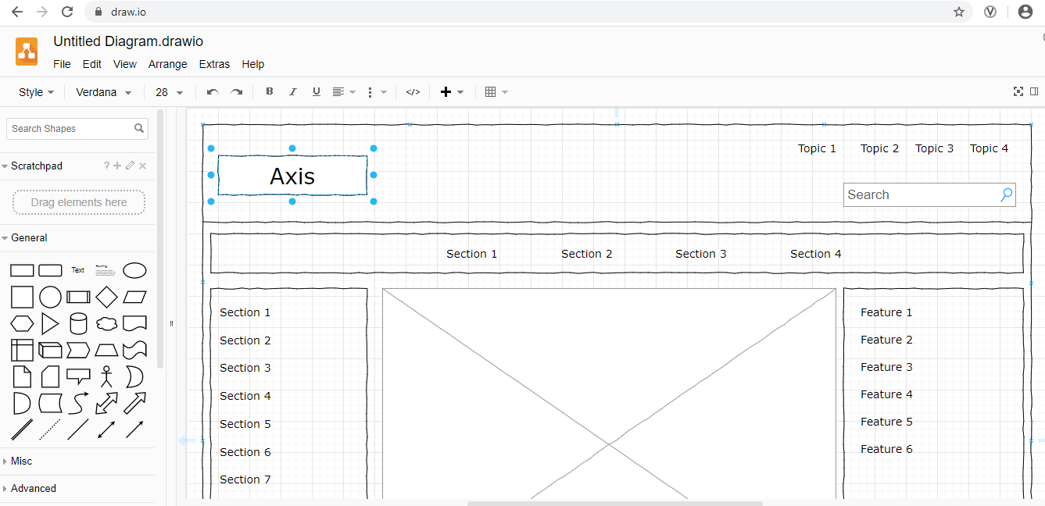*<Wireframe/ Mock-up 2>*

*<Network Diagram for Internal IT requirements (Multiple such other templates available)>*

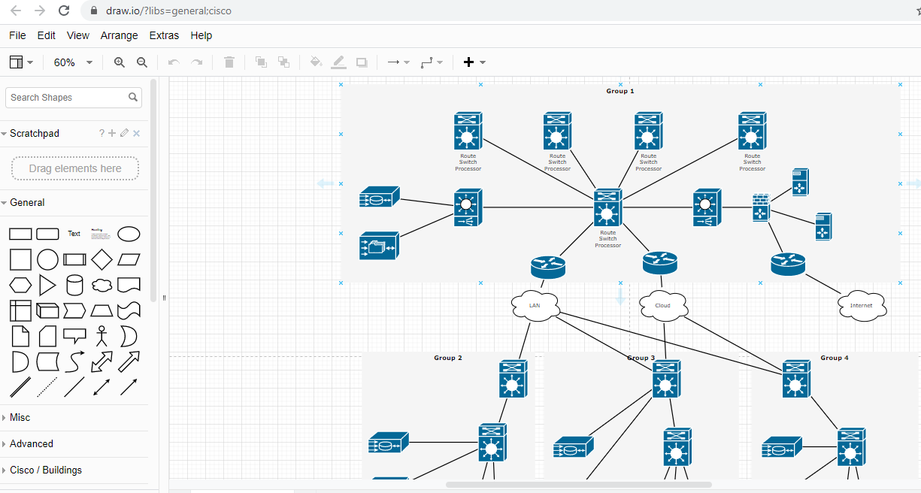

1. **Non-functional Requirements:**

*<In case any Non Functional requirement is applicable, please mention the same here. Non-functional requirement is a specification that describes the system’s operation capabilities and constraints that enhance its functionality. These may be speed, security, reliability, etc. E.g. System should be able to handle 10000 transactions per second or page should load in 1 mil second >*

|  |  |  |
| --- | --- | --- |
| Sr No. | ID | Detailed description of the Non-Functional Requirement |
| 1 | NFR 1 | < Mention the individual requirement in detail> |
| 2 | NFR 2 | < Mention the individual requirement in detail> |
| ..10 | ..NFR 10 | < Mention the individual requirement in detail> |

# 4. Risks, Assumptions, Issues, Dependencies (RAID)

*<Please mention the RAID details in the below format as per the illustrative example>*

|  |  |  |  |  |  |
| --- | --- | --- | --- | --- | --- |
| **Sr No.** | **Description** | **Type**  **(R|A|I|D)** | **Criticality**  **(Critical/High /Medium/Low)** | **Next Actions** | **Owner** |
| 1 | *<Resource bottlenecks due to team members being assigned to parallel projects>* | *<Risk>* | *<Medium>* | *<Look for suitable external vendor>* | *<Manish Joshi>* |
| 2 | *<Dependent Sub-systems should be available before parent system go-live>* | *<Assumption>* | *<Critical>* | *<Confirm go live for dependent Sub-systems>* | *<John Taylor>* |
| N |  |  |  |  |  |

# 5. Acceptance Criteria

*<Please specify Acceptance Criteria/s for signoff>*

# 6. Signoff

|  |  |  |
| --- | --- | --- |
| NAME | DEPARTMENT | DATE |
| Amit Prasad | CXT | DD- MMM-YYYY |
| Sanchita Tulsiyan | CXT |  |
| Pooja Deshpande | DLMS IT |  |
| Santosh Singh | DLMS IT |  |
| Shefali Dixit | CXT |  |
| Praneetha |  |  |

**Disclaimer: Any requirements not signed off, over and above those mentioned in BRD will be considered out of scope.**

# 7. Glossary –

***<Delete this entire section from the actual BRD>***

***Risks*** *- Risks are events that will adversely affect the project if they eventuate. Evaluate their importance based on the likelihood they’ll occur, along with the impact on the project if they do.*

*Ask: What events might occur that will have a negative impact? Actions: Implement risk mitigation strategies based on the criticality of each risk.*

***Assumptions -*** *Assumptions are aspects of the project that you assume will be in place to help the project run but can’t be guaranteed. If they are proved wrong, there will be an impact on the project.*

*Ask: What exists, or do we presume to be true, that will help our project to succeed?*

*Actions: Reassess assumptions at regular intervals to ensure they are still valid.*

***Issues -*** *Issues are events that have an adverse impact on the project. They are risks that have eventuated, and you must manage ASAP to keep the project on track.*

*Ask: What must we deal with to make the project run to plan?*

*Actions: Contain or remove the issue.*

***Dependencies –***

*Dependencies are activities which need to start or be completed so the project can progress and succeed. Dependencies may rely on internal or external events, suppliers, or partners.*

*Ask: Who or what are we dependent on and who depends on us?*

*Actions: Monitor and manage dependencies.*

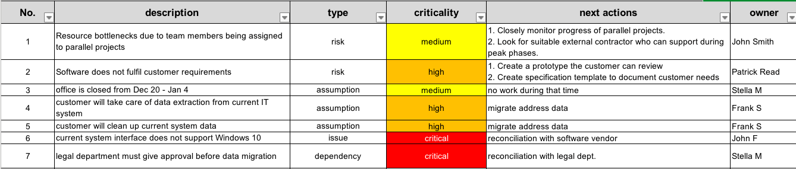

*Source - www.tacticalprojectmanager.com*