sonarLint screenshot.

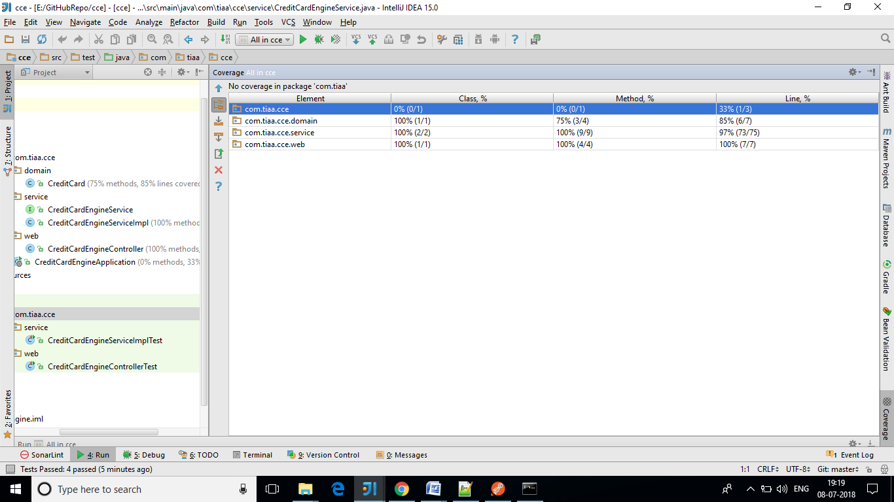

http://localhost:18080/CCEngine/visa/4

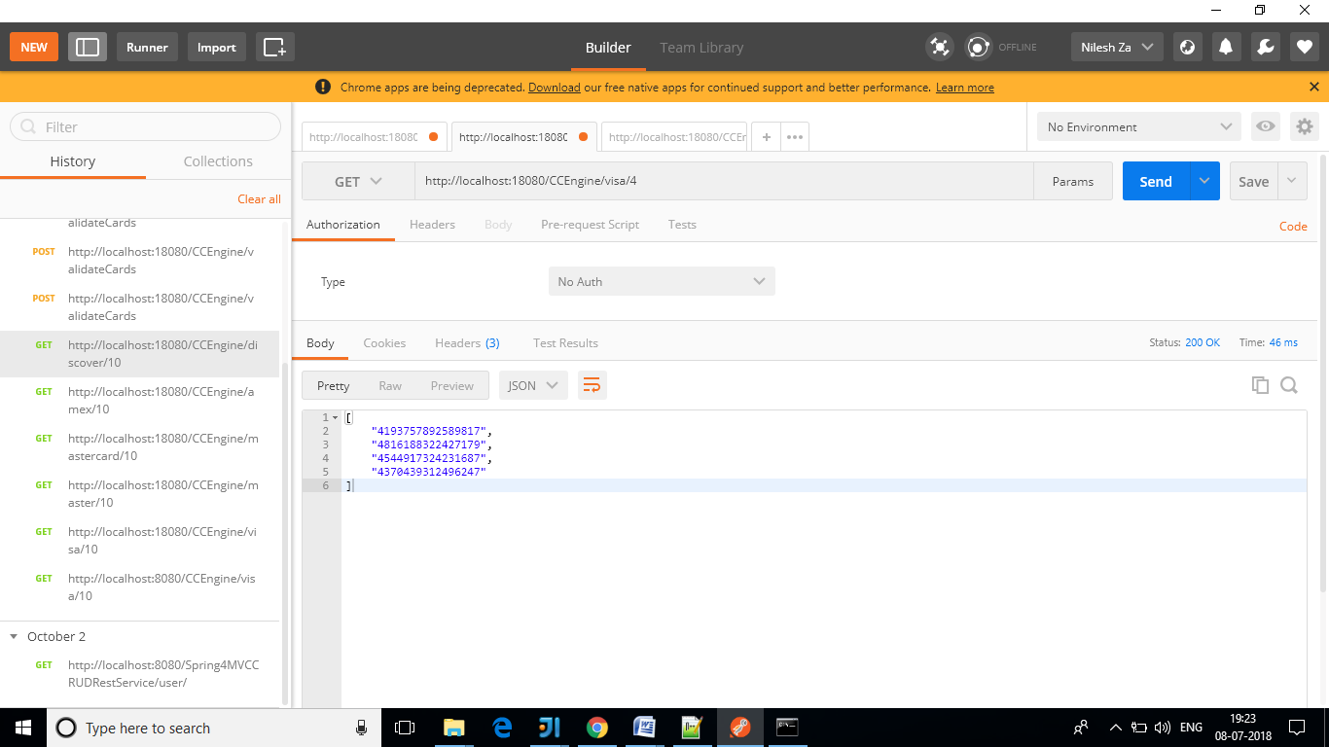

<http://localhost:18080/CCEngine/validateCards>

