Signal:

3 signal observation periods, 5 min, 11:45am, 12:45pm, 2:15pm, applied on index

3 trade execution periods, 15 min, TWAP, 12:00pm, 1:00pm, 2:30pm, applied on tradeable futures

PChange(t, i) = IndexTWAP(t, i) / Index(t-1) - 1.0

Thresh(t) = 0.5 \* sqrt(1/22\*sum(ln\*\*2))





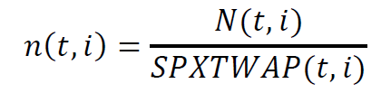

Calc performance

