AWS Setup for GemFire Ops Suite

This document walks through setting up an AWS account for use with GemFire Ops Suite. The requirements are listed below:

* AWS Credentials consisting of an “AWS access key id” and an “AWS secret access key”. These can either be the master credentials for the account or the credentials for an IAM user with appropriate privileges. This guide assumes the latter.
* A key pair must be created within the AWS account and the private half of the key, in the form of a “.pem” file must downloaded to the machine running GemFire Ops Suite.

There are two parts of the instructions. The first part must be done once within the AWS management console. The second part, entitled “Local Machine Setup” must be done on the local machine running GemFire Ops Suite

Open the AWS Management Console

Navigate to <https://aws.amazon.com> and sign in or create an account.

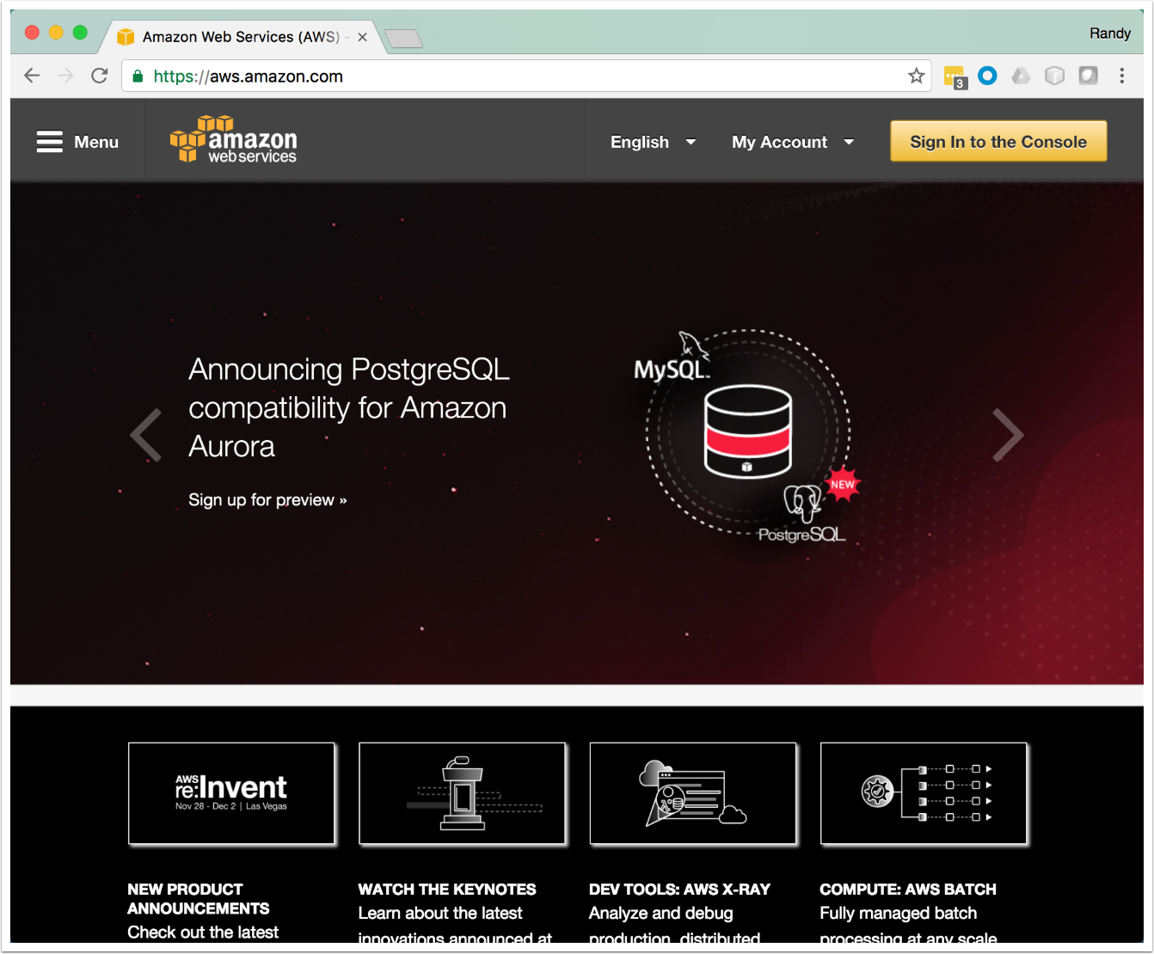

Click on Key Pairs

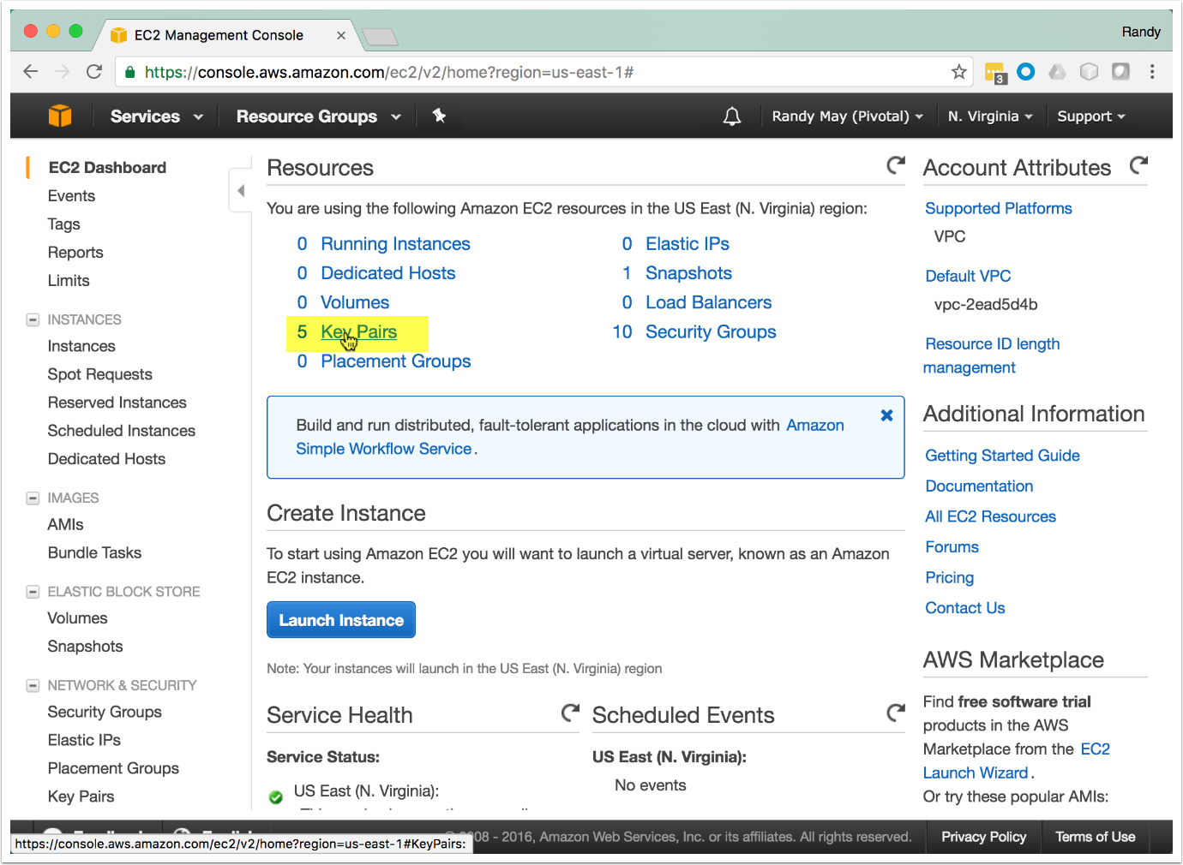

Click "Create Key Pair"

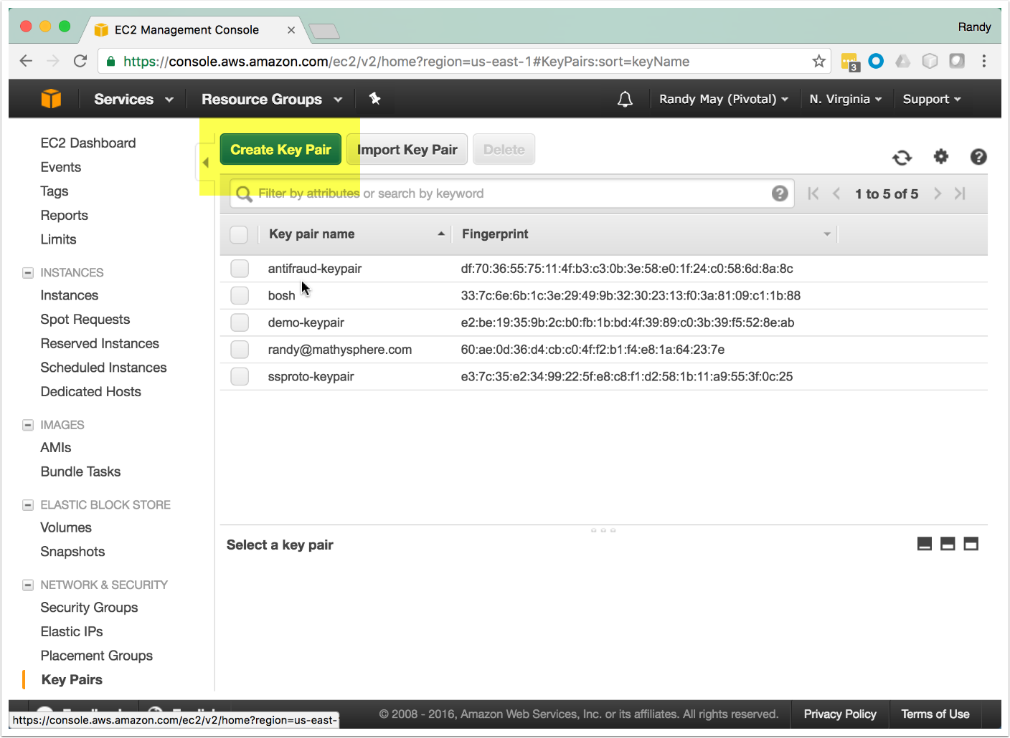

Create the Key Pair

Provide a name for the key pair (e.g. gemfire-keypair) and create it. A .pem file will be downloaded immediately. **You will need this file later.**

After downloading the .pem file, click on the "Services" menu at the top.

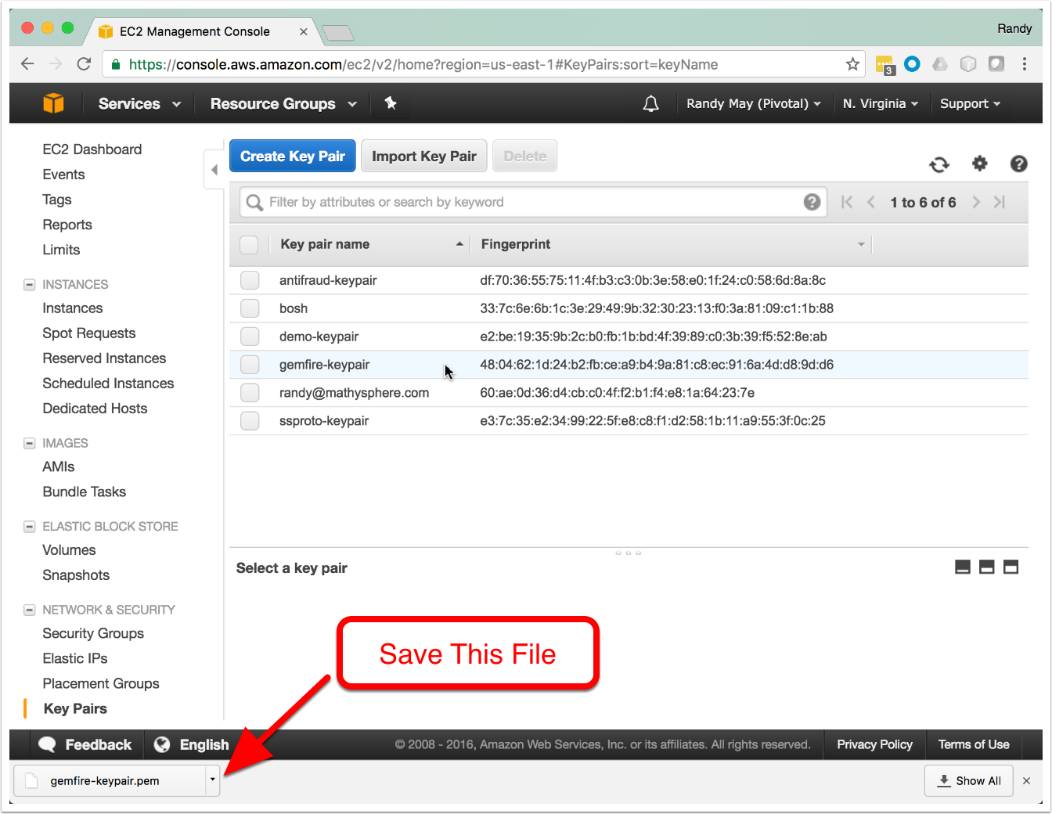

Click on IAM

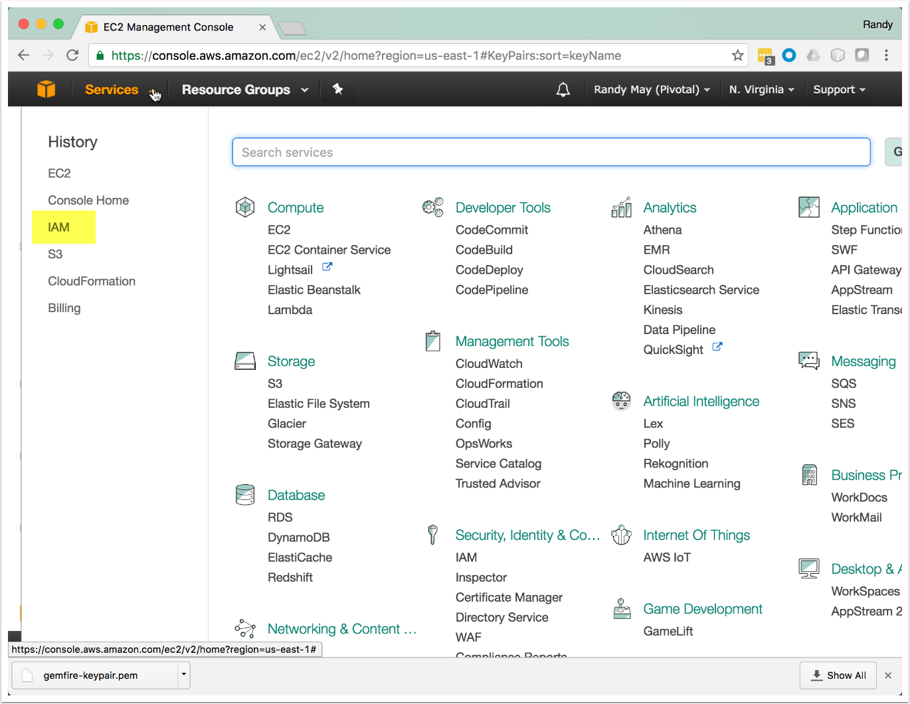

Click on Users

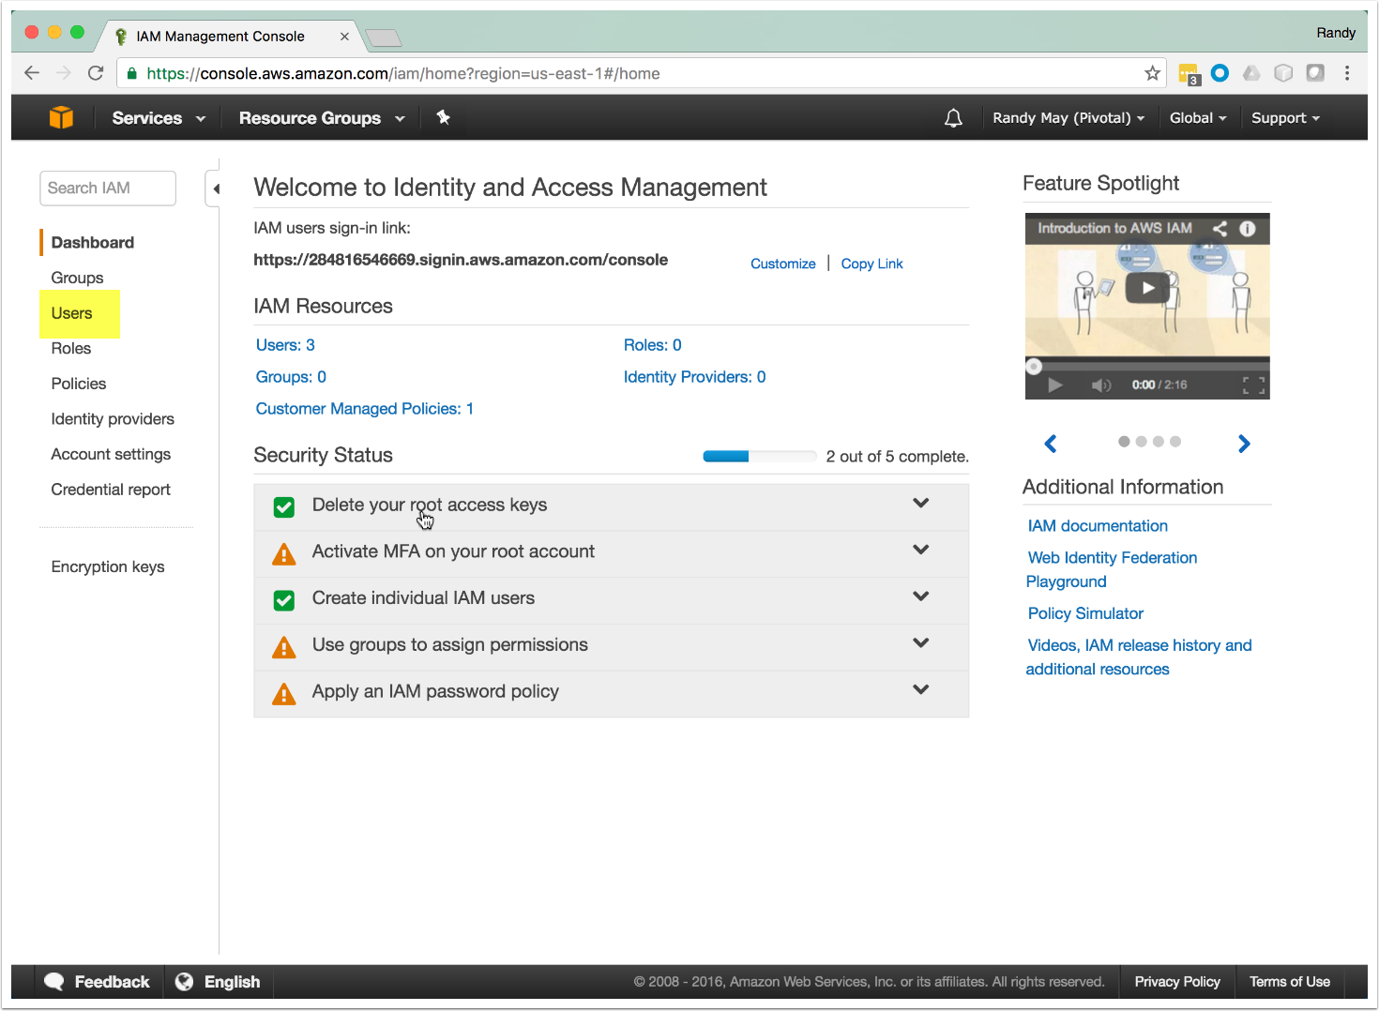

Click on Add User

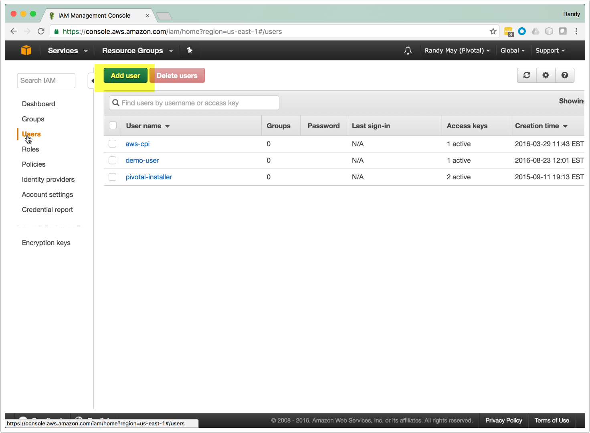

Fill Out the Add User Dialog

Provide the user name and check the "programmatic access" check box. Click "Next".

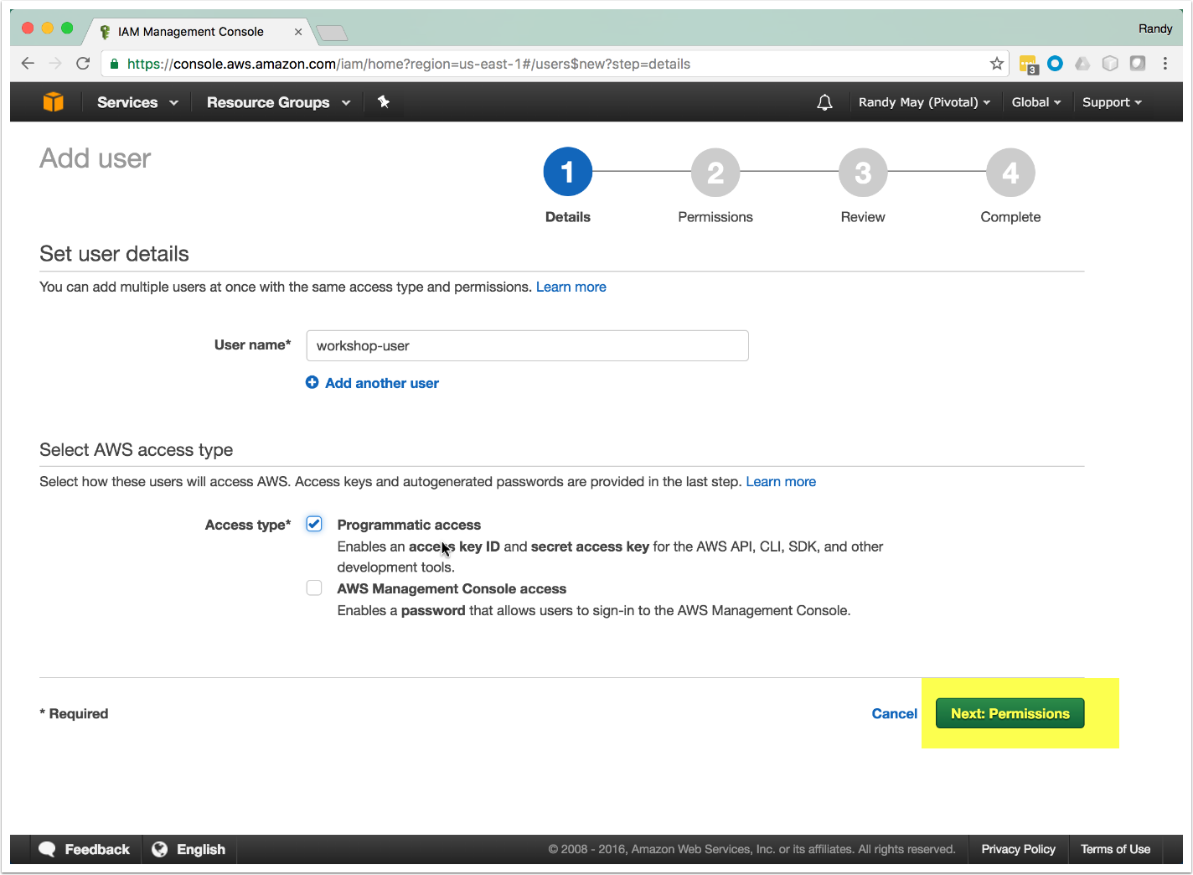

Click Next

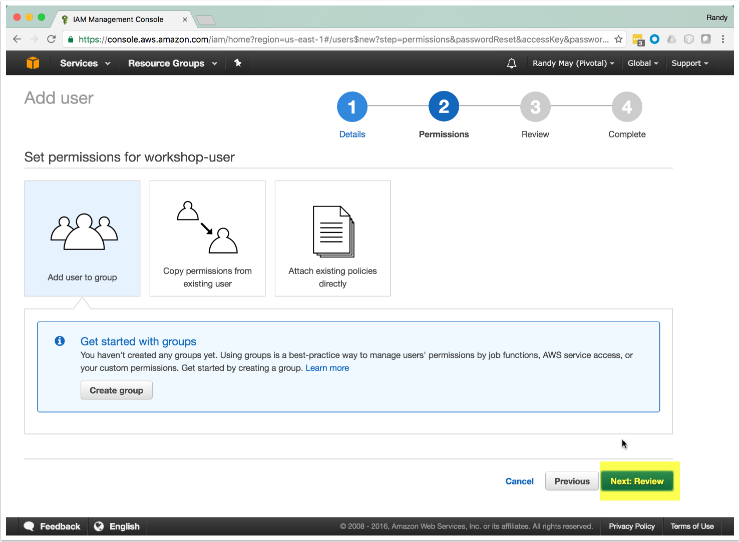

Create the User

Permissions will be added after the user is created.

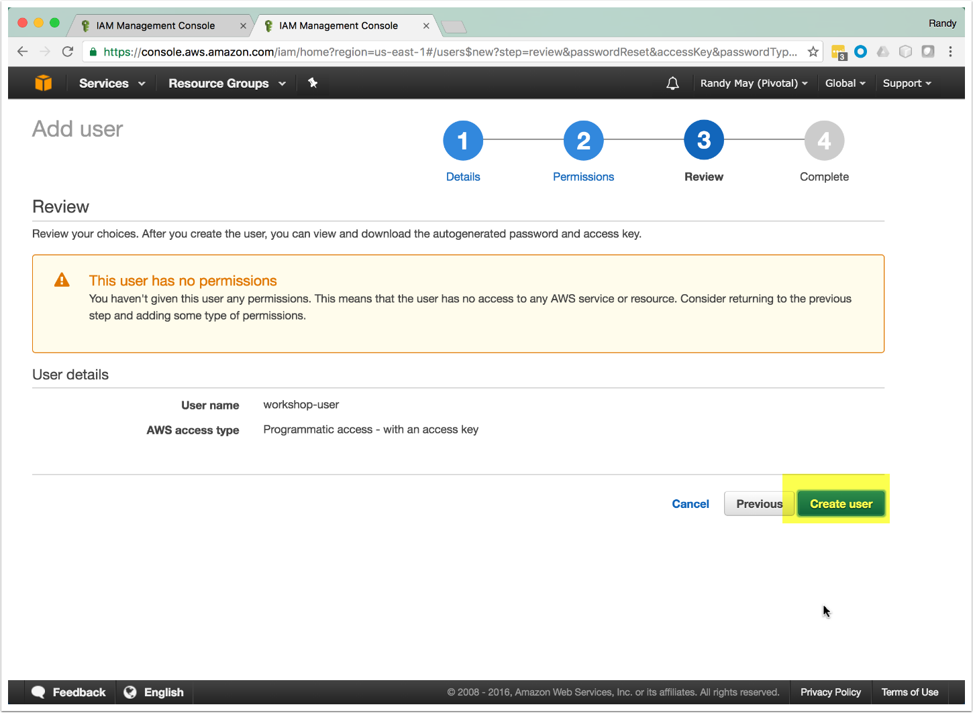

Download the .csv File

It's important to save this file. You will not be able to obtain the credentials again.

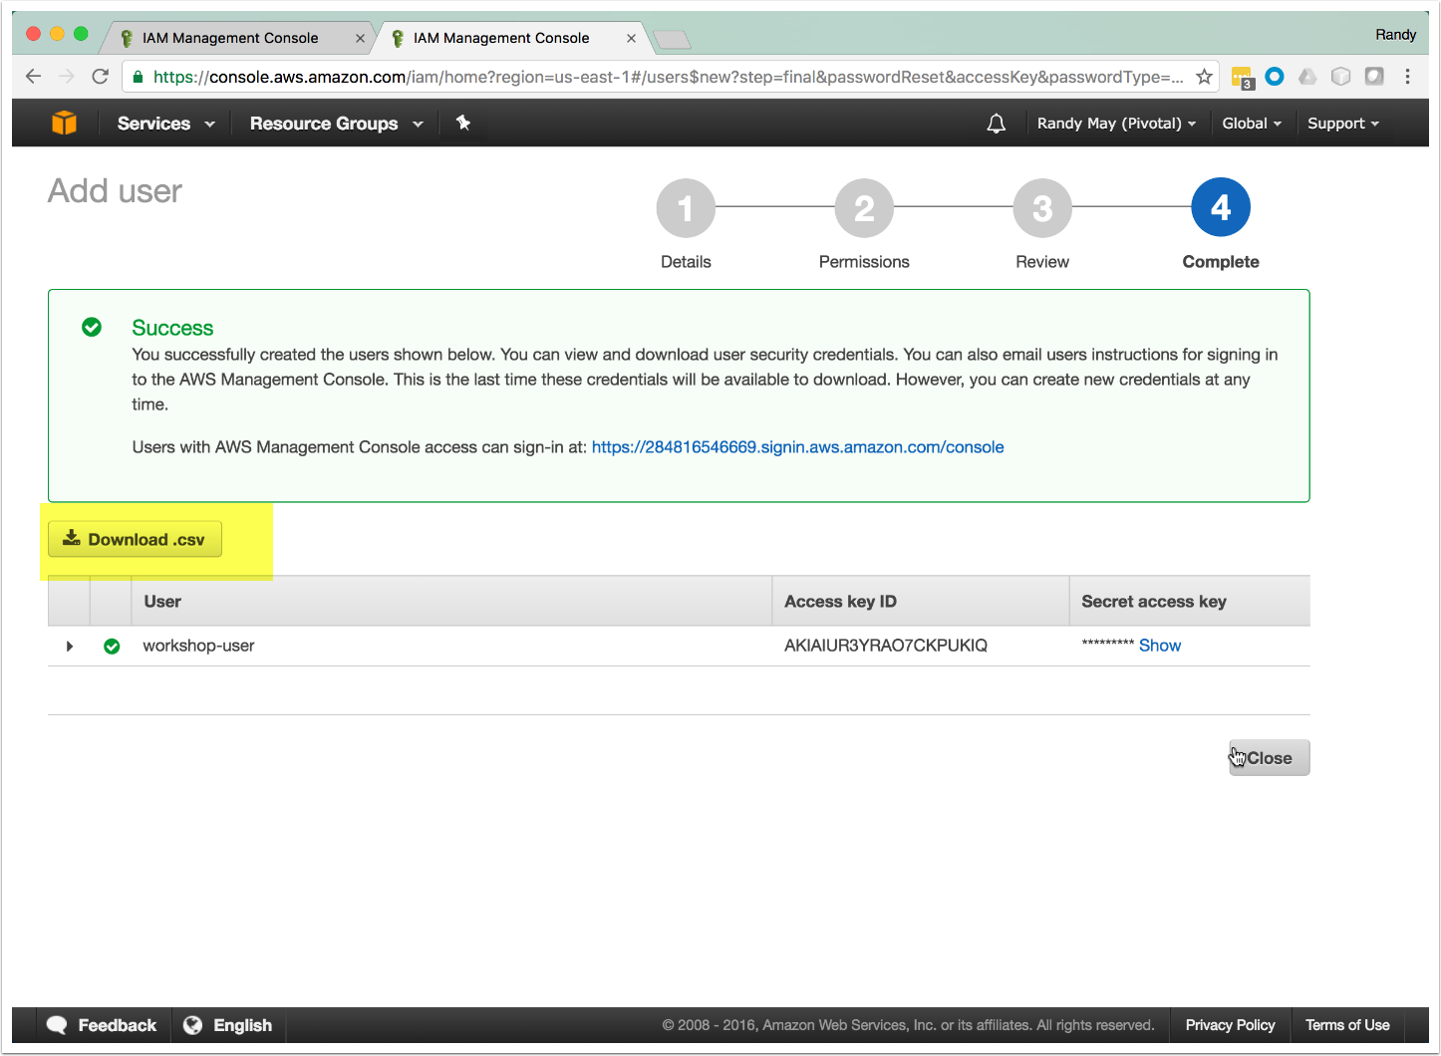

Select the New User

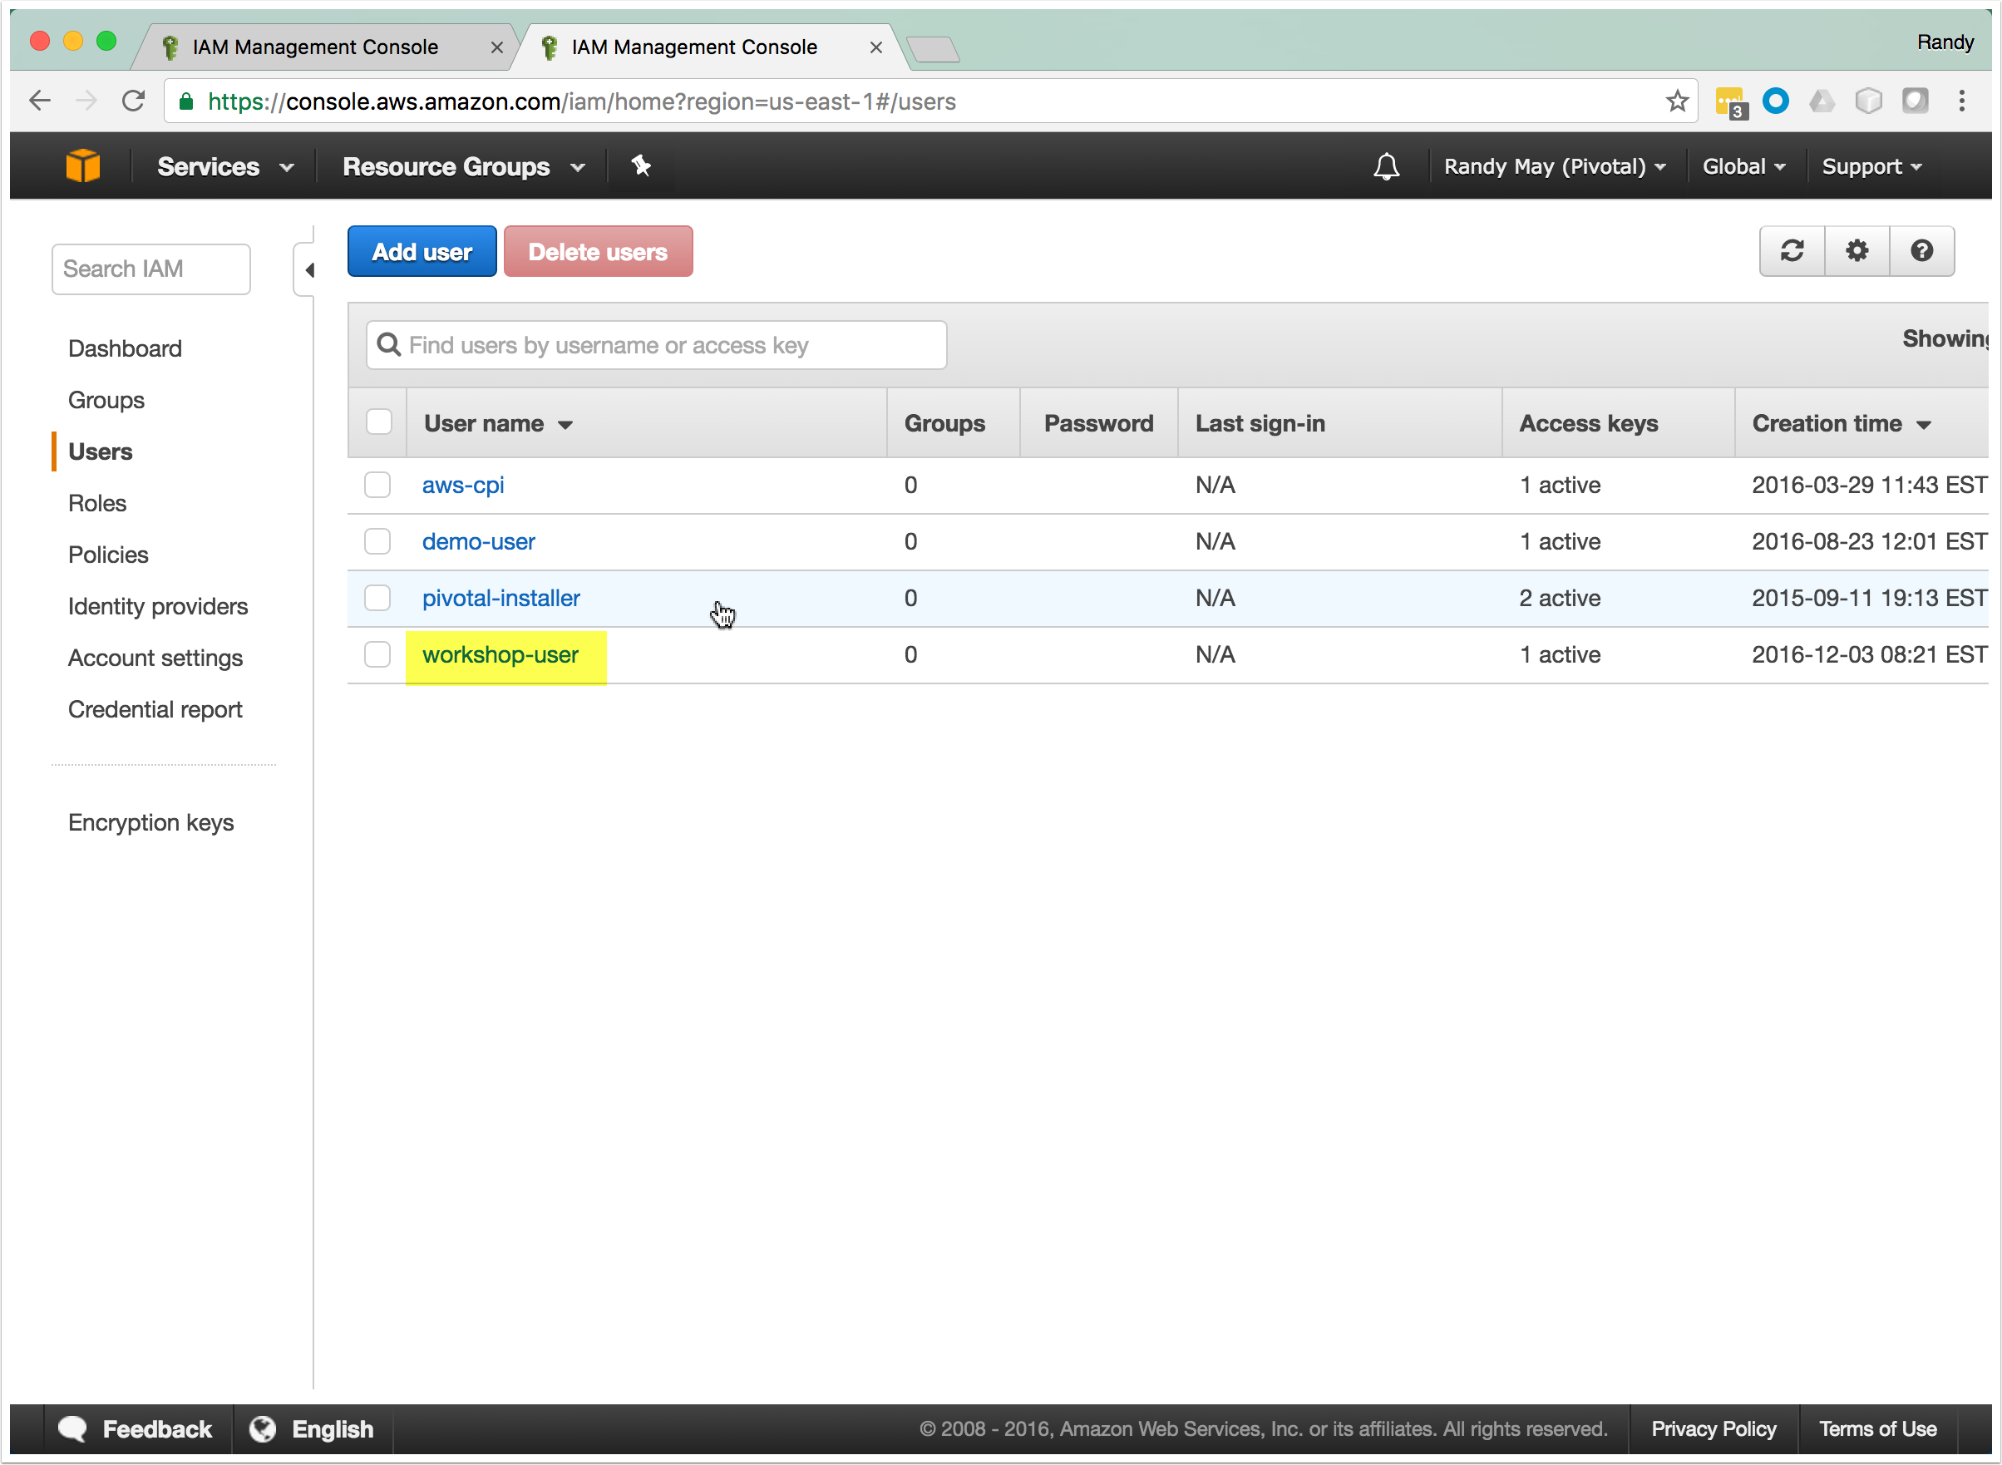

Click Add Permission

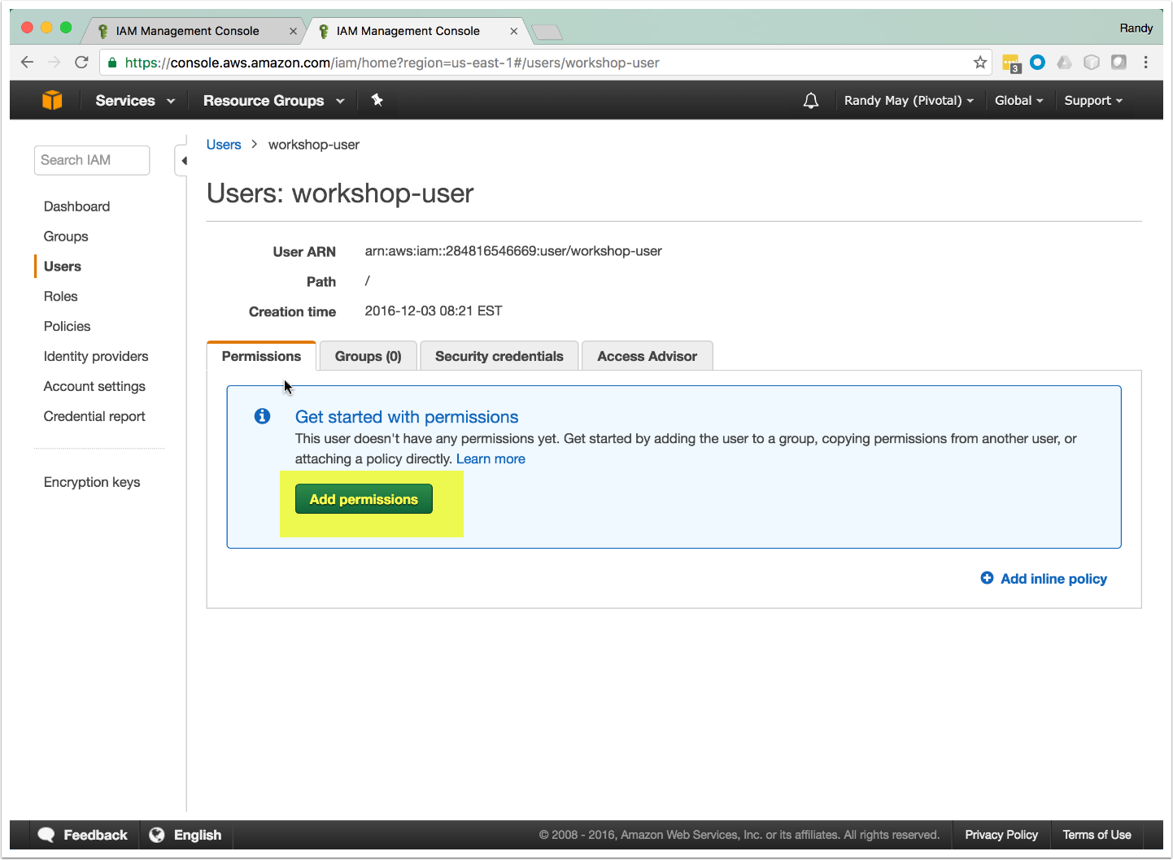

Select the Custom Policy Generator

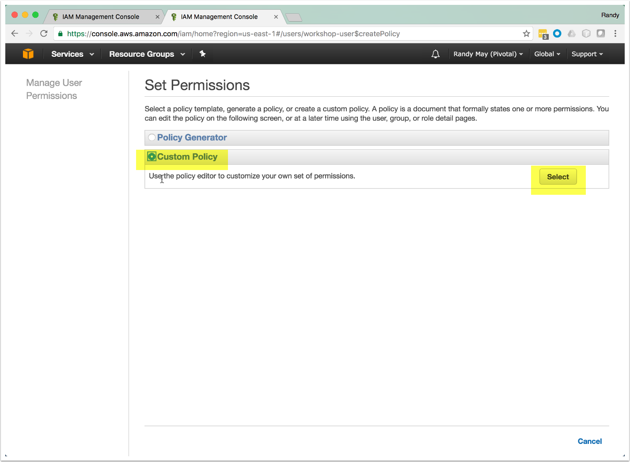

Create The Policy

Paste the text below into the Policy Editor Window, provide a name finally click on "Apply Policy"

{  
 "Version": "2012-10-17",  
 "Statement": [  
 {  
 "Action": [  
 "ec2:*",  
 "cloudformation:*",  
 "elasticloudbalancing:*"  
 ],  
 "Effect": "Allow",  
 "Resource": "*"  
 }  
 ]  
}

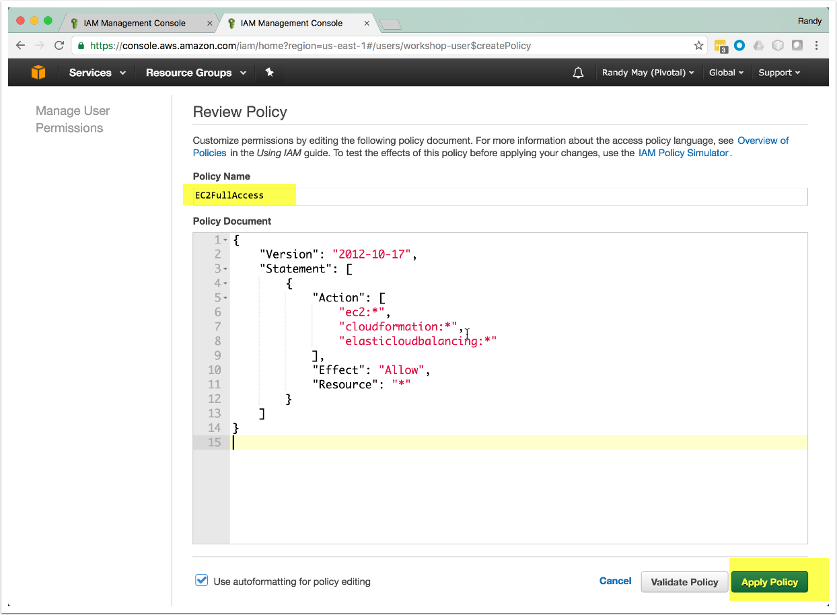

Setup Almost Complete

To use GemFire Ops Suite, you will need the following ...

1. The name of the key pair you created.
2. The .pem file that was downloaded when you created the key pair.
3. The .csv file containing the credentials for the user you just created

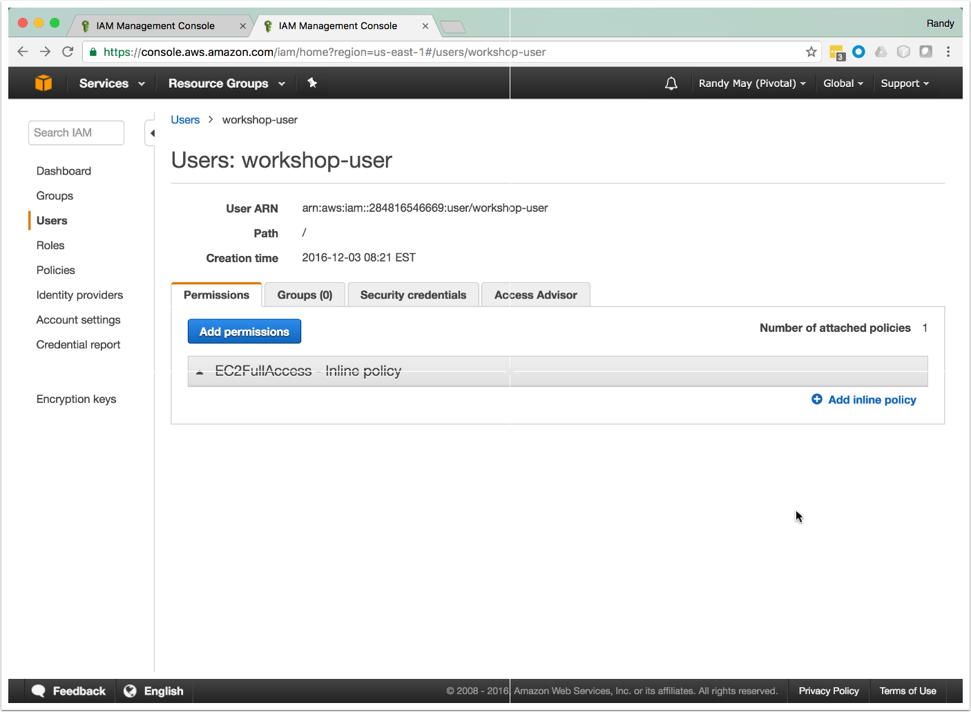

Local Machine Setup

Execute the following steps on the local machine *as the user who will be running GemFire Ops Suite*.

1. Create the directory ~/.aws if it does not exist.
2. If a file named ~/.aws/credentials exists, save it so it can be restored later.
3. With a text editor, create or edit ~/.aws/credentials. Format the file as shown below, using the aws access key id and secret access key from the .csv file you downloaded.

[default]  
aws_access_key_id = ABCDEFG  
aws_secret_access_key = jnCThisIsN0taReal/passw0rdC

1. Save the file.
2. Save the .pem file to any location on the local machine (e.g. /users/me/Downloads/gemfire-keypair.pem).
3. **Set the permission bits on the file to 400 (e.g. chmod 400 /users/me/Downloads/gemfire-keypair.pem )**

**SETUP IS COMPLETE!**

