1. In Photoshop, transparency is visually represented as:

a. Light grey
b. 100% black
c. Checkerboard
d. Round dots

2. Which file format preserves the editability of a multi-layered Photoshop file?

a. mov
b. jpg
c. psd
d. bmp

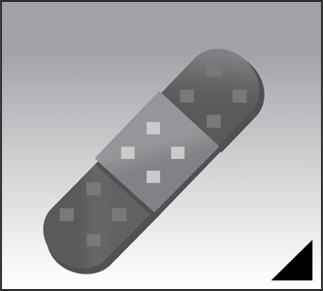
3. There is a black triangle in the lower-right corner of this tool icon. Its significance is:

a. It’s just a decorative element. There is no significance
b. It represents the keyboard shortcut for that tool
c. It serves as the visual cue of additional grouped tools
d. It shows that the tool is new to this version of Photoshop

4. Match the Photoshop workspace element (left) with its primary functionality (right).

______ Adjustments panel  ______ Layers panel  ______ Menu bar  ______ Options bar | a. Provides numerous ways to modify the appearance of an image  b. Provides for the management and control of a multi-level file  c. Provides available settings for the currently selected tool  d. Provides drop-down lists of Photoshop commands

5. True/False: Before a Background layer can be masked it must be converted to a normal layer.

a. True
b. False

6. To view a mask, ________-click the mask thumbnail.

a. Shift (Mac and PC)
b. Tab (Mac and PC)
c. Option (Mac) or Alt (PC)
d. Control (Mac) or Control (PC)

7. True/False: With a selection in place, clicking the [Add a pixel mask] button in the Masks panel will create a blank mask.

a. True
b. False

8. To flood a mask or selection with pixels, from the Menu bar, go to:

a. Edit > Fill
b. Layer > Fill
c. Image > Place
d. Window > Place

9. A user can control the strength of a mask with the (a) _____________ slider while the softness of a mask edge can be controlled with the (b) _____________ slider – both are located in the Masks panel.

(a) Power (b) Feather
(a) Density (b) Feather
(a) Power (b) Blur
(a) Density (b) Blur

10. Match the Mask panel button (left) with the reason you would click it (right).

______ Mask Edge …  ______ Invert  ______ Color Range … | a. To create a mask based on similar pixels  b. To begin fine-tuning an existing mask  c. To flip a mask to its exact opposite

11. To modify the rotation, size, shape or position of a mask, from the Menu bar, go to:

a. Image > Outline
b. Window > Outline
c. Edit > Free Transform
d. Layer > Free Transform

12. Use the words below to fill in the paragraph. Each word is used only once. Print clearly (thanks).

Words to use:
adjustment
brush
conceals
filters
gradient
grayscale
magic wand
reveals

Masking is the process of revealing and hiding layer pixels as well as the effects of _____________________ and _____________________ layers. A mask is a special type of layer into which users place only _____________________ pixels, in a variety of ways, depending on what they are attempting to do.
For example:
- One might use the _____________________ tool to create a mask that gently fades one layer radially into another, or …
- With the _____________________ tool, one might gently draw a mask in order to create a precision blend of two layers, or …
- One might even create a mask based on the selection choices offered by the _____________________ tool.
In the end, just try to remember, “white _____________________ and blacks _____________________.”

