I. Instructor Performance:

1. The instructor was knowledgeable on the topic of masking (circle one).

Strongly Disagree Disagree Agree Strongly Agree

2. The instructor presented material in a well-organized manner (circle one).

Strongly Disagree Disagree Agree Strongly Agree

3. The instructor encouraged questions and active participation (circle one).

Strongly Disagree Disagree Agree Strongly Agree

4. The instructor covered the topic appropriately in the time allowed (circle one).

Strongly Disagree Disagree Agree Strongly Agree

5. The instructor provided a suitable workshop handout (circle one).

Strongly Disagree Disagree Agree Strongly Agree

6. The instructor provided a useful workshop website (circle one).

Strongly Disagree Disagree Agree Strongly Agree

II. The Workshop Environment:

1. The workshop was the appropriate length of time (circle one).

Strongly Disagree Disagree Agree Strongly Agree

2. The workshop pace was appropriate for me (circle one).

Strongly Disagree Disagree Agree Strongly Agree

3. The workshop exercises were of an appropriate difficulty level (circle one).

Strongly Disagree Disagree Agree Strongly Agree

4. The workshop exercises were interesting and challenging (circle one).

Strongly Disagree Disagree Agree Strongly Agree

5. The workshop met my expectations (circle one).

Strongly Disagree Disagree Agree Strongly Agree

III. Personal Experience:

1. I would rank my level of masking knowledge before the workshop as (circle one):

None Beginner Intermediate Expert

2. I would rank my level of masking knowledge after the workshop as (circle one):

None Beginner Intermediate Expert

3. I learned useful skills that I will apply to my Photoshop use (circle one).

Strongly Disagree Disagree Agree Strongly Agree

4. I feel confident that I will be able to apply these skills on my own (circle one).

Strongly Disagree Disagree Agree Strongly Agree

5. I believe that I will utilize the workshop website and handout as a reference (circle one).

Strongly Disagree Disagree Agree Strongly Agree

6. I believe this hands-on style of workshop learning is productive for me (circle one).

Strongly Disagree Disagree Agree Strongly Agree

IV. Exercises:

1. Rate your enjoyment of the exercises from one to five stars (1 lowest, 5 highest)

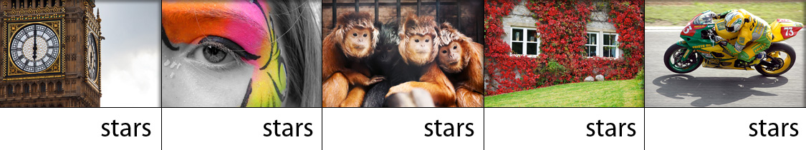

2. Rate the usefulness of exercise skills from one to five stars (1 lowest, 5 highest)

Additional comments on the exercises:

V. Overall

1. If I were in charge, I would make the following changes to the workshop:

2. Do you have any additional comments about this workshop?

