Adobe Photoshop Masking Workshop
Instructor: Bill Morrison (wrmorris@hawaii.edu)
Online @ http://www.bill-morrison.com/masking-workshop/

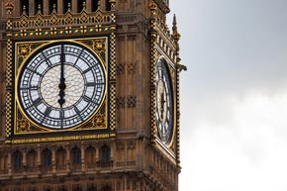 | Exercise 1:  Masking with a Selection
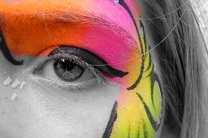 | Exercise 2:  Masking with the Gradient Tool
 | Exercise 3:  Masking with the Brush Tool
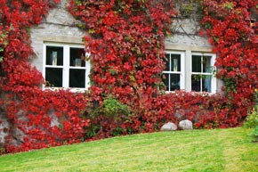 | Exercise 4:  Masking Adjustment Layers
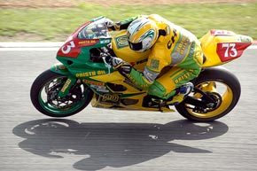 | Exercise 5:  Masking a Smart Filter

