***Lab 5: Inheritance***

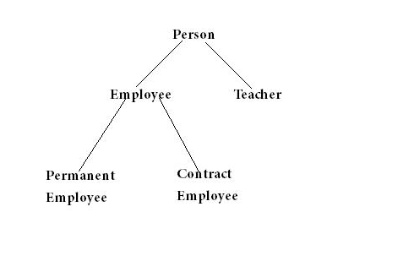

public class Person {  
  
    String name;  
    int age;  
  
    public Person(String n, int a) {  
        name = n;  
        age = a;  
    }  
  
    public void printDetails() {  
        System.out.println("Name: " + name);  
        System.out.println("Age: " + age);  
    }  
}

Student : name , age, major, and gpa

Teacher:name, age, faculty

Employee:name, age, employeeId,

PermanentEmployee:name, age, employeeId, salary

ContractEmployee: name, age, employeeId, payment

Write test program to

1 create object and call every methods

2 create an ArrayList to keep every object that created in 1.

|  |
| --- |
| Person |
| - name : String  - age : int |
| + Person(String name, int age)  + String getName()  + void setName(String name)  + int getAge()  + void setAge(int age)  +void printDetails() |

|  |
| --- |
| PermananceEmployee |
| - salary : int |
| + PermanentEmployee(String name,int age,String employeeId,int salary)  + int getSalary()  + void setSalary(int salary)  + void printDetails() |

|  |
| --- |
| Teacher |
| - faculty : String |
| + Teacher(String name,int age,String faculty)  + String getFaculty()  + void setFaculty(String faculty)  + void printDetails() |

|  |
| --- |
| Employee |
| - employeeId : String |
| + Employee(String name,int age,String employeeId)  + String getEmployeeId()  + void setEmployeeId(String employeeId)  + void printDetails() |

|  |
| --- |
| ContractEmployee |
| - payment : int |
| + ContractEmployee(String name,int age,String employeeId,int payment)  + int getPayment()  + void setPayment(int payment)  + void printDetails() |

***Flowchart***

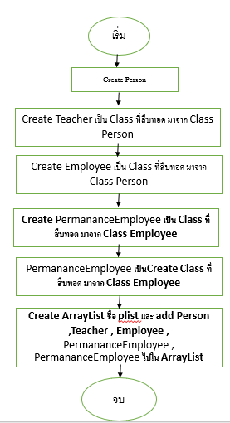

***Object Diagram***

|  |
| --- |
|  |

|  |
| --- |
| Name : Person |
| age : 22 |

|  |
| --- |
|  |

|  |
| --- |
| Name : Person |
| age : 27 |
| employeeid : 14040 |

|  |
| --- |
|  |

|  |
| --- |
| Name : Person |
| age : 35 |
| Employee : 40,000 |
| Payment : 22000 |

|  |
| --- |
|  |

|  |
| --- |
| Name : Teacher |
| age : 40 |
| Faculty : CoE |

|  |
| --- |
|  |

|  |
| --- |
| Name : PermananceEmployee |
| age : 25 |
| employee : 14045 |
| Salary : 4500 |

**Sorce Code**

**class Person**

public class Person{

private String name;

private int age;

public Person(String name, int age){

this.name = name;

this.age = age;

}

public String getName(){

return this.name;

}

public void setName(String name){

this.name = name;

}

public int getAge(){

return this.age;

}

public void setAge(int age){

this.age = age;

}

public void printDetails(){

System.out.println("Name: " + name);

System.out.println("Age: " + age);

}

}

**class Teacher**

public class Teacher extends Person{

private String faculty;

public Teacher(String name,int age,String faculty){

super(name,age);

this.faculty = faculty;

}

public String getFaculty(){

return this.faculty;

}

public void setFaculty(String faculty){

this.faculty = faculty;

}

public void printDetails(){

super.printDetails();

System.out.println("Faculty: " + faculty);

}

}

**class Employee**

public class Employee extends Person{

private String employeeId;

public Employee(String name,int age,String employeeId){

super(name,age);

this.employeeId = employeeId;

}

public String getEmployeeId(){

return this.employeeId;

}

public void setEmployeeId(String employeeId){

this.employeeId = employeeId;

}

public void printDetails(){

super.printDetails();

System.out.println("Employee Id: " + employeeId);

} }

class ContractEmployee

public class ContractEmployee extends Employee{

public int payment;

public ContractEmployee(String name,int age,String employeeId,int payment){

super(name,age,employeeId);

this.payment = payment;

}

public int getPayment(){

return this.payment;

}

public void setPayment(int payment){

this.payment = payment;

}

public void printDetails(){

super.printDetails();

System.out.println("Payment: " + payment);

}

}

**class PermanentEmployee**

public class PermanentEmployee extends Employee{

public int salary;

public PermanentEmployee(String name,int age,String employeeId,int salary){

super(name,age,employeeId);

this.salary = salary;

}

public int getSalary(){

return this.salary;

}

public void setSalary(int salary){

this.salary = salary;

}

public void printDetails(){

super.printDetails();

System.out.println("Salary: " + salary);

} }

**class Main**

import java.io.*;

public class Main{

public static void main(String[] args){

Person p = new Person("Person",25);

p.printDetails();

Student st = new Student("Student",20,"CoE",3.00f);

st.printDetails();

Teacher t = new Teacher("Teacher",40,"ENG");

t.printDetails();

Employee e = new Employee("Employee",35,"EM001");

e.printDetails();

PermanentEmployee pe = new PermanentEmployee("Permanent Employee",35,"EM002",15000);

pe.printDetails();

ContractEmployee ce = new ContractEmployee("Contract Employee",40,"EM003",9000);

ce.printDetails(); }