William Rossell

CE 417

Homework 26 (Problem 6.1)

Due Date: 03-21-2018

Question:

A four wheeled tractor whose operating weight is 47,877 lb is pulled up a road whose slope is +3.5% at a uniform speed. If the average tension in the towing cable is 4,860 lb, what is the rolling resistance of the road?

Solution:

$$Tow Cable Tension \left(lbs\right)=\left[Rolling Resistance \left(\frac{lbs}{ton}\right)+Grade Resistance \left(\frac{lbs}{ton}\right)\right]Weight of Machine (ton)$$

$$Grade Resistance \left(\frac{lbs}{ton}\right)=20 \left(\frac{lbs}{ton}\right)*Percent Grade (\%)$$

$$Rolling Resistance \left(\frac{lbs}{ton}\right)=\frac{Tow Cable Tension \left(lbs\right)}{Weight of Machine (ton)}-20 \left(\frac{lbs}{ton}\right)*Percent Grade (\%)$$

$$Rolling Resistance \left(\frac{lbs}{ton}\right)=\frac{4,860 lbs}{\frac{47,877}{2,000}ton}-20\frac{lbs}{ton}*3.5\%=133.02\frac{lbs}{ton}$$

**Final Solution:**

Rolling Resistance equals 133.02 pounds per ton weight of machine.

William Rossell

CE 417

Homework 27 (Problem 6.7)

Due Date: 03-21-2018

Question:

A pneumatic-tired tractor with a 354-hp engine has a maximum speed of 3.6 mph in first gear.

1. Determine the maximum rimpull of the tractor in each of the indicated gears if the engine efficiency is 91%
2. The tractor weighs 31.7 tons. It is operated over a haul road having a slope of +1.2% and a rolling resistance of 84 lb/ton. Determine the maximum external pull by the tractor in each of the four gears.



Solution:

$$Rimpull=\frac{375*hp*efficiency (decimal)}{speed (mph)}$$

$${Rimpull}_{First Gear}=\frac{375*354 hp*0.91}{3.6 mph}=33,556.3 lb$$

**Final Solution a.:**

.



$$External Pull$$

$$=Rimpull-Force to Overcome Rolling Resistance-Force to Overcome Grade Resistance$$

$${Force}_{Rolling}={Weight}_{Machine} (ton)*100\frac{lbs}{ton}$$

$${Force}_{Grade}={Weight}_{Machine}(ton)*\left(20\frac{lbs}{ton}*Grade (\%)\right)$$

First Gear:

$${Force}_{Rolling}=31.7 ton*100\frac{lbs}{ton}=3,170 lbs$$

$${Force}_{Grade}=31.7 ton*\left(20\frac{lbs}{ton}*1.2 \%\right)=760.8 lbs$$

$${External Pull}_{First Gear}=33,556.3 lbs-3,170 lbs-760.8 lbs=29,625.5 lbs$$

**Final Solution b.:**



William Rossell

CE 417

Homework 28 (Problem 6.9)

Due Date: 03-21-2018

Question:

A wheeled tractor with high-pressure tires and weighing 74,946 lb is pulled up a 5% slope at a uniform speed. If the tension in the tow cable is 13,000 lb, what is the rolling resistance of the road? What type of surface would this be?

Solution:

$$Rolling Resistance \left(\frac{lbs}{ton}\right)=\frac{13,000 lbs}{\frac{74,946}{2,000}ton}-20\frac{lbs}{ton}*5\%=246.92\frac{lbs}{ton}$$

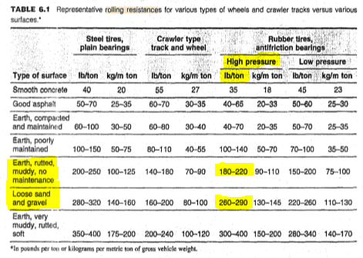

**Final Solution:**

Rolling resistance of the road in question is 246.92 pounds per ton weight of machine. Knowing this, we look to Table 6.1 and find that that specific rolling resistance quantity is not included as a definitive roadway surface. From this, it can be assumed that there is a mixture of surface type: Earth, rutted, muddy, no maintenance and Loose sand and gravel. This is probably a temporary hauling road being used.