William Rossell

CE 417

Homework 29 (Problem 6.10)

Due Date: 03-26-2018

Question:

A wheel tractor-scraper is operating on a 3% adverse grade. Assume that no power derating is required for equipment condition, altitude, and temperature. Use equipment data from Figure 6.10. Disregarding tractor limitations, what is the maximum value of rolling resistance (in lb per ton) over which the empty unit can maintain a speed of 15 mph?

Solution:

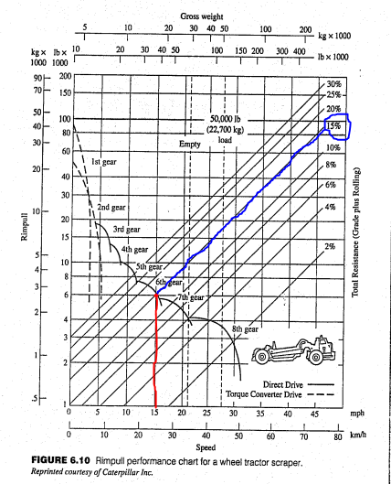Based on the procedure for determining operating speeds, as seen in the text succeeding this diagram, and working in reverse order we find the follow:

1. A vertical line projected upwards from the 15 mph tick mark shows that the machine is presumed to be in 6th gear.

2. Normally, one would project a horizontal line to the right that would connect with the intersection of the gross vehicle weight and the total resistance curve. In this problem, we find that the 15% curve intersects exactly on the 15 mph intersection with the 6th gear curve. This means this is the maximum total resistance over which the empty unit can maintain speed. From there the following is true.

$$\text{Total Resistance = 15\%}$$

$$\text{Grade Resistance = 3\%}$$

$$Total Resistance=Rolling Resistance+Grade Resistance$$

$$Rolling Resistance=15\%-3\%=12\%$$

$$Rolling Resistance \left(\frac{lb}{ton}\right)=20\frac{lb}{ton}*Rolling Resistance \left(\%\right)=20\frac{lb}{ton}*12\%=240\frac{lb}{ton}$$

**Final Solution:** The maximum value of rolling resistance over which the machine can maintain a speed of 15 mph is 240 pounds per ton operating weight.

William Rossell

CE 417

Homework 30 (Problem 6.16)

Due Date: 03-26-2018

Question:

A wheel-type tractor unit, operating in its fourth-gear range and at its full rated rpm, is observed to maintain a steady speed of 8 mph when operating under the conditions described herein. Ambient air temperature is 60°F. Altitude is sea level. The tractor is climbing uniform 4% grade with a rolling resistance of 75 lb/ton, and it is towing a pneumatic-tired trailer loaded with fill material. The single-axle tractor has an operating weight of 74,946 lb. The loaded trailer has a weight of 50,000 lb. The weight distribution for the combined tractor-trailer unit is 52% to the drive axle and 48% to the rear axle.

1. The manufacturer, for the environmental conditions described, rates the tractive effort of the new tractor at 330 rimpull horsepower. What percentage of the rated rimpull hp does the tractor actually develop? The “20 lb of rimpull required per ton of weight per % of slope” approximation will be acceptable. Assume traction is not a limiting factor.
2. What is the value of the coefficient of traction if the drive wheels of the tractor are at the point of incipient slippage for the conditions just described?

Solution:

Known:

Weight of Tractor = 74,946 lb, Weight of Loaded Trailer = 50,000 lb, Total Weight = 124,946 lb

Operating Speed = 8 mph

Rolling Resistance (RR) = 75 lb/ton, Grade Resistance (GR) = 4%

Environmental Conditions

Weight Distributions

Rated Horsepower = 330 hp

a.

$$\text{Total Resistance (TR) = RR + }\left(20\frac{lb}{ton}*GR\right)=75\frac{lb}{ton}+\left(20\frac{lb}{ton}*4\%\right)=155\frac{lb}{ton}$$

$$TR=155\frac{lb}{ton}*\left(\frac{Total Weight}{2,000\frac{lb}{ton}}\right)=155\frac{lb}{ton}*\left(\frac{124,946 lb}{2,000\frac{lb}{ton}}\right)=9,683.32 lb$$

$$Developed Horsepower (HP)= \frac{TR \left(lb\right)*Operating Speed \left(\frac{ft}{sec}\right) }{550 \frac{\frac{ft*lb}{sec}}{hp}}$$

$$HP= \frac{9,683.32 lb*8 mph*5,280\frac{ft}{mile}}{550 \frac{\frac{ft*lb}{sec}}{hp}*3,600\frac{sec}{hour}}=206.58 hp$$

$$\text{Percent of Rated Horsepower Developed = }\frac{206.58 hp}{330 hp}*100=62.6\%$$

**Final Solution a.:** The percentage of the rated rimpull horsepower developed in the operation and environment described above is approximately 62.6 %.

b.

$$Coefficient of Traction \left(C_{trac}\right)= \frac{TR (lb)}{Weight on Drive Axle (lb)}$$

$$C_{trac}= \frac{TR (lb)}{Total Weight \left(lb\right)*Drive Axle Weight Distribution}$$

$$C_{trac}= \frac{9,683.32 lb}{124,946 lb*0.52}=0.149$$

**Final Solution b.:** The coefficient of traction of the drive wheels at the point of incipient slippage in the operation and environment described above is 0.149 or approximately 0.15.