William Rossell

CE 417

Homework 31 (Problem 7.6)

Due Date: 03-28-2018

Question:

A contractor wants to investigate using a 7U blade on a D7H dozer. The material is a dry, noncohesive silty sand and is to be moved a distance of 200 ft from the beginning of the cut. The dozing is downhill on a 2% grade. The operator will have excellent skill, the dozer has a power-shift transmission, and both visibility and traction are assumed to be satisfactory. The material weighs 110 pcf in the bank state. Job efficiency is assumed to be equivalent to a 50-min hour. Calculate the direct cost of the proposed earthmoving operation in dollars per bcy. Assume that the O&O cost for the dozer is $89.50 per hour and the operator’s wage is $19.00 per hour plus 30% for fringes and worker’s compensation. ($0.436 per bcy)

Solution:

Step 1: Ideal Maximum Production

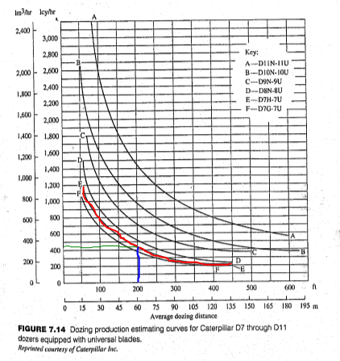

D7H dozer with 7U blade

Dozing distance = 200 ft

Ideal Production = 440 lcy/hr

Step 2: Material Weight Correction Factor

Bank Weight = 110 pcf = 2,970 lb/bcy

From Table 4.3, Percent Swell = 15%

$$\frac{2,970\frac{lb}{bcy}}{1.15}=2,582.6\frac{lb}{lcy}$$

Standard condition is 2,300 lb/lcy

$$\text{Material Weight Correction = }\frac{2,300\frac{lb}{lcy}}{2,582.6\frac{lb}{lcy}}=0.89$$

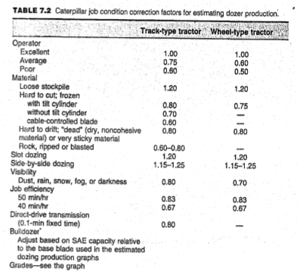Step 3: Operator Correction Factor

From Table 7.2, with operator skill of excellent quality

Operator Correction = 1.00

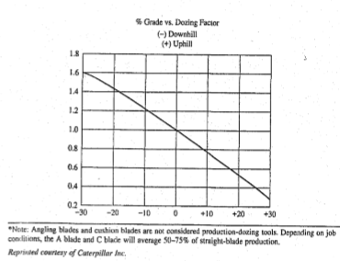

Step 4: Material-Type Correction Factor

From Table 7.2, with dry, noncohesive material

Material (type) Correction = 0.80

Step 5: Operating-Technique Correction Factor

Single Dozer

Operating-Technique Correction = 1.00

Step 6: Visibility Correction Factor

Satisfactory visibility, Visibility Correction Factor = 1.00

Step 7: Efficiency Factor

$$\text{Job Efficiency Correction = }\frac{50 min. hour}{60 min. hour}=0.83$$

Step 8: Machine Transmission Factor

Power-shift transmission, Transmission Factor = 1.00



Step 9: Blade Adjustment Factor

Blade Correction = 1.00

Step 10: Grade Correction Factor

See plot on diagram above from Table 7.2,Grade Correction Factor = ~1.05

Step 11: Determine the Product of the Correction Factors

$$\text{Combined Correction}=0.89*1.00*0.80*1.00*1.00*0.83*1.00*1.00*1.05=0.62$$

Step 12: Determine Dozer Production

$$\text{Dozer Production = Ideal Production Rate }*\text{Combined Correction}=440\frac{lcy}{hr}*0.62$$

Dozer Production = 272.8 lcy/hr

Step 13: Determine the Material Conversion, if required

$$\frac{272.8\frac{lcy}{hr}}{1.15}=237.2\frac{bcy}{hr}$$

Step 14: Determine the Total Cost to Operate the Dozer

O&O Cost = $89.50 per hour

Operator Cost = $19.00 per hour + 30% = $24.70 per hour

Total Cost = $114.20 per hour

Step 15: Determine the Direct Unit Production Cost

$$\text{Direct Production Cost }= \frac{\$114.20 per hour}{237.2\frac{bcy}{hr}}=\$0.481 per bcy$$

**Final Solution:**

Based on the presented calculations, the approximate direct production cost in dollars per bank cubic yards is $0.481 per bcy. This is $0.045 per bcy more expensive than the approximation stated by the author of the textbook. Possible sources of error are chart readings such as that of Figure 7.14 and Table 7.2, whereby a great deal of information such as ideal production rate and grade correction factor is attained. Based on backward calculations, for the given solution of $0.436 per bcy to be accurate, the ideal production rate would be nearing that of 480 lcy/hr. Again, since that figure is found by way of using a chart and it shares proximity with my estimation of 440 lcy/hr, it becomes a reasonable figure suggesting that this is where the error occurs.

William Rossell

CE 417

Homework 32 (Problem 7.7)

Due Date: 03-28-2018

Question:

A contractor wants to investigate the production and cost differences of using a 7S blade on a D7H dozer or an S blade on an 824 dozer. The material is very sticky and is to be moved a distance of 200 ft from the beginning of the cut. The dozing is uphill on 5% grade. The operator will have average skill, the dozers have power-shift transmissions, and traction is assumed to be satisfactory. The site conditions will be good for visibility. The material weighs 106 pcf in the bank state. Job efficiency is assumed to be equivalent to a 55-min hour. Calculate the direct cost of the proposed earthmoving operation in dollars per bcy. Assume that the O&O cost for the D7 dozer is $95.00 per hour and $86.00 per hour for the 824. The operator’s wage for the 824 is $23.00 per hour plus 40% for fringes, worker’s compensation, and other benefits. The operator’s wage for the D7 is $25.00 per hour plus 40% for fringes, worker’s compensation, and other benefits.

1. Which machine would you use on this job?
2. It rains and the coefficient of traction for the 824 is now 0.36. The coefficient of traction for the D7 is 0.55. Which machine would you use on this job?

a.

Follows the same process as HW 31 Prob. 6.6

D7H-7S

Ideal Production Rate = 290 lcy/hr

Material Weight Correction Factor = 1.085

Operator Correction Factor = 0.75

Material Type Correction Factor = 0.8

Operator-Technique Correction Factor = 1.00

Visibility Correction Factor = 1.00

Efficiency Factor = 0.917

Machine Transmission Correction Factor = 1.00

Blade Adjustment Factor = 1.00

Grade Correction Factor = 0.9

Combined Correction Factor = 0.54

Dozer Production = 156.6 lcy/hr

Material Conversion (if required) = 116 bcy/hr

Total Cost to Operate Dozer = $130/hr

Direct Production Cost = $1.12/bcy

824-S

Ideal Production Rate = 425 lcy/hr

Material Weight Correction Factor =1.085

Operator Correction Factor = 0.75

Material Type Correction Factor = 0.8

Operator-Technique Correction Factor = 1.00

Visibility Correction Factor = 1.00

Efficiency Factor = 0.917

Machine Transmission Correction Factor = 1.00

Blade Adjustment Factor = 1.00

Grade Correction Factor = 0.9

Combined Correction Factor = 0.54

Dozer Production = 229.5 lcy/hr

Material Conversion (if required) = 170 bcy/hr

Total Cost to Operate Dozer = $118.20/hr

Direct Production Cost = $0.695/bcy

**Final Solution a.:**

Based on the above analysis, it is more cost efficient to use the 824 dozer equipped with the S blade.

b.

D7H-7S

Ideal Production Rate = 290 lcy/hr

Material Weight Correction Factor = 1.085

Operator Correction Factor = 0.75

Material Type Correction Factor = 0.8

Operator-Technique Correction Factor = 1.00

Visibility Correction Factor = 1.00

Efficiency Factor = 0.917

Machine Transmission Correction Factor = 1.00

Blade Adjustment Factor = 1.00

Grade Correction Factor = 0.9

Coefficient of Traction = 0.55

Combined Correction Factor = 0.297

Dozer Production = 86.13 lcy/hr

Material Conversion (if required) = 63.8 bcy/hr

Total Cost to Operate Dozer = $130/hr

Direct Production Cost = $2.038/bcy

824-S

Ideal Production Rate = 425 lcy/hr

Material Weight Correction Factor =1.085

Operator Correction Factor = 0.75

Material Type Correction Factor = 0.8

Operator-Technique Correction Factor = 1.00

Visibility Correction Factor = 1.00

Efficiency Factor = 0.917

Machine Transmission Correction Factor = 1.00

Blade Adjustment Factor = 1.00

Grade Correction Factor = 0.9

Coefficient of Traction = 0.36

Combined Correction Factor = 0.194

Dozer Production = 82.62 lcy/hr

Material Conversion (if required) = 61.2 bcy/hr

Total Cost to Operate Dozer = $118.20/hr

Direct Production Cost = $1.931/bcy

**Final Solution b.:**

When taking the effect of the rain of production, it is still more cost effective to use the 824 dozer equipped with the S blade.

William Rossell

CE 417

Homework 33 (Problem 7.10)

Due Date: 03-28-2018

Question:

A contract is being bid to clear and grub 600 acres. You are considering the cost associated with using a 460-hp dozer. The dozer’s O&O cost is $145 per hour. The wage determination for heavy-duty operators is $29 per hour, plus 30% for fringes. Project overhead will run $600 per workday. Assume a 10-hr workday.

A field engineer has made a site visit and provided you with the following information. The site is practically level and the machines will have no problems with bearing or traction. About 80% of the trees are pines (softwood) and the rest are oak (hardwood). The total number of trees per acre is about 500; of these

180 trees per acre are 1 to 2 ft in diameter.

40 trees per acre are 2 to 3 ft in diameter.

30 trees per acre are 3 to 4 ft in diameter.

You plan to clear and grub in one operation, and then to follow with piling-up in windrows and burning. Burning will require that the dozer be employed twice the time expected for piling-up alone.

1. What is the estimated production rate for clearing, grubbing, and piling and burning?
2. What is the cost associated with the total operation, including overhead, when only one 460-hp dozer is used?
3. Is it cheaper to employ two, three, or four of the 460-hp dozers?

Solution: (REF: TEXTBOOK PG. 200-202)

a.

$$Time \left(min\right)per acre for cutting=H\left[A\left(B\right)+ M_{1}N_{1}+M_{2}N_{2}+M_{3}N_{3}+M_{4}N_{4}+DF\right]$$

20% Hardwood, H = 0.7

500 trees per acre, A = 1.0

Tractor HP 460,

B = 15.79 minutes per acre

M1 = 0.1 min

M2 = 0.4 min

M3 = 1.3 min

M4 = 3.0 min

F = 1.0 min per foot of dia. for trees above 6 ft in dia.

N1 = 180 trees per acre that are 1-2 ft in diameter

N2 = 40 trees per acre that are 2-3 ft in diameter

N3 = 30 trees per acre that are 3-4 ft in diameter

N4 = 0 trees per acre that are 4-6 ft in diameter

D = 0 (sum of dia. in foot increments of all trees per acre above 6 ft in dia. at ground level)

$$Time \left(min\right)per acre for cutting=0.7\left[1.0\left(15.79\right)+ 0.1*180+0.4*40+1.3*30+3.0*0+0*1.0\right]=62.15\frac{min}{acre}$$

Cutting and grubbing will be performed as one operation, therefore time of production is increase 25%.

$$62.15\frac{min}{acre}*1.25=77.69\frac{min}{acre}$$

$$Time \left(min\right)per acre for piling up=B+ M_{1}N_{1}+M_{2}N_{2}+M_{3}N_{3}+M_{4}N_{4}+DF$$

Tractor HP 460,

B = 39.27 minutes per acre

M1 = 0.08 min

M2 = 0.1 min

M3 = 1.2 min

M4 = 2.1 min

F = 0.3 min per foot of dia. for trees above 6 ft in dia.

N1 = 180 trees per acre that are 1-2 ft in diameter

N2 = 40 trees per acre that are 2-3 ft in diameter

N3 = 30 trees per acre that are 3-4 ft in diameter

N4 = 0 trees per acre that are 4-6 ft in diameter

D = 0 (sum of dia. in foot increments of all trees per acre above 6 ft in dia. at ground level)

$$Time \left(min\right)per acre for piling up=39.27+ 0.08*180+0.1*40+1.2*30+2.1*0+0*0.3=93.67\frac{min}{acre}$$

Piling materials will include grubbed vegetation, therefore total piling time will be increased 25%.

$$93.67\frac{min}{acre}*1.25=117.09\frac{min}{acre}$$

Burning requires doubling the piling employment time of the dozer.

$$117.09\frac{min}{acre}*2=234.18\frac{min}{acre}$$

$$Total Production Rate \left(\frac{min}{acre}\right)=77.69+234.18=311.87\frac{min}{acre}=5.198\frac{hr}{acre}$$

**Final Solution a.:**

The total estimated production rate of cutting, grubbing, piling, and burning will be approximately 311.87 minutes (5.198 hours) per acre of vegetation.

b.

$$\text{O\&O Cost }= \left[\frac{\$145}{hr}+\frac{\$29*1.3}{hr}\right]*5.198\frac{hr}{acre}*600 acre=\$569,805$$

$$\text{Overhead Cost }=\frac{\$600}{workday}*\frac{workday}{10 hr}*5.198\frac{hr}{acre}*600 acre=\$187,128$$

$$\text{Total Cost }=\$569,805+\$187,128=\$756,933$$

**Final Solution b.:**

Total cost of operation, including overhead, for the use of one dozer is $756,933.

c.

**Final Solution c.:**

O&O Cost will remain the same regardless of the number of dozer if efficiency is not accounted for. Financial consequences will fall under Overhead Cost, but without some consideration of efficiency in use of multiple dozers within the one operation, Overhead Cost will simply decrease with each additional dozer. If this is the case, then there is no need for numerical comparison. Obviously, this is not the realistic case, but there is nothing more I can do.