William Rossell

CE 417

Homework 35 (Problem 9.4)

Due Date: 04-11-2018

Question:

For each of the stated conditions, determine the probable production expressed in cubic yards per hour bank measure for a shovel equipped with a 3-cy bucket. The shovel has a maximum digging height of 30 ft. Us a 45-min-hour efficiency factor.

|  |  |  |  |  |
| --- | --- | --- | --- | --- |
| Condition | Class of Material | | | |
| Common Earth | Common Earth | Rock-Earth/ Earth-Gravel | Shale, poorly blasted |
|
|
| Height of excavation (ft) | 12 | 7.2 | 12 | 18 |
| Angle of Swing (degrees) | 90 | 120 | 60 | 150 |
| Loading haul Units | no | no | no | no |

Solution:

Step 1: Size of Bucket, 3 cy

Step 2: Bucket fill factor (Table 9.1), using 100% conservative estimate for each aforementioned material classification:

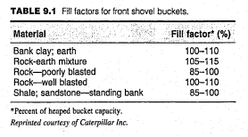

|  |  |  |  |  |
| --- | --- | --- | --- | --- |
| Condition | Class of Material | | | |
| Common Earth | Common Earth | Rock-Earth/ Earth-Gravel | Shale, poorly blasted |
|
|
| Fill Factor (%) | 100 | 100 | 105 | 85 |

Step 3: Cycle element times,

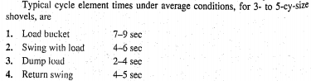

|  |  |  |  |  |
| --- | --- | --- | --- | --- |
| Condition | Class of Material | | | |
| Common Earth | Common Earth | Rock-Earth/ Earth-Gravel | Shale, poorly blasted |
|
|
| Load Time (sec) | 8 | 8 | 7 | 9 |
| Loaded Swing Time (sec) | 4 | 4 | 4 | 4 |
| Dump Time (sec) | 4 | 4 | 3 | 4 |
| Empty Swing Time (sec) | 4 | 4 | 4 | 4 |
| Total Time (sec) | 20 | 20 | 18 | 21 |

Each estimate based on material type with leanings toward more conservative (probable) measures…

Height and swing factor: From Table 9.2, found using the percent of optimum height found by:

$$\frac{Height of Excavation }{Optimum Height of Excavation}*100$$

$$Optimum Height of Excavation=\% of Max Dig Height*Max Dig Height$$

Percent of Max Digging Height is assumed based on the following paragraph:

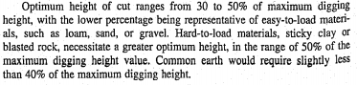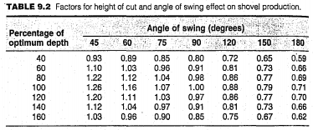

|  |  |  |  |  |
| --- | --- | --- | --- | --- |
| Condition | Class of Material | | | |
| Common Earth | Common Earth | Rock-Earth/ Earth-Gravel | Shale, poorly blasted |
|
|
| Percent of Max Digging Height | 40 | 40 | 30 | 50 |
|
| Optimum Height (ft) | 12 | 12 | 9 | 15 |
| Percent of Optimum Digging Height | 100 | 60 | 133.3 | 120 |
|
| Height/Swing Factor | 1 | 0.81 | 1.06 | 0.77 |

**Cell fill denotes necessary interpolation has taken place…

Step 4: Efficiency Factor

Given as 45-min-hour = 0.75

Step 5: Swell Factor (Table 4.3)

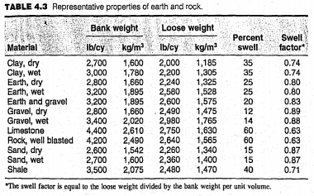

|  |  |  |  |  |
| --- | --- | --- | --- | --- |
| Condition | Class of Material | | | |
| Common Earth | Common Earth | Rock-Earth/ Earth-Gravel | Shale, poorly blasted |
|
|
| Swell Factor | 0.8 | 0.8 | 0.83 | 0.71 |

Step 6: Production Rate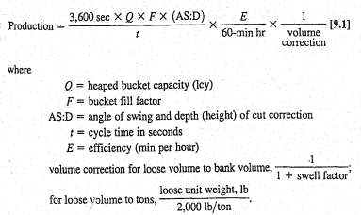

**Final Solution:**

|  |  |  |  |  |
| --- | --- | --- | --- | --- |
| Condition | Class of Material | | | |
| Common Earth | Common Earth | Rock-Earth/ Earth-Gravel | Shale, poorly blasted |
|
|
| Production Rate (bcy/hr) | 324 | 262 | 416 | 179 |

William Rossell

CE 417

Homework 36 (Problem 9.9)

Due Date: 04-11-2018

Question:

A 7-cy wheel loader will be used to load a crusher from a quarry stockpile of blasted rock (well blasted) 160 ft away. The rock has a loose unit weight of 2,750 lb/cy. Estimate the loader production in tons based on a 45-min-hour efficiency factor.

Solution:

Step 1: Size of bucket, 7 cy

Step 2: Bucket fill factor (Table 9.6)

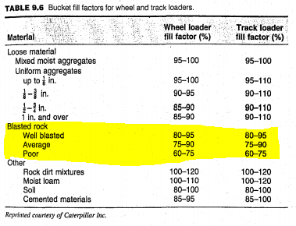

Well blasted rock, 80-95%; use 80% conservative estimate.

Check Tipping:

Load Weight: 7 cy*0.8= 5.6 lcy

5.6 lcy*2,750 lb/cy (unit weight)

=15,400 lb

From Table 9.8, static tipping load =50,000 lb

Operating Load = 0.5*50,000lb =25,000

15,400 lb < 25,000 lb; OKAY  
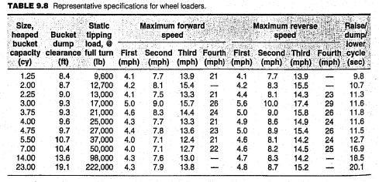

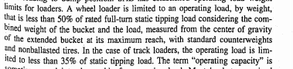

Step 3: Typical Fixed Cycle Time (Table 9.10)

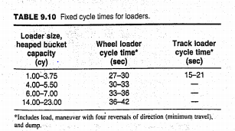

7-cy wheel loader, 33-36 seconds;

use 33 seconds

Step 4: Efficiency Factor

Given as 45-min-hour = 0.75

Step 5: Class of Material, Well Blast Rock, 2,750 lb/lcy

Step 6: Probable Production

$$Production$$

$$=\frac{3,600\left(\frac{sec}{hr}\right)*bucket capacity \left(cy\right)*bucket fill factor}{cycle time\left(\frac{sec}{cycle}\right)}*Efficiency*Unit Weight\left(\frac{ton}{lcy}\right)$$

$$=\frac{3,600\left(\frac{sec}{hr}\right)*7 cy*0.80}{33\left(\frac{sec}{cycle}\right)}*0.75*\frac{2,750}{2,000}\left(\frac{ton}{lcy}\right)=630\frac{ton}{hr}$$

**Final Solution:** The production rate of the wheel loader acting under the conditions described is approximately 630 tons per hour of operation