NO1. Project Name
NO labels are document numbers, not value ranking.
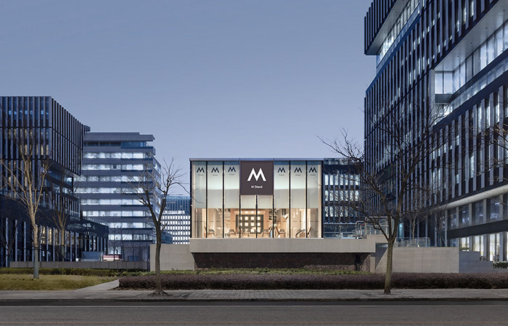
项目类型 | Project Type
设计/机构 | Design/Agency
地点/年份 | Location/Year
原网址 | Original URL

1.核心判断
This sample project is used to verify the deep-mode Word renderer, not to judge a real design case. Its value is that it tests whether the approved template can be filled without changing the layout.
From an automation perspective, it checks the most important deep-mode positions: project image, project information table, core judgment, reference tables, risk bullets, and expanded conclusion.
Therefore, it is suitable as the first renderer test case. The script should keep the template order, preserve the project image slot, and avoid inventing a new report structure.

2.最值得参考
参考点 | 为什么重要 | 项目怎么用
Fixed template | Prevents the renderer from creating a free-layout report. | Copy the approved project block and only replace content.
Representative image | Avoids using web-page screenshots as project images. | Require a local image path before rendering.
Expanded conclusion | Deep mode needs readable judgment,notone-line comments. | Use three conclusion paragraphs for each project.

3.借鉴方向建议
方向 | 可借鉴做法 | 落地提醒
Form / space | Keep the original direction row and replace only the content. | Do not add unrelated columns.
Material | Keep the material direction row from the template. | Use concise, project-related text.
Function | Connect the suggestion to workplace needs. | Avoid writing it like a visual card.
Operation | Include maintenance and use reminders. | Keep the language readable.

4. 不能照搬点
不要照搬 | 原因 | 替代做法
Do not redesign the template | The template has already been approved by the user. | Replace placeholders only.
Do not change image type | The project image must be a representative project image. | The sample image is only for script verification.
Do not compress table text | Hidden text damages readability. | Allow table rows to expand when needed.

5. 成本 / 施工 / 维护初判 (1-3)
维度 | 评分 | 判断 | 处理建议
Cost | 1/3 | The test case has no real cost data. | Judge real cases from available source material.
Construction | 1/3 | The test case has no real construction data. | Judge real cases from materials and visible details.
Maintenance | 1/3 | The test case has no real maintenance data. | Judge real cases from usage intensity.

6.风险提醒
• If required input fields are missing, the renderer should fail instead of generating an incomplete document.
• If the image path is invalid, the renderer should fail instead of using a web screenshot as a replacement.
• If the template cannot be opened, the renderer should fail instead of inventing a new structure.
7.结论
Sample Young Office is a useful automation test case because it verifies the rendering process rather than presenting a real design recommendation. Its purpose is to confirm that the deep-mode template can be filled consistently, including tables, image position, risk notes, and conclusion structure.
For the current Insight-Space workflow, this helps separate research judgment from document production. The agent can spend its thinking budget on selecting and evaluating projects, while this script handles repeated Word formatting work after the content is prepared.
In real use, this sample data should be replaced by verified project sources, accurate representative images, and user-specific design analysis. The final document should remain visually consistent with the approved deep-mode template while carrying project-specific judgment.

