

Feature List for

**Design and Development of Classified Mobile Application**

|  |  |
| --- | --- |
|  | **Matrix Media Solutions (P) Ltd.**  Stesalit Towers, 5th Floor, E2/3, Block EP & GP  Sector V, Salt Lake, Kolkata – 700 091. India  [www.matrixnmedia.com](http://www.matrixnmedia.com) |

# Document Details

|  |  |  |  |  |
| --- | --- | --- | --- | --- |
| **Document Name:** | | Feature List for Design and Development of Classified Mobile App | | |
| **Version:** | | 1.0 | | |
| **Document Date:** | | 02.09.2020 | | |
| **Prepared By:** | | Mr. A. Ghosh | | |
| **Reviewed By:** | | Mr. A. Ghosh | | |
| **Approved By:** | | Mr. Vivek Jain | | |
| **Signature:** | |  | | |
| **Modification History** | | | | |
| **Sl. No.** | **Description of Change** | | **Date of Change** | **Version No.** |
| 1 | Initial Version | | 02.09.2020 | 1.0 |
| 2 |  | |  |  |
| 3 |  | |  |  |

# Contents

1 Document Details 2

2 Contents 3

3 Project Scope 4

4 Type of Users 4

5 Features of Guest and Registered users 4

6 Feature of Administrator 9

7 Assumptions 12

8 Development Platform 13

# Project Scope

The client wants to build a classified mobile application where users can search for products nearby which is selling by some other user similar to him. There also will be a web based admin control panel for admin to manage the application data. We have mentioned about the details of the functionality below.

# Type of Users

The application will have following type of users and mode of platform to use:

1. Guest users: These type of users are either not registered to the site or not logged in. They will have mobile app to use the platform.
2. Registered users: These type of users are able to contact a product owner as well as post his own product to the platform. They will also have mobile app to use the platform.
3. Administrator: Admin will have web based interface to manage the website.

# Features of Guest and Registered users

**Splash Screen**

* This is a static image screen which will appear when user opens the app

**Register:**

* User can register with valid E-mail address and Password
* User need to verify their mobile number and Email ID via OTP verification

**Login:**

* User can login with valid email and password. User can hide/visible the password while typing.
* User can re-set the password using registered mail-Id by clicking the “Forgot Password” in the bottom of the page.

**Home:**

* In the home page, list of categories will be displayed with category name.
* By clicking this category field, user can move to “Subcategory” page.
* Home page will also have a search panel for the user to search a specific product related ads quickly.
* User can filter the search result by:
  + Location (*User can provide location access permission to the app when installing to device as well as can select location manually*)
  + Category / Sub-category / Service type
  + Price
* In the home page there is a navigation menu which contains the follows:
  + Home
  + My Ads
  + Profile (*User will be redirected to the login page, if not logged in already*)
  + Logout

**My Ads:** (*This feature is for Registered/Logged in users only*)

* In this page, shows list of products which are all posted by the user himself.
  + User can sort the list by active ads and ads are under review by admin
* Its shows the product’s name, image, price, location, date added
* User can view this page by clicking “My Ads” in navigation menu.
* User can mark an ad with followings:
  + Sold
  + Delete ad
  + 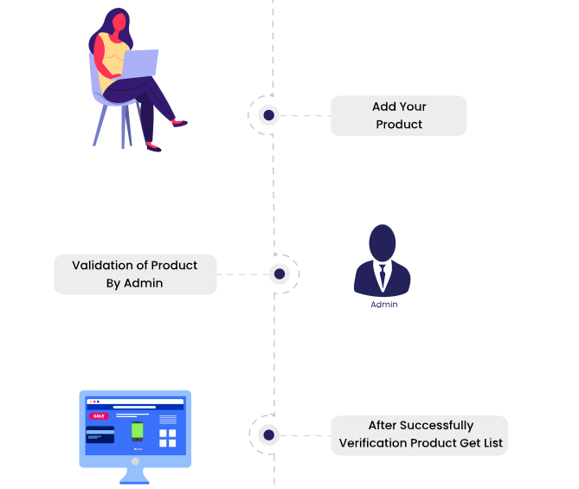Inactive/Reactive an ad
* My Messages
  + User can open an ad to see the responses/messages he has got from other users
  + User can reply them from this section

**Post Your Ad:** (*This feature is for Registered/Logged in users only*)

* In this page, user can post their ads.
* User needs to give necessary details to post their ad by filling up a form with various details such as brand name, manufacturing date, Ad title, prices etc. along with uploading necessary details such as images.
* User can post an ad for free, however the ad will be listed to the application once the same is approved by admin.

*(The above image is for reference purpose)*

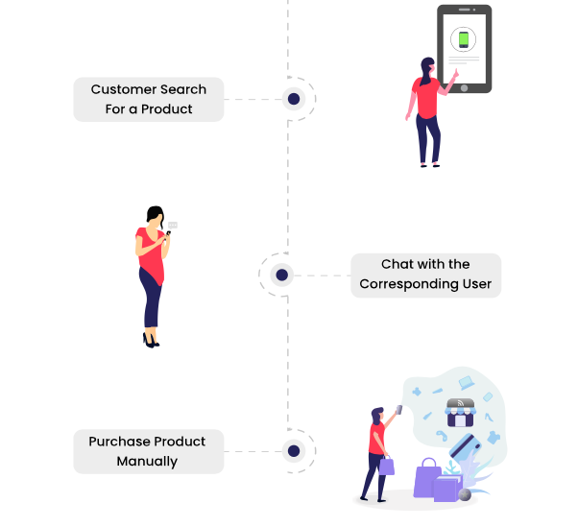**Products View:**

* By clicking any of subcategories, user can view the list of products/ads in the list view format.
* User can turn the list view to grid view.
* The ad will show the product’s name, image, price, location, date added.
* By clicking an ad, user can view full details of that product.
* User can share an ad on WhatsApp and or Facebook.
* User can mark an ad as favourite and can find all the favourite marked ads in one place under respective section.
* Contact user (*Features available only for registered/logged in users*)
  + If user wish to buy that product or wants to know more about the product, user can make call to the owner of the product by clicking “make phone call” button. Once clicking on the call button user will have the contact number displayed on the dial pad.
  + User can also use in-app personal message box to chat with the owner. User can chat with the seller/buyer in real time if the other person is online, otherwise can leave an offline message as well.
    - User will have two separate sections on message window; one as messages from sellers and other one as messages from buyers.
    - On chat window will have option to report/block a user. Once blocked any of the users/parties will be able to contact/text each other further on that chat window.
  + User can view seller profile. Seller profile will have following info to access publicly
    - Profile picture
    - Name
    - Verified user or not (*Badge icon will displayed if verified by admin*)
    - List of all active ads by the seller
    - Rating and Reviews
      * User can see all rating and reviews from other users
      * User can also submit own rating and review to the seller. Display of that rating and review is subject to the approval of Admin.
    - Share seller’s profile link with others via message or email
  + User can buy the product from the seller/owner offline.
  + If the user selects for a service (ex: Doctor) and try to seek consultancy/advice on a specific illness then user can send message to the Doctor as well as can share necessary document such as medical test report etc.

**My profile:** (*This feature is for Logged in users only*)

* User can view their profile by clicking “Profile” in navigation screen.
* User can edit their account info by clicking “Edit profile”. User can edit the following details in his account:
  + Name
  + Gender
  + Age
  + Phone number (*User have to verify it again if changed via OTP verification process*)
  + Add/ Edit Address
* User can change/update their password

**Other sections:**

* Privacy Setting
* Notification settings
* Help and Support- This page will have contact info as well as a form to fill up submit.
* Option to- Account Deactivation and Logout

**Push Notification:**

* User will get push notifications if any new message received on any query that he made or any product that have posted to sell.
* User will get push notification for a specific product added to the platform by others that he has searched for and/or shown interest. User will also find the same product panel under ‘**Recommendation**’ section on home page, for quick access.

**Favourite List**

* Favourite list is a collection of desired products saved by user to their account. A user can access desired products that they have saved in their favourites list to purchase later (*if the ad is still active*).

**Coupon Code**

* User will be able to use coupon code (*Coupon codes will be shared to the users offline*) to get the benefits from the admin side.

# Feature of Administrator

Admin will have the following modules available to manage the application:

**Login:**

* Admin can login to the back-end using valid username and password
* Admin can retrieve the password using valid email id, if forgotten

**My Account:**

* Admin can manage personal info
  + Name
  + Profile image
* Admin can change password

**Dashboard**

* Dashboard would be user-friendly and easy to use so that the admin can easily track the various activities running in the application.

**User Management**

* Admin can manage users account
  + Admin can add/create a user account
  + Admin can edit user info
  + Admin can remove an user account
  + Admin can inactive/reactive an user account
* Admin can search user by name, type, Email
* Admin can sort the user list by user type
* Admin can reset user’s account password

**Category, Sub-category and Service management:**

* Admin can add/remove a category, sub-category and service
* Admin can active/inactive a category, sub-category and service

**Ads/Listing Management**

* Admin can see the list of all ads posted
* Admin can filter the list by:
  + Approved
  + Not approved
  + Active ads
  + Closed ads
* Admin can see details of an ad and can approve/reject it.

**Manage Reward and Coupon**

* Admin can see the list of owners and their details
* Admin can also manage (Add/Edit/Remove) coupons
* Admin can set the discount amount of a coupon
* Admin can set duration of a coupon

**CMS**

* All pages are managed by the admin
  + Add/edit page
  + Manage content of a page in both languages English using a WYSIWYG editor
* Pages are filtered using date, category
* Admin can search pages using search box

**Banner Management:**

* Admin can add/remove banners
* Admin can embed links to a banner
* Admin can arrange the sequence of the banners

**Payment Gateway Integration**

* Admin can manage payment that would make by the seller.
* Payment are going to receive on admin’s account.

**Paid categories**

* The advertiser will get the opportunity to post the Ads in most popular category so as his/her products are seen by most of the users on the app. This will help the seller to sell the Products and Admin will earn from listing the ads in most popular category.

**Promoted ads**

* Everyone wants to be distinguished among the competition, and the distinction of an advertisement is a great way to attract visitors' attention. The advertiser who will be paying more will be displayed at the top automatically.

# Assumptions

* We have consider standard design based on your reference app OLX. If you need any customized design then we will need additional time.
* Logo and branding you need to provide. We will design the screens based on it.
* App will be in single languages only that is English.
* App will be available in online mode only.
* App will be available in portrait mode only.
* App will be available in phone resolutions only.
* Admin panel will not be accessible from the app.
* Server and hosting cost is not added in the estimate.
* All the business rules and necessary documents, information and support will be available from Client whenever required.
* All type of content or data to be used or displayed in the app, should be shared by the client.
* Any type of 3rd Party API (ex: SMS gateway) that may needs to be integrated in the project should be purchased by client. We will only integrate those with the project.
* Android app will work best from version 7.0 and above
* iOS app will work best from version 11+ and above
* Client will provide playstore and appstore developer login details to do app submission.
* Anything additional request made by client in later stage and the following is not in the scope will be treated as “Change Request”. Separate estimation will be provided on the same.
* Digital Marketing is not included in this project scope.

# Development Platform

In order to deploy a robust and scalable application, decisions have been taken to implement the total solution using the following development platform as detailed below:

**Admin Panel:**

* Laravel (Ver. 5.1)/Node or other suitable web technologies
* MySQL

**Mobile Application:**

* Cross platform