Ruoting Wang

Assignment 1

Assumptions:

We are buying/selling at the open and close price, and our algorithm depends on these two values, regardless of dividend devaluation. Based on office hours, this project will use close price and not adj_close price.

Rounding takes place after each calculation.

* Shares bought/sold are first calculated for each day and rounded to 2 decimal places.
* End of day profit is calculated using the number of shares * close rounded to 2 decimal places.
* Finally, total Profit/Loss (including the initial day investment) for the day is rounded to 2 decimal places.

While price per share was discussed, there is no requirement it needs to be included in the assignment answers, therefore calculations of per share per day were left out.

Short positions are taken with a threshold < -x%, but shown in the graph with their absolute values. So a trading threshold of < -5% would show up at the 5% x value on the graph in question 4.

The Stock Ticker ‘WMT’ was used.

**Question 1:**

Average daily profit was calculated as the following:

If current day open > previous close:

Go Long:

If current day open < previous close:

Go Short:

Adding each day’s total profits divided by the total number of days:

Average total daily profit: **$-0.04**

**Question 2:**

Long position profit: $-0.73

Short position profit: $-54.13

The total long profit is greater than the short profit. Taking long positions seems to be more profitable, albeit both lose money in the end.

**Question 3:**

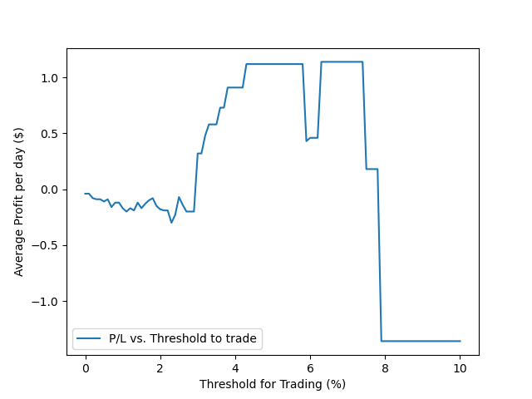

There seems to be a maximum average profit per day from ~ 4-6% threshold, with a steep drop for at 6%, and an increase past a 6% threshold. There are significantly fewer trading days after ~4%, since the slightest drops are due to changes in one or two data points. The optimal threshold is probably within that 4-6% for our x (threshold) value.

**Question 4:**

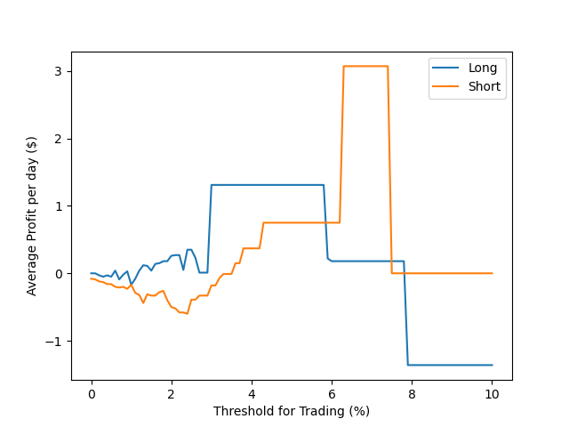

It seems like short profits are maximized from 6-8%, with one data point driving the increase. The drop at ~6% seen in Question 3 is indicated here since there is a drop in long profit. The subsequent increase in total average profit is attributed to the profits from the short position after the 6% threshold.