CRM Database
Configuration Notes
This document details the configuration for the CRM Database Project
Nicholas Garvey
Matthew McCoy
William Wenzel
5/11/2012

Table of Contents
Introduction 3
1 Design and Implementation Considerations 3
1.1 Requirements 3
2.2 Design Considerations 3
2 System Architecture 4
2.1 Back end 4
2.2 Intermediate Processing 5
2.3 Front end
3 Tomcat/EE Eclipse Set up 6
4 System Use 7
3.1 Web Front End Overview 7
3.2 Example Use 7
5 Team Member Contributions 9
4.1 Nicholas Garvey 9
4.2 William Wenzel 9
4.3 Matt McCoy 9

Introduction

This document details the configuration and design for the CRM Database project for group 6. This document contains information relevant to design and implementation considerations, system architecture, system usage, and user contributions.

Design and Implementation Considerations
This CRM system was designed as a business tool. This CRM system’s main goal was to provide business with a way to manage quotes, orders, and potential clients. Design considerations were made with respect to the business, trying to create the most robust end product.

Requirements
- Web-Interface for data display
- Database Back-end (Trigger, View, CRUD, Primary and Foreign Keys)
- Enter quotes
- Convert quotes to orders
- Add customers and potential future customers
- Add contacts

Design Considerations
- Present data from database in readable, interactive format
- Convert from relational objects to eventually html
- Error Handling for connection issues
- Logic Processing for incorrect front-end use
- Distinct separation between back-end and front-end

System Architecture
An overview of our system setup is displayed below.
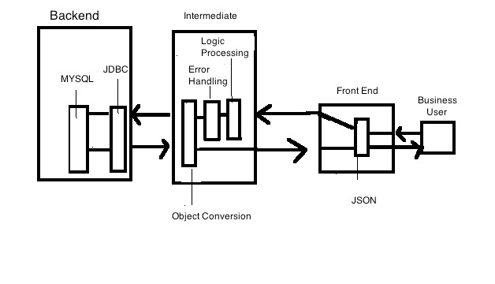

Back-end Processing
Database technology is MYSQL. The database resides on its own server. Requests for CRUD queries from MySQL are sent through by JDBC. Our Database follows the following ER Diagram shown below. Also included but not in the diagram below are “View” statements , which form “Grids” during front-end processing.
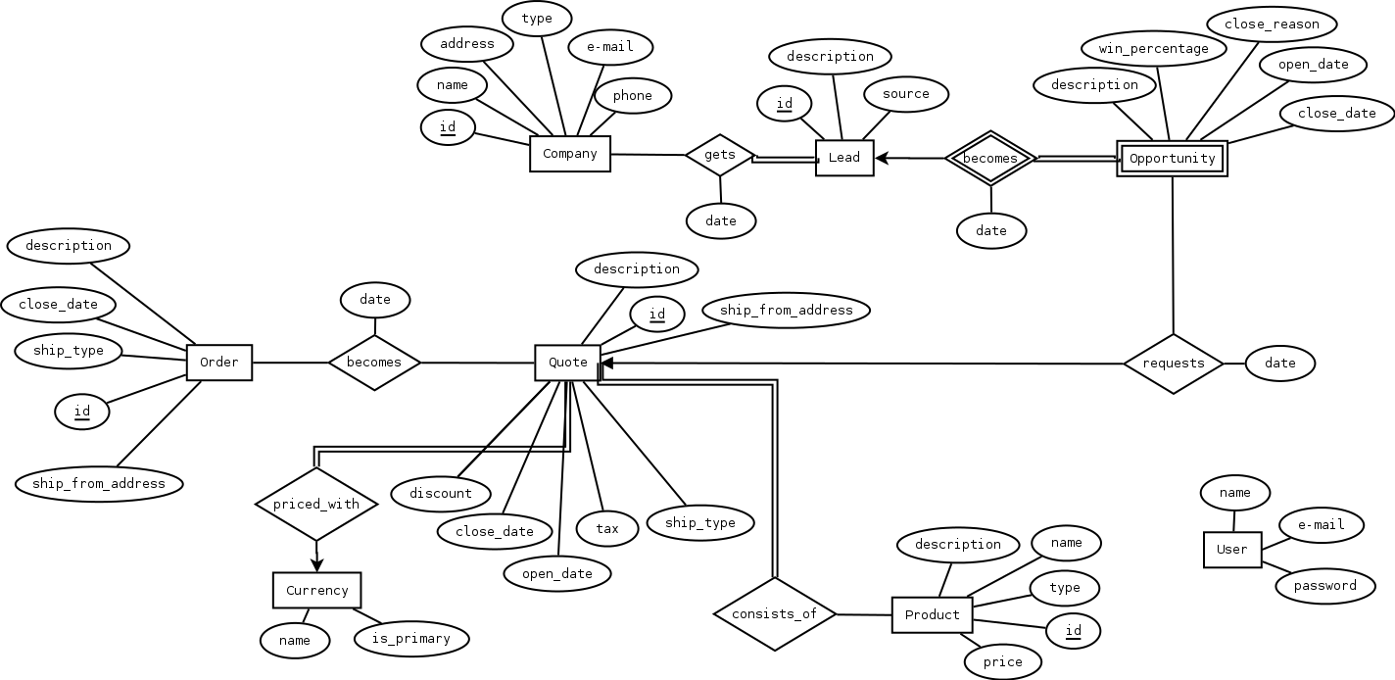

Intermediate Processing
The UML descriptions of our intermediate processing can be seen below. The intermediate processing stage has three major components: Error Handling , Object Conversion, and Logic Processing. Error handling ensures that no erroneous or invalid calls are made to the database layer or that connection problems are correctly resolved. Object Conversion refers to the translation of javascript objects being sent from the front-being correctly converted to the corresponding java objects. Logic Processing refers to the process of making sure the user is performing a valid operation before applying such an operation to the database.

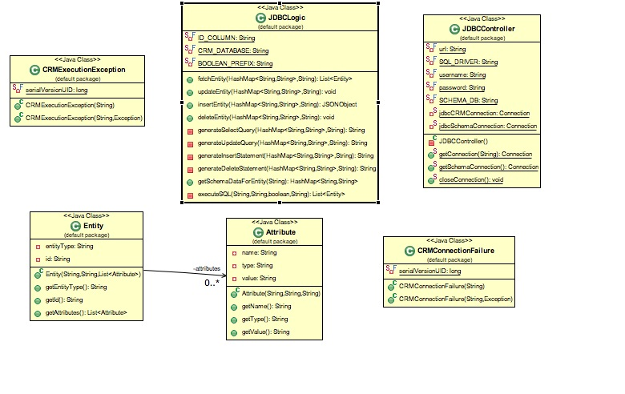

Front-end Processing

The front-end consists of four main pages. entityList, entityPage, index, and register. Content on the entityList and entityPage is dynamically generated based on information from the databases. User input from the html is collected and put into Javascript object models using JSON. The JSON then passes the data to the intermediate processing stage for error correction , logic processing , and the conversion to objects to interact with JDBC connection layer.

Tomcat Installation in Eclipse EE

To run our program ,Tomcat must be installed on your machine.

Install Eclipse EE. The regular version of Eclipse will not work here.
- Create a new project in Eclipse EE, referencing our "Database-Group-6-CRM\Code\Server" folder.
- If you do not have Apache Tomcat on your machine, you will first need to download and unzip Apache Tomcat v 7.0.
- Start the Eclipse .
- Navigate to Window -> Preferences -> Server -> Runtime Environments to create a Tomcat installed runtime.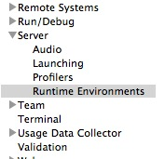

- Click on Add... to open the New Server Runtime dialog, then select your runtime under Apache
- 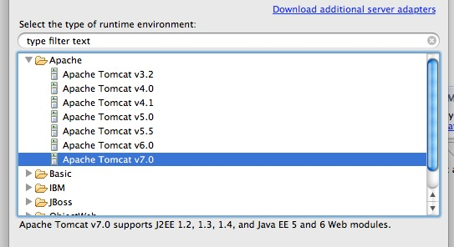
- Click next and then underneath Tomcat Installation Directory browse to the recently downloaded and unzipped Tomcat folder.
- Click Finish .
- The eclipse project should now have a "WebContent" folder under it. You must add an external reference to our "Database-Group-6-CRM\Code\Webroot" folder to have Tomcat serve up our web files.
- Navigate to http://localhost:8080/DatabaseConceptsServer/Webroot (localhost or localhost:8080 depending on your tomcat configuration) to access the system.
- You will also need to have a SQL server running on your localhost on the standard port. You can set up this server by running the scripts in "Database-Group-6-CRM\Scripts".

System Usage

Frontend Overview

The following is an image of the registration page. Access to the internal CRM system is not permitted without first being authenticated by the system. The system stores SHA-2 (256) hash information to the MySQL database and uses that to verify password validity.
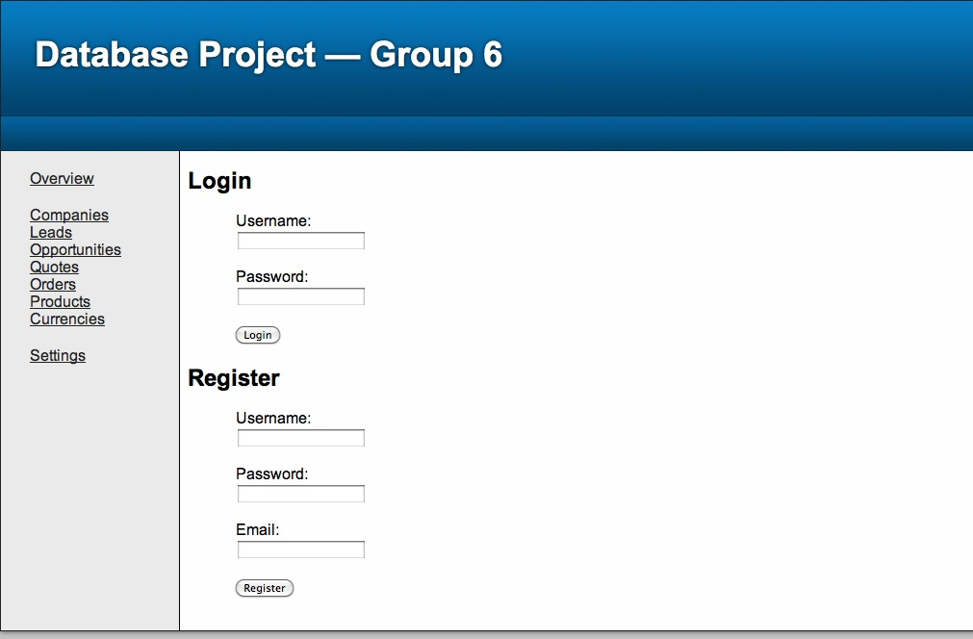
Upon entry to the system , the user is present with access to links on the left-hand side of the page. The index page contains our proposal for the system for demonstration purpose.
Clicking on the Product page with query the database for products, and the contents of the table will be displayed for the user. Options to modify the table are presented.
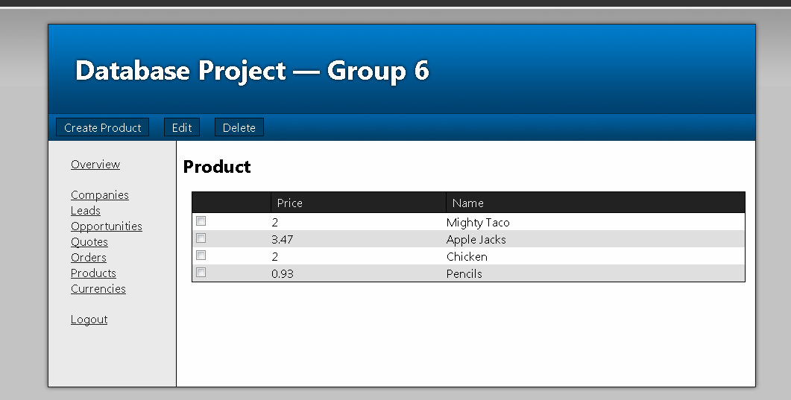
The entity list page shows a full list of all of the values for the entity you have selected.The values shown here are taken from a view named currentEntity + "View" where currentEntity is the entity you are viewing.
By clicking a row in the table, it will bring up the full entity:
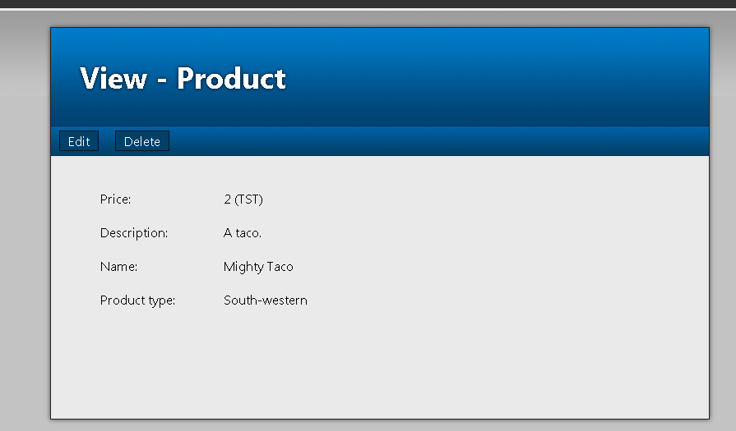
This page shows all of the attributes on the selected entity. Please note that on this entity you can see that prices are followed by their price code in parenthesis. From this screen you can use the top menu to edit or delete the current entity from the database.

Team Member Contributions

System design was created by committee . Each member contributed their thoughts and ideas to come up with the system plan listed in this document.

Nicholas Garvey
Worked with William to create the JDBC layer of the project. Set up the REST endpoint for interacting with the database from the front end. Worked on ensuring a successful interaction between front-end and back-end. Worked with William to build the interface between the front-end and back-end for performing the necessary CRUD operations. Set up the server we used to deploy the project to.

William Wenzel
William created the entire front-end for the system including generation of the pages, styling of the pagse and JavaScript logic and worked on the JDBC layer of the system. Wrote JDBC logic to generate SQL queries in a generic way to make handling the database interactions easier. Wrote the JavaScript code required to interact with the database. He also worked on creating scripts for the creation of tables and their relations.

Matt McCoy
Matt helped configure the MySQL database for use within the scope of the project. He created insertion scripts to populate the database with data. He worked on some code involving JDBC connection to the CRM database. Matt verified the relational model and tables generated by William. Matt created the final documentation for submission.

