Cooking Textbook

Weird Wendy

2022

Contents

# Preface

This cooking textbook is a labor of love, motivated purely by my interest in learning and doing something new. I enjoy cooking, and this book attempts to deconstruct my cooking process and to approach the conventional cooking book in a non-conventional way. I hope it as odd for you to read as it was for me to conceive.

# Introduction

In this cookbook you will find three main chapters. Each chapter focuses on a different aspect of my cooking process, including meal planning, meal preparation, and meal evaluation. The book ends with some concluding thoughts on the cooking journey.

Although I have included a couple of recipes, they are mostly incidental.

# Chapter 1: Meal Planning

Here is a chapter on meal planning.

## Why is meal planning important?

Meal planning matters in my house for several key reasons. Meal planning:

* Reduces waste
* Reduces reliance on fast food
* Reduces cognitive load on a daily basis by removing a decision point (what to have for dinner)

How often do you throw away those wilted, spoiled vegetables that you intended to eat? How many times a week do you come home from a long day, open the refrigerator, and think, “Let’s just go out.” How many times a week do you think, “We went out last night. I *have* to cook something tonight. What should I make? What do we have?” It can feel exhausting.

## How do you plan meals?

Meal planning is not terribly difficult and becomes easier over time. As you gather recipes and gain a better understanding of likes and dislikes, it becomes easier to think about what to cook for the coming week. I usually plan meals on Sunday for the coming seven days.

Once I have decided on the meals, I’ll assign them to a day of the upcoming week. Thinking about the shelf-life of vegetables can help you create the order in which you will eat your meals. For example, peppers, onions, broccoli, cauliflower, and green beans will last for several days in the refrigerator. Green onions, fresh herbs, and pre-sliced mushrooms can spoil a little more quickly, so plan to eat those earlier in the coming week.

Meal planning can take some time and thought, but it’s worth it.

## How do you shop?

Once you decide on the meals, make a list of the ingredients that you need to buy (because you don’t already have them) for each meal. For example, if I’m planning to make fried sauerkraut with bacon, I might not include bacon on my list because I already have it, but I will include sauerkraut on my list because I don’t already have it. Go through each meal, and make sure you write down each ingredient that you need to purchase. Then go shop!

Below is a sample shopping list of ingredients for a week. I always list the meals themselves at the top of the list so that if I cannot find a particular ingredient on my list, I can easily reference the meal and determine a good substitute. I have experimented with putting the list together in different ways; this method works best for me. Find a method that works well for you.

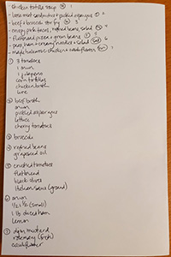

Sample shopping list for a week of meals

# Chapter 2: Meal Prepping

Here is a chapter on meal prepping.

## Why is meal prepping important?

Meal prepping helps make the actual cooking process easier. Meal prepping helps ensure that you have all of your ingredients out of the cupboards and on the counter, ready to use. Sometimes you can even measure out ingredients ahead of time so that when you start cooking, the ingredient is ready to be added. For example, you can measure out a cup of rice in the morning and leave it on the counter all day. Sometimes, managing cooking (or any number of other activities) is about managing in small increments at opportune moments.

Many experts will suggest that you prep your ingredients on a weekend or all at once at some other time (Walker and Keenan 2015, 5). I don’t usually have the time or all the necessary containers to do this all at once, and anyway, some things are better prepped on the day you’re planning to use them. If I’m home for lunch, I usually have time to cut up the bell pepper or even the broccoli that I’ll use in the dinner meal that evening. I also usually have time to take out the skillet and the baking sheet that I’ll need. When I come home from work, those one or two things are already done.

At this point, you might be asking why you can’t just prep right before you start cooking. You can! Do what works for you. If you don’t like to prep at all, I highly recommend that you at least know what ingredients you will need and where they are located in your kitchen so that you’re not scrambling for that infrequently used spice that got jostled to the back of the cabinet while your garlic is burning.

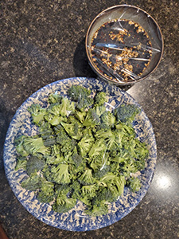

Prepped ingredients for beef and broccoli stir fry

# Chapter 3: Meal Evaluation

Here is a chapter on meal evaluation.

## Why is meal evaluation important?

Meal evaluation helps you determine whether or not you want to add the meal you made to your repertoire. After you finish your meal, take some time to think about what you just ate. Here are some questions you can ask:

* Did you like the meal?
* Did your family like the meal?
* Did your pet(s) end up eating it? Did they like it? (I was surprised once when my dog snubbed a piece of shrimp.)
* What, specifically, did you or others not like? (The spicing, the texture, the mushrooms, the potatoes, the overall meal…? Identifying the specifics can help you decide if you want to try and tweak the recipe or just ditch it altogether.)
* Did you enjoy making it?
* Was the process worth the outcome? (Some meals are really complicated, and the final meal just isn’t great. You might decide that the meal isn’t worth the effort.)
* Was the time spent cooking worth the outcome? (If it took a really long time and was just “OK”, you might decide not to make it again.)
* In general, would you want to make and eat that meal again?

You can consider all of these questions - and others that you’ll ask given your circumstances - while you’re eating, but my family prefers that I wait until after dinner to bring out the clipboard and survey questions. (I’m kidding, of course. I don’t have a clipboard. I’m left-handed, and they’re awkward to use.)

## Meal Evaluation Over Time

I could have amassed a large collection of recipes over the last ten years. The meal evaluation process helps me curate my recipe files so that I don’t keep recipes that I know I’ll never make again. It also helps me better understand likes and dislikes so that I can choose new recipes that are likely to make it into the regular rotation. Evaluating the meal can also help highlight areas of cooking strengths and areas that could use improvement. My vegetable chopping skills have definitely improved. Chopped pieces are more uniformly sized and therefore cook through more evenly. I’m not sure if I will ever understand how (or even why) to cook cube steak.

## Recipe Examples

And now for the part you might have expected all along: A couple of recipes. This book is, afterall, about cooking.

### Shopsky Salad

Shopsky salad is a delicious blend of fresh tomatoes, cucumber, green onion, and sour cream. (You could probably substitute plain Greek yogurt for the sour cream.) Add salt and pepper to taste, and you’ve got an easy, healthy, fast side dish to accompany whatever protein you choose to serve. It’s a nice, light summer salad, but its green, red, and white colors can also add compliment your Yuletime festivities.

[Shopsky Salad Recipe](https://chrisdaaz.github.io/forking/recipes/shopsky.html)

### Crispy Pork Tacos

I love shredded pork, and I like my taco shells crispy! The pork takes time, and the taco shells cook one at a time, but I **love** tacos, so for me, the time is worth it.

*For the Pork*

1. Pre-heat the over to 325 degrees Fahrenheit, and place the oven rack in the lower third of the oven.
2. Place a 3-4 pound pork shoulder roast in a Dutch oven. (The roast can be boneless or bone-in.)
3. Generously season the roast all over with salt and pepper.
4. Add liquid to the pot until the roast is half-way submerged. The liquid can be water, chicken broth, or beef broth.
5. Place the Dutch oven on the stove over medium-high heat and bring the liquid to a simmer.
6. Once simmering, put a lid on the pot, and put the pot in the oven for 2-4 hours.
7. When the pork is fork-tender and obviously shreddable, remove it to a cutting board and let it rest until it is cool enough to handle.
8. Using two forks or your fingers, shred the pork.

*For the Taco Shells*

1. Heat about a cup of oil in a small skillet over medium-high heat. (I use grapeseed oil and a 7” skillet.)
2. Once the oil is heated, use tongs to place one corn tortilla into the skillet. Submerge one side then turn over to submerge the other side.
3. Using the tongs, fold the tortilla in half and fry in the oil for ten seconds or so. You want the tortilla to start taking the shape of a taco shell.
4. Turn the tortilla over again and use the tongs to hold one half of the tortilla at a 45 degree angle (out of the oil) so that as it cooks and hardens, it will be an easily fillable taco shell, not a closed one that you have to pry open (and crack) in order to fill with pork. Cook, holding up the tortilla edge 45 degrees out of the oil for about a minute, or until the half of the shell in the oil looks crispy and slighly brown.
5. Turn the shell over one last time and cook the remaining half until it looks crispy and slightly brown.
6. Remove the shell and place open-side down (to drain excess oil and help the shell maintain its taco shape) on a paper-towel lined plate or surface.
7. Repeat process with remaining tortillas. (This is all easier than it sounds.)

*Final Assembly*

1. Fill your crispy taco shells with some of the shredded pork.
2. Add whatever toppings you like: shredded lettuce, avocado, salsa, sour cream, onions, cilantro, cheese, etc.

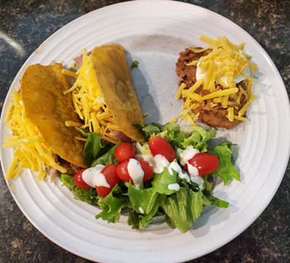

Crispy pork tacos served with side salad and refried beans

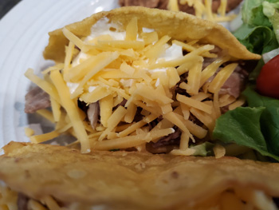

Crispy pork taco close-up

# Conclusion

The cooking journey is unique to each individual. In my own journey, I started with very little basic knowledge. There were a few things I knew how to cook well, namely:

* Sauteed Brussels sprouts
* Taco shells
* Chocolate chip cookies

Otherwise, my meals were mostly box- or can-driven or just not very good. I seemed to have no natural ability to “wing it” in the kitchen or to understand how to use spices or how to use a knife without ending up in the emergency room.

When I was living alone, I ate a lot of eggs and toast for breakfast…and dinner.

Interestingly, I had always enjoyed watching cooking shows. I just never imagined that I could actually replicate the recipes at home with any success.

It wasn’t until I had kids that I thought more seriously about cooking healthier, tastier meals, but I knew that I couldn’t just experiment and hope for the best. In the end, I had to approach cooking in a more methodical, research-driven way. I subscribed to a cooking magazine and began identifying recipes that seemed basic and relatively simple. And I slowly learned to make my way in the kitchen.

Yes, there were some disasters. I recall accidentally using hot paprika instead of sweet paprika in a recipe that called for quite a lot of paprika, and in the end, it was simply inedible. But there have been some great successes as well, including a delicious cod and corn chowder that I’ve made multiple times over the last few years. My knife skills have improved as have my instincts for when to turn off the heat and when to let it go just another minute or so. And I can read a recipe – I think I will always need a recipe – and pretty accurately imagine how it will taste.

I’m not a gourmet chef, but I’m more proficient in the kitchen than I was ten years ago, and most days, I actually look forward to cooking.

# References

Walker, Wendy, and Teressa Keenan. 2015. “Do You Hear What i See? Assessing Accessibility of Digital Commons and CONTENTdm.” *Journal of Electronic Resources Librarianship* 27 (2): 69–87.