This essential knowledge provides detailed instructions on how you can create a UML profile using papyrus.

To create the Webpage UML Profile:

1. Metamodel elements Web, Webpage, Category and Article can be identified as Nodes in your profile, whereas references: +pages (of Web), +article (of Category) and +category (of Webpage) can be identified as edges. Thus, you need to create Stereotypes for all these elements first, regardless of the metaclass they extend. You may also define the relationships among the nodes by creating the “Association” edge in your Papyrus palette. Like below:

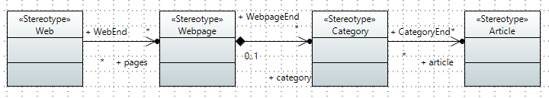

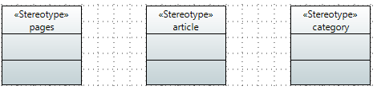

1. Then you need to associate these Stereotypes to their corresponding meta-classes, import the meta-classes *Class* and the *Association* in your profile diagram (the Import Metaclass tool is in the UML profile editor palette).

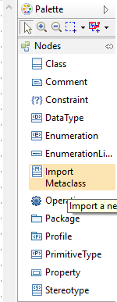

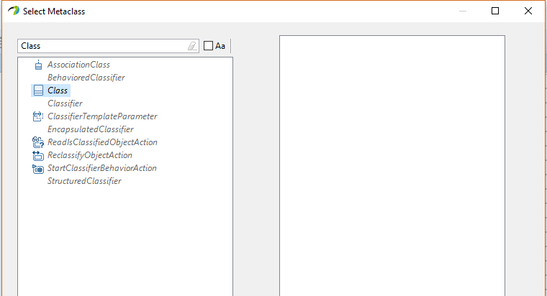

You may select *Class* and *Association* in the dialog that appeared and Papyrus will import these two metaclasses on your canvas, like below:

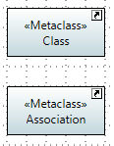

1. You need to use the "Extension" connection tool from the palette to link these Stereotypes to the meta-classes you imported in step 2). The “Extension” tool is located under the “Edges” drawer of the palette.

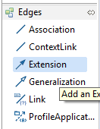

1. You may link your Web, Webpage, Category, Article Stereotypes to the *Class* metaclass, and your pages, article and category Stereotypes to the *Association* metaclass, like so:

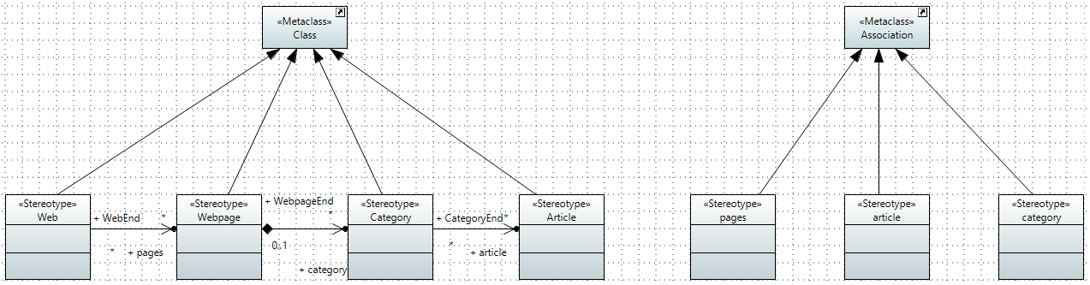

**Note: You have 20 minutes to complete this task**