You need to create an Palette Configuration Model from new -> Others -> then select the corresponding entry like below:

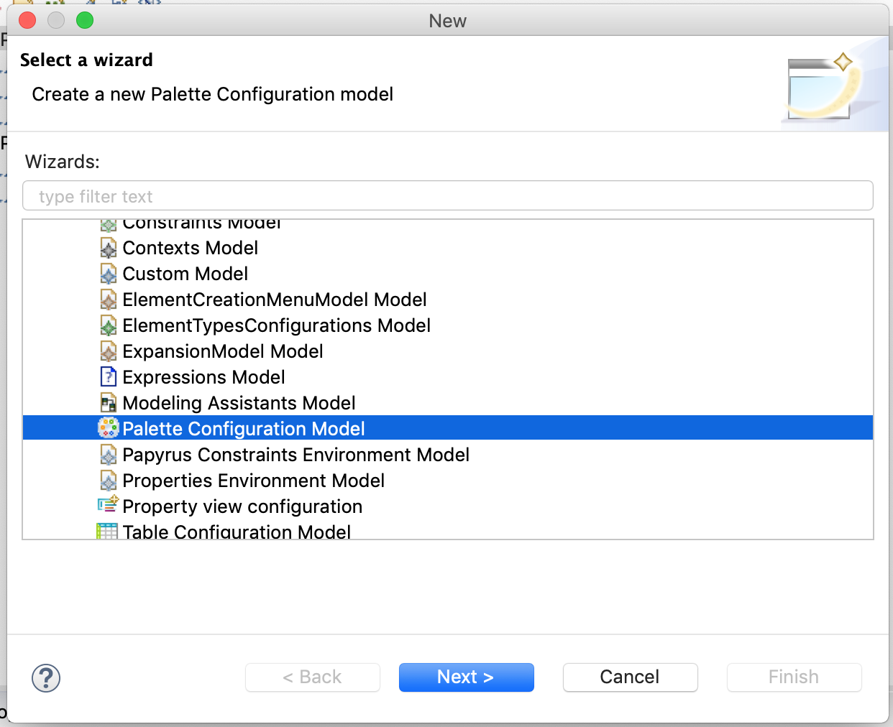

Once open the model, you will see a small tool bar below.



To create a creation tool, you need to press the 4th entry to the left.

You can change the type of a creation tool by inspecting the properties of the entry, like below:

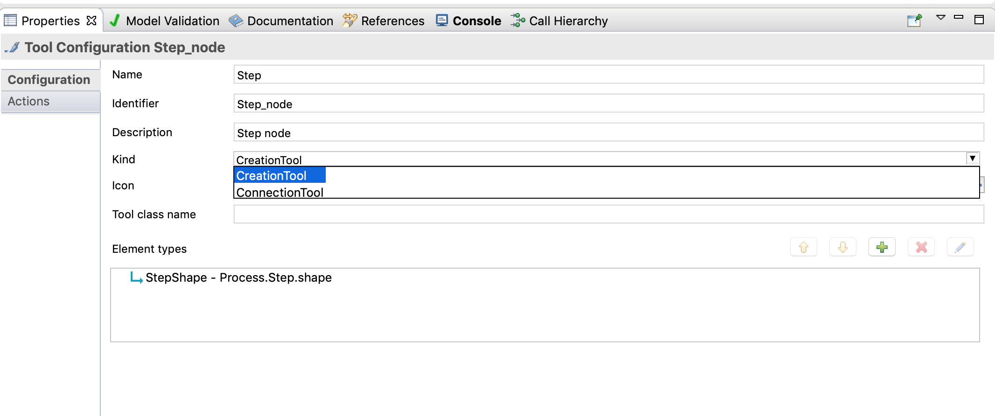

The next step is to populate the features of the tools:

* Name: give it a name
* Identifier: give it an id
* Kind: select the correct kind
* Icon: provide the location of the icon for this tool
* Element types: you should refer to your SpecialisationTypeConfiguration you defined in your ElementTypesConfiguration model.

The most difficult part is to refer to the SpecialisationTypeConfiguration in your ElementTypesConfiguration model, since there is no way to register the Element Types Configuration model to Papyrus, you are required to populate the reference by your very self.

<ownedConfigurations xmi:type="paletteconfiguration:ToolConfiguration" id="Step_node" label="Step" description="Step node" kind="CreationTool">

      <elementDescriptors xmi:type="paletteconfiguration:ElementDescriptor">

        <elementType xmi:type="elementtypesconfigurations:SpecializationTypeConfiguration" href="platform:/plugin/org.papyrus.process/resources/diagramshapes.elementtypesconfigurations#_CwG-ITQ3EemBkOmftjkSEQ"/>

      </elementDescriptors>

    </ownedConfigurations>

To do that, open the palette configuration using a text editor, and under the <elementDescriptors> tag, add:

<elementType xmi:type="elementtypesconfigurations:SpecializationTypeConfiguration" href="diagramshapes.elementtypesconfigurations#_O9VNozCBEemejazLoa-CDw"/>

Note: remember in the code above "_O9VNozCBEemejazLoa-CDw" is the XMI id I have in my own ElementTypesConfiguration model, you need to find out the XMI id for your SpecialisationTypeConfiguration in your ElementTypesConfiguration model.

**Note: You have 10 minutes to complete this task**