To define your OCL constraints, you can select the “Constraint” creation tool in the UML profile diagram editor to drop a constraint on the canvas.

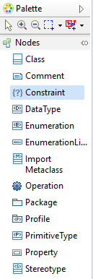

Now you define the constraints associate them to the Stereotype you wish to apply the constraints on

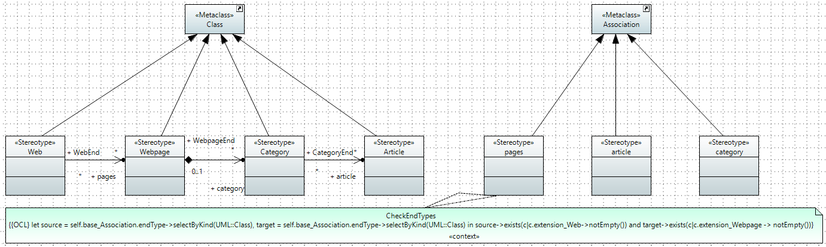

Below are example OCL code for the ‘pages’ Stereotype in the WebPage example:

**checkEndTypes:**  
let source = self.base_Association.endType->selectByKind(UML::Class), target = self.base_Association.endType->selectByKind(UML::Class) in source->exists(c|c.extension_Web->notEmpty()) and target->exists(c|c.extension_Webpage -> notEmpty())

**checkNavigability:**  
let memberEnds = self.base_Association.memberEnd in let WebpageEnd = memberEnds->select(type.oclIsKindOf(UML::Class) and type.oclAsType(UML::Class).extension_Web->notEmpty()), WebEnd = memberEnds->select(type.oclIsKindOf(UML::Class) and type.oclAsType(UML::Class).extension_Webpage->notEmpty())in if WebEnd->notEmpty() and WebpageEnd->notEmpty() then WebEnd->first().isNavigable() = true and WebpageEnd->first().isNavigable() = false else false endif

Now define constraints for all connector Stereotypes

**Note: You have 20 minutes to complete this task**