1М

SW – root/toor
1. hostnamectl set-hostname hq-sw;exec bash
2. mcedit /etc/sysconfig/network
HOSTNAME= hq-sw
3. timedatectl set-timezone utc+3
ISP – root/toor
1. hostnamectl set-hostname isp;exec bash
2. mcedit /etc/sysconfig/network
HOSTNAME= isp

HQ-RTR – admin/admin
1. en
2. conf
3. hostname hq-rtr
4. ip domain-name au-team.irpo
5. ip name-server 10.10.100.2
6. exit
7. write memory
8. ip route 0.0.0.0/0 172.16.1.1
9. exit
10. write memory

BR-RTR – admin/admin
1. en
2. conf
3. hostname br-rtr
4. ip domain-name au-team.irpo
5. ip name-server 10.10.100.2
6. exit
7. write memory
8. ip route 0.0.0.0/0 172.16.2.1
9. exit
10. write memory

CLI – resu
1. su -
toor
2.. acc
ethernet-интерфейсы
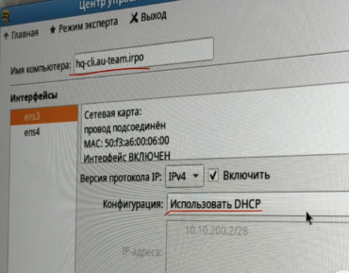
5. mcedit /etc/net/ifaces/ens3/options
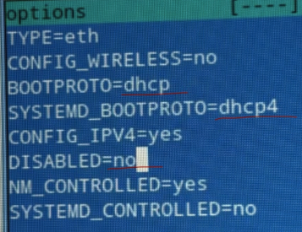
6. mcedit /etc/net/ifaces/ens3/resolv.conf
nameserver 77.88.8.8
7. systemctl restart network
8. timedatectl set-timezone utc+3
9. reboot

HQ-SRV – root/toor
1. hostnamectl set-hostname hq-srv.au-team.irpo;exec bash
2. mcedit /etc/sysconfig/network
HOSTNAME= hq-srv.au-team.irpo
3. mcedit /etc/net/ifaces/ens3/ipv4address
10.10.100.2/27
4. mcedit /etc/net/ifaces/ens3/ipv4route
default via 10.10.100.1
5. mcedit /etc/net/ifaces/ens3/resolv.conf
nameserver 77.88.8.8
6. systemctl restart network
7. echo "sshuser ALL=(ALL:ALL) NOPASSWD: ALL" » /etc/sudoers

BR-SRV – root/toor
1. hostnamectl set-hostname br-srv.au-team.irpo;exec bash
2. mcedit /etc/sysconfig/network
HOSTNAME= br-srv.au-team.irpo
3. mcedit /etc/net/ifaces/ens3/ipv4address
10.20.20.2/28
4. mcedit /etc/net/ifaces/ens3/ipv4route
default via 10.20.20.1
5. mcedit /etc/net/ifaces/ens3/resolv.conf
nameserver 77.88.8.8
6. systemctl restart network
7. echo "sshuser ALL=(ALL:ALL) NOPASSWD: ALL" » /etc/sudoers

ISP – root/toor
1. iptables -t nat -A POSTROUTING -s 172.16.1.0/28 -o ens3 -j MASQUERADE
2. iptables -t nat -A POSTROUTING -s 172.16.2.0/28 -o ens3 -j MASQUERADE
3. iptables-save >> /etc/sysconfig/iptables
4. systemctl enable --now iptables
5. systemctl restart network
6. timedatectl set-timezone utc+3

HQ-SRV – root/toor
1. mcedit /etc/openssh/sshd_config
a)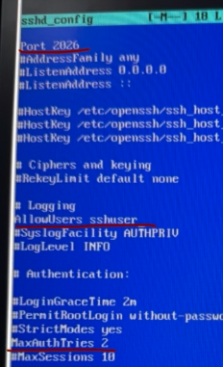 б) 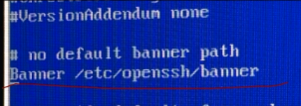
2. mcedit /etc/openssh/banner
Authorized access only
3. systemctl restart sshd
4. systemctl restart network

BR-SRV – root/toor
1. mcedit /etc/openssh/sshd_config
a) б)
2. mcedit /etc/openssh/banner
Authorized access only
3. systemctl restart sshd
4. systemctl restart network
5. timedatectl set-timezone utc+3

HQ-RTR – admin/admin
1. en
2. conf
3. int tunnel.0
10. description "GRE"
11. ip address 10.10.10.1/30
12. ip tunnel 172.16.1.2 172.16.2.2 mode gre
13. ex
15. router ospf 1
16. ospf router-id 10.10.10.1
17. passive-interface default
18. no passive-interface tunnel.0
19. network 10.10.10.0/30 area 0
20. network 10.10.100.0/27 area 0
21. network 10.10.200.0/28 area 0
22. network 10.10.30.0/29 area 0
23. ex
24. int tunnel.0
25. ip ospf authentication message-digest
26. ip ospf message-digest-key 1 md5 P@ssword
27. exit
28. write memory

BR-RTR – admin/admin
1. en
2. conf
3. int tunnel.0
4. description "GRE"
5. (hq) ip address 10.10.20.2/30
6. (hq) ip tunnel 172.16.2.2 172.16.1.2 mode gre
7. ex
8. router ospf 1
9. ospf router-id 10.10.10.2
10. passive-interface default
18. no passive-interface tunnel.0
19. network 10.10.10.0/30 area 0
20. network 10.20.20.0/28 area 0
21. ex
22. int tunnel.0
23. ip ospf authentication message-digest
24. ip ospf message-digest-key 1 md5 P@ssword
25. exit
26. write memory

HQ-RTR – admin/admin
1. en
2. conf
3. int isp
4. ip nat outside
5. ех
6. int vl100
7. ip nat inside
8. ех
9. int vl200
10. ip nat inside
11. ех
12. int vl999
13. ip nat inside
14. ex
15. ip nat pool VLAN100 10.10.100.1-10.10.100.30
16. ip nat pool VLAN200 10.10.200.1-10.10.200.254
17. ip nat pool VLAN999 10.10.30.1-10.10.30.6
18. ip nat source dynamic inside-to-outside pool VLAN100 overload interface isp
19. ip nat source dynamic inside-to-outside pool VLAN200 overload interface isp
20. ip nat source dynamic inside-to-outside pool VLAN999 overload interface isp
21. exit
22. write memory
23. ntp timezone utc+3

BR-RTR – admin/admin
1. en
2. conf
3. int isp
4. ip nat outside
5. ex
6. int br
7. ip nat inside
8. ex
9. ip nat pool BR-Net 10.20.20.1-10.20.20.16
10. ip nat source dynamic inside-to-outside pool BR-Net overload interface isp
11. exit
12. write memory
12. ntp timezone utc+3

HQ-SRV – root/toor
1. mcedit /var/lib/bind/etc/options.conf
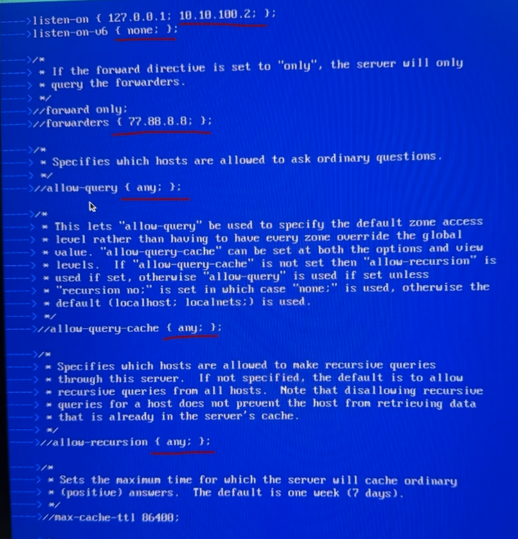
2. mcedit /var/lib/bind/etc/rfc1912.conf
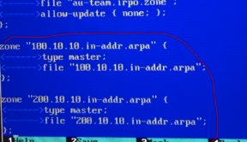
3. cp /var/lib/bind/etc/zone/empty /var/lib/bind/etc/zone/au-team.irpo
4. cp /var/lib/bind/etc/zone/empty /var/lib/bind/etc/zone/100.10.10.in-addr.arpa
5. cp /var/lib/bind/etc/zone/empty /var/lib/bind/etc/zone/200.10.10.in-addr.arpa
6. mcedit /var/lib/bind/etc/zone/au-team.irpo
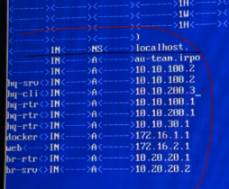
7. mcedit /var/lib/bind/etc/zone/100.10.10.in-add.arpa
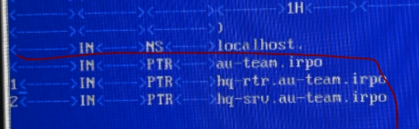
8. mcedit /var/lib/bind/etc/zone/200.10.10.in-add.arpa
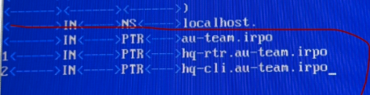
9. rndc-confgen > /etc/bind/rndc.key
10. sed -i '6,$d' /etc/bind/rndc.key
11. chown -R root:named /var/lib/bind/etc/zone/*
12. systemctl enable --now bind.service
13. systemctl status bind. service
14. timedatectl set-timezone utc+3

