FZMotion人体关节顺序及命名
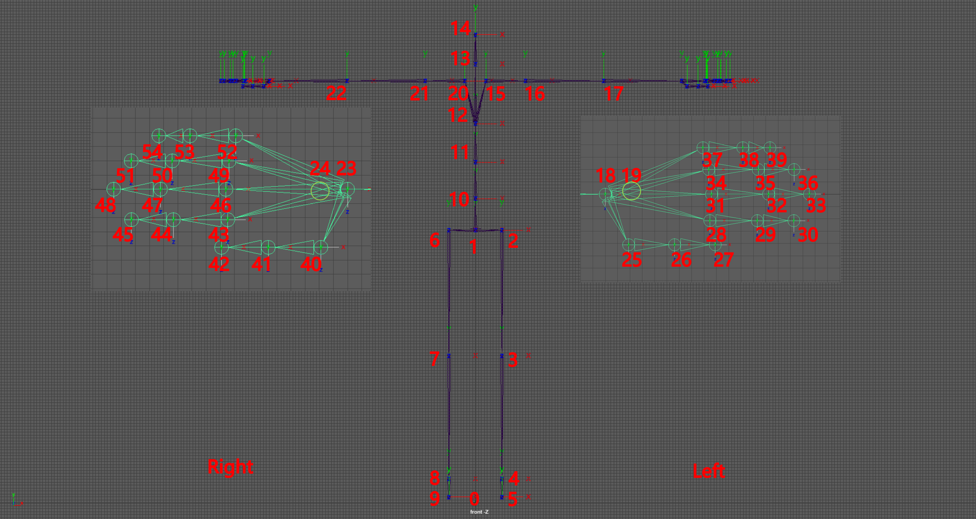
序号 | 名称 | 备注
0 | Root
1 | Hips
2 | LeftUpLeg
3 | LeftLeg
4 | LeftFoot
5 | LeftToe
6 | RightUpLeg
7 | RightLeg
8 | RightFoot
9 | RightToe
10 | Spine1
11 | Spine2
12 | Chest
13 | Neck
14 | Head
15 | LeftShoulder
16 | LeftArm
17 | LeftForeArm
18 | LeftHand
19 | LefthandPalm | 待舍弃
20 | RightShoulder
21 | RightArm
22 | RightForeArm
23 | RightHand
24 | RighthandPalm | 待舍弃
25 | FZLeftThumb1
26 | FZLeftThumb2
27 | FZLeftThumb3
28 | FZLeftIndex1
29 | FZLeftIndex2
30 | FZLeftIndex3
31 | FZLeftMiddle1
32 | FZLeftMiddle2
33 | FZLeftMiddle3
34 | FZLeftRing1
35 | FZLeftRing2
36 | FZLeftRing3
37 | FZLeftPinky1
38 | FZLeftPinky2
39 | FZLeftPinky3
40 | FZRightThumb1
41 | FZRightThumb2
42 | FZRightThumb3
43 | FZRightIndex1
44 | FZRightIndex2
45 | FZRightIndex3
46 | FZRightMiddle1
47 | FZRightMiddle2
48 | FZRightMiddle3
49 | FZRightRing1
50 | FZRightRing2
51 | FZRightRing3
52 | FZRightPinky1
53 | FZRightPinky2
54 | FZRightPinky3

