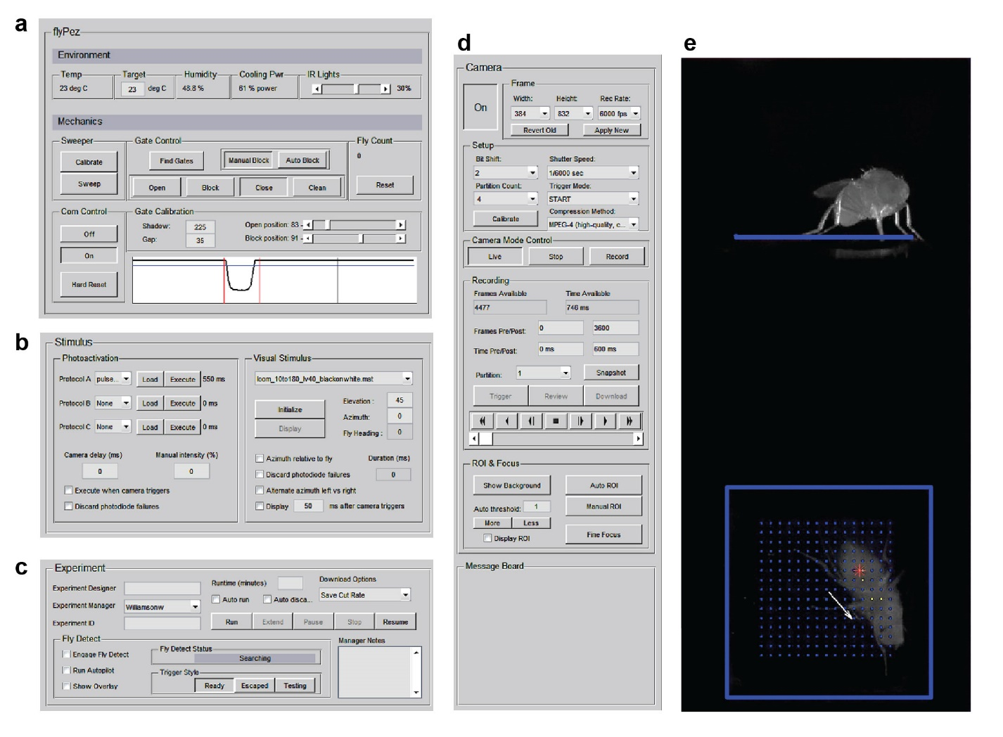

**FlyPEZ control graphical user interface for data acquisition**

The control computer runs the FlyPEZ control graphical user interface, which manages the fly release mechanism, the high-speed camera, the experimental status, and triggers visual (via the visual stimulus computer) or optogenetic stimuli.

(a) Under “Environment,” current temperature and humidity, target temperature, active cooling power, and a slider to set the brightness of the IR lights. In “Mechanics,” sweep manually triggers the sweeper servo. “Calibration” positions the sweeper directly above the tunnel opening to adjust the sweeper height. Communication can be turned on or off, and the connection can be reset if the FlyPEZ is turned off for maintenance. Gate control sets the position of the gate manually to open, block, close, and clean (see Supplementary Fig. 3c). “Find gates” automatically determines the position of the gate (vertical red lines in display). When set to “Auto Block,” the gate will close automatically when a fly passes, an operation performed locally on the FlyPEZ. Fly count is the number of times the gate has closed when set to “Auto Block.” The noise baseline threshold for signals transmitted by the linear array is set with “Shadow”, and “Gap” determines the distance past the gate a single fly must reach before the gate closes when set to “Auto Block.” The “Open” and “Block” sliders set those gate positions, which lie between the extremes “Clean” and “Close.”

(b) Optogenetic activation stimuli are set via FlyPEZ communications, and up to three can be set to present on rotation during a single experiment. Only one visual stimulus can be set per experiment (see Supplementary Fig. 4, Supplementary Fig. 5, and materials and methods). One or both types of stimuli can be set to automatically display when a video recording is triggered by “Fly Detect” (see below).

(c) When a valid 16-digit experiment ID is entered by scanning a barcode or manual entry, the FlyPEZ is prepared for a single experiment according to the parameters encoded by that ID. If “Auto run” is selected, the experiment starts automatically when a barcode is scanned. “Trigger Style” sets the condition which must be met for a video recording to be initiated. See Figure 1e and Supplementary Figure 3a.

(d) The Photron camera models SA-X and SA-4 are fully controlled here. The values here are automatically set by entering an experiment ID, however a video can be captured, reviewed, and downloaded manually. “Message board” is reserved space for displaying various status and error messages.

(e) Live display at 15 Hz when camera status is set to “Live.” Displays recorded frames when camera status is set to “Record” and “Review” is selected under the “Recording” section.