**Looking for strange particles in ALICE (Web edition)**

**1 Overview**

The exercise proposed here consists of a search for strange particles, produced from collisions at LHC and recorded by the ALICE experiment. It is based on the recognition of their decay patterns known as V0-decays, such as *Ks*0 *→* *π*+*π−*, Λ *→* *p* + *π−* and cascades, such as Ξ*−* *→* Λ + *π−*(Λ *→* *p* + *π−*). The identification of the strange particles is based on the topology of their decay combined with the identification of the decay products; the information from the tracks is used to calculate the invariant mass of the decaying particle, as an additional confirmation of the decaying particle species.

In what follows the ALICE experiment and its physics goals are first presented briefly, then the physics motivation for this analysis. The method used for the identification of strange particles as well as the tools are described in detail; then all the steps of the exercise are explained followed by the presentation of the results as well as the method of collecting and merging all results. In the end the large scale analysis is presented.

**2 Introduction**

ALICE (A Large Ion Collider Experiment), one of the four large experiments at the CERN Large Hadron Collider, has been designed to study heavy ion collisions. It also studies proton proton collisions, which primarily provide reference data for the heavy ion collisions. In addition, the proton collision data allow for a number of genuine proton proton physics studies. The ALICE detector has been designed to cope with the highest particle multiplicities anticipated for collisions of lead nuclei at the extreme energies of the LHC.

**3 The ALICE Physics**

Quarks are bound together into protons and neutrons by a force known as the strong interaction, mediated by the exchange of force carrier particles called gluons. The strong interaction is also responsible for binding together the protons and neutrons inside atomic nuclei. Even though we know that quarks are elementary particles that build up all known hadrons, no quark has ever been observed in isolation: the quarks, as well as the gluons, seem to be bound permanently together and confined inside composite particles, such as protons and neutrons. This is known as confinement. The exact mechanism that causes it remains unknown.

Although much of the physics of strong interaction is, today, well understood, two very basic issues remain unresolved: the origin of confinement and the mechanism of the generation of mass. Both are thought to arise from the way the properties of the vacuum are modified by strong interaction.

The current theory of the strong interaction (called Quantum Chromo-Dynamics) predicts that at very high temperatures and/or very high densities, quarks and gluons should no longer be confined inside composite particles. Instead, they should exist freely in a new state of matter known as quark-gluon plasma. Such a transition should occur when the temperature exceeds a critical value estimated to be about 100 000 times hotter than the core of the Sun! Such temperatures have not existed in Nature

since the birth of the Universe. We believe that for a few millionths of a second after the Big Bang the temperature was indeed above the critical value, and the entire Universe was in a quark-gluon plasma state. When two heavy nuclei approach each other at a speed close to that of light and collide these extreme conditions of temperature are recreated and release the quarks and the gluons. Quarks and gluons collide with each other creating a thermally equilibrated environment: the quark–gluon plasma. The plasma expands and cools down to the temperature (1012 degrees) at which quarks and gluons regroup to form ordinary matter, barely 10*−*23 seconds after the start of the collision. ALICE will study the formation and the properties of this new state of matter.

**4 Strangeness enhancement as a signature for quark gluon plasma**

The diagnosis and the study of the properties of quark-gluon plasma (QGP) can be undertaken using quarks not present in matter seen around us. One of the experimental signatures relies on the idea of strangeness enhancement. This was one of the first observable of quark-gluon plasma, proposed in 1980. Unlike the up and down quarks, strange quarks are not brought into the reaction by the colliding nuclei. Therefore, any strange quarks or antiquarks observed in experiments have been “freshly” made from the kinetic energy of colliding nuclei. Conveniently, the mass of strange quarks and antiquarks is equivalent to the temperature or energy at which protons, neutrons and other hadrons dissolve into quarks. This means that the abundance of strange quarks is sensitive to the conditions, structure and dynamics of the deconfined matter phase, and if their number is large it can be assumed that deconfinement conditions were reached.

In practice, the strangeness enhancement can be observed by counting the number of strange particles, that is particles containing at least one strange quark, and calculating the ratio of strange to non-strange particles. If this ratio is higher than that given by the theoretical models that do not foresee the creation of QGP, then enhancement has been observed.

Alternatively, for lead ion collisions, the number of strange particles is normalised to the number of nucleons participating in the interaction and compared with the same ratio for proton collisions.

**5 Strange Particles**

Strange particles are hadrons containing at least one strange quark. This is characterized by the quantum number of “strangeness”. The lightest neutral strange meson is the *Ks*0 (ds̄) and the lightest neutral strange baryon is the Λ (uds), characterized as hyperon.

Here we will be studying their decays, for example *Ks*0 *→* *π*+*π−*, Λ *→* *p* + *π−*. In these decays the quantum number of strangeness is not conserved, since the decay products are only composed of up and down quarks. Therefore, these are not strong decays (which in addition would be very fast, with a *τ* = 10*−*23s) but weak decays, in which the strangeness can be conserved (∆*S* = 0) or change by 1 (∆*S* = 1). For these decays the mean life *τ* is between 10*−*8s and 10*−*10s. For particles travelling close to the speed of light, this means that the particle decays at a distance (on average) of some cm from the point of production (e.g., from the point of the interaction).

**6 How we look for strange particles**

The aim of the exercise is to search for strange particles produced from collisions at LHC and recorded by the ALICE experiment.

As mentioned in the previous section, strange particles do not live long; they decay soon after their production. However, they live long enough to travel some cm distance from the interaction point (IP), where they were produced (primary vertex). Their search is thus based on the identification of their decay products, which must originate from a common secondary vertex.

Neutral strange particles, such as *Ks*0 and Λ, decay giving a characteristic decay pattern, called V0. The mother particle disappears some cm from the interaction point and two oppositely charged particles appear in its place, which are bent in opposite directions inside the magnetic field of the ALICE solenoid.

In the following red tracks indicate positively charged particles; green tracks indicate negatively charged particles.

The decays we will be looking for are:

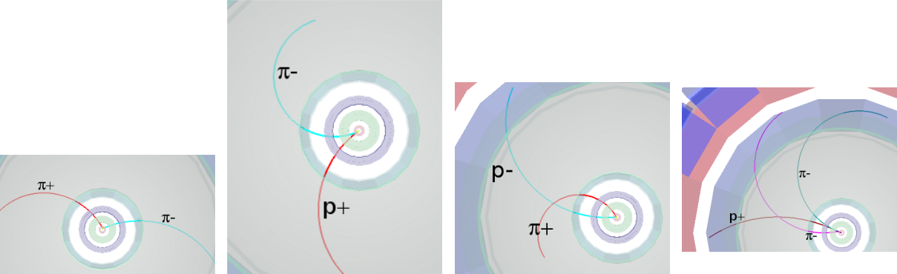

(d) Ξ*−* *→* *π−* + Λ(*→* *p* +

(a) *Ks*0 *→* *π*+*π−* (b) Λ *→* *p* + *π−* (c) anti-Λ *→* *p−* + *π*+ *π−*)

We see that for a pion-pion final state the decay pattern is quasi-symmetric whereas in the pion-proton final state the radius of curvature of the proton is bigger than that of the pion: due to its higher mass the proton carries most of the initial momentum.

We will also be looking for cascade decays of charged strange particles, such as the Ξ*−*; this decays into *π−* andΛ; theΛthen decays into *π−* and proton; the initial pion is characterized as a bachelor (singlecharged track) and is shown in purple.

The search for V0s is based on the decay topology and the identification of the decay products; an additional confirmation of the particle identity is the calculation of its mass; this is done based on the information (mass and momentum) of the decay products as described in the following section.

**7 The (invariant) mass calculation**

We consider the decay of the neutral kaon to two charged pions, *Ks*0 *→* *π*+*π−*.

Let *E*, p and m be the total energy, momentum (vector!) and mass of the mother particle (*Ks*0). Let *E*1, p1 and *m*1 be the total energy, momentum and mass of the daughter particle number 1 (*π*+); and *E*2, p2 and *m*2 the total energy, momentum and mass of the daughter particle number 2 (*π−*).

|  |  |  |
| --- | --- | --- |
| Conservation of energy | *E*=*E*1+*E*2 | (1) |
| Conservation of momentum | **p = p1 + p2** | (2) |
| From relativity (with the assumption c=1) | *E*2= *p*2+ *m*2 | (3) |

Where *p* = *|***p***|* is the length or magnitude of the momentum vector p. This applies, of course, also for the daughter particles:

|  |  |  |
| --- | --- | --- |
| *E*12 | = *p*12 + *m*12 | (4) |
| *E*22 | = *p*22 + *m*22 | (5) |

where *p*1 = *|***p1***|* and *p*2 = *|***p2***|* are the lengths of **p1** and **p2**. From the above equations, we find that:

*m*2= *E*2 *− p*2= (*E*1+ *E*2)2 *−* (**p1**+**p2**)2

(6)

= *E*12 + *E*22 + 2*E*1*E*2 *−* **p1p1** *−* **p2p2** *−* 2**p1p2**

where we have introduced the scalar product p1p2 of the two vectors sum of the products of the *x*, *y* and *z* components of the two vectors:

***p1p2*** *= p1xp2x + p1yp2y + p1zp2z*

***p1p1*** *= p21x + p21y + p21z = p21*

***p2p2*** *= p22x + p22y + p22z = p22*

Equation (6) therefore becomes:

p1 and p2, which is equal to the

(7)

(8)

(9)

|  |  |
| --- | --- |
| *m*2= *E*12+ *E*22+ 2*E*1*E*2 *− p*12 *− p*22 *−* 2**p1p2** | (10) |
| = *m*12 + *m*22 + 2*E*1*E*2 *−* 2**p1p2** |  |

We can therefore calculate the mass of the initial particle from the mass and the momentum components of the daughter particles. The masses of the daughter particles *m*1 and *m*2 are known: a number of different detectors in ALICE identify particles. The momenta of the daughter particles *p*1, *p*2 can be found by measuring the radius of curvature of their trajectory due to the known magnetic field. In the exercise we use the three components of the momentum vector of each track associated with the V0 decay, as in the above equations.

The invariant mass calculation gives typically distributions as shown below. The distribution on the left is the mass calculated for pion-proton pairs; the peak corresponds to Λ and the continuum is “background” from random combinations of pions and protons which appear as coming from the same secondary vertex or that have been misidentified; the distribution on the right is the mass calculated for negative and positive pion pairs; the peak corresponds to *Ks*0.

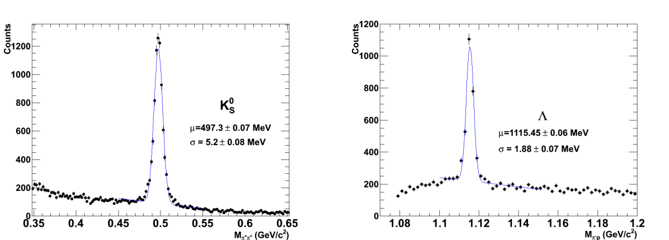

(a) Kaon spectrum (b) Lambda spectrum

**8 The tools and how to use them**

The exercise is done in a web application, which closely resembles the ALICE event display. You should open your favourite web browser on your computer and follow the link presented in the “Installation” section of the main site. You will be presented with the MasterClass home page, as shown in the Figure [3].

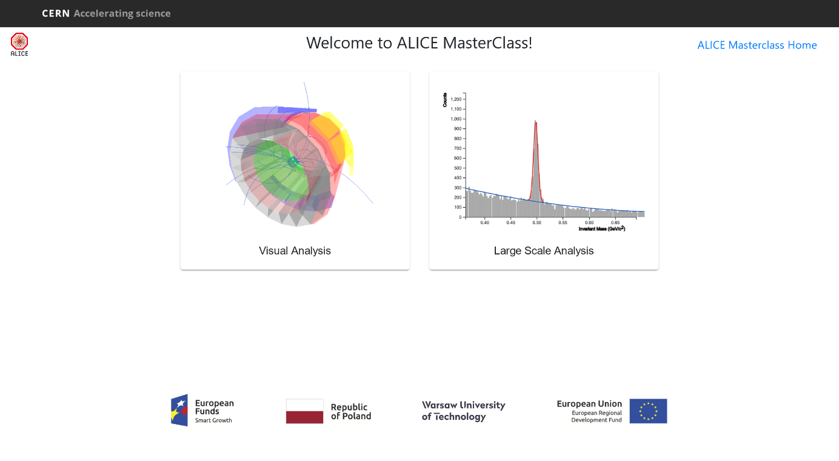

Figure 3: Initial screen of the Strange Particles MasterClass

The home page displays two clickable buttons: “Visual Analysis” and “Large Scale Analysis”. You should click the “Visual Analysis” button. You will now be presented with the following site (Figure [4]).

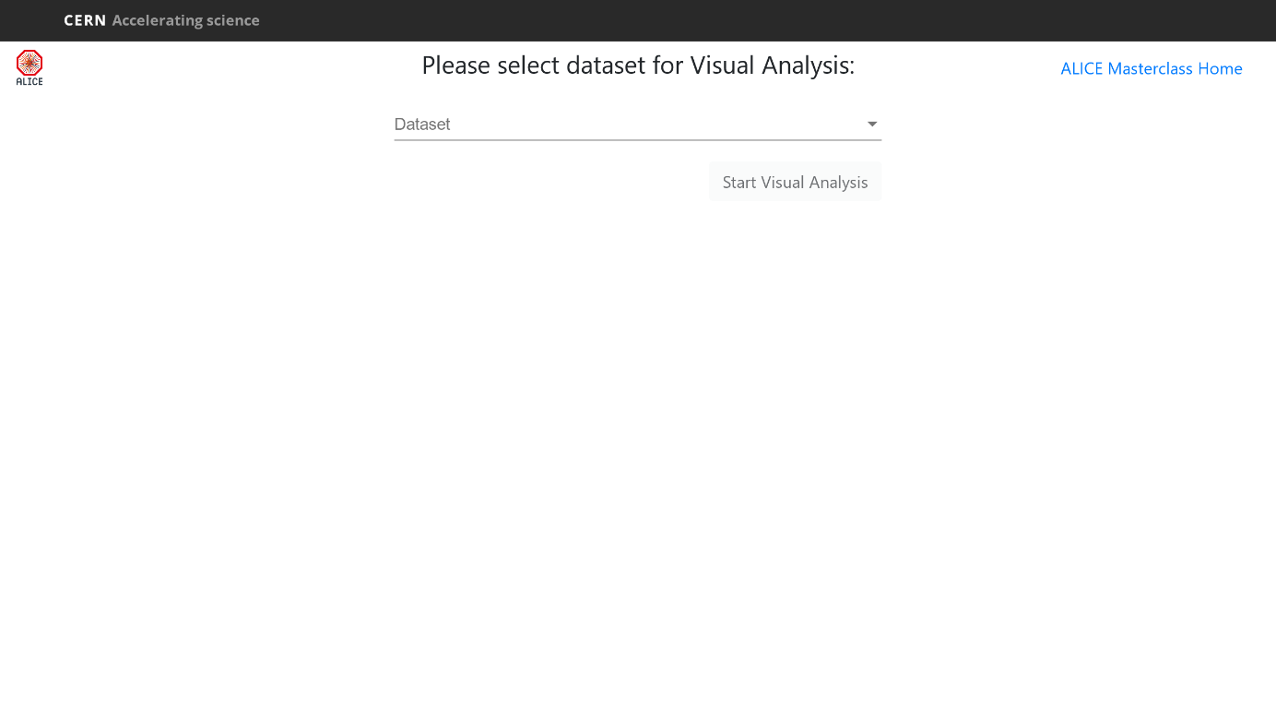

Figure 4: Dataset selection screen for the Visual Analysis

If you want to see examples of *Ks*0, Λ, anti-Λ and Ξ*−* decays, select “Demo Dataset”. Otherwise, select the dataset designated to you by your instructor. Either way, click the “Start Visual Analysis” button, which will take you to the next page, as shown in the Figure [5].

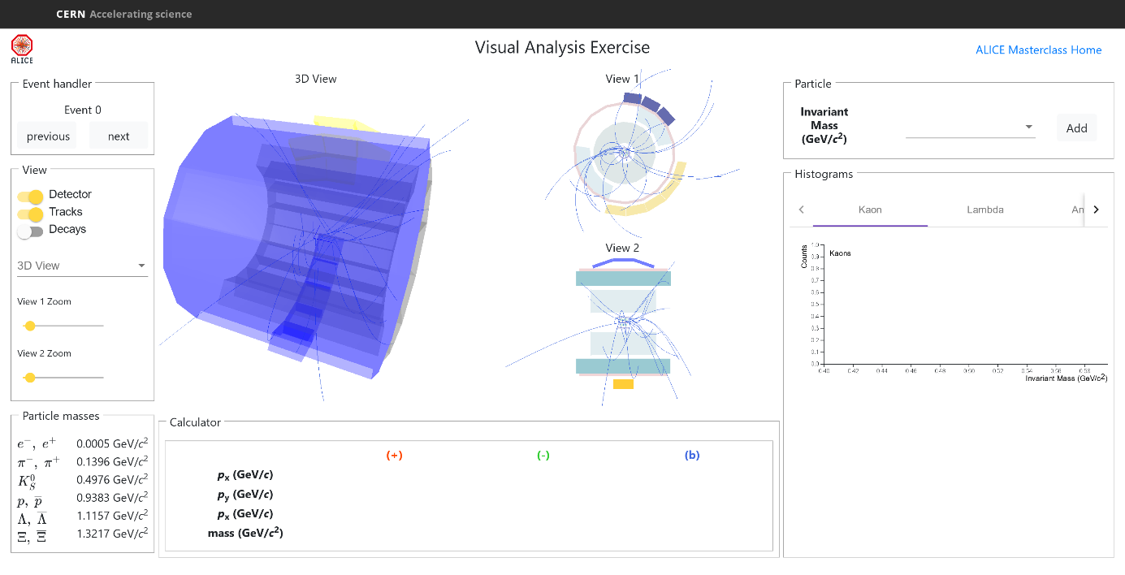

Figure 5: Dataset selection screen for the Visual Analysis

The column on the left offers a number of options: Event Navigation, selection of what is displayed (detector geometry, tracks, decaying particles), visualisation adjustments and a particle mass cheat sheet. The event display shows three views of the ALICE detector (3-dimensional view, *rϕ* projection and *rz* projection). You can select the information displayed for each event. If you click on the relevant box, you see all tracks of the event; if you click the Decays box, the V0s (and Cascades) are highlighted, if they exist. Once a V0 is found, the rest of tracks of the event can be removed from the display so that only the tracks associated with the V0 are shown. The colour convention is that positive tracks from V0s are red, negative tracks are green (and “bachelors”, in the case of cascades, blue).

By clicking on each track (of the V0 or Cascade) the values of the momentum components and the particle mass, (the one with the maximum probability, from the particle identification algorithms) are automatically copied to the calculator (located under the event display views). After clicking on both tracks (for V0s) or all three tracks (for Cascades) the invariant mass of the mother particle is automatically calculated using the formula explained in the previous section (in the “Particle” box, in the upper-right corner).

The program includes four invariant mass histograms (for *Ks*0, Λ, anti-Λ and Ξ*−*). After inspecting each V0 decay you can identify the mother particle from the decay products and the invariant mass value (a reference table with the masses of some particles is given in the cheat sheet on the left). You can then select the relevant option from the drop-down menu and press “Add” button. In this way you add an entry to the corresponding histogram. The invariant mass histograms are displayed underneath the “Particle” box.

**9 Exercise 1 - Analyse events and find the strange hadrons**

The analysis part consists of the identification and counting of strange particles in a given event sample, typically containing 30 events. When starting the exercise, you should select the dataset that you will analyse. Currently there are 19 different datasets with data from proton proton collisions at 7 TeV centre-of-mass energy. When looking at each event display, you initially have to click on clusters and tracks; you can observe the complexity of the events and the high number of tracks produced by the collisions inside the detectors. Most of these tracks are pions. By clicking on “Decays” box the tracks from V0 decays - if any - and cascade decays – if any – appear highlighted. From the V0 topology you can try to guess what the mother particle is. From the decay products you can already guess what the mother particle is; to confirm it, you calculate the invariant mass as described in Section 8 and compare its value with the values on the table of your calculator.

* If the mass is 497 MeV *±*13 MeV (in the interval [484, 510] MeV) it is a *Ks*0.
* If the mass is 1115 MeV *±*5 MeV (in the interval [1110, 1120] MeV) and the daughter particles are a proton and a negative pion then it is a Λ.
* If the mass is 1115 MeV *±*5 MeV (in the interval [1110, 1120] MeV) and the daughter particles are an antiproton and a positive pion then it is an anti-Λ.
* For a cascade decay, if the mass calculated from the 3 tracks is 1321 *±*10 MeV (in the interval [1311, 1331] MeV) then it is a Ξ*−*.

Depending on the outcome, you select the relevant option from the drop-down menu and press “Add” button. In this way this entry is added in the corresponding invariant mass histogram. It can happen that the calculated mass does not correspond to any of the above values; this is “Background”: the tracks appear as coming from a secondary vertex, but in this case the vertex has been misidentified. For the purpose of this exercise, we will ignore these V0’s.

**10 Exercise 2 - Large statistics analysis**

The event display is a powerful tool which helps check the quality of the data and their reconstruction and gives a “feeling” of what events look like. However, in real life data analysis is not done visually –– that would be far too tedious and time-consuming. To analyse the millions of events that we collect daily at the LHC we run programs, and this is what you will do here, in order to look for V0s in a bigger event sample.

Open the MasterClass home page as before, but now select the “Large Scale Analysis” button. In the opened page you should select one of the available particles (*Ks*0, Λ or anti-Λ) and then one of the centralities. After clicking “Plot Invariant mass” button, you should be presented with a view similar to Figure [6].

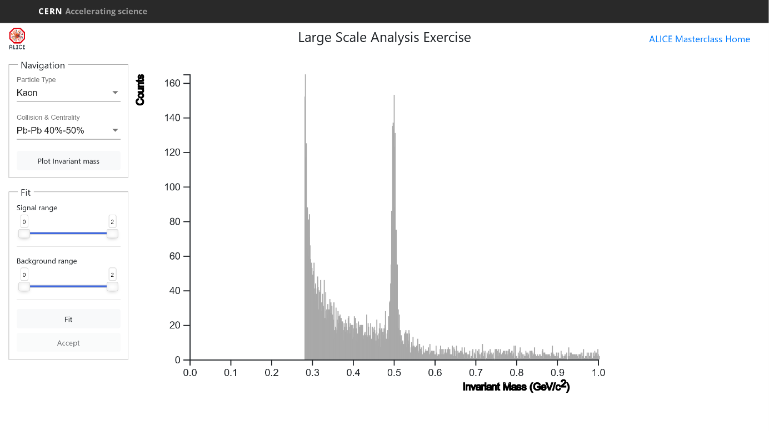

Figure 6: Main window of the Large Scale Analysis

You will now analyse recordings from hundreds of events at once. You can see that the invariant mass is a continuous distribution – this is because the pairs of pions combined are random, not coming from a common secondary vertex and can give any value of mass. Most of them are background.

In order to find the number of particles of a certain type, for example *Ks*0, you need to find the number of events in the peak after background subtraction. In order to fit a curve (second degree polynomial) to the background, you first choose the fit range using the slider. To fit a Gaussian distribution to the signal you also have to select the range of the peak. When you click on “Fit”, the fitted functions are superimposed on the histogram and you can check visually whether the fit is reasonable. If you think the fitted functions match the data well, you can push the “Accept” button. On the histogram; after clicking the “Accept” button, you will get the total number of events in the peak, the number of back-ground events and those which are signal.

1. **Find** K0s**,** Λ**, anti-**Λ **in PbPb collisions in different centrality regions**

When studying heavy ion collisions, we often classify the events in different classes, according to the centrality of the collision.

The lead nucleus is much bigger than the proton and this leads to differences in how the particles collide. In the case of proton-proton there is only one kind of collision while lead collisions are differentiated by the size of the region of each nucleus that overlap.

To see the difference between proton-proton and lead-lead collisions we first define different event classes for heavy ion collisions. One of the criteria used is the collision centrality, which is related to the impact parameter (the distance between the colliding nuclei perpendicular to the beam axis). However, this parameter is not directly measurable. One of the ways in which ALICE determines the centrality of the events is from the signal amplitude in the VZERO counters (2 arrays of plastic scintillators placed at +330 cm and -90 cm from the interaction point). This is shown in the Figure [7b]. Quantitative estimate of the collision centrality is given by the number of participating nucleons Npart (shown in red in the Figure [7a]).

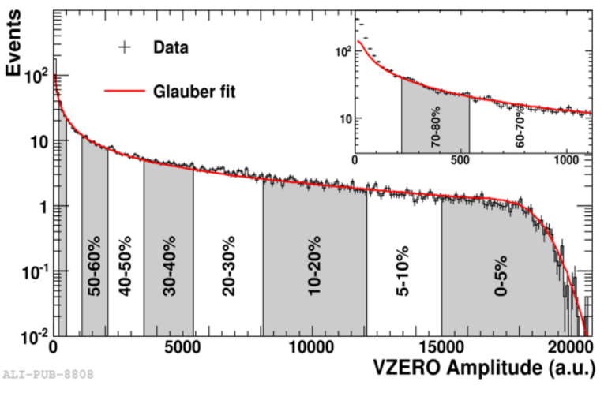

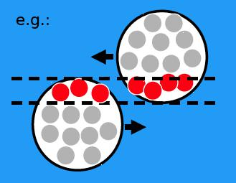

(a) Illustration of the PbPb collision (b) VZERO counters graph

Figure 7: Illustrations for Npart and centrality

**12 Calculation of particle yields**

Once you have found the number of *Ks*0, Λ, anti-Λ you can calculate the yield (number of particles produced per interaction) for each type of V0. To do this you need additional information which will be given to you after you have finished the analysis (for example: tracking efficiency for each type of particle; number of events from which the sample you analyse has been extracted).