java.lang.IllegalStateException: Failed to load ApplicationContext

org.apache.ibatis.builder.BuilderException: Error parsing Mapper XML. The XML location is 'com/atbj/mapper/StudentMapper.xml'. Cause: org.apache.ibatis.builder.BuilderException: Error resolving class. Cause: org.apache.ibatis.type.TypeException: Could not resolve type alias 'Student'. Cause: java.lang.ClassNotFoundException: Cannot find class: Student

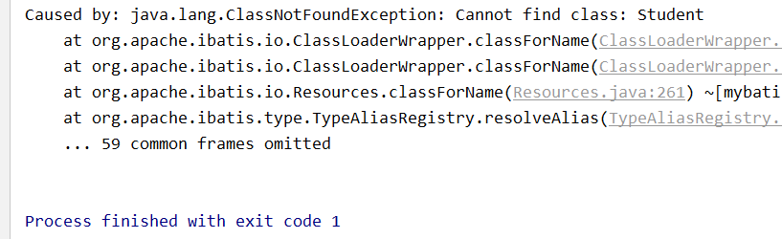

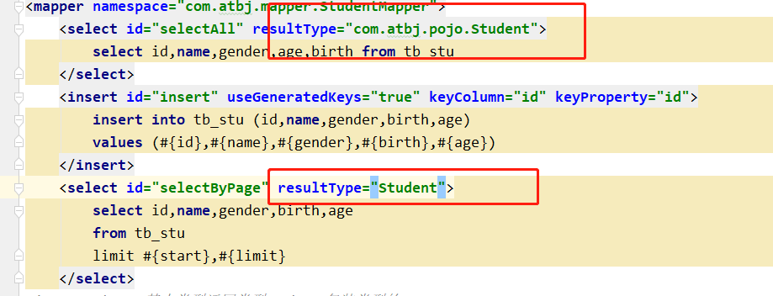

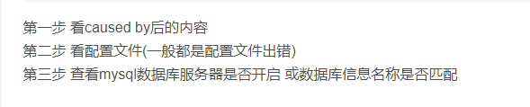

**没有配置类型别名直接使用了Student，所以说找不到Student类**

Caused by: org.springframework.beans.factory.NoSuchBeanDefinitionException: No qualifying bean of type 'com.atbj.mapper.StudentMapper' available: expected at least 1 bean which qualifies as autowire candidate. Dependency annotations: [{@org.springframework.beans.factory.annotation.Autowired(required=true)}](mailto:%7b@org.springframework.beans.factory.annotation.Autowired(required=true)%7d)

**没有加@mapper注解或者没有定义在主类上@MapperScan（扫描mapper接口的注解）。**

**空指针异常 ：有可能是传的参数有问题，（名字不一致等）**

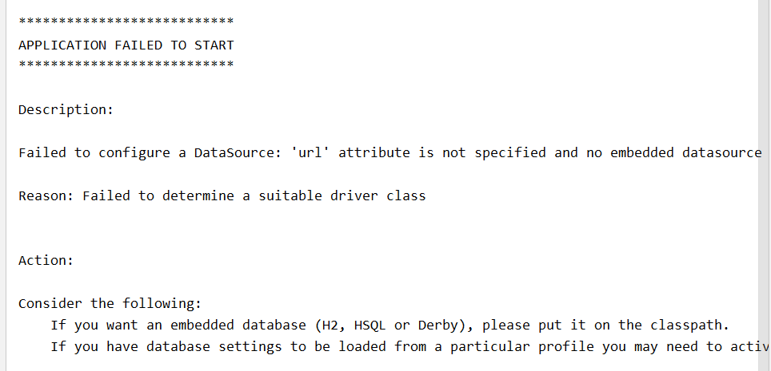

**数据源出现问题，application.yml出现问题。或者pom包导入的不对，仔细查看。**

|  |
| --- |
| **org.springframework.beans.factory.BeanDefinitionStoreException: Invalid bean definition with name 'eurekaClient' defined in classpathresource[org/springframework/cloud/netflix/eureka/EurekaClientAutoConfiguration$RefreshableEurekaClientConfiguration.class]: @Bean definition illegally overridden by existing bean definition:**    **启动类的命名错误，不能是EurekaClient, Spring-cloud-eureka** |