Web Technologies  
WorldSkills 2024 National Competition  
HUNGARY

Final

Competition Description

Submitted by:

Skills IT

**Contents**

1. Introduction 3
2. About the Ultrabalaton (UB) Running Fest 3
3. Description of the modules 4
4. Submitting your source code and deploying your work 5
5. Database 6
6. General information for all modules 6

# Introduction

You used to work as a freelance web developer, but now you've applied for a job as a developer at a large software development company. The company's management wants to test your skills, so as part of the recruitment process, they asked you to develop a prototype web application for the Ultrabalaton (UB) Running Fest.

In the first round of the recruitment process, you were asked to develop a prototype of the information page for the festival and the stage calculator for the team category. You have successfully completed this round, as you have been selected from more than 100 applicants to be one of the 6 people who will be tested by the management with a new task.

In the second round, you faced more serious challenges. You had to prove your place among the best in a 6-hour full stack task. Congratulations on successfully completing this challenge.

This two-day final test will show whether the company will hire you.

# About the Ultrabalaton (UB) Running Fest

The Ultrabalaton Running Fest is an annual running event in Hungary that encircles Lake Balaton which is the largest freshwater lake in Europe. The race can be completed as a team or as an individual runner and has a 32-hour time limit. Runners traversing a distance of 221 kilometers, which is more than 5 marathon distances.

The Ultrabalaton course covers a diverse range of terrain, including forests, fields, hills, and the shores of Lake Balaton. The route has 54 checkpoints where runners must check in to verify their progress. The race must also be completed at night, so runners must be equipped with appropriate gear, including headlamps and reflective vests.

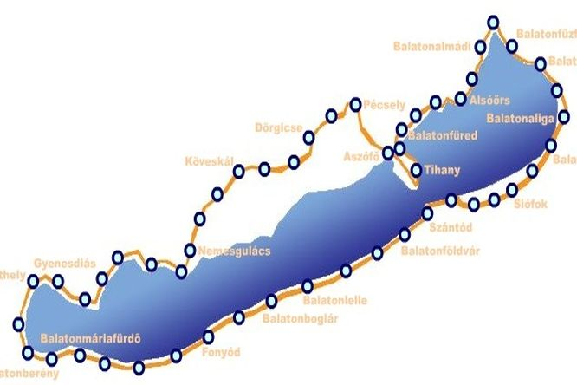

In the team category, each team is made up of up to 14 members, who take turns to run each section of the 54-stage course. At the checkpoints, team members exchange running duties by passing the baton to the next runner. The team members must work together and coordinate their efforts to complete the race within the 32-hour time limit. This team format adds an element of strategy and teamwork to the race, making it a unique and challenging experience for participants.

The Ultrabalaton running race is very popular among runners and presents a challenge to those who want to test their limits and endurance. The course is unique and provides runners with stunning views of Lake Balaton and the surrounding region's cultural and historical landmarks. The Ultrabalaton race also provides runners with the opportunity to appreciate the natural beauty of Lake Balaton and the region's cultural and historical landmarks.

# Description of the modules

In this round, you have to prove your skills in 4 different modules. All of them focus on the Ultrabalaton team race. (Individual runners are not covered in this competition.)

Each module gives you new exercises on the topics covered in the first two rounds. Some of them will be completely new and some will be improved versions of the tasks from the previous rounds of this competiton.

* Module A
  + Topic: Speed Test
  + Duration: 1 hour
  + Description: This module will test your ability to apply your knowledge of HTML, CSS and Javascript effectively and creatively. You will be asked to complete several tasks in 1 hour. There will be some easy, routine tasks and some more complex, thought-provoking tasks. You can typically spend 5-15 minutes on each task.
* Module B
  + Topic: HTML/CSS Design and Implementation
  + Duration: 3 hours
  + Description: In this module you have to design and build a website. You can only use HTML and CSS, not Javascript.
* Module C
  + Topic: Backend & admin
  + Duration: 3 hours
  + In this module you have to create a REST API backend and an admin application for a fullstack application. The REST API backend can be built in PHP/Laravel or Node.js/Express. To build the admin interface you can use a JavaScript framework (with our fully functional REST API backend) or PHP/Laravel with SSR (Server Side Rendering) technology.
* Module D
  + Topic: Frontend
  + Duration: 3 hours
  + Description: In this module, you will build a mobile optimized web application that communicates with our fully functional REST API backend using REST API technology. You can use JavaScript framework (or vanilla JS) to build the application.

# Submitting your source code and deploying your work

You will use a virtual machine during the competition, which will be available to you at   
**ub2023-YY.hu** via ssh with the **competitor** username and **qwe123** password. The **www** folder in the home folder will be your working directory. **Only work uploaded here will be evaluated!**

You can also reach the www folder on your Windows workstation as a network drive with the drive name **z:**, so you don't necessarily need to use ssh access.

The structure of the www folder (01 is replaced by your own workstation number):

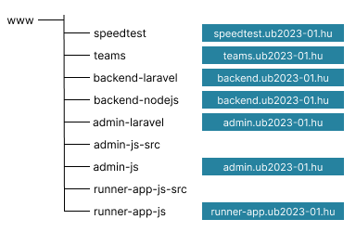

As you can see that the contents of speedtest, backend-laravel, backend-nodejs, admin-laravel, admin-js and runner-app-js folder are available as virtual webhosts.

* **Module A – Speedtest (speedtest.ub2023-YY.hu):**
  + For the speedtest, you will need to place the HTML/CSS/JS code for each task in the appropriate subfolder.
* **Module B – UB2023 Team Site (teams.ub2023-YY.hu):**
  + The teams folder contains the HTML/CSS code of the team site
* **Module C - REST API backend (backend.ub2023-YY.hu):**
  + The backend-laravel folder contains the code of the REST API backend, if the backend is created in Laravel.
  + In the backend-nodejs folder, you should place the source code for the REST API backend if you are building the backend with Node.js/Express.
* **Module C - Admin app (admin.ub2023-YY.hu):**
  + In the admin-js folder, you need to copy the built code if you are building the admin application as a REST API client using Javascript framework. The source code for the applications should be in the admin.js-src folder.
  + The admin-laravel folder contains the code of the admin site, if this site is created in Laravel SSR technology.
* **Module D – Runner app (runner-app.ub2023-YY.hu:**
  + In the runner-app-js folder, you need to copy the built code of the Runner app. The source code for the applications should be in the runner-app-js-src folder.

**Note:** For Laravel projects, **php artisan** commands can be used on the Windows host.

# Database

Your database server can be reached using **db.ub2023.hu** hostname. The available user is **root** and password is **password**.

You can use two different external tools for handling the database:

* **PHPMyAdmin** via[**http://pma.ub2023-YY.hu**](http://pma.ub2023-YY.hu)
* **mysql** command line tool on your Windows workstation

# General information for all modules

* You can use any resource in the assets folder unless the task does not explicitly specify which tools you can use.
* Clean code and user interface accessibility are also important considerations.
  + Please use semantic elements in HTML files wherever possible.
  + Provide the necessary amount of comments in your HTML, CSS and JS files.
  + Check accessibility using the Axe browser extension.
* The application must work with at least the latest versions of Google Chrome and Firefox.