HW5-Report

Wenbo Song

ws2505

Problem 1

a ) The top 25 teams and their corresponding values in wt for t = 10,100,1000,10000 are

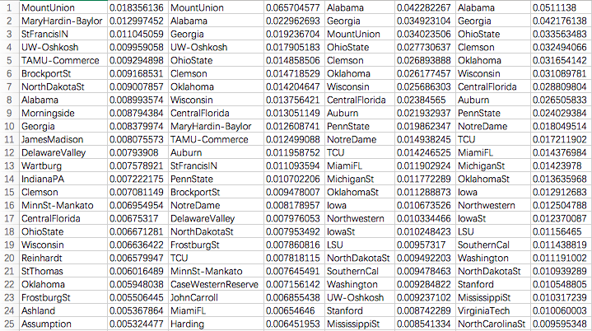

b )

Plot||wt –w || as a function of t for t = 1,...,10000.

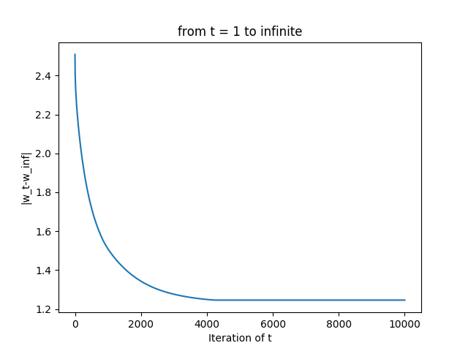

Problem 2

a ) Implement and run the NMF algorithm on this data using the divergence penalty. Plot the objective as a function of iteration.

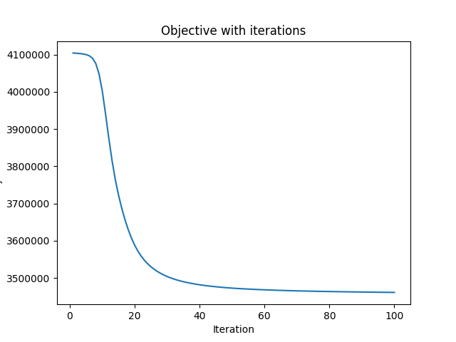

b ) After running the algorithm, normalize the columns of W so they sum to one. For each column of W, list the 10 words having the largest weight and show the weight. The ith row of W corresponds to the ith word in the “dictionary” provided with the data. Organize these lists in a 5 × 5 table.

