UNICEF Consultancy Assessment Report

# Introduction

This report presents a data-driven assessment of two essential maternal health indicators: **Antenatal Care (ANC4)** and **Skilled Birth Attendance (SBA)**. The analysis focuses on understanding how coverage levels differ over time across countries grouped by their **Under-5 Mortality Rate (U5MR) progress status**: *Achieved*, *On Track*, and *Acceleration Needed*. By visualizing trends and comparing weighted averages based on annual births, this report highlights disparities and informs policy interventions that can accelerate progress toward global child health goals.

These groups show how well each country is doing in terms of achieving the **Sustainable Development Goal (SDG)** objective for under-five mortality, which is 25 deaths per 1,000 live births by 2030. While Acceleration Needed indicates countries who are off-track and need to make faster progress, countries that have Achieved the target or are On Track to accomplish it are those with better child survival results.

## Data Sources:

This assessment integrates multiple data sources to enable robust, population-weighted analyses. National coverage estimates for ANC4, and SBA were sourced from UNICEF’s global maternal and newborn health coverage databases. The number of live births per country was obtained from the WPP 2022 dataset. Lastly, country classifications for progress toward the Sustainable Development Goal (SDG) target on under-five mortality (U5MR) – categorized as Achieved, On Track, or Acceleration Needed – were based on data provided by UNICEF. These datasets were cleaned and harmonized to ensure consistency, including aligning country identifiers, selecting comparable years (primarily 2018–2022), and addressing missing values. This combined set of data is used to calculate population-weighted values and determine the significance of trends across countries.

# Findings and Interpretation of Coverage Comparisons

Both **ANC4** and **SBA** coverage are consistently much greater in countries that have *Achieved* or are *On Track* to reach the U5MR objective. In comparison, coverage is significantly lower in countries that are categorized as *Acceleration Needed*. This service coverage discrepancy highlights an equity divide linked to child mortality outcomes. This gap in service coverage highlights an equity divide correlated with child mortality outcomes.

## Antenatal Care (ANC4) Coverage

The 2022 population-weighted analysis of ANC4 coverage reveals notable disparities across U5MR progress categories. Countries that have already Achieved the under-five mortality target exhibit the highest ANC4 coverage at 90.8%, reflecting strong access to essential prenatal care services. In contrast, countries in the Acceleration Needed category report a lower but still substantial coverage rate of 72.9%, suggesting ongoing gaps in service availability or uptake. Most unexpectedly, On Track countries display the lowest weighted ANC4 coverage at 45.5%, a counterintuitive result given their classification as progressing toward the U5MR goal. This discrepancy may point to structural weaknesses in maternal health service delivery, data limitations, or a lag between maternal care investments and observed child mortality outcomes.

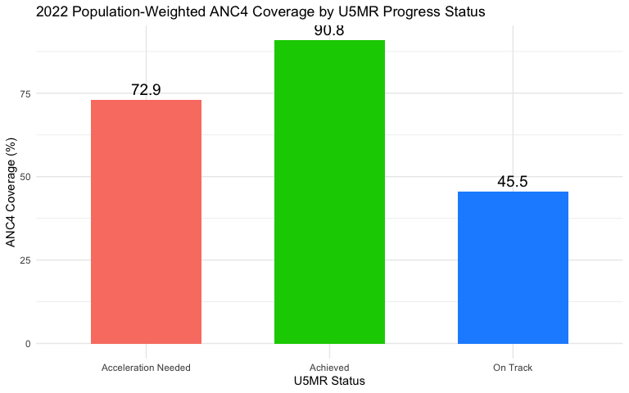

**Interpretation:** Countries that have Achieved U5MR targets show the highest population-weighted ANC4 coverage, suggesting robust maternal health systems. While countries labeled *Acceleration Needed* still fall behind, they outperform *On Track* countries in this specific indicator, a counter-intuitive finding that may reflect limitations in service delivery data, differences in programmatic emphasis, or recent fluctuations in coverage trends.

**This pattern highlights a critical insight**: U5MR progress does not always align with antenatal care coverage. Some “On Track” countries may be improving child survival through targeted neonatal interventions or other health system strategies, while still struggling to scale up comprehensive ANC services. This divergence underscores the need for a multi-dimensional approach to maternal and child health, ensuring that progress on under-five mortality is not decoupled from sustained investments in maternal care.

## Skilled Birth Attendance (SBA) Coverage

The 2022 population-weighted analysis of Skilled Birth Attendance (SBA) coverage similarly highlights disparities across U5MR progress categories. Countries that have Achieved the under-five mortality target report the highest SBA coverage at 95.9%, reflecting near-universal access to skilled delivery care. *Acceleration Needed* countries follow with a moderately high rate of 87.7%, suggesting progress but continued challenges in ensuring consistent access to professional care during childbirth.

Unexpectedly, *On Track* countries report the lowest weighted SBA coverage at 71.6%, which is inconsistent with their classification as making adequate progress toward U5MR targets. This may reflect delayed investment in maternal health systems, data gaps, or a disconnect between service delivery and mortality outcomes. These findings reinforce the critical importance of targeted policy and programmatic interventions — especially in “On Track” and “Acceleration Needed” countries — to scale up skilled birth attendance and reduce maternal and neonatal health risks.

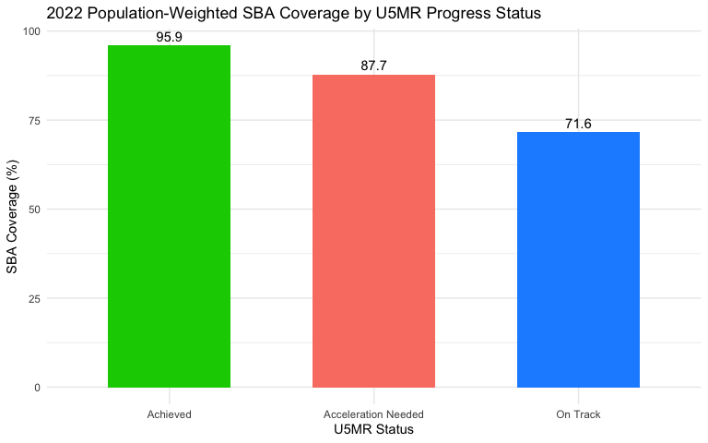

**Interpretation:** In 2022, population-weighted SBA coverage was highest in countries that had Achieved U5MR targets (95.9%), followed by *Acceleration Needed* countries (87.7%), and lowest in *On Track* countries (71.6%). This unexpected pattern suggests that while Achieved countries have maintained strong maternal health systems, *On Track* countries may be facing hidden service delivery gaps despite progress in child mortality outcomes. The relatively strong performance of *Acceleration Needed* countries may reflect focused global efforts or recent health investments. These disparities highlight the need to align service coverage improvements with mortality reduction goals to ensure sustainable and equitable maternal care progress.

## Summary Table: ANC4 and SBA

Overall, the comparative analysis reveals a persistent equity gap in maternal health coverage across U5MR progress categories. Even when adjusting for population size through birth-weighted averages, countries requiring accelerated progress on under-five mortality (Acceleration Needed) consistently report lower service coverage. In 2022, ANC4 and SBA coverage in these countries stood at 72.9% and 87.7%, respectively—substantially below the rates seen in countries that have Achieved U5MR goals (90.8% for ANC4 and 95.9% for SBA).

Surprisingly, countries classified as On Track show the lowest weighted ANC4 (45.5%) and SBA (71.6%) coverage. This counterintuitive finding may reflect limitations in service delivery or data availability, despite their progress in reducing child mortality. These results underscore the importance of not equating mortality improvements with health system strength and reveal a potential misalignment between outcome indicators and service access metrics.

The use of population-weighted averages enhances the policy relevance of this analysis, reflecting conditions experienced by the majority of mothers and newborns. For example, off-track countries—often in sub-Saharan Africa or South Asia—account for a large share of global births, yet lag significantly in essential maternal care. Improving ANC4 and SBA coverage in these settings remains critical for sustainable progress.

In summary, countries that have achieved U5MR targets demonstrate the strongest maternal health coverage, while those still progressing—especially On Track countries—require renewed attention to ensure that service access aligns with survival gains.

Weighted ANC4 and SBA Coverage by Year and U5MR Status

| Year | Status | ANC4 (%) | SBA (%) | # Countries |
| --- | --- | --- | --- | --- |
| 2022 | Acceleration Needed | 72.9 | 87.7 | 7 |
| 2022 | Achieved | 90.8 | 95.9 | 6 |
| 2022 | On Track | 45.5 | 71.6 | 2 |

# Key Findings

1. **ANC4 Coverage Patterns**:

* In 2022, countries classified as Achieved reported the highest population-weighted ANC4 coverage at 90.8%, indicating near-universal access to antenatal care.
* *Acceleration Needed* countries followed with 72.9%, reflecting moderate but still insufficient coverage.
* *On-Track countries* reported the lowest ANC4 coverage at 45.5%, a surprising finding that highlights potential service delivery gaps despite their progress in child mortality outcomes.

1. **SBA Coverage Patterns**:

* SBA coverage shows a similar gradient. *Achieved* countries had the highest population-weighted SBA coverage at 95.9%, followed by Acceleration Needed at 87.7%, and On Track at 71.6%.
* These findings reveal that even among countries progressing toward U5MR targets, gaps in skilled birth attendance persist—particularly in the On Track group.

1. **Coverage Gaps by U5MR Status**:

* There is a clear disparity in both ANC4 and SBA coverage across U5MR progress categories.
* Despite some improvements, countries requiring acceleration continue to lag significantly in access to essential maternal health services, indicating structural inequities and capacity constraints.

1. **Weighted Analysis Insights**:

* By using population-weighted averages, this analysis provides a more representative picture of maternal health service access, emphasizing the real-world experience of women and children.
* Countries with larger birth cohorts (often those needing acceleration) have an outsized influence on global progress, reinforcing the urgency of targeted investments in those contexts.

# Conclusion

The analysis highlights persistent disparities in maternal health service coverage across U5MR progress categories. While countries in the Achieved group consistently demonstrate high ANC4 and SBA coverage, those in the Acceleration Needed category continue to lag behind, even as incremental gains are observed. Surprisingly, coverage in some On Track countries remains lower than expected, particularly for ANC4. By using birth-weighted averages, this assessment offers a more accurate reflection of the real-world impact, emphasizing that countries with larger populations disproportionately shape regional trends. These findings underscore the need for targeted policy interventions and resource allocation to close service delivery gaps in under-performing contexts and ensure that progress in maternal health is both equitable and impactful.

# References

* UNICEF Data. (2024). Skilled Attendance at Birth and Antenatal Care Data. <https://data.unicef.org/topic/maternal-health/antenatal-care/>
* UNICEF. (2024). Tracking Progress Towards Under-Five Mortality Targets. UNICEF Data Portal. <https://data.unicef.org/topic/child-survival/under-five-mortality/>
* UNICEF. (2024). Global Databases on Child Health Coverage and Mortality Classifications.
* United Nations. (2022). World Population Prospects 2022. Department of Economic and Social Affairs, Population Division. <https://population.un.org/wpp/>