**Instructions: Managing the Backend of the WSBF Website**

The Clemson University student-run radio station (WSBF) uses its websites for many administrative purposes. These instructions are intended to help new computer engineers at the station learn how to perform these various web-related duties which are unique to WSBF and its websites, including managing the “fishbowl” system and adding PSAs to the cart machine. Before attempting these tasks alone, the new computer engineer should have some previous experience using databases, managing remote file systems, and developing websites. Contact the previous computer engineer for all password information.



**WARNING: Placing lewd or vulgar content on the website may prompt severe punishment from the Clemson Board of Trustees or the FCC!**

**Operating the Fishbowl Ranking System**

The senior staff members of the radio station use the “fishbowl” system at the start of each semester to rank DJs (based on quality) and determine an order in which DJs will be allowed to select weekly show times for the semester.

1. Visit he fishbowl preparation webpage (http://new.wsbf.net/wizbif/fishbowl/fishbowl_clear_table.php) and click the button that says “Move!” This action will clear the “fishbowl” table in the database and move its data (entries from last semester’s fishbowl process) to the “fishbowl_log” table, which stores all previous semesters’ fishbowl data.

*Note: So that station’s sensor staff has the time to rate the DJs’ fishbowl applications, make sure that the application deadline is before the senior staff meeting on the night of show picks.*

1. Using the file system, open the fishbowl configuration file (/var/www/wizbif/fishbowl/fishbowl_config.php) with a text editor. Select whether to use the ‘spring’ or ‘fall’ version of the application. Indicate a date from which to start the count of DJs’ CD reviews and indicate a deadline for DJs to finish their fishbowl applications. Save the changes.
2. Open the main menu page of the website (/var/www/wizbif/submit_login.php) from the file system and add a hyperlink (as shown below in Figure 1) so that logged-in DJs can access the fishbowl application page (http://new.wsbf.net/wizbif/fishbowl/fishbowl_app.php)

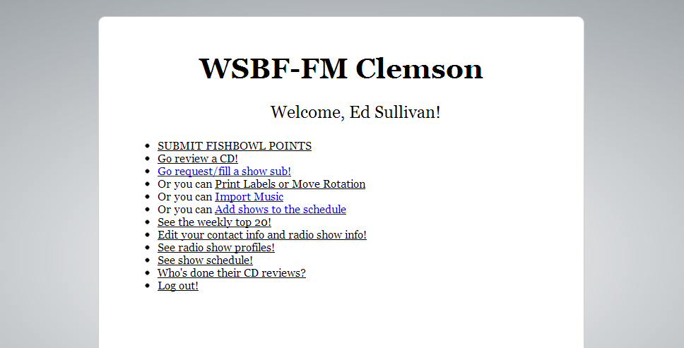

New hyperlink

Figure : Main menu for DJs on the WSBF website with a link to the fishbowl system

1. Email all the active DJs and tell them that they are required to fill out their applications (http://new.wsbf.net/wizbif/fishbowl/fishbowl_app.php) by the deadline.
2. After the fishbowl deadline has passed, tell all the members of the senior staff that they each must rate all the fishbowl applications by visiting the evaluation webpage (http://new.wsbf.net/wizbif/fishbowl/fishbowl_review.php).
3. Once all the members of the senior staff have judged the fishbowl applications, visit the results webpage (http://new.wsbf.net/wizbif/fishbowl/fishbowl_print.php) to see the order in which DJs should be allowed to select show times. The highest class (5) will contain the names of the highest-rated DJs-—they receive first priority when picking their weekly show times for the semester. The order of DJs within a single fishbowl class is random.

**Adding Public Service Announcements (PSAs) and Underwritings to the Cart Machine**

The DJs in the studio use the “cart machine” to play commercials, public services announcements, and similar non-musical audio clips over the air.

1. If the audio file is not an MP3, visit a free file-conversion website (e.g., http://media.io) to convert the audio file to an MP3 format.
2. Using the file system, place the MP3 file in the /var/www/wizbif/ZAutoLib/carts folder.
3. Log into the database (http://new.wsbf.net/phpmyadmin/), use the left-hand panel to open the “def_cart_type” table, and determine the type ID of the audio file. For example, type “1” refers to underwritings while type “7” refers to show sweeps.
4. Navigate to the “libcart” table using the left-hand panel and select the “Insert” tab at the top of the page. In the “Value” column of the form, leave the “cartID,” “play_mask,” and “issuer” fields blank. Select start and end dates to air the PSA, choose the cart type determined in the third step, enter a descriptive title to appear on cart machine, and enter the filename without any path information (e.g., “newPsa.mp3”). When finished, click the “Go” button. A completed example of the form is below in Figure 2.

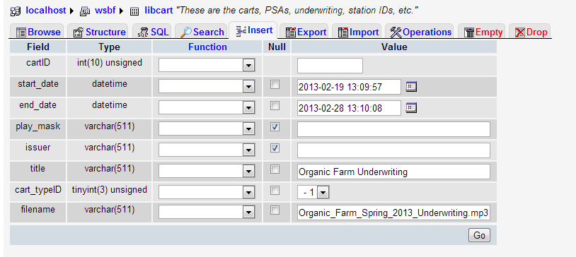

Filename without path

Leave blank

Figure : The database form for inserting audio files into the cart machine

1. On the cart machine in Studio A, click the “Reload” button and confirm that the new audio file appears as an option in the cart machine.

Note: Once the audio file is on the cart machine, the automation software will automatically start playing it (if it is a PSA or underwriting) roughly once per two hours. There is currently no way to set the frequency with which automation plays certain underwritings.

1. If the new audio file is an underwriting, leave a note on the main desk in Studio A to tell DJs how often to play the underwriting. Use marker to write the note on a small piece of paper and tape it securely to the desk.

**Resetting DJs’ Account Passwords**

The current website does not have any automated way for DJs to reset their own passwords. Thus it is the task of the computer engineer.

1. When someone requests a new account password, verify that he or she is a DJ at the station. Ask for his or her name and email. Then, open the “users” table in the database and perform a search. Take note of the username. Proceed to the next step only if there is a valid entry in the database for the person.
2. Open the “password_reset” table of the database and click the “insert” tab at the top of the page. Enter the DJ’s username. For the “transaction_id” field, write a random string (up to 191 characters in length) of just letters and numbers with no spaces. Keep track of the string.

Next, select an expiration time (usually within 24 hours of the request) for the DJ to reset his or her password. Click “Go.”

1. Send an email to the DJ containing the DJ’s account username along with a link to a page where the DJ can reset his or her password. The proper link consists of the string “http://new.wsbf.net/wizbif/password/password_reset_form.php?transaction_id=” with the random transaction-id string attached to the end. Warn the DJ that the link will only remain active until the expiration time determined in the previous step.

**Troubleshooting**

Since the computer systems of WSBF are unique and since such a broad array of potential problems exists, the best troubleshooting method is to contact one or the previous computer engineers at the WSBF radio station. The recent computer engineers include:

* Edward Sullivan

240 383 0498

elsulli@g.clemson.edu

* David Cohen

864 986 0007

dcohenii@gmail.com

* Yates Monteith

803 4794747

jymonte@g.clemson.edu

* Zach Musgrave

724 244 8932

zmusgrave@gmail.com