**Executive Summary Report 1**

M1 Project

William Breckwoldt

Professor Dee Chiluiza Reyes

Northeastern University: College of Professional Studies

ALY 6000: Introduction to Analytics

**A. R Console Screenshots**

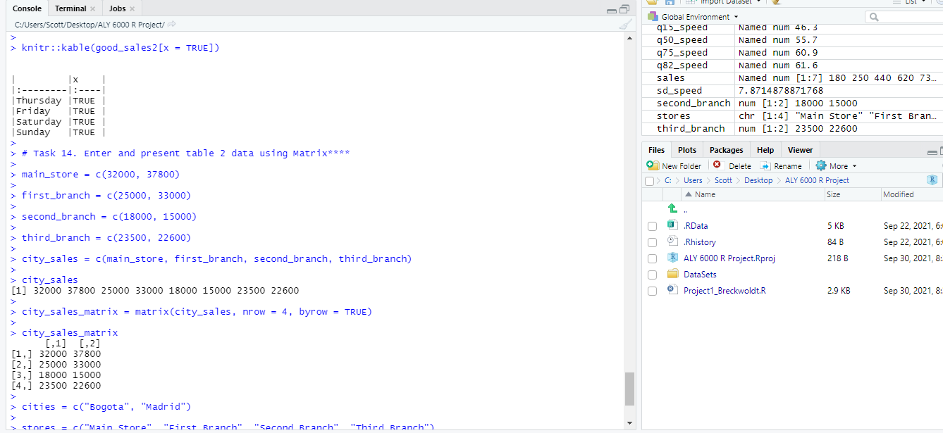

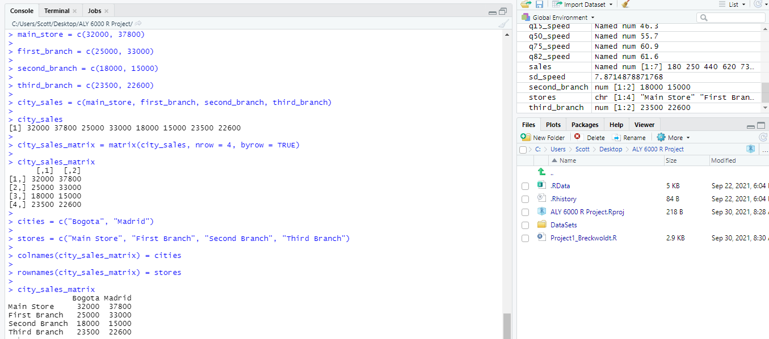

**B. Key Points**

I hope the audience understands how I obtained the descriptive statistics, filtered the data, and created tables from the vectors I created. For tasks 1 through 7, we know where our quantiles are, we can tell that our vector is negatively skewed (the mean is less than the median), our data is not very consistent (relatively high standard deviation), and we can see how adding and removing values affects our descriptive statistics. For tasks 8 through 14, we found the days of the week with the most sales and the sales of each individual store branch located in Bogota and Madrid.