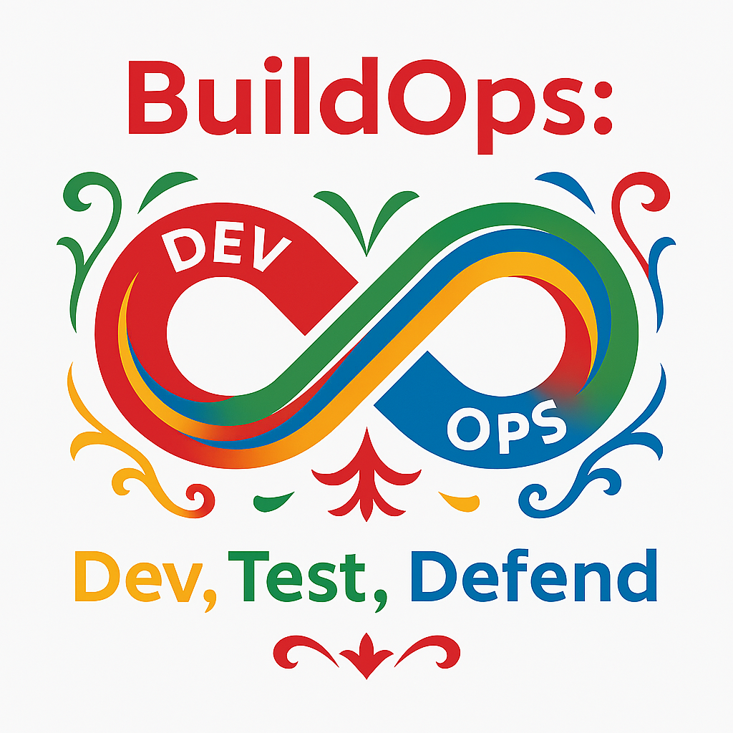Sprint Result
Mother Nature Strikes

Lightening strikes your data center, taking it offline. If this is not mitigated, you'll only get half of the work done next sprint that you would like to, as you will be restoring the machine the entire time. Thus, when planning for your next sprint, only plan for half of the PBI's that you would normally plan for.

Sprint Result
Competition Strikes

Your lead developer is hired by a new startup, Appear, Inc. to develop a new computing platform, code named Golden Delicious. The largest PBI in the previous sprint did not get completed. Adjust the order of your tasks and place arrow above the longest task, which is highest priority for the current task.

Sprint Result
No Attack

The attackers were lured by other things and other sites. Do not draw any attack cards for this sprint.

Sprint Result
Lottery Winner

You won the lottery. Your project got done early and to celebrate your boss sends you to Hawaii for a weeks vacation at a major cyber security conference. But, because you are gone, reduce the number of story points in the next sprint by 4.

