
BuildOps: Dev, Test, Defend
Player Instructions

Introduction
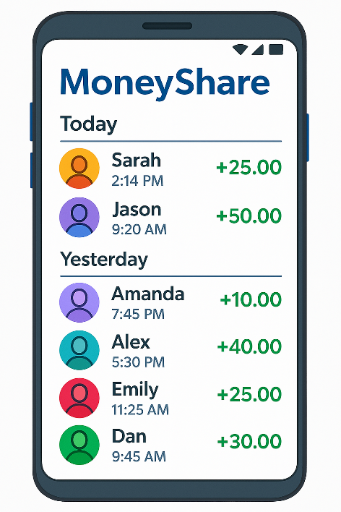
A remarkable new mobile application has recently entered the market. MoneyShare, available on both iOS and Android, enables users to seamlessly send money to one another. Aside from a $5.00 monthly fee, there are no additional charges for using the service. The app is quickly gaining popularity and has been downloaded extensively.

However, as with many startups, the development process may not have followed the most rigorous software engineering standards. While the functionality is in place and was impressively delivered by the team within a tight timeline, security features may be incomplete. As is often the case, user demand has driven a rapid push for new features—sometimes at the expense of robust security practices. And unfortunately, with all the hype, the system has also drawn the attention of potential attackers.

To evolve the application and strengthen the platform, development priorities must be set. There are Product Backlog Items (PBIs) focused on improving security, many of which are critical. There are also PBIs that introduce new features, which can drive market share and enhance user satisfaction. Complicating matters further, attacks may occur, shifting the trajectory of your sprint planning.

Game Simulation Overview
In this simulation, you’ll manage the project using two-week Agile sprints. Your objective is to decide how best to allocate your team’s efforts toward security enhancements, new features, or a strategic combination of both.

Each sprint functions as follows:
- You’ll receive a set of user story cards for the sprint.
- Each card includes:
  - An option or action to take
  - Its estimated cost (in story points)
  - An estimated value or impact
- Cards may represent:
  - Security improvements
  - Testing actions (including fixes found during testing)
  - Research tasks (which can unlock new opportunities)
  - New feature development
You begin each sprint with a budget of 11 story points. You must stay within budget—unused points do not carry over. You’ll choose which actions to take, simulate two weeks of work, and then release updated versions of both the app and its backend.

As the game progresses, new options may become available based on past decisions and research efforts. But beware: while you're busy developing, the application is live—and attackers may strike. Whether they succeed will depend on the precautions and priorities you established during previous sprints.

To keep things streamlined, the game simplifies certain real-world complexities. It skips over delays between release and deployment and assumes your development team is remarkably agile—capable of seamlessly shifting between server-side and mobile work, from coding to reviews to penetration testing.

Even more impressively, every task you undertake takes exactly the number of story points estimated as long as you choose to work on it during the sprint. The estimations are just that good.

At the end of each sprint, once you’ve deployed your release, you’ll receive feedback. Sometimes it’ll be good news. But other times… well, let’s just say there may be NASTY SURPRISES lurking.

About MoneyShare
MoneyShare is an off-bank financial app designed to give users convenient access to key money management features. As a user, you can:
- View your past transactions
- Update personal details such as your name, address, and contact information
- Transfer funds to other MoneyShare users
- Pay bills to recognized organizations (utilities, taxes, etc.)
- Send money directly to external bank accounts
- Add funds to your account using your payment card
- Buy lottery tickets without needing to go to a convenience store

The current implementation of the software follows relatively straightforward architecture. Mobile clients for both iOS and Android platforms communicate with a shared web service hosted on the MoneyShare domain. This central server uses SOAP protocols to interact with an internal database that handles all transactional data, excluding user authentication and authorization. These authentication functions are delegated to a separate identity server. Additionally, the system makes SOAP calls to external banking services for broader financial integration.

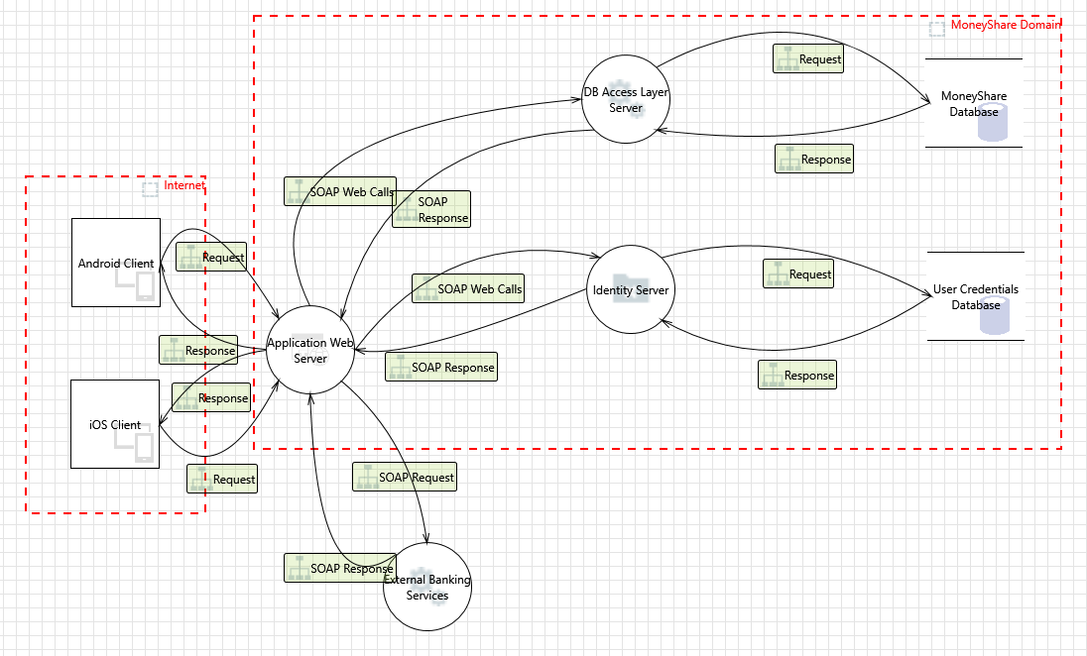
Figure 1: MoneyShare Architecture
Most of the application’s business logic resides in the web service layer, though a considerable portion is also embedded within the native mobile clients. Each mobile app is independently developed using its respective platform’s preferred native framework.

Playing the Game
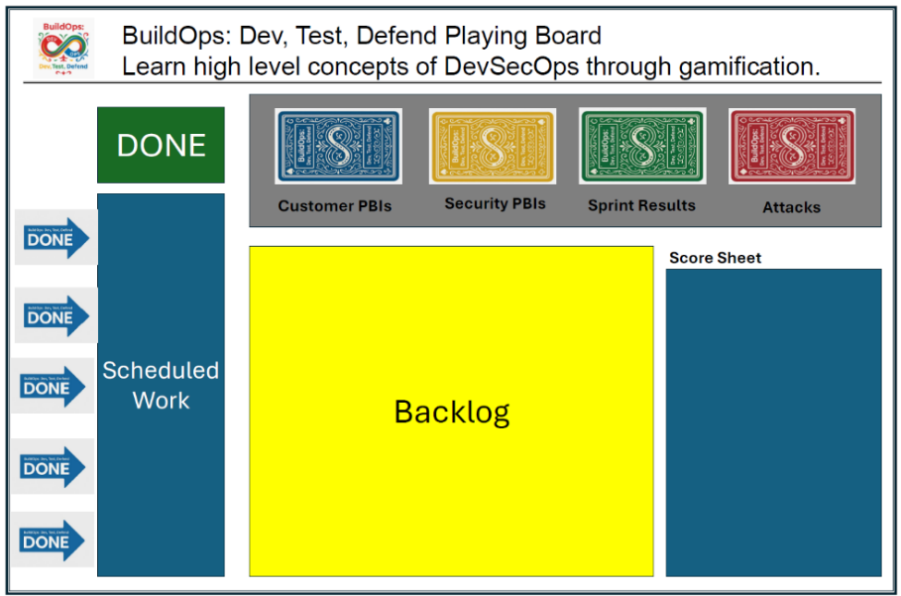
To begin, set up the playing board. There are four types of cards, each color-coded:
- Customer PBIs (Blue)
- Security PBIs (Yellow)
- Sprint Results (Green)
- Attacks (Red)

Start by sorting the cards by color.
- Customer PBIs (Blue):
  - Shuffle all these cards randomly.
  - Place them face down in the Customer PBI segment of the board.
- Security PBIs (Yellow):
  - Sort these cards by the Sprint number printed on the front.
  - First, place all cards not labeled Sprint 1 or 2 on the board.
  - Then stack the Sprint 2 cards on top of those.
  - Finally, place the Sprint 1 cards on top of the stack.
- Sprint Results (Green):
  - Shuffle the green cards randomly.
  - Place them face down in the Sprint Results segment of the board.
- Attack Cards (Red):
  - Sort by Round number:
  - Place Round 3 cards on the board in random order.
  - Stack Round 2 cards on top.
  - Finish by placing Round 1 cards on top of the stack, also randomly sorted within their group.
Lastly, place the "Done" arrow to the left side of the board. This completes your board setup.

Starting the Game
To begin the game:
- Place all Sprint 1 yellow cards (Security PBIs) face-up in the Backlog.
- Turn over two blue Customer PBIs and place them face-up in the Backlog as well.

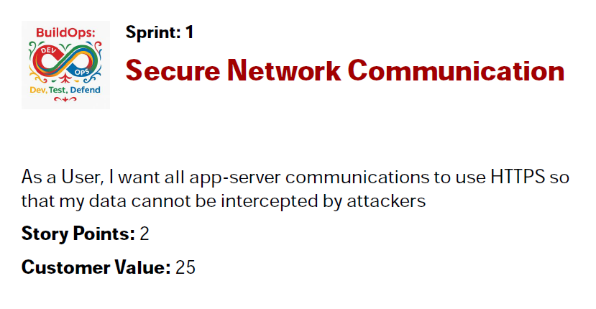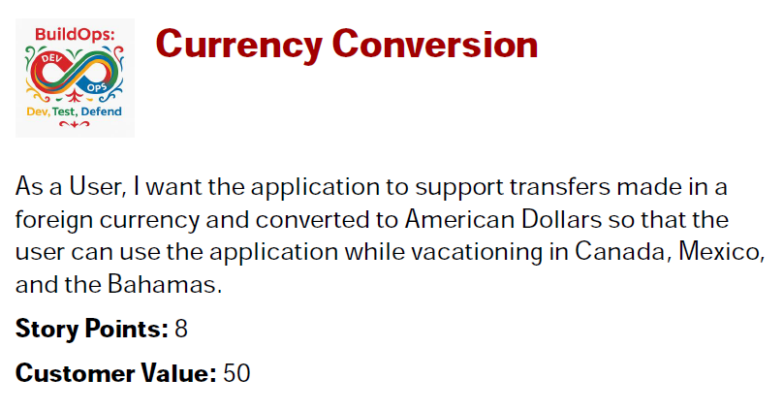
Figure 2: A Sample Security PBI and a Sample Customer PBI.

Each card includes several important elements:
- Title: Provides a high-level summary of the PBI.
- User Story: Describes the functionality or task in more detail.
- Story Points: Indicates the level of effort or complexity.
- Customer Value: Reflects the desirability or impact of the PBI from an end user’s perspective.

Sprint Planning and Execution
As a team, discuss which PBIs (Product Backlog Items) you’d like to include in your first sprint. Your primary objective is to maximize customer value—but proceed with caution. If you neglect security-related PBIs, you may suffer the consequences later in the form of system attacks.

You have a budget of 11 story points for this sprint. Choose your PBIs accordingly. Once your selections are made:
- Place the chosen user story cards face up in the Scheduled Work area of the board.
- Arrange them in order of priority, from highest to lowest, within the sprint column.

At this point, sprint planning is complete.

In a real-world project, development would begin. However, in this game, we simulate sprint results without building the actual system—so we jump straight to the sprint’s conclusion.

Reviewing the Sprint
- Reveal the Sprint Result:
  - Draw the top card from the green Sprint Results deck.
  - This card reveals what happened during the sprint.
  - Based on its outcome, place the "Done" arrow to the left of the last completed PBI.
- Record Customer Value:
  - For each completed PBI (above the Done arrow), record its customer value on the score sheet.
  - PBIs below the arrow are considered incomplete and should not be scored.
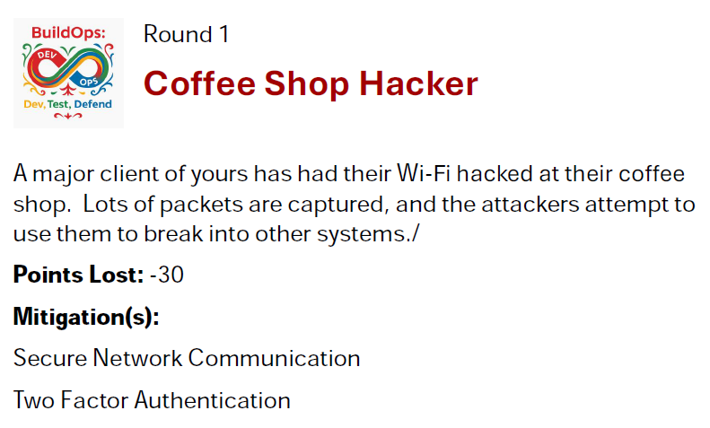
- Handle Attacks:
  - Draw two red Attack cards.
  - Each card describes an attack and lists the PBIs that mitigate it.
  - Review your previously completed PBIs:
    - If you’ve completed the required mitigation PBI(s), score 0 points for the attack.
    - If you haven’t, enter the attack’s penalty points on the score sheet.
- Calculate the Sprint Score:
  - Tally your completed customer values and any penalties from attacks to compute your net score for the sprint.

Transitioning Between Sprints
At the end of each sprint:
- Move all completed PBIs to the Done pile, keeping them face up for future reference.
- Return any incomplete PBIs to the top of the current sprint’s backlog, maintaining their existing order.

Sprint 2 Setup
If you're beginning Sprint 2, make the following updates:
- Add Sprint 2 Security PBIs to the backlog.
- If the “Server Penetration Testing” PBI was completed during Sprint 1, add the following PBIs to the backlog:
  - Encrypt & Hide Data on Server
  - Network Monitoring for Server
  - Honeytrap in Server
  - Filter Server Logs
These cards have a PT in the sprint.
- If the “Security Review of Application” PBI was completed, add the following PBIs:
  - SSL Pinning for Enhanced HTTPS Security
  - Prevent OS Keylogging via App
  - Block Outdated App Versions
  - Strengthen Login Security
These cards have an RSC in the sprint.
- Add all Round 2 Attack cards, and shuffle them together with any undrawn Attack cards from Round 1.
Now you’re ready to plan Sprint 2—follow the same process as in Sprint 1.

Sprint 3 Setup and subsequent sprint setups
If you're beginning Sprint 3, make the following updates:
- If the “Server Penetration Testing” PBI was completed during Sprint 1, add the following PBIs to the backlog:
  - Encrypt & Hide Data on Server
  - Network Monitoring for Server
  - Honeytrap in Server
  - Filter Server Logs
These cards have a PT in the sprint.
- If the “Security Review of Application” PBI was completed, add the following PBIs:
  - SSL Pinning for Enhanced HTTPS Security
  - Prevent OS Keylogging via App
  - Block Outdated App Versions
  - Strengthen Login Security
These cards have an RSC in the sprint.
- Add all Round 3 Attack cards, and shuffle them together with any undrawn Attack cards from Round 1 and 2.
Now you’re ready to plan Sprint 3—follow the same process as in Sprint 2.

Game Conclusion
The game continues until you complete 7 sprints. At the end of Sprint 7, tally your final score based on completed PBIs and the outcome of all attacks.
Credits: The concept for this game came from a game devised for a different purpose by Charles Weir, namely the Agile App Security Game.

