The Chimera
Handbook

Contributions to this manual provided by the Oswego State University CSC480/HCI521 Spring 2009 Class

SUNY Oswego CSC480/HCI521 Chimera Contributors
Faculty Advisors
Dr. James Early (Computer Science Department, SUNY Oswego)
Dr. Sashi Kanbur (Physics Department, SUNY Oswego)

Photometry Team
Scott Doherty (Team Contact: scott.doherty777@gmail.com)
Jeremy Heiler (Team Leader)
Jeremy Lombardo
Chintan Modha
Raymond Pauldine

Seeing Team
Daryl Benitez
Joe Cutro
Daron Farina
Andrew Hafner
John Kane (Team Leader; Team Contact: jkane11235@gmail.com)
Josh Sargrad

Extinction Coefficient Team
Lisette Antigua
Brandon Fink
Brandon Gilfus
Chris Guida
Kendall Moore (Team Contact: kendall8688@gmail.com)
Dawn Orlandella (Team Leader)
Dan Schlegel
Introduction
Purpose of this Book
The purpose of this book is to provide a clear and concise mini-handbook for installing and running the Chimera Software package developed by Paulo Henrique da Silva and Antonio Kanaan. Because of the scope of Chimera, not everything will be contained in this mini-handbook, rather important concepts, definitions, and instructions will be our focus. Slight modifications to the underlying code base were required to complete our tasks, and thus much of this handbook discusses the incorporation of the modules we've added to the system.

Intended Audience
The intended audience of this mini-handbook is first and foremost the developers who work on Chimera now and in the future. Secondly this mini-handbook may be useful to scientists, clients, and users that will use Chimera on a regular basis whether within a work related setting or as a hobby.

Handbook Layout
This handbook will be divided into six subsections. The first is the introduction, what you are reading now. The next section will detail how to install Chimera on the Linux based Ubuntu operating system. The next three sections are the core of the work we have done on Chimera; photometry, seeing, and the extinction coefficient. After, we will discuss the database that we've developed in order to store the data collected or computed from our new modules. Finally the last section will include a glossary of terms we've needed to know.

What is Chimera?
Chimera is a computer application that allows the user to gather particular information about stars from an image taken from a telescope. The information that can be gleaned from this application includes Right Ascension (RA), Declination (DEC), star magnitude, image coordinates for a particular star based at an origin.
According to an article “Autonomous Observing Systems: The Making of Chimera”, the goal of Chimera is to have a list of targets (stars), captured, reduced, and possibly even analyzed by a autonomous robotic telescope.

Furthermore, since Chimera was developed using Python and is under the GNU open source license, any individual may modify and use the application for their own needs.

Installation

General

Although Chimera may be installed on a variety of Linux based platforms, we will include here instructions for installing on Ubuntu 8.10. This will not work on Ubuntu 8.04.

Ubuntu 8.10 (Linux)

First point your web-browser to http://code.google.com/p/chimera/ to download the appropriate files, namely numpy-chimera-1.2.3.tar.gz . Next point your web-browser to http://code.google.com/p/csc480-chimera and download the install script chimera_install_v6.py . Then follow these instructions:
- type sudo python chimera-install.py
- say yes to all presented options
- navigate to the folder where you have the downloaded source code from subversion
- open a terminal and cd to that folder, then enter cd src/chimera/core
- now type sudo cp chimera.global.config /usr/lib/python2.5/site-packages/chimera_python-0.2.dev_r415-py2.5.egg/chimera/core
For more information on getting chimera installed and running chimera on Ubuntu 8.10 please see our website at http://code.google.com/p/csc480-chimera.

Microsoft Windows

Currently Chimera will not run properly on windows. The coordinates which Chimera uses are not supported and therefore not much of the package is useful at this time.

Running Chimera

Starting the Server
After installing, follow these instructions to start the Chimera server:

- Enter chimera -vv in a terminal
- This has started the server, you should see:
Running /FakeTelescope/faketelescopedriver
- The last line should contain System up and running.

Starting the Client
In a terminal separate from the one you started the server in, type the following commands:

chimera-dome --help | Will show the chimera help menu
sudo chimera-dome --open | Will open the fake dome slit
sudo chimera-cam --shutter=OPEN | Will open the camera shutter and start the cooler
sudo chimera-cam --filters | Lists available filters for you
sudo chimera-cam --expose -n 1 filter=R | Takes a picture through the R filter
ls | You should now see some *.fits files which you can view with GIMP or any FITS viewer

Later in this handbook, we will go review the command line interface we put together in order to operate the modules we've developed for Chimera.

Script Locations:

Everything we have worked on will be located in the src/chimera/util directory in the SVN repository. The files we've created are are:

- astrometry_net.py
- seeing.py
  - seeing.sex
  - seeing.param
  - seeing.conf
  - seeing.nnw
- extinction.py
- database/chimeradb.py

There is also a mock scheduler located in /src/chimera/controllers.

Overview of Our Projects

As a class, our task was to implement three new modules for Chimera. These modules are entitled Photometry, Seeing, and Extinction. Each module is its own separate entity, and is not dependent on any other in order to function, provided the correct data is available. This is consistent with the architecture of Chimera.

In addition, a database was needed to efficiently store any important data, either generated or gathered, by the modules. This also ensures data from one module is stored in the same format needed by another. Thus, because none of the modules are directly dependent on each other, a new module may be swapped in without great difficulty.

The diagram shown in figure 1 is an abstract view of the flow of data between our modules. As you can see, each module stores information into the database and interacts with the Scheduler. Please note, work on the Scheduler was not one of our tasks. In fact, on of the main reasons for this document is to help those who do work on the Scheduler to understand how each of the modules we have developed work.
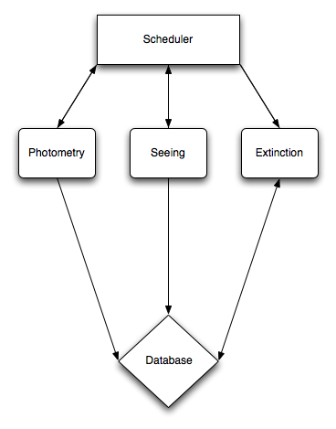

Figure 1: The flow of data

Photometry

Photometry is a technique of astronomy concerned with measuring a star’s flux, and flux is the intensity of an astronomical object’s electromagnetic radiation. This is measured by taking an image of a star and counting the number of “excited” pixels within a circle centered around the astronomical object. An excited pixel is one where an electron has hit the CCD in a camera and produces a bright spot on the image. This idea is shown in figure 2.

The Photometry module in Chimera is a script by which the telescope provides an image which can then passed to an application called Astrometry.net. This application can either be installed on a Linux based system, or used as a web service. The application is used to determine what celestial bodies are in photos of the sky. The program examines the aperture photometry of the photo and produces a number of output files. The most important one is a FITS (Flexible Input Transport System) file, which contains the image and any data the application was able to extract. For more information regarding the application, visit their site: astrometry.net.

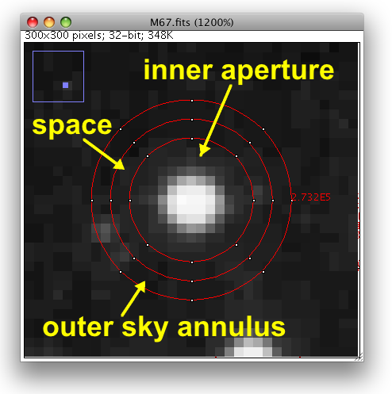

Figure 2: Image of a star

The FITS file, as we've said, contains meta data inserted by astrometry.net as well as the image itself. This works via the following steps:

- First astrometry.net attempts to identify the objects in the image and circles them in red. This is stored as its own FITS file.
- Next it attempts to locate the brightest stars in the image and circles them in green. This is also stored in its own FITS file.
- From there, astrometry.net outlines a “quad” labeled ABCD. That is with A and B being the two furthest separated from each other. The positions of stars C and D are used to compute the quad. Again, this is stored in its own FITS file.
- The quad is then compared with other known quads, searching a large database for matches. This can be a time consuming process.

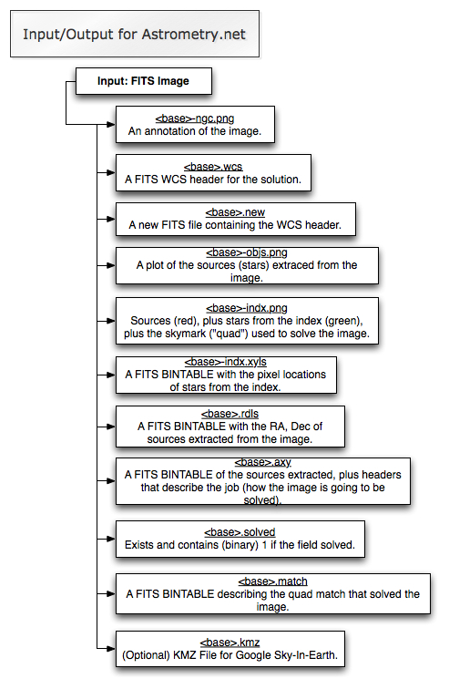

Figure 3: Input and output for Astrometry.net

After astromety.net matches the quad to a known quad, a new FITS image is produced with a header that contains the RA, DEC, Flux, and a Time/Date stamp of when the photo was taken. Chimera’s own database is then sent the relevant information from the header, namely the RA, DEC, Flux, and Time/Date Stamp.

If astrometry.net cannot identify the celestial objects in the image, or astrometry.net identifies the celestial objects as something the camera was not supposed to be taking a picture of, a signal would be sent back to the Scheduler. Then, the Scheduler would reposition the camera in prepare to take another picture.

Seeing

Seeing is essentially the measure of the steadiness in the air; its value represents the quality of the atmosphere for the given time. Variations are caused by rapid small scale turbulences in the atmosphere, often due to thermal variations, wind gusts, suspended air particles, air moistures, and so forth. Poor seeing will result in small, erratic movements of the observed object which can create a blurry image.

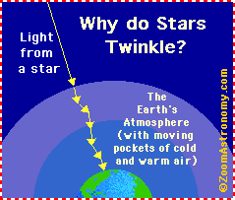

Figure 4: Why do stars twinkle?

Seeing is measured by the flux of a star, and is naturally mapped as a Gaussian Distribution. It is determined by the Full Width Half Maximum (FWHM) of the flux of a star.
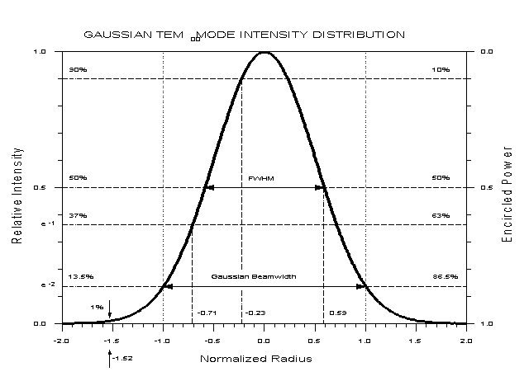

Figure 5: Full-Width Half-Maximum Graph

Source Extractor (SExtractor) is a program which extracts data on point sources (stars) from a FITS image file. SExtractor is also capable of extracting data such as the RA/DEC of individual stars in an image, the instrumental magnitude, the star flux, and the seeing value.

Seeing.py is a python module which configures SExtractor to perform operations based on the needs of the user. The module allows the user to find a star in a FITS image based on a specified RA/DEC, as well as find the brightest star in the FITS file. The module will write the brightest star to the database by default, along with the 9 other stars by decreasing brightness, for a total of 10 stars. The module will run through a catalog of stars output by SExtractor; it keeps a list of the brightest stars which is overwritten each time a brighter star is found. If the RA/DEC is supplied, after SExtractor identifies the RA/DEC of each star in the image, the module will iterate through the catalog of found stars and find the closest star to the specified RA/DEC, and then write that star to the database.

Usage:
photometry <filepath> [RA DEC] [NAME OF STAR}
photometry <filepath> [NUMBER OF BRIGHTEST STARS]
Note: the arguments are optional and when extracting information on user specified star from the given FITS file the star closest to the given RA and DEC will extracted.
Argument Definitions:
NUMBER OF BRIGHTEST STARS
This specifies the number of brightest stars (the default is 10) to extract
RA
The RA of the specific star
DEC
The Dec of a specific star
STAR_NAME
The name of the specific star.
Sample Use:

Default:
seeing /home/me/something.fitsdefault
To specify the number of brightest stars to extract:
seeing /home/me/something.fits 20
To extract a star at RA=320.3 and DEC=20.6:
seeing /home/me/something.fits 320.3 20.6
To extract a star at RA=320.3 DEC=20.6 and name it mystar
seeing /home/me/something.fits 320.3 20.6 mystar

Extinction Coefficient

The Extinction Coefficient is a measure of how light from the stars gets distorted by the atmosphere throughout the night. Once a series of images of a single star has been taken throughout a time period, the star’s RA and Dec will be confirmed with astrometry.net and run through Source Extractor. The data output from Source Extractor will be placed into the database. The Extinction Coefficient program will then pull the RA, Dec, Local Sidereal Time and the Flux and compute the airmass and magnitude of the star. The airmass and magnitude are plotted for each image and a Least Fits run on the points. The slope of the Least Fits line is the Extinction Coefficient.
Ideally once Chimera is working as planned, the scheduler would be told to measure the extinction coefficient of a star at a specific RA and DEC over a certain time period taking images at a specified interval. The scheduler would handle taking pictures, running photometry on those images and then the images would be added to the database. When the time frame has elapsed the scheduler would invoke the extinction coefficient code which would automatically run and insert into the database the extinction coefficient along with generating an image of the data graphically.
As it stands though the scheduler is not fully implemented, so the extinction coefficient can be easily invoked from the command line using the following syntax:

python extinction.py [-f:<path to images> | ra=<RA> dec=<DEC> s=<Start Time> e=<End Time>] -o:<Output image filename>

The -f: option will determine the extinction coefficient from a folder containing a series of images. Instead of finding information in a database, the FITS files would have their headers analyzed and will be run through the seeing code to determine the variables needed to calculate the extinction coefficient. Without using that argument the database is used gather the information about the images.

Database Documentation

As part of our project requirements, we developed a database for Chimera. We decided on MySQL as it is a stable open source project that is familiar to many of us. The purpose of this document is to describe the database so that it may be implemented with any database tool.

Understanding the Schema:

Here follows a database schema for Chimera, created based on the needs of our three tasks. The schema consists of four tables: star, exposure, extinction_co, and extinction_star. Describing the information held in these tables is beyond the scope of this manual, however, we will explain where the information comes from in the next section. As development on Chimera grows, this schema may be revised very quickly. The next few paragraphs are provided to assist future developers.

- exposure
  - exposure_id (primary key)
  - filter
  - date
  - sky_flux
  - image_path
  - lst

- star
  - star_id (primary key)
  - object_name
  - ra
  - dec
  - air_mass
  - flux
  - fwhm
  - instrumental_mag
  - exposure_id (foreign key)

- extinction_co
  - extinction_id (primary key)
  - extinction_co

- extinction_star
  - extinction_id (primary key)
  - star_id (foreign key)

The exposure table holds information regarding the actual exposure such as time the exposure was taken and the filter that was used. The star table consists of information derived from the exposures themselves. That is, there can be many stars per exposure. The extinction_co holds a specific star's extinction coefficient, which is calculated over many exposures. Finally, the extinction_star table was made to relate a star with it's extinction coefficient.

Python Interface:

A python script was written in order for our scripts to interface with the database. In order to do this, we needed to install the MySQLdb python module. The script contains a handful of static functions which provide the necessary queries used by each of our three tasks.
Glossary
Air mass: (1) A large body of air with only small horizontal variations of temperature, pressure, and moisture. (2) A widespread body of air that originates over a large area of land or ocean and assumes the temperature and humidity of that area, with characteristics distributed fairly evenly throughout the horizontal layers of the mass. Air that stands over the Caribbean Sea, for example, becomes a warm, humid maritime tropical air mass, while air that lies in the Arctic regions of northern Canada takes on the cold and dry characteristics of its surroundings and becomes a continental polar air mass. When air masses of differing properties come into contact in the middle latitudes, they frequently generate storm fronts.
Astrometry.net: an application external to the chimera program. It provides a web interface or downloadable database with reference to stars and the stars’ attributes, such as ra (right ascension), dec (declination), flux, and magnitude. By using astrometry.net, one can submit a photo of a region of the sky and astrometry.net will provide the name of the star, or space object, and a list of parameters for that object.
CCD (charged-coupled device): A semiconductor device in which the individual semiconductor components are connected so that the electrical charge at the output of one device provides the input to the next device. Because they can store electrical charges, CCDs can be used as memory devices, but they are slower than RAMs. CCDs are sensitive to light, and are therefore used as the light-detecting components in video and digital cameras and in optical scanners.
Chimera: a computer application that allows the user to gather particular information about stars from an image, or a series of images taken from a telescope and the focus of this document.
DEC (declination): Astronomy the angular distance, esp. in degrees, of a star, planet, etc., from the celestial equator measured north (positive) or south (negative) along the great circle passing through the celestial poles and the body.
Extinction Coefficient: is a measure of how light from the stars gets distorted by the atmosphere throughout the night using data provided by a series of images of a single star that has been taken throughout a specific time period.
FITS file (Flexible Image Transport System): is a digital file format used to store, transmit, and manipulate scientific and other images. FITS is the most commonly used digital file format in astronomy. Unlike many image formats, FITS is designed specifically for scientific data and hence includes many provisions for describing photometric and spatial calibration information, together with image origin metadata. A major feature of the FITS format is that image metadata is stored in a human readable ASCII header, so that an interested user can examine the headers to investigate a file of unknown provenance. Each FITS file consists of one or more headers containing ASCII card images (80 character fixed-length strings) that carry keyword/value pairs, interleaved between data blocks. The keyword/value pairs provide information such as size, origin, coordinates, binary data format, free-form comments, history of the data, and anything else the creator desires: while many keywords are reserved for FITS use, the standard allows arbitrary use of the rest of the name-space.
FWHM (Full width half maximum): is the measurement of the Gaussian distribution of a star’s flux determined by the full width of the distribution at the midpoint of the distributions height.
Image Coordinates: is the (x,y) coordinates of a point source with respect to some specified origin usually measured in pixels.
Magnitude: Astronomy The degree of brightness of a celestial body designated on a numerical scale, on which the brightest star has magnitude -1.4 and the faintest visible star has magnitude 6, with the scale rule such that a decrease of one unit represents an increase in apparent brightness by a factor of 2.512. Also called apparent magnitude.
Photometry: Photometry is a technique of astronomy concerned with measuring the flux, or intensity of an astronomical object's electromagnetic radiation.
Pixel: The basic unit of the composition of an image on a television screen, computer monitor, or similar display.
Python Programming Language: is a high-level programming language first released by Guido van Rossum in 1991. Python is designed around a philosophy which emphasizes readability and the importance of programmer effort over computer effort. Python core syntax and semantics are minimalist, while the standard library is large and comprehensive. Community practices in Python programming have led to the recognition of a Python philosophy. Python is a multi-paradigm programming language (functional, object oriented and imperative) which has a fully dynamic type system and uses automatic memory management; it is thus similar to Perl, Ruby, Scheme, and Tcl. The language has an open, community-based development model managed by the non-profit Python Software Foundation. While various parts of the language have formal specifications and standards, the language as a whole is not formally specified. The de facto standard for the language is the CPython implementation.
RA (Right Ascension): The position of a celestial object east of the vernal equinox along the celestial equator. Right ascension is measured in hours, minutes, and seconds from the vernal equinox (0 hours) to the point where a great circle drawn through the object and the north and south celestial poles intersects the celestial equator. Each hour corresponds to 15° of angular distance along the celestial equator for a total of 24 hours.
Scheduler: The scheduler is a module in Chimera which controls the telescope and the camera. It tells the hardware what to do, like reposition the telescope or change a filter.
Seeing: An arc-second measurement that is a determinate in the resolution of the images observed by a telescope. It is a value which describes the quality of the atmospheric conditions at the time of observation.
Source Extractor (SExtractor): This is a utility that extracts information for sources (particularly images) and is a dependency of the Seeing module.
Star Flux (Luminous Flux): In photometry, luminous flux or luminous power is the measure of the perceived power of light. It differs from radiant flux, the measure of the total power of light emitted, in that luminous flux is adjusted to reflect the varying sensitivity of the human eye to different wavelengths of light.

Isaac Richter, Paulo Henrique Silva, Antonio Kanaan, Denis Barrett, Timothy DeHass, Ryan Mann, Andrew Missert, Matthew Turner, and Shashi Kanbur
The American Heritage® Dictionary of the English Language, Fourth Edition copyright ©2000 by Houghton Mifflin Company. Updated in 2003. Published by Houghton Mifflin Company. All rights reserved.
The American Heritage® Science Dictionary Copyright © 2005 by Houghton Mifflin Company. Published by Houghton Mifflin Company. All rights reserved.
Britannica Concise Encyclopedia. Copyright © 1994-2008 Encyclopædia Britannica, Inc.
Collins Discovery Encyclopedia, 1st edition © HarperCollins Publishers 2005.
http://www.wikipedia.org
The American Heritage® Dictionary of the English Language, Fourth Edition copyright ©2000 by Houghton Mifflin Company. Updated in 2003. Published by Houghton Mifflin Company. All rights reserved.
http://www.wikipedia.org
The American Heritage® Science Dictionary Copyright © 2005 by Houghton Mifflin Company. Published by Houghton Mifflin Company. All rights reserved.
http://www.wikipedia.org
The American Heritage® Science Dictionary Copyright © 2005 by Houghton Mifflin Company. Published by Houghton Mifflin Company. All rights reserved.
http://www.wikipedia.com

