This document provides:

* A “before” version of a topic I edited
* Comments about the changes I made
* An “after” version that reflects the comments

# Before version

The original text spans two pages.

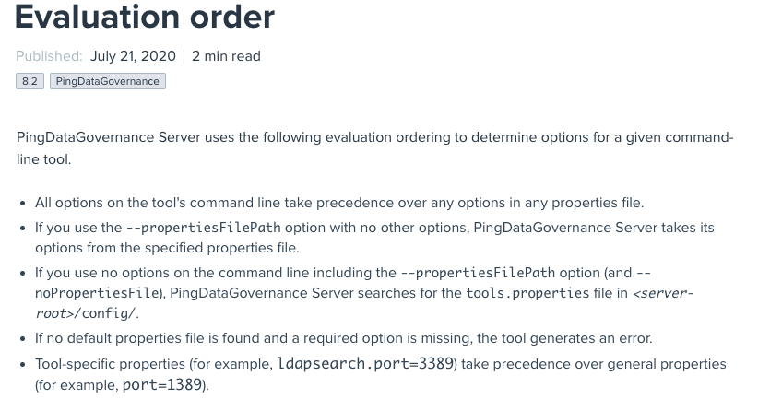

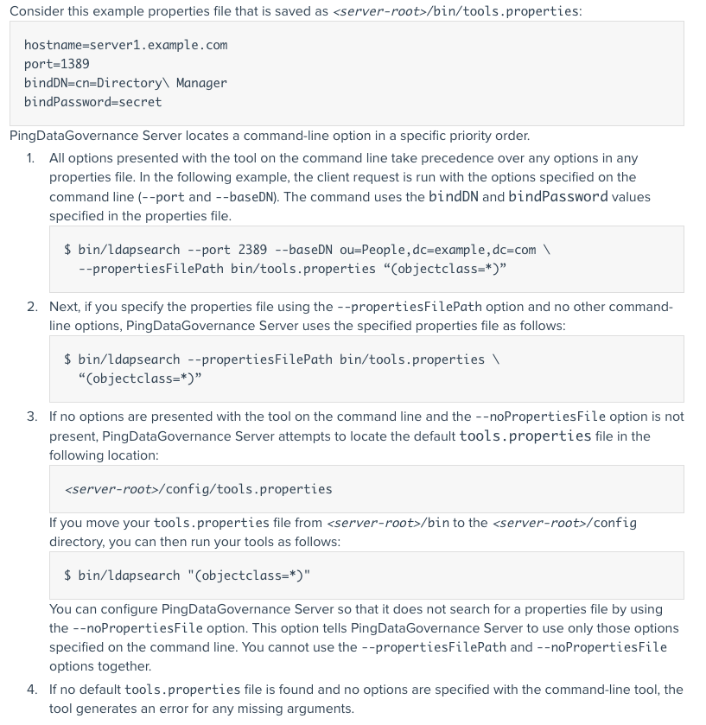

# Comments

The following list summarizes the updates I made to the text and why.

* The “Evaluation order” title works okay when seen in context. However, the new title, “Evaluation of command-line options and file options,” immediately tells the reader what we are evaluating.
* The section focused on the order of evaluation. However, the content is actually about different scenarios where order of evaluation does not matter. To make those scenarios and their results easier to scan, I created a table with the scenarios in the first column and the product responses to the scenarios in the second column.
* In addition to easier scanning, the table removes filler text and discusses the scenarios in the same way, reducing the cognitive load from the original text.
* The original text has this line:  
    
  If no default properties file is found and a required option is missing, the tool generates an error.  
    
  Given that the tool does produce an error in this case, this line seems unnecessary. I removed it from the rewrite.
* The original text has this line:  
    
  Tool-specific properties (for example, ldapsearch.port=3389) take precedence over general properties (for example, port=1389).  
    
  Describing how the properties file works does not seem relevant in this section. Also, the section about creating the properties file already mentions this behavior. I removed this line from the rewrite.
* I like having an example to illustrate the behavior. To help the reader see the example, I created an “Example” subsection for this content.
* The example in the original text mentioned order and even has a numbered list to reflect the order. However, as mentioned, this content covers scenarios where order does not matter. I changed the numbered list to a bulleted list.
* If I had kept the numbered list though, I would have needed to change step 2 to remove “Next.” The word is not needed because the numbered list already indicates an order.
* In the rewrite, step 1 becomes the first bullet, but I use multiple paragraphs in the bullet to make the text less dense. Also, I changed the “client request” text to “command” to match the wording used later in the paragraph. I also added the “With the port value both on the command line and in …” sentence to clarify how that relationship works.
* Step 3 becomes the third bullet in the rewrite. The step has this text:  
    
  If no options are presented with the tool on the command line and the --noPropertiesFile option is not present,  
    
  I reduced that text to the following text to reduce the cognitive load:  
    
  If you don’t specify any command-line options,
* The rewrite also uses some contractions.
* Step 3 has a para that starts “You can configure PingDataGovernance Server so that it does not search …” Most of that para is a scenario, so I moved it to the table with the other scenarios.  
    
  I removed the last line from that para, which starts with “You cannot use.” Presumably, the tool will produce an error in the specified case that indicates proper usage.
* Step 4 is another example of text that mentions when the tool produces an error. I left out this text in the rewrite.

# After version

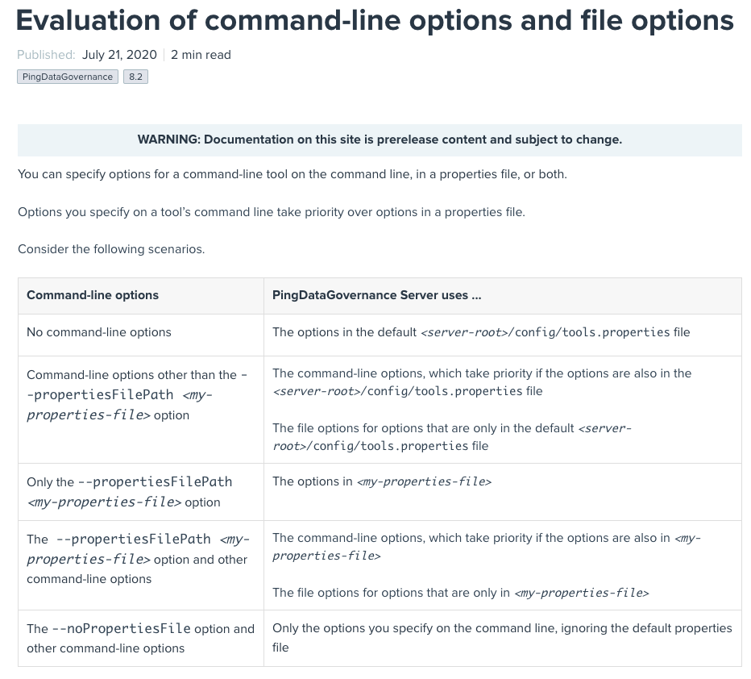The rewrite reflects my updates.

