GitHub入门与实践

第三章使用github的前期准备
1.设置姓名和邮箱地址
$ git config --global user.name “Yong ren”
$ git config --global user.email “1195608550@qq.com”
2.提高命命令输出的可读性
$ git config --global color.ui auto

——》Github使用前准备
1.创建账号
2.设置头像
3.设置SSH Key
$ ssh-keygen -t rsa -C "1195608550@qq.com" Generating public/private rsa key pair.Enter file in which to save the key (/Users/your_user_directory/.ssh/id_rsa):

3.1代码
Enter passphrase (empty for no passphrase):
Enter same passphrase again:
Passphrases do not match. Try again.
Enter passphrase (empty for no passphrase):
Enter same passphrase again:
Your identification has been saved in /c/Users/lenovo/.ssh/id_rsa.
Your public key has been saved in /c/Users/lenovo/.ssh/id_rsa.pub.
The key fingerprint is:
SHA256:VtDcj4nwL7gHCSwanvmtXGaOCPd5HrSjwnTXUnqTIoA 1195608550@qq.com
The key's randomart image is:
+---[RSA 2048]----+
| .o . |
| ..o . |
| . . o.. + |
|E o . o ..o o . |
| . * ..=S+ . |
| * o.=oO . . |
|.o.o +B+ + . |
| oo+.Ooo. . |
| ..B+o . |
+----[SHA256]-----+

查看id_rsa.pub文件里的内容：$ cat ~/.ssh/id_rsa.pub

4.添加公开密钥
测试链接：$ ssh -T git@github.com
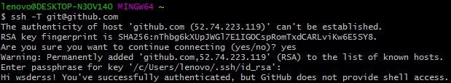
5.创建仓库
评论/注释：一定要学会Markdown语法
7.克隆已有仓库至本地
$ git clone git@github.com:wsderss/gdpx.git
8.创建文件夹/文件，命令同linux
9.查看repository/git状态命令：$ git status (git:分布式版本控制系统)
10.将文件提交给git管理：
将文件加入暂存区：$ git add hello_world.php (暂存区：在Index数据结构中记录文件提交之前的状态。)
再通过commit命令提交：$ git commit -m “add hello world script by php”
11.通过log命令查看提交日志：$ git log

