

SCHOOL OF DIGITAL TECHNOLOGIES

SUBJECT

«Database Management System»

«The database of the hotel booking system»

Completed by the students
2 courses of the specialties
"Digital Engineering",
"Digital Management and Design"
Shaimuratov S. O.,
Yestleu I. B.

Checked by
Senior Lecturer,
Master of Technical Sciences
Tanzharykova M. G.

ALMATY
2024

Table of Contents
Introduction 3
Objectives and Scope 3
Relevance and Impact 3
The main part 5
Problem statement 5
Database modeling (ER diagram) 7
Main tables and their roles: 7
Key Features Ensured by the ER Diagram: 7
Based on the ER diagram, a database structure was formed that provides: 8
Database implementation in PostgreSQL 9
PHP Database Connection with PDO 10
GUI via HTML+PHP+JS 11
Conclusion 14
List of used literature 15
Applications 16

Introduction
The project on the theme "Database of the hotel reservation system" was implemented in order to create an effective information system that facilitates room reservations, customer management, and the generation of detailed reports, as well as automation of tasks related to employees and payments. The increasing reliance on digital platforms in the hospitality industry makes this project particularly relevant, as it addresses the need for efficiency and streamlined operations in hotel management.

Objectives and Scope
During the work on the project, the following tasks were set:
- Database modeling: Developing a database model that includes customers, employees, hotel rooms, reservations, and payments;
- SQL Implementation: Database implementation in PostgreSQL using SQL queries, ensuring data integrity and adherence to business logic;
- Interface Design: Creating an intuitive and user-friendly interface for interacting with the database using HTML, Bootstrap, PHP, and JavaScript;
- Functionality Enhancements: Providing data management and analysis functions such as search, filtering, sorting, record counting, and data aggregation to improve usability and efficiency.

This project was carried out by a collaborative team of two participants. The first participant focused on modeling and developing the database structure, including writing SQL queries for data creation and validation. The second participant specialized in designing the web interface, integrating it with the database, and implementing client-side functionalities. Both participants contributed to testing, debugging, and refining the system to meet the requirements.

Relevance and Impact
The importance of this project lies in its ability to improve existing booking and data management processes by integrating advanced database features with a modern web interface. Such a system not only automates routine tasks but also enhances the accuracy and reliability of data. Furthermore, the project serves as a practical application of theoretical knowledge, providing the team with valuable experience in database management and full-stack development.

In summary, this system demonstrates how technology can be leveraged to address real-world challenges in the hospitality industry, ensuring that hotel operations remain efficient, customer-focused, and scalable for future growth.

The main part

Problem statement
The aim of this project was to create an information system that simplifies the management of hotel reservations and automates processes related to the processing of data about customers, employees, payments, and rooms. The hospitality industry often struggles with inefficient manual processes that lead to errors, delays, and customer dissatisfaction. By providing an automated solution, this project addresses the need for better operational efficiency and customer experience.
The main requirements for the system include:
- Storing information about customers, employees, rooms, bookings and payments;
- Support for data creation, reading, updating and deletion (CRUD) operations;
- Implementation of data verification logic, such as the uniqueness of the email and the correctness of the phone number format;
- Data optimization using SQL queries for sorting, searching and aggregation;
- Intuitive interface for interacting with the database, ensuring ease of use for staff members.

To illustrate these requirements, consider the scenario of a hotel manager needing to quickly determine room availability during a peak season. This system allows real-time data retrieval, ensuring that decisions are made based on accurate and up-to-date information. Similarly, the inclusion of payment tracking ensures that financial records are maintained without manual intervention, reducing errors.

To achieve these goals, the project included the following stages:
- Database modeling and ER diagram creation: This stage focused on analyzing the data entities and their relationships to form a clear blueprint for implementation;
- Implementing a database structure using SQL in PostgreSQL: Ensuring data integrity and enabling robust data management through advanced SQL functionalities;
- Web interface development using HTML, Bootstrap and JavaScript: The user interface was designed for seamless interaction with the database, featuring intuitive navigation and responsive design;
- Integration of the interface with the database via PHP: Leveraging PHP’s PDO extension to establish a secure and flexible connection between the application and the PostgreSQL database.

The system also includes additional features like data validation rules (e.g., enforcing proper email formats) and optimized query designs to handle large datasets efficiently. These enhancements were designed with scalability in mind, ensuring the system could adapt to the needs of larger hotel chains or complex operational requirements.

Database modeling (ER diagram)
Database modeling began by analyzing the domain and highlighting key entities such as customers, employees, rooms, reservations, and payments. This step was crucial in ensuring the system's design accurately reflected real-world relationships and operational requirements. To visually represent the data structure, an ER diagram was created that displays the relationships between tables and the main attributes of each entity. The process also involved discussions with potential users to gather requirements, which informed the entity relationships and data validation rules.

Main tables and their roles:
- clients: Stores information about hotel clients, including unique identifiers (id), names, contact details, and email addresses. These details are critical for tracking customer reservations and ensuring seamless communication;
- employees: Contains information about hotel staff, including their roles (position). For example, a manager may oversee bookings, while a technician might handle room maintenance tasks;
- rooms: Describes the hotel rooms, including types (e.g., Single, Suite), pricing, and availability status. For instance, a Suite with a higher price and lower availability can be prioritized during peak seasons;
- bookings: Tracks reservation details such as check-in and check-out dates. Each booking links a client to a specific room, ensuring no double bookings occur;
- payments: Records financial transactions, associating clients with payment amounts and dates. This table is crucial for generating financial reports;
- employees_activities: Logs employee tasks associated with specific bookings, such as room cleaning or guest check-ins, providing a clear overview of staff responsibilities.

Key Features Ensured by the ER Diagram:
- Data Integrity: The diagram ensures that one-to-many relationships (e.g., one client can have multiple bookings) are accurately represented, avoiding inconsistencies in the database.
- Validation Rules: Constraints such as unique email addresses and phone formats were added based on insights from the ER model.
- Scalability: The modular design of the ER diagram allows easy integration of additional features, such as loyalty programs or multi-property management.

The ER diagram will be included in the report as a graphical application to provide a clear and comprehensive overview of the system’s structure and relationships.

Based on the ER diagram, a database structure was formed that provides:
- Maintaining data integrity through one-to-many relationships and restrictions (FOREIGN KEY);
- The uniqueness of the data (for example, email and phone number of customers);
- Checking the correctness of the data using CHECK restrictions (for example, the positive cost of the room and the amount of payment).

Database implementation in PostgreSQL
The implementation of the database began with the translation of the ER diagram into SQL code to create tables. Based on the model, the following SQL queries were developed:
- Creating tables: The CREATE TABLE commands were used, and the uniqueness of the data was set separately through ALTER TABLE constraints. Example:
CREATE TABLE clients (
id SERIAL PRIMARY KEY,
name VARCHAR(255) NOT NULL,
surname VARCHAR(255) NOT NULL,
phone VARCHAR(20) NOT NULL,
email VARCHAR(255) NOT NULL
);
ALTER TABLE clients ADD CONSTRAINT unique_phone UNIQUE (phone);
ALTER TABLE clients ADD CONSTRAINT unique_email UNIQUE (email);

- Integrity constraints: Data format checks (for example, CHECK) are implemented to ensure the correctness of information, for example:
ALTER TABLE clients ADD CONSTRAINT check_email_format CHECK (email LIKE '%@%');
ALTER TABLE clients ADD CONSTRAINT check_phone_starts CHECK (phone LIKE '+7%');

- Data insertion: The INSERT INTO commands were used to fill the database, allowing you to pre-test the functionality:
INSERT INTO clients (name, surname, phone, email) VALUES
('Aizhan', 'Kuanyshbayeva', '+77011234567', 'a.kuanyshbayeva@gmail.com');

- Relationships between tables: Foreign keys were used to maintain data integrity. For example, the relationship between customers and bookings:
ALTER TABLE bookings ADD CONSTRAINT bookings_client_id_fkey FOREIGN KEY (client_id) REFERENCES clients(id) ON DELETE CASCADE;

- Data testing: After creating the structure and filling the database, test queries were carried out to verify the correctness of constraints and relationships, such as data sampling using JOIN and filtering.

Thus, the database was fully prepared for integration with the web interface.

PHP Database Connection with PDO
To connect PHP to PostgreSQL, we utilized the PHP Data Objects (PDO) extension along with the php-pgsql driver. This approach provides a secure and efficient method for database interaction, ensuring support for prepared statements and error handling. Below is an example, demonstrating the connection in our case:
<?php
$host = 'localhost';
$port = '5432';
$dbname = 'hotel_bookings';
$user = 'postgres';
$password = '123456';
try {
$pdo = new PDO("pgsql:host=$host;port=$port;dbname=$dbname", $user, $password);
$pdo->setAttribute(PDO::ATTR_ERRMODE, PDO::ERRMODE_EXCEPTION);
} catch (PDOException $e) {
die("Database connection error: " . $e->getMessage());
}
?>

The use of PDO ensures flexibility and security, particularly when dealing with dynamic queries and large datasets.

GUI via HTML+PHP+JS
The web interface for interacting with the database was developed using HTML, Bootstrap, JavaScript and PHP technologies. It includes the following main functions:
- Data View: This function sends a request to the server to retrieve data from the selected table. The received data is displayed as an HTML table using the generate Table function:
function displayData() {
fetchData('display').then(data => {
const resultsDiv = document.getElementById('results');
resultsDiv.innerHTML = generateTable(data);
});
}

- Adding data: The user enters data through the form, and it is sent to the server, where it is processed for addition to the database. After successful addition, the display is updated:
function addRecord() {
const data = promptForData();
fetchData('add', { data: JSON.stringify(data) }).then(() => {
alert('Record added!');
displayData();
});
}

- Data update: The user enters the record ID and new data. The request is sent to the server, where the record is updated in the database:
function updateRecord() {
const id = prompt('Enter the ID of the record to update:');
const data = promptForData();
fetchData('update', { id, data: JSON.stringify(data) }).then(() => {
alert('Record updated!');
displayData();
});
}

- Data Deletion: This function allows the user to delete an entry by ID. After deletion, the table is updated:
function deleteRecord() {
const id = prompt('Enter the ID of the record to delete:');
fetchData('delete', { id }).then(() => {
alert('Record deleted!');
displayData();
});
}

- Search Data: The function sends a request with a search term to the server. The results are displayed in a table:
function searchData() {
const term = prompt(`Enter a search term for the "${currentTable}" table:`);
if (!term) return;
fetchData('search', { term }).then(data => {
const resultsDiv = document.getElementById('results');
resultsDiv.innerHTML = generateTable(data);
});
}

- Data aggregation: This function counts all records in the selected table and displays the result on the page:
function totalRecords() {
fetchData('calculate').then(data => {
const resultsDiv = document.getElementById('results');
if (data.count !== undefined) {
resultsDiv.innerHTML = `<h1>Number of records in table "${currentTable}": ${data.count}</h1>`;
} else {
resultsDiv.innerHTML = `<h1>Error: ${data.error}</h1>`;
}
});
}

Each function uses the fetchData helper function to send requests to the server:
function fetchData(action, data = {}) {
return fetch('api.php', {
method: 'POST',
headers: { 'Content-Type': 'application/x-www-form-urlencoded' },
body: new URLSearchParams({ action, table: currentTable, ...data })
}).then(response => response.json());
}

This structure allows you to unify the interaction between the client and the server, simplifying the processing of various actions (viewing, adding, updating, deleting, etc.).

The web interface is styled using Bootstrap to ensure adaptability and user-friendliness. Example of data display:
<table class="table table-striped">
<thead>
<tr>
<th>ID</th>
<th>Name</th>
<th>Email</th>
</tr>
</thead>
<tbody>
<tr>
<td>1</td>
<td>Aizhan Kuanyshbayeva</td>
<td>a.kuanyshbayeva@gmail.com</td>
</tr>
</tbody>
</table>

An example of HTML code for selecting a table and displaying data:
<select id="tableSelector" class="form-select w-auto" onchange="updateTable()">
<option value="clients">Clients</option>
<option value="employees">Employees</option>
<option value="rooms">Rooms</option>
<option value="bookings">Bookings</option>
<option value="payments">Payments</option>
<option value="employees_activities">Employees Activities</option>
</select>

Thus, the interface provides users with a convenient tool for working with the database, including search, filtering and record management functions.

Conclusion
The project successfully met the objectives set out in the beginning. The developed system for hotel booking and management is capable of handling all CRUD operations, data validations, and offering a user-friendly GUI. The ER diagram, SQL implementation, and interface development contributed to a fully operational solution. Further enhancements could include real-time updates and user authentication.
Additionally, the project allowed the team to enhance their technical skills in PostgreSQL and web technologies, as well as to explore practical solutions to common challenges in database design and integration. The implementation of constraints and validations ensures data accuracy, which is critical for the real-world application of such systems.
In terms of usability, the interface developed with Bootstrap and JavaScript simplifies interaction with the database, making the system accessible even to non-technical users. Future work could involve integrating advanced features such as automated notifications, a mobile-friendly design, and more robust security measures, including user authentication and authorization.
Overall, this project highlights the importance of collaboration, planning, and the application of theoretical knowledge to solve practical problems. The completed system serves as a foundation for more complex hotel management solutions.

List of used literature
- PostgreSQL Documentation: https://www.postgresql.org/docs/
- PHP work with PDO: https://ru.hexlet.io/blog/posts/php-modul-pdo
- PHP Documentation: https://www.php.net/docs.php
- Bootstrap Documentation: https://getbootstrap.com/docs/
- JavaScript Guide by Mozilla: https://developer.mozilla.org/en-US/docs/Web/JavaScript/Guide

Applications
- ERD:
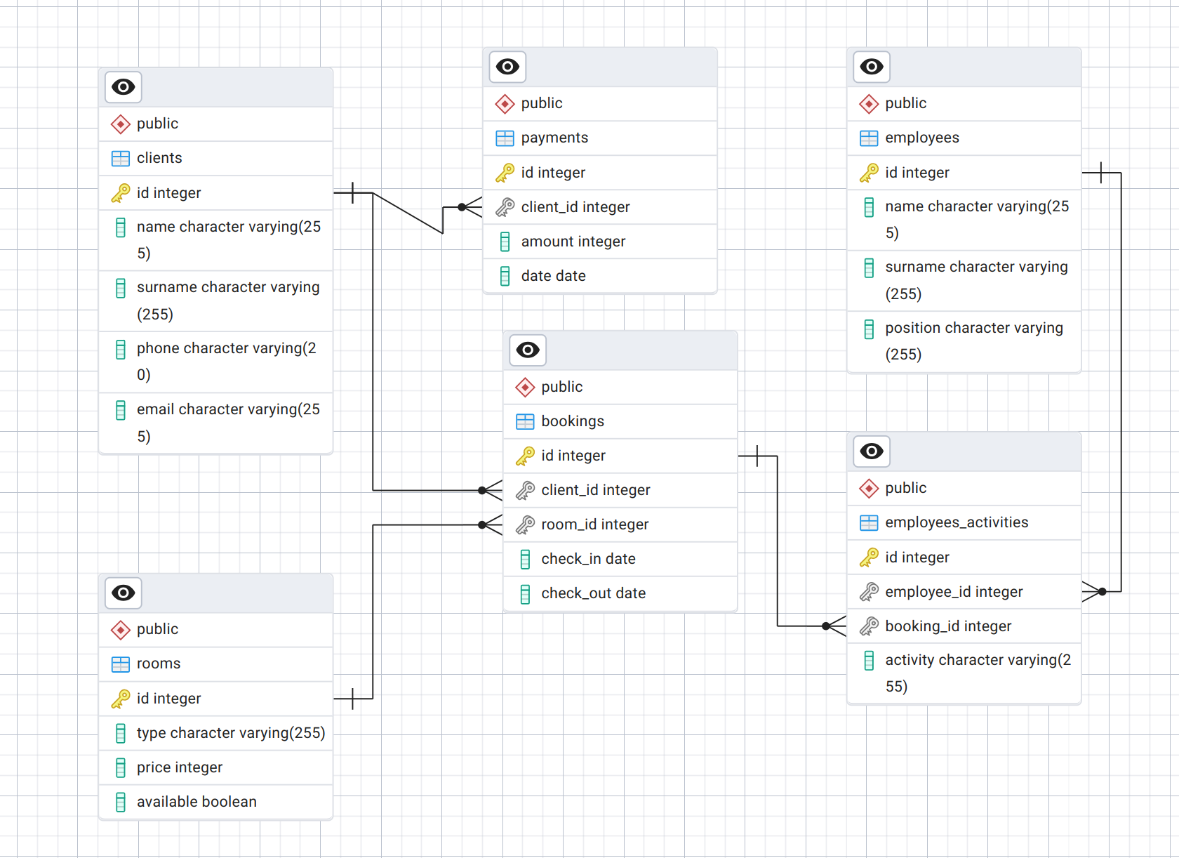
- Database creation queries:
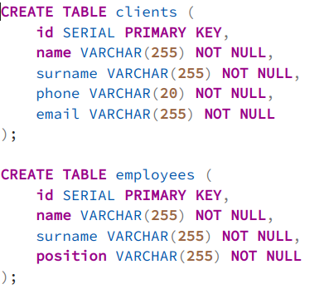
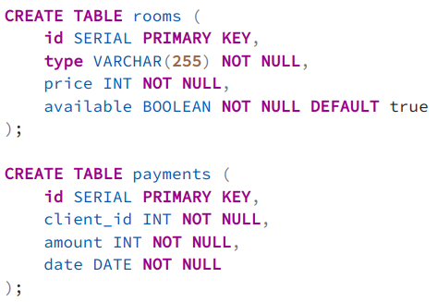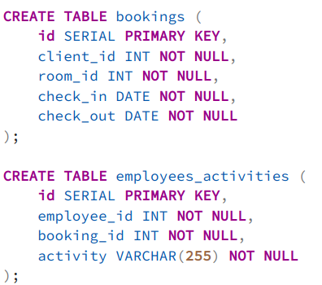
- Constraints for database:
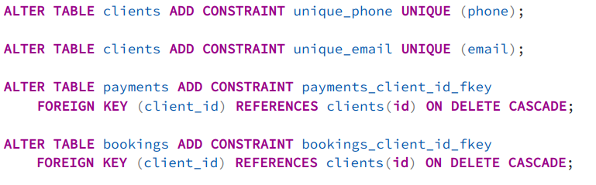
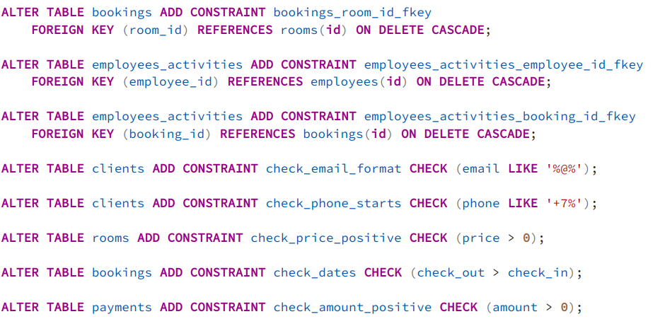
- Inserts in database:

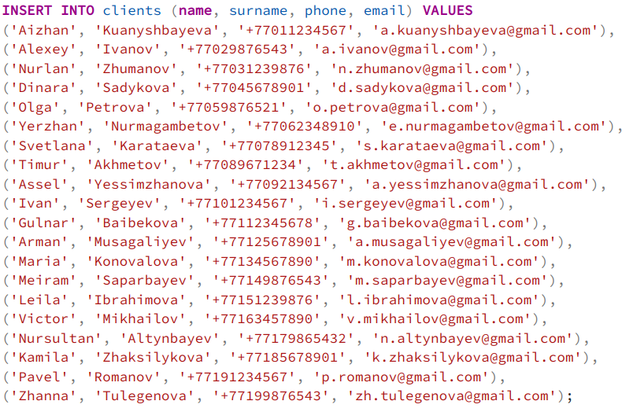
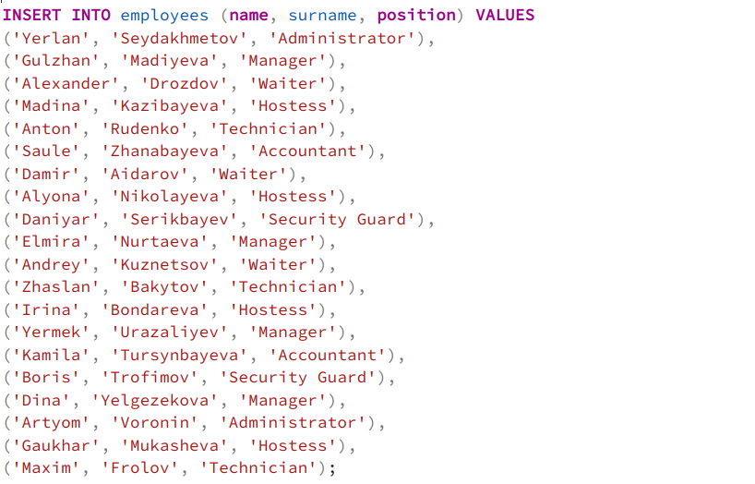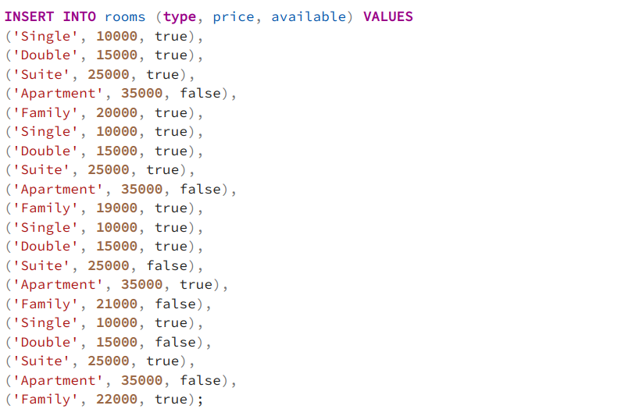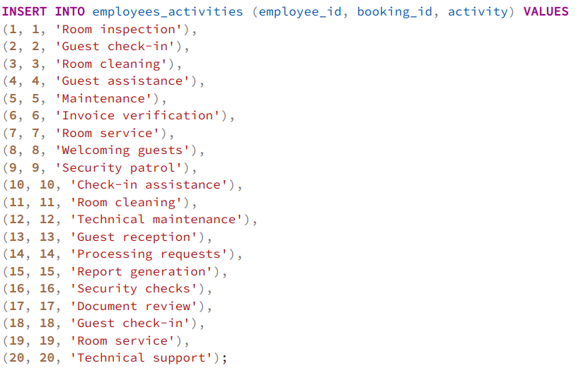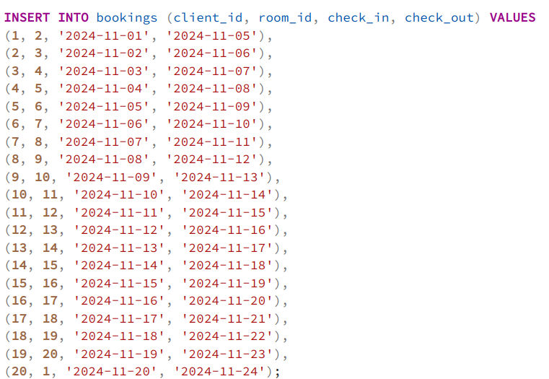

- Queries for fix ID sequences:
