RUNWAY
Know how far your money goes.
M1: Specification, Data Model, Wireframes and Accessibility Plan
Student | Wezzie Selemani
Assignment | Summative Assignment: Building Responsive UI. Theme: Student Finance Tracker (vanilla HTML, CSS, JavaScript)
Contact | GitHub: github.com/selemaniwezzie5 | Email: [add your email address]

1. Project Concept
Runway is a responsive web app that helps university students see where their money goes and, more importantly, how long it will last. Students often receive money in lumps (a monthly allowance, a stipend, a family transfer) and then watch it shrink with no clear picture of the pace. Runway turns every expense into an answer to one question: at the pace I am spending, how many days will my money last?
Sample persona (replace with real habits you have observed):
Who | Aline, second-year student living off campus in Kigali
Money and spending | A monthly allowance arrives on the 1st by mobile money (part from family in MWK, converted to RWF). It goes on cafeteria meals, transport, data bundles, printing and books.
Main frustration | “By the 20th I do not know where it went, and I cannot tell if I will last until the next transfer.”

The Runway card. The brief requires a spending cap and a last-7-days trend. Runway combines them into one number, shown as the largest item on the dashboard, with a neutral, never-shaming message (polite status under the cap, assertive alert over it):
remaining = cap − total spent this calendar month (in base currency)
dailyPace = spending in the last 7 days ÷ 7
runwayDays = floor( remaining ÷ dailyPace )

2. Data Model
Each expense is one record. Money is stored as a plain number (never "5,000 RWF") so the amount regex works and totals can be calculated; the currency is a separate field.
Field | Type | Rule | Example
id | string | Unique; txn_ plus 4 digits | txn_0001
description | string | No leading/trailing space; no repeated words | Lunch at cafeteria
amount | number | Zero or positive; up to 2 decimals | 5000
currency | string | One of the 3 currencies in Settings | RWF
category | string | Letters, spaces, hyphens; from the editable list | Food
needWant | string | Exactly need or want | need
date | string | YYYY-MM-DD and a real calendar date | 2026-10-08
createdAt, updatedAt | string | ISO timestamps; updatedAt refreshes on every edit | 2026-10-08T12:14:03Z

{ "id": "txn_0001", "description": "Lunch at cafeteria", "amount": 5000, "currency": "RWF",
"category": "Food", "needWant": "need", "date": "2026-10-08",
"createdAt": "2026-10-08T12:14:03Z", "updatedAt": "2026-10-08T12:14:03Z" }

- Settings are saved separately: base currency (RWF), manual rates for two more currencies (USD, MWK), the spending cap, and the editable category list. Both records and settings auto-save to localStorage.
- Seed file (10+ records): a leap day, year boundaries, amounts of 0, 0.01 and 999999.99, all three currencies, and a repeated-word description such as Coffee coffee.

3. Validation Plan (5 regex rules)
Field | Pattern | Accepts | Rejects
Description | ^\S(?:.*\S)?$ | Lunch at cafeteria | " Lunch", "Lunch "
Amount | ^(0|[1-9]\d*)(\.\d{1,2})?$ | 5000, 12.50, 0 | 05, 5., -3
Date | ^\d{4}-(0[1-9]|1[0-2])-(0[1-9]|[12]\d|3[01])$ | 2026-10-08 | 2026-13-01
Category | ^[A-Za-z]+(?:[ -][A-Za-z]+)*$ | Food, Mobile-Data | Food2, Food/
Advanced: repeated word | \b(\w+)\s+\1\b (back-reference, ignore case) | Lunch at cafeteria | "the the"

- Double spaces are collapsed before the description is tested. The date regex alone accepts 2026-02-31, so a short JavaScript check confirms the date exists.
- Errors appear under the field as the user types, linked with aria-describedby, and say how to fix the problem (for example, "Use digits only, like 12.50"). Search uses a safe compiler (try/catch) with an ignore-case toggle and <mark> highlighting.

4. Wireframes
One page with five <section>s, designed mobile-first: base CSS for about 360px, then min-width: 768px and min-width: 1024px layouts using Flexbox and Grid. Navigation changes with the screen: a bottom tab bar on phones, a top bar on tablets, and a sidebar on desktops. Records are cards on mobile and a table from 768px.

4.1 About
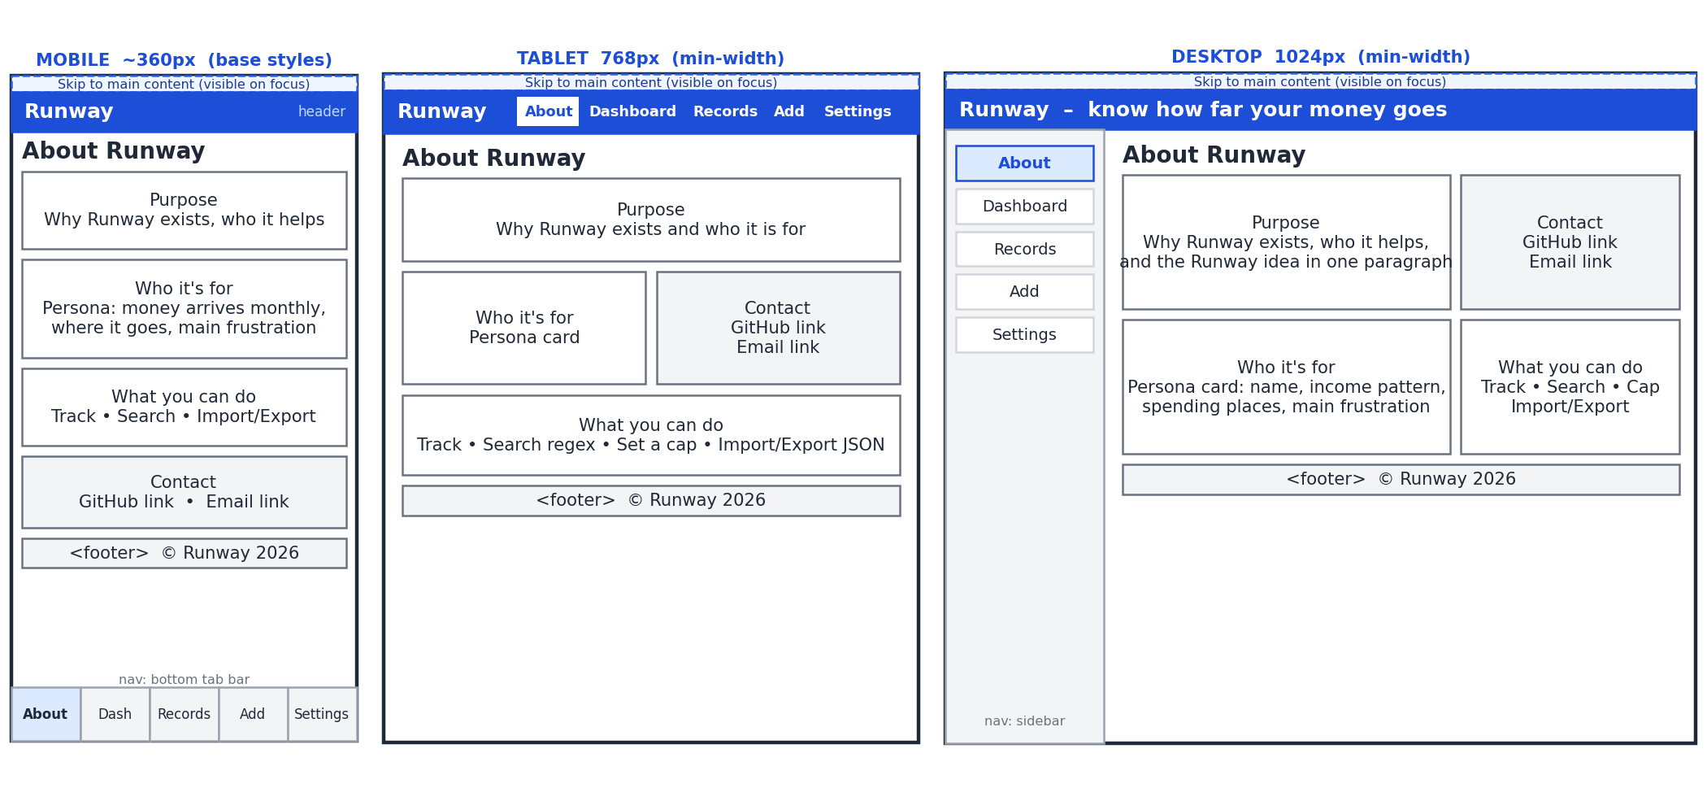
Notes: Purpose and persona stack on mobile; at desktop the purpose sits beside the contact card (GitHub and email links).

4.2 Dashboard
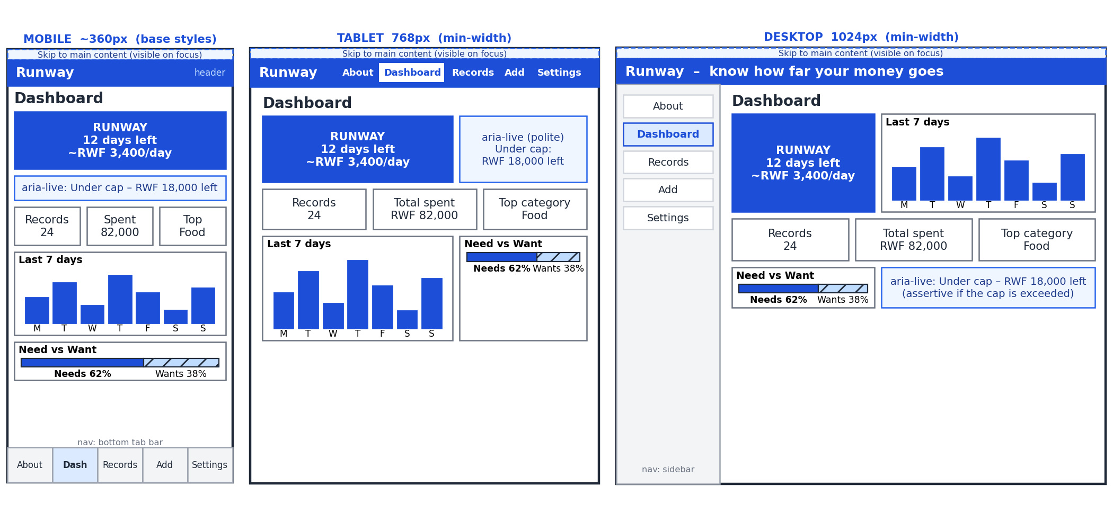
Notes: The Runway card is always first and largest. The cap message is an ARIA live region. The bar chart has a text table alternative.

4.3 Records
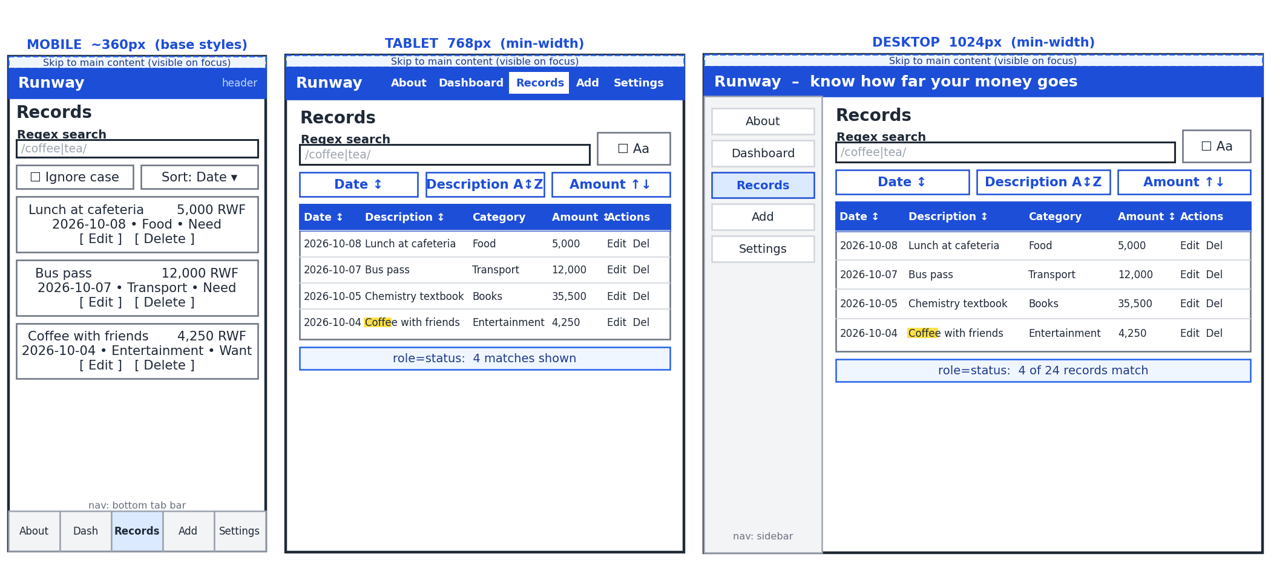
Notes: Regex search with an ignore-case toggle; matches are wrapped in <mark>. Sort by date, description or amount. A status line announces the match count.

4.4 Add / Edit expense
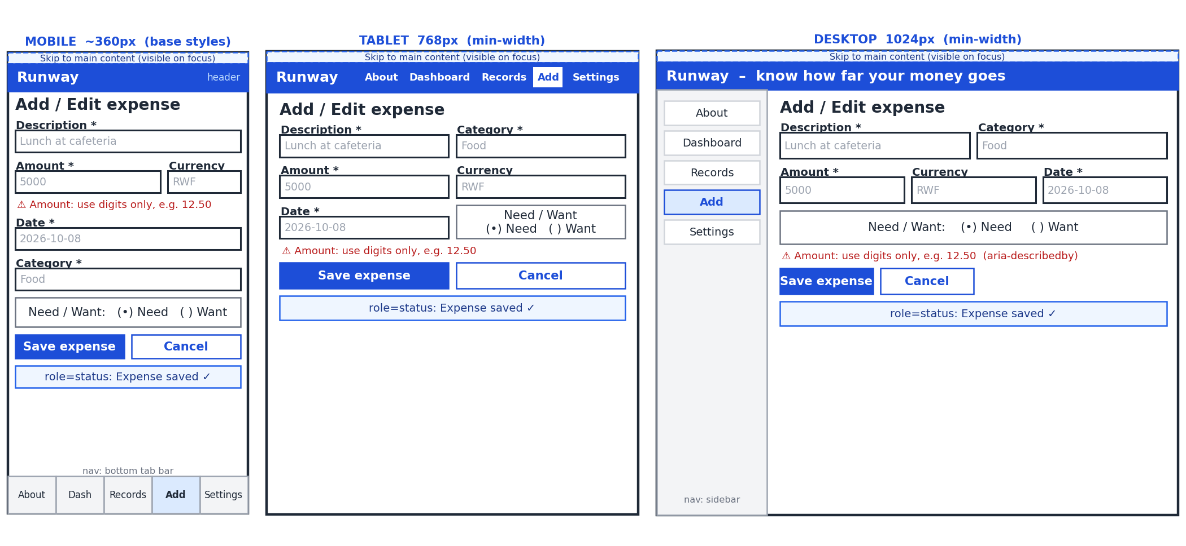
Notes: Visible labels bound to inputs; errors under each field; "Expense saved" announced in a role="status" region. Need/Want is a fixed radio pair.

4.5 Settings
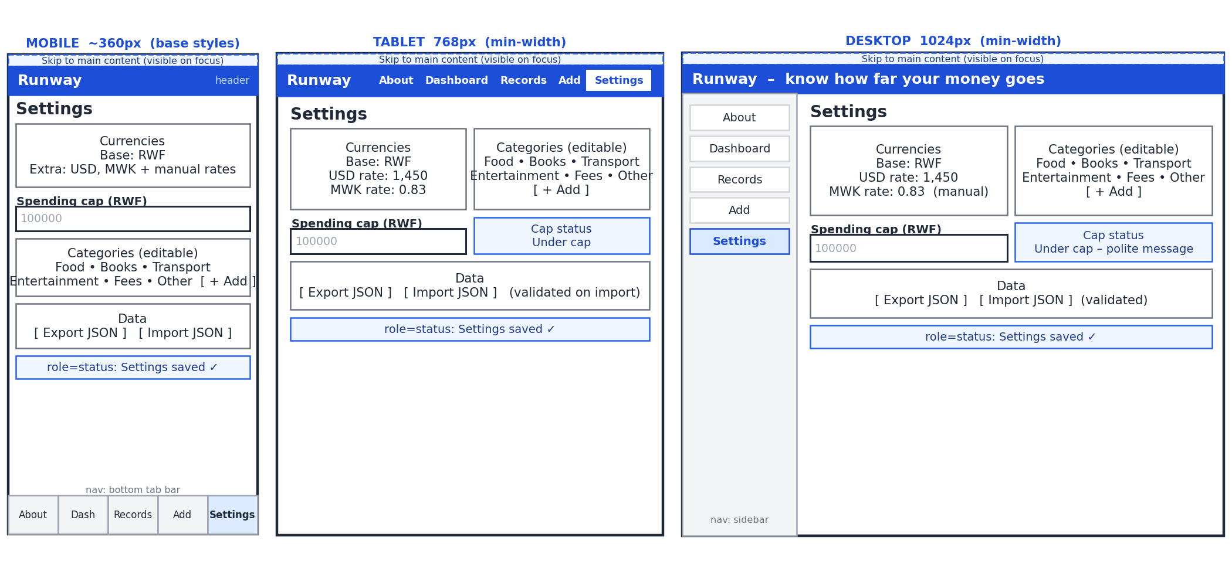
Notes: Base currency plus two others with manual rates, spending cap, editable categories, and JSON import/export (validated before loading).

5. Accessibility Plan
Requirement | What I will build | How I will test it
Landmarks and headings | <header>, <nav>, <main>, five <section>s each with an <h2>, <footer>; one <h1>, no skipped levels | Browser accessibility tree
Skip link | "Skip to main content" is the first focusable element and shows on focus | Press Tab on page load
Labels and forms | Every input has a visible <label for>; Need/Want radios sit in a <fieldset> with a <legend> | Click each label
Keyboard-only use | Everything works with Tab, Shift+Tab, Enter, Space and Esc, in an order that follows the visual layout | Add, edit, search, sort, delete and import with no mouse
Visible focus | Outline of at least 3px, never removed with outline: none | Tab through the app
Live regions | role="status" for saves, search counts and under-cap messages; role="alert" for over-cap and failed imports | Screen reader or browser inspector
Colour contrast | Text at least 4.5:1, controls 3:1; Need/Want and cap state always use text or icons, not colour alone | Lighthouse; WebAIM checker
Highlight and chart | <mark> with underline as well as background; chart sits in a <figure> with a text table | Read both with a screen reader
Delete confirmation | Native <dialog>: focus moves in, Esc cancels, focus returns to the row | Delete using only the keyboard
Responsive and motion | Works at 360, 768 and 1024px; touch targets at least 44px; transitions respect prefers-reduced-motion | Browser device toolbar

Keyboard map: Tab / Shift+Tab move through controls; Enter or Space activate buttons; Esc cancels an edit or closes the delete dialog; arrow keys switch Need/Want; / (outside a text field) jumps to the search box.
Integrity: all HTML, CSS and JavaScript will be written by me. AI is used only for documentation and seed data, as the brief permits.

