Integrated Personal Mobility Services Architecture:

A need beyond WWW

Anirach Mingkhwan, Madjid Merabti, Bob Askwith

School of Computer and Mathematical Sciences
Liverpool John Moores University,
Byrom Street, Liverpool L3 3AF, UK.
Email: {cmsaming, M.Merabti, R.Askwith}@livjm.ac.uk

Abstract
Today, mobile users already utilize a wide variety of mobile terminal ranging from simple mobile phones and personal digital assistants (PDA) to high-end multimedia notebooks. Personal mobility services require an advanced architecture that integrates support protocol, mechanisms, and special functionality to dynamically reconfigure applications when users change from one terminal to another. This convergence raises the challenge of managing services while users roam from one device to another. Personal mobility also has to deal with new information spaces where information is not just coming from the Internet but also from other equipment nearby and the environment around them.
This paper introduces an architecture that enables personal mobility. There are five components to a comprehensive solution to this problem: 1) allowing services mobility, 2) building underlying discovery and connectivity services architecture in information spaces, 3) free format application skin definition, 4) services connectivity agent, 5) services connection mode (visible/invisible).

- Introduction
The convergence of mobile equipment and wireless technology bring us to a new era of mobile computing. Many kinds of small devices free the user from their desk enabling them to move around whilst still remaining connected to the network to continue their work.
Personal mobility [1] is another extension to mobile computing. In real life we are not just using only one type of device. Starting from our desktop PC, Notebook on the train, and PDA on the road or a smart Mobile Phone.
All these devices have different properties, user interfaces and capabilities. All these small processing devices open up the new paradigm that is called a “Smart Space”, when all devices become alive [2,3].



Figure 1. Personal Mobility and their devices
Although many mobile computing systems supports are being proposed [4,5,6,7,8] none of them address the problem of how to integrate all the services that are needed to support personal mobility underlying. In particular how to manage the working state when users disconnect (unintentionally or by design) and then re-connect to carry-on computation where they left off. This is further complicated by the likely change in the connecting device e.g., PC to PDA and its implications.
When an end-user can get their information not just from their machine or Internet but also from their environment and equipment nearby and we name it “Information Space”. In this information space devices can communicate with other devices and servers to exchange information and get the services they need.
- Information Space Requirements
Information that comes from Information spaces can be group as:
- Information from an internet can be separated into 3 types:
  - Pull information - information that users retrieve from the network by submitting their request to the network.
  - Push information - a set of data relevant to the user needs, extracted from their profile, are sent from network to user.
  - Event monitoring information – a set of data reported to user according to user specified rules (e.g. Tell me if my stock is lower than 300).
- Local Information Filtering, by using GPS system or name of the place, mobile equipment can perform a location filters included such things as traffic and weather reports; nearby restaurants and theatres; temporal filters sent "just in time" information such as the advertising of a restaurant's nightly specials menu and discounts. This can be from the network or from the nearby services node.
- Information about other equipment within the range of communication, e.g. in case that user wants to establish a connection with his group [7,8]. By this the tuning algorithm is needed to classify which group of equipment the user wants.

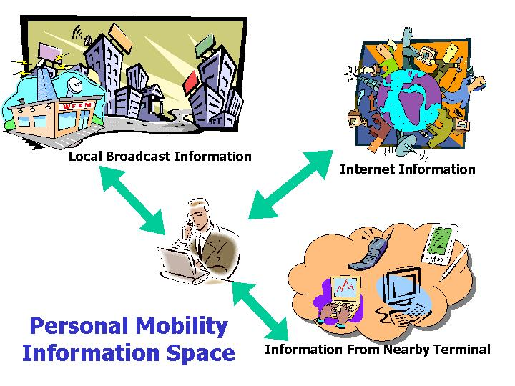
Figure 2 Personal Mobility Information Space
Much recent research has addressed the wide range of issues in mobile computing. Some researchers have focused on reliable connections [4], some, for example MAP [6], provide a middleware layer that works with a mobile host to collect results and mange the data transfer path. AOAC [7], HP Cool Town project [8] and JINI [9] work on an automatic discovery of services and other devices from our physical surroundings using mobile equipment. Partitioning application services has been proposed as a method to enable personal mobility [5]. This work focuses on the capability changing of user terminal and how to continue working on a different user interface. In summary the available research presents many very interesting and useful ideas, however, these works do not meet our requirements for a Personal Mobility Information Space individually or collectively.
This paper introduces an architecture that provides roam-able services to a personal mobility world. The key elements of the architecture we have designed include: 1) an interface definition language that defines what the interface will look like and what service functions will be there, 2) client-user agent that maintains work at the client side and remaps services for users, 3) services node and a definition language that represents what services it can provide to each client terminal, 4) server-user agent that works on behalf of user at the network side and 5) a user profile server that stores user data and profiles.

- Designing a Personal Mobility Services Architecture
The needs of personal mobility from information space go beyond the current WWW architecture. The question is not about whether you can browse the information from WWW server. A simple example of the question here is that when we press the print button which printer will print our job. To achieve this we need additional control and management functionality whilst roaming. We need underlying services support architecture on both server side and client side, something more than just the offers of web pages from WWW servers. This raises the major challenge of how to provide the services to users in a seamless fashion.
Our architecture for personal mobility needs to satisfy the services the following questions:
- Does the user interface have to be the same for every user?
- Do the services of a user interface have to be provided by the same server?
- How can service functionality move along with us while we are roaming?
- How can we continue our work from where we left off (willingly or unintentionally)?
- How can we know what services are available to use when we move to a new environment?
- How to screen information we need when there are a lot of services and information offers?
- Can we make a personal mobility end-user untraceable?
- How can we provide chargeable services to personal mobility terminals?
The challenge posed by these questions is to develop an open services architecture that allows client devices in a personal mobility world to discover what they can do in a new environment, carry on end-user work from the last state and can work on behalf of users while they are off-line.
From the requirement analysis of the above questions, we can derive a set of required or desirable function as:
- Resource discovery and mapping – provided via Jini [9].
- Manage changing environment and deliver the services – this can be available through Mobile-IP [10].
- Visible/Invisible mode of connection - this can be enabled through client and server user agents [11, 15].
- Network side information storage – this requires a user data and profile server.
- User interface and services definition. – XML can be used to create this [12, 13].
- Services Node and services definitions to provide services to client terminal (Charge/Free).

- Integrated Personal Mobility Services Architecture
The Integrated Personal Mobility Services Architecture provides a solution to the personal mobility services problem. The novelty is bringing the new idea of a Services Space that consists of a Services Node that provides a service connection for each user.
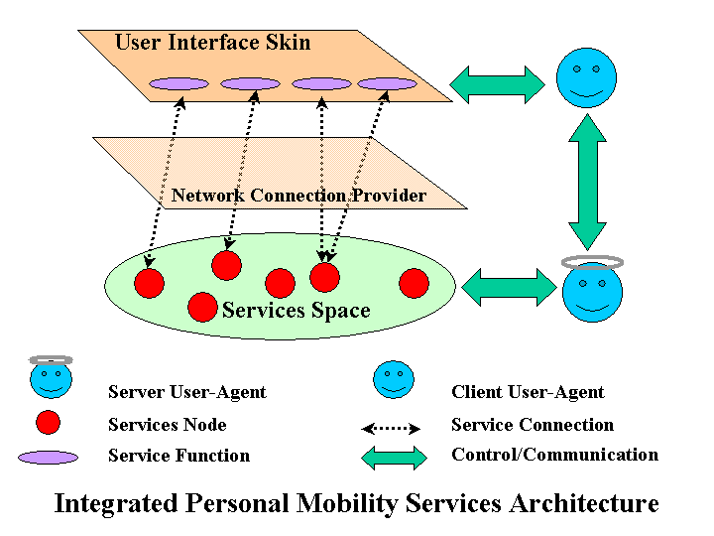
Figure 3 Integrated Personal Mobility Services Architecture.

The main components of the architecture are:
- User Interface Skin is the user interface that may be freely designed by the user. This allows users to get what kind of interface they want. They also can specify how many functions they need on that interface.
- Function is the definition of what kind of services from the network side are executed when the user selects this function (e.g. search, print, map).
- Network Connection Provider is the layer 1-3 of the OSI seven layers. We are not concerned with this in our work. This work assumes that user can connect to network through some kind of services (LAN, MODEM, IEEE 802.11, Bluetooth, IrDA, HomeRF).
- Services Space is a definition perspective of places that has a services node. This services space can be a place nearby or a services node far away that provide services through the network.
- Services Node is a node that is connected to network and provides services for personal mobility equipment. Types of services are both free and charging. This services node has a services definition that can be discovered by the user equipment if they are nearby and also can be located through the network as well. An example of this services node could be the printer at the airport that can print and charge for service.
- Service Connection is representing the link between Function on the User Interface Skin and Services Node. This link can be changed to another node that provides the same function if current node is out of service or beyond the range that can connect.
- Control/Communication is representing the path used to communicate between two Services Agents. This path is secured to send the code or name between network and user equipment. This enables a user to establish the connection with the network by both visible and invisible modes. The invisible mode connection allows the users movements to be untraceable.

- Server User-Agent is an intelligence component that works on behalf of user on the network side to provide services, negotiate and carry on end-user work while they are off-line.
- Client User-Agent looks after a services connection for the user and remaps it again if the user moves to a new environment to keep the services available.

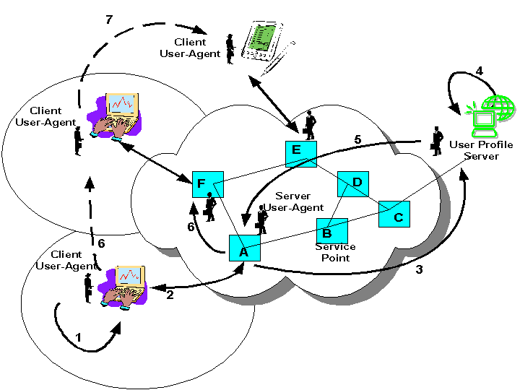
Figure 4 Overview of the working Architecture
In this system we can see how the client and server user agent facilitate Personal Mobility in the following steps:
- When a user turns their terminal on the Terminal will create a Client User-Agent that works properly with it. The Client User-Agent starts gathering information from the environment, discover services, show all information and service to the user according to the user interface skin definition and restores the last working state.
- When the user wants to connect to the network the Client User-Agent will select the best offer from the services node to get the best Service Point (negotiate parameter can be cost and QoS) and establish the connection, this is a visible mode. In invisible mode it will use the provider and secret code to connect to the network.
- Client User-Agent will send all the working parameters of the establishment to the User Profile Server to create a Server User-Agent.
- The User Profile Server launches the Server User-Agent, which is suitable for those kinds of terminal that Client User Agent is working on. It then packs up the last state of work and necessary information.
- The Server User-Agent migrates to the service point to work with Client User-Agent. This can reduce the network traffic between the terminal and service point. The working condition could be like the following:
  - Filtering only data appropriate to the Terminal by determining the QoS and cost [14].
  - Working with other selling or service provider agents in multi agent systems.
  - Send a mobile agent to work for the needed information if necessary.
  - Carry on the work and call back when all done.
  - Carry on the working state in case of unreliable connection.
- Server User-Agent and Client User-Agent working together to keep all service functions available to the user. Server User-Agent will migrate to the new service point after successfully establishing the session (This is a case of terminal mobility).
- In case the user has to disconnect from the network (personal mobility) all the working state will be saved. If the current work is not finished the Server User-Agent will carry on the work and supply all needed information until it is finished and go back to the User Profile Server, save the working state and wait for the user to connect to the network again.
Note that On-line and Off-line working functions that are mentioned here will not maintain the real-time application since it is impossible to do that. However buffer algorithms can be implemented for a very short time whilst disconnected. In case of the system going off-line and being unable to come back on-line again both Client User-Agent and Server User Agent take care of all transaction and related data to make sure that the system can go back to work properly after it restarts again.
At the service point side the service provider can implement the proxy algorithm that can share the same information between Server User-Agents and also the library used by Server User-Agents.
- Future Work
We are currently at the design stage and investigating implementation approaches that can suit our architecture. The implementation of the prototype is aimed to operate within the university environment by providing services to Desktop PC, Notebook, PDAs and Mobile Phone.
The prototype will target a Personal Information Management System that also includes Internet and services nodes as defined in our information spaces. A services node will include both free and chargeable services like print services, photocopy and university information.

- Conclusion
We have presented an architecture for “Integrated Personal Mobility Services” allowing a user to continue working with applications, discover and remap service function while they are roaming.
The key elements of the architecture we have designed include: 1) an interface definition language that defines what the interface will look like and what service functions will be there, 2) client-user agent that maintains work at the client side and remaps services for users, 3) services node and a definition language that represents what services it can provide to each client terminal, 4) server-user agent that works on behalf of user at the network side and 5) a user profile server that stores user data and profiles.
We are focusing our work at the services layer to support personal mobility paradigm that include both wired and wireless devices.

References

[1] S. Campadello, K. Raatikainen, “Agents in Personal Mobility”. In Proceedings of the First International Workshop on Mobile Agents for Telecommunication Application (MATA'99) Ottawa Canada October 6-8 1999 World Scientific, pp. 359-374.

[2] L. Kleinrock, "Nomadicity: Anytime, Anywhere In A Disconnected World", Mobile Networks and Applications, Vol. 1, No. 4, January 1996, pp. 351-357.

[3] L. Kleinrock., "Nomadic Computing and Smart Spaces", IEEE Internet Computing, Vol. 4, No. 1, pp. 52-53, Jan.-Feb. 2000.

[4] M. Yarvis, P. Reiher, and G. J. Popek. , “A Reliability Model for Distributed Adaptation”, Third IEEE Conference on Open Architectures and Network Programming (OPENARCH 2000), Tel-Aviv, Israel, URL: http://fmg-www.cs.ucla.edu/Conductor/

[5] O. Koskimies, K. Raatikainen: “Partitioning Applications with Agents”, In Proceeding of the Second International Workshop on Mobile Agents for Telecommunication Applications (MATA2000), pp. 79-93. Lecture Notes in Computer Science, Springer Verlag, September 2000.

[6] A Duda, S Perret, “Mobile Agent Architecture for Nomadic Computing”, In Proceeding of the International Conference on Computer Communications, Cannes, 1997, URL: http://citeseer.nj.nec.com/duda97mobile.html

[7] K. Flemming, R. J. Hunter, J. Inouye, J. Schiffer. , “Enabling Always On, Always Connected (AO/AC) Computing with Bluetooth Technology”, Intel Technology Journal Q2, 2000, URL: http://developer.intel.com/technology/itj/q22000/articles/art_3.htm

[8] D. Caswell, “Creating A Web Representation For Places”, HP Cool Town Project, October, 2000 URL: http://www.cooltown.hp.com/papers.htm

[9] Jini Technology Architecture Overview URL: http://www.sun.com/jini/whitepapers/
architecture.html

[10] C. Perkins., “Mobile Networking Through Mobile IP”. IEEE Internet Computing, January-February, 1998

[11] B. Askwith, M. Merabti, Q. Shi., “MNPA: a mobile network privacy architecture”, Computer Communications 23 (2000) pp. 1777-1788

[12] N. Walsh., “A Technical Introduction to XML” March, 1998, URL: http://www.xml.com/pub/a/98/10/guide0.html

[13] T. Hodes, R. Katz, E. Servan-Schreiber, and L. Rowe. “Composable Ad hoc Mobile Services for Universal Interaction”. In Proceedings of the 3rd ACM International Conference on Mobile Computing and Networking, pp. 1-12, 1997 URL: http://citeseer.nj.nec.com/hodes97composable.html

[14] R. Titmuss, C. Winter, B. Crabtree, "Agents, Mobility & Multimedia Information”, In Proceedings of the First International Conference on the Practical Application of Intelligent Agents and Multi-Agent Technology, London, 1996

[15] J. Li, M. Yarvis, and P. Reiher. “Securing Distributed Adaptation”,
In Proceedings of the Fourth IEEE Conference on Open Architectures and Network Programming (OPENARCH 2001), Anchorage, Alaska, April 2001.

