FACULDADE DE ENGENHARIA DA UNIVERSIDADE DO PORTO

Influence of outliers in a railway remote monitoring system

Vítor A. Morais

DRAFT VERSION


Programa Doutoral em Engenharia Electrotécnica e de Computadores

Supervisor: António P. Martins

June 28, 2017

Influence of outliers in a railway remote monitoring system

Vítor A. Morais

Programa Doutoral em Engenharia Electrotécnica e de Computadores

June 28, 2017

Abstract

This work addresses the problem of outlier detection in a railway wireless sensor network for energy monitoring purposes. Based on the state of the art, an important contribution of a wire-less sensor network in the railway system is the availability of useful knowledge of the energy consumption to the decision support systems.
Therefore, such acquisition systems are required to provide accurate data regardless of the quality of the acquisition sensors, electromagnetic influences (EMI), sensor supply fluctuations, among others.
Through computational algorithms, the increasing of communication reliability and fault tol-erance is possible. Those computational algorithms detect outliers or, in the scope of this PhD, detect erroneous data that will perturb the outcomes of decision support systems.

i

ii

Contents

1 | Introduction |  |  | 1
 | 1.1 | Context and motivation of PhD . . . . . . . . . . . . . . . . . . . . . . . . . . . |  | 1
 | 1.2 | Shift2Rail Framework . . . . . . . . . . . . . . . . . . . . . . . . . . . . . . . . |  | 1
 | 1.3 | PhD state of the art . . . . . . . . . . . . . . . . . . . . . . . . . . . . . . . . . |  | 2
 | 1.4 | Influence of outliers in a railway remote monitoring system . . . . . . . . . . . . |  | 3
 | 1.5 | Document structure . . . . . . . . . . . . . . . . . . . . . . . . . . . . . . . . . |  | 3
2 | Outliers Detection |  |  | 5
 | 2.1 | Definition of outlier detection . . . . . . . . . . . . . . . . . . . . . . . . . . . . |  | 5
 | 2.2 | Outlier detection in WSNs . . . . . . . . . . . . . . . . . . . . . . . . . . . . . |  | 7
 |  | 2.2.1 | Motivation . . . . . . . . . . . . . . . . . . . . . . . . . . . . . . . . . | 7
 |  | 2.2.2 | Research areas . . . . . . . . . . . . . . . . . . . . . . . . . . . . . . . | 7
 |  | 2.2.3 | Challenges . . . . . . . . . . . . . . . . . . . . . . . . . . . . . . . . . | 8
 | 2.3 | Classification of outlier . . . . . . . . . . . . . . . . . . . . . . . . . . . . . . . |  | 9
 | 2.4 | Taxonomy of Outlier Detection Techniques . . . . . . . . . . . . . . . . . . . . |  | 11
 | 2.5 | Classification based techniques . . . . . . . . . . . . . . . . . . . . . . . . . . . |  | 12
 |  | 2.5.1 | Bayesian Networks . . . . . . . . . . . . . . . . . . . . . . . . . . . . . | 13
 |  | 2.5.2 | Rule-based techniques . . . . . . . . . . . . . . . . . . . . . . . . . . . | 15
 |  | 2.5.3 | Support Vector Machines . . . . . . . . . . . . . . . . . . . . . . . . . . | 16
 | 2.6 | Statistical based techniques . . . . . . . . . . . . . . . . . . . . . . . . . . . . . |  | 18
 |  | 2.6.1 | Parametric — Gaussian based . . . . . . . . . . . . . . . . . . . . . . . | 18
 |  | 2.6.2 | Non-parametric — Histogram based . . . . . . . . . . . . . . . . . . . . | 18
 |  | 2.6.3 | Non-parametric — Kernel function based . . . . . . . . . . . . . . . . . | 19
 | 2.7 | Nearest Neighbor-based techniques . . . . . . . . . . . . . . . . . . . . . . . . . |  | 20
 |  | 2.7.1 | Using distance . . . . . . . . . . . . . . . . . . . . . . . . . . . . . . . | 20
 |  | 2.7.2 | Using relative density . . . . . . . . . . . . . . . . . . . . . . . . . . . . | 20
 | 2.8 | Clustering based techniques . . . . . . . . . . . . . . . . . . . . . . . . . . . . |  | 21
 | 2.9 | Spectral Decomposition-based approach . . . . . . . . . . . . . . . . . . . . . . |  | 22
 | 2.10 | Synthesis . . . . . . . . . . . . . . . . . . . . . . . . . . . . . . . . . . . . . . |  | 23
3 | Future Research |  |  | 25
 | 3.1 | Evaluation of effect of undetected outliers in railway WSN . . . . . . . . . . . . |  | 25
 | 3.2 | Selection of Outlier detection mechanism . . . . . . . . . . . . . . . . . . . . . |  | 26
4 | Conclusion |  |  | 29

iii

Chapter 1

Introduction

This chapter presents the context, motivation and document structure of a study of outlier detection in a railways WSN-based smart grid.

1.1 Context and motivation of PhD

The railway system is responsible for 1.3% of entire European energy consumption, Birol and Loubinoux (2016). The discussion of the energy efficiency in railways is a grown topic due to its contribution to the global energy consumption.

The energy efficiency analysis and management requires a detailed mapping of the energy consumption/generation in the railway system.

This detailed mapping of the energy flows should include, not only the rolling stock level but also the traction substations and the auxiliary services.

The knowledge of all the load curves permits the load prevision, peak shaving and energy cost optimization for all global railway system.

1.2 Shift2Rail Framework

This work is supported by the iRail PhD programme – Innovation in Railway Systems and Tech-nologies whose objectives are aligned with the Shift2Rail objectives, Shift2Rail Joint Undertaking (2015):

1. Cutting the life-cycle cost of railway transport by as much as 50%; 2. Doubling the railway capacity;

3. Increasing the reliability and punctuality by as much as 50%.

Framed on the Shift2Rail (S2R) Innovation Programme 3 (IP3) with the focus on ”Cost effi-cient and reliable infrastructure”, it is proposed to develop a Smart Metering Demonstrator (SMD) that reach a detailed monitoring and supervision of various energy flows on the premises of em-brace the entire Railway System.

1

2 Introduction
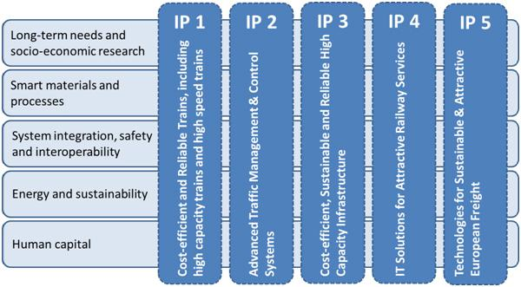

Figure 1.1: Shif2Rail Inovation Programmes.

The purpose of any energy management strategy is to build the dynamics of every loads and generators of the power system.

This should be performed based on an extensive knowledge of every energy flows.

This way, the SMD is required to propose and validate a standard metering architecture that involves the coordination of every measurements either in on-board and in ground. In advance, energy data analysis should be provided based on relevant stored data.

1.3 PhD state of the art

This section will cover a summary of the state of the art that supports this PhD.

Based on the state of the art, current metering systems focus on rolling stock on-board en-ergy meters for energy billing purposes only, where the metering devices are located close to the pantograph, Shift2Rail Joint Undertaking (2015).

An advance beyond the state of the art is the expansion of the measurement system at railway system level, making it a distributed one, including both on-board and track-side measurements, thus achieving detailed mappings.

Other point in the state of the art is the intrusion level of currently used metering systems, that in one way, became a critical subsystem of the rolling stock and in other way, requires relatively long implementation, Shift2Rail Joint Undertaking (2015).

An advance beyond the state of the art is a solution based on non-intrusive technology. More detailed simulation models in conjunction with field measurements is the methodology to be in-vestigated.

Specific challenges and requirements of this research are the development of non-intrusive Wireless Sensor Networks (WSN) in the railway environment. It is intended that this technology should be based on an open system and open interfaces for the data collection, aggregation and analysis. Issues like metering redundancy, outlier detection, fault tolerance and communication reliability, should be considered during the research. In addition, it is expected to design and
1.4 Influence of outliers in a railway remote monitoring system | 3

specify a set of user applications. Those applications are focused in the energy analysis process with the aim of providing more information and detailed knowledge. It is expected that this de-tailed knowledge would be useful in a decision support system related with, in e.g., eco-driving strategies, timetable planning and preventive maintenance.

1.4 Influence of outliers in a railway remote monitoring system

Having in mind the state of the art that was previously presented in section 1.3, an important con-tribution of a wireless sensor network in the railway system is the availability of useful knowledge of the energy consumption to the decision support systems.

Therefore, such acquisition systems are required to provide accurate data regardless of the quality of the acquisition sensors, electromagnetic influences (EMI), sensor supply fluctuations, among others.

Through computational algorithms, the increasing of communication reliability and fault tol-erance is possible. Those computational algorithms detect outliers or, in the scope of this PhD, detect erroneous data that will perturb the outcomes of decision support systems. Further on in chapter 2, this thematic is extensively explored.

1.5 Document structure

This document is divided in 5 chapters, each of them incorporate the relevant subsections to present the subjects mentioned.

Table 1.1: Document structure

Chapter Title

- Introduction

- Outliers Detection

3Future Research

4Conclusions
4 Introduction

Chapter 2

Outliers Detection

In this chapter it is made the study of the state of the art of outliers and it’s relevance in railways. In section 2.1 is defined what is an outlier either with base on the literature and with base on the scope of the PhD. In section 2.2 is covered the motivation, research opportunities and challenges in outlier detection for Wireless Sensor Networks (WSNs) and for the scope of the PhD. In section 2.3 different aspects of outlier detection that has been used in the literature are presented. In
section 2.4 the taxonomy to divide and classify the different techniques is presented.

The remaining sections will extensively cover the different techniques. Section 2.5 covers the classification techniques; Section 2.6 presents the statistical based techniques; In section 2.7 the nearest neighbor techniques are covered; Section 2.8 presents the cluster-based techniques and section 2.9 covers the Spectral-based techniques.

In section 2.10 is made a synthesis of the outlier detection techniques for WSNs.

2.1 Definition of outlier detection

Outlier detection is a computational task to detect and retrieve information from erroneous data values. The definition is usually close to anomaly detection or deviation detection.

Branch et al. (2006) identifies the outlier detection as an essential step to either suppress or amplify outliers and precedes most any data analysis routine. Abid et al. (2016) points the need of detecting aberrant data and sensors within an WSN. Zhuang and Chen (2006) extends the outlier definition to the case where the outliers introduce in sensing queries and in sensing data analysis.

In the scope of the PhD and as previously presented in chapter 1, an outlier is a data value or a data instance that do not represent the correct consumption status.

The threshold of what is an outlier or not (or a value that do represent the correct consumption status or not) is given by the output of the subsystem that is immediately after the acquisition of consumption status subsystem, the decision support subsystem, gave a correct output or not. Figure 2.1 illustrates the integration of the consumption acquisition subsystems with the decision support subsystem.

5

6 Outliers Detection
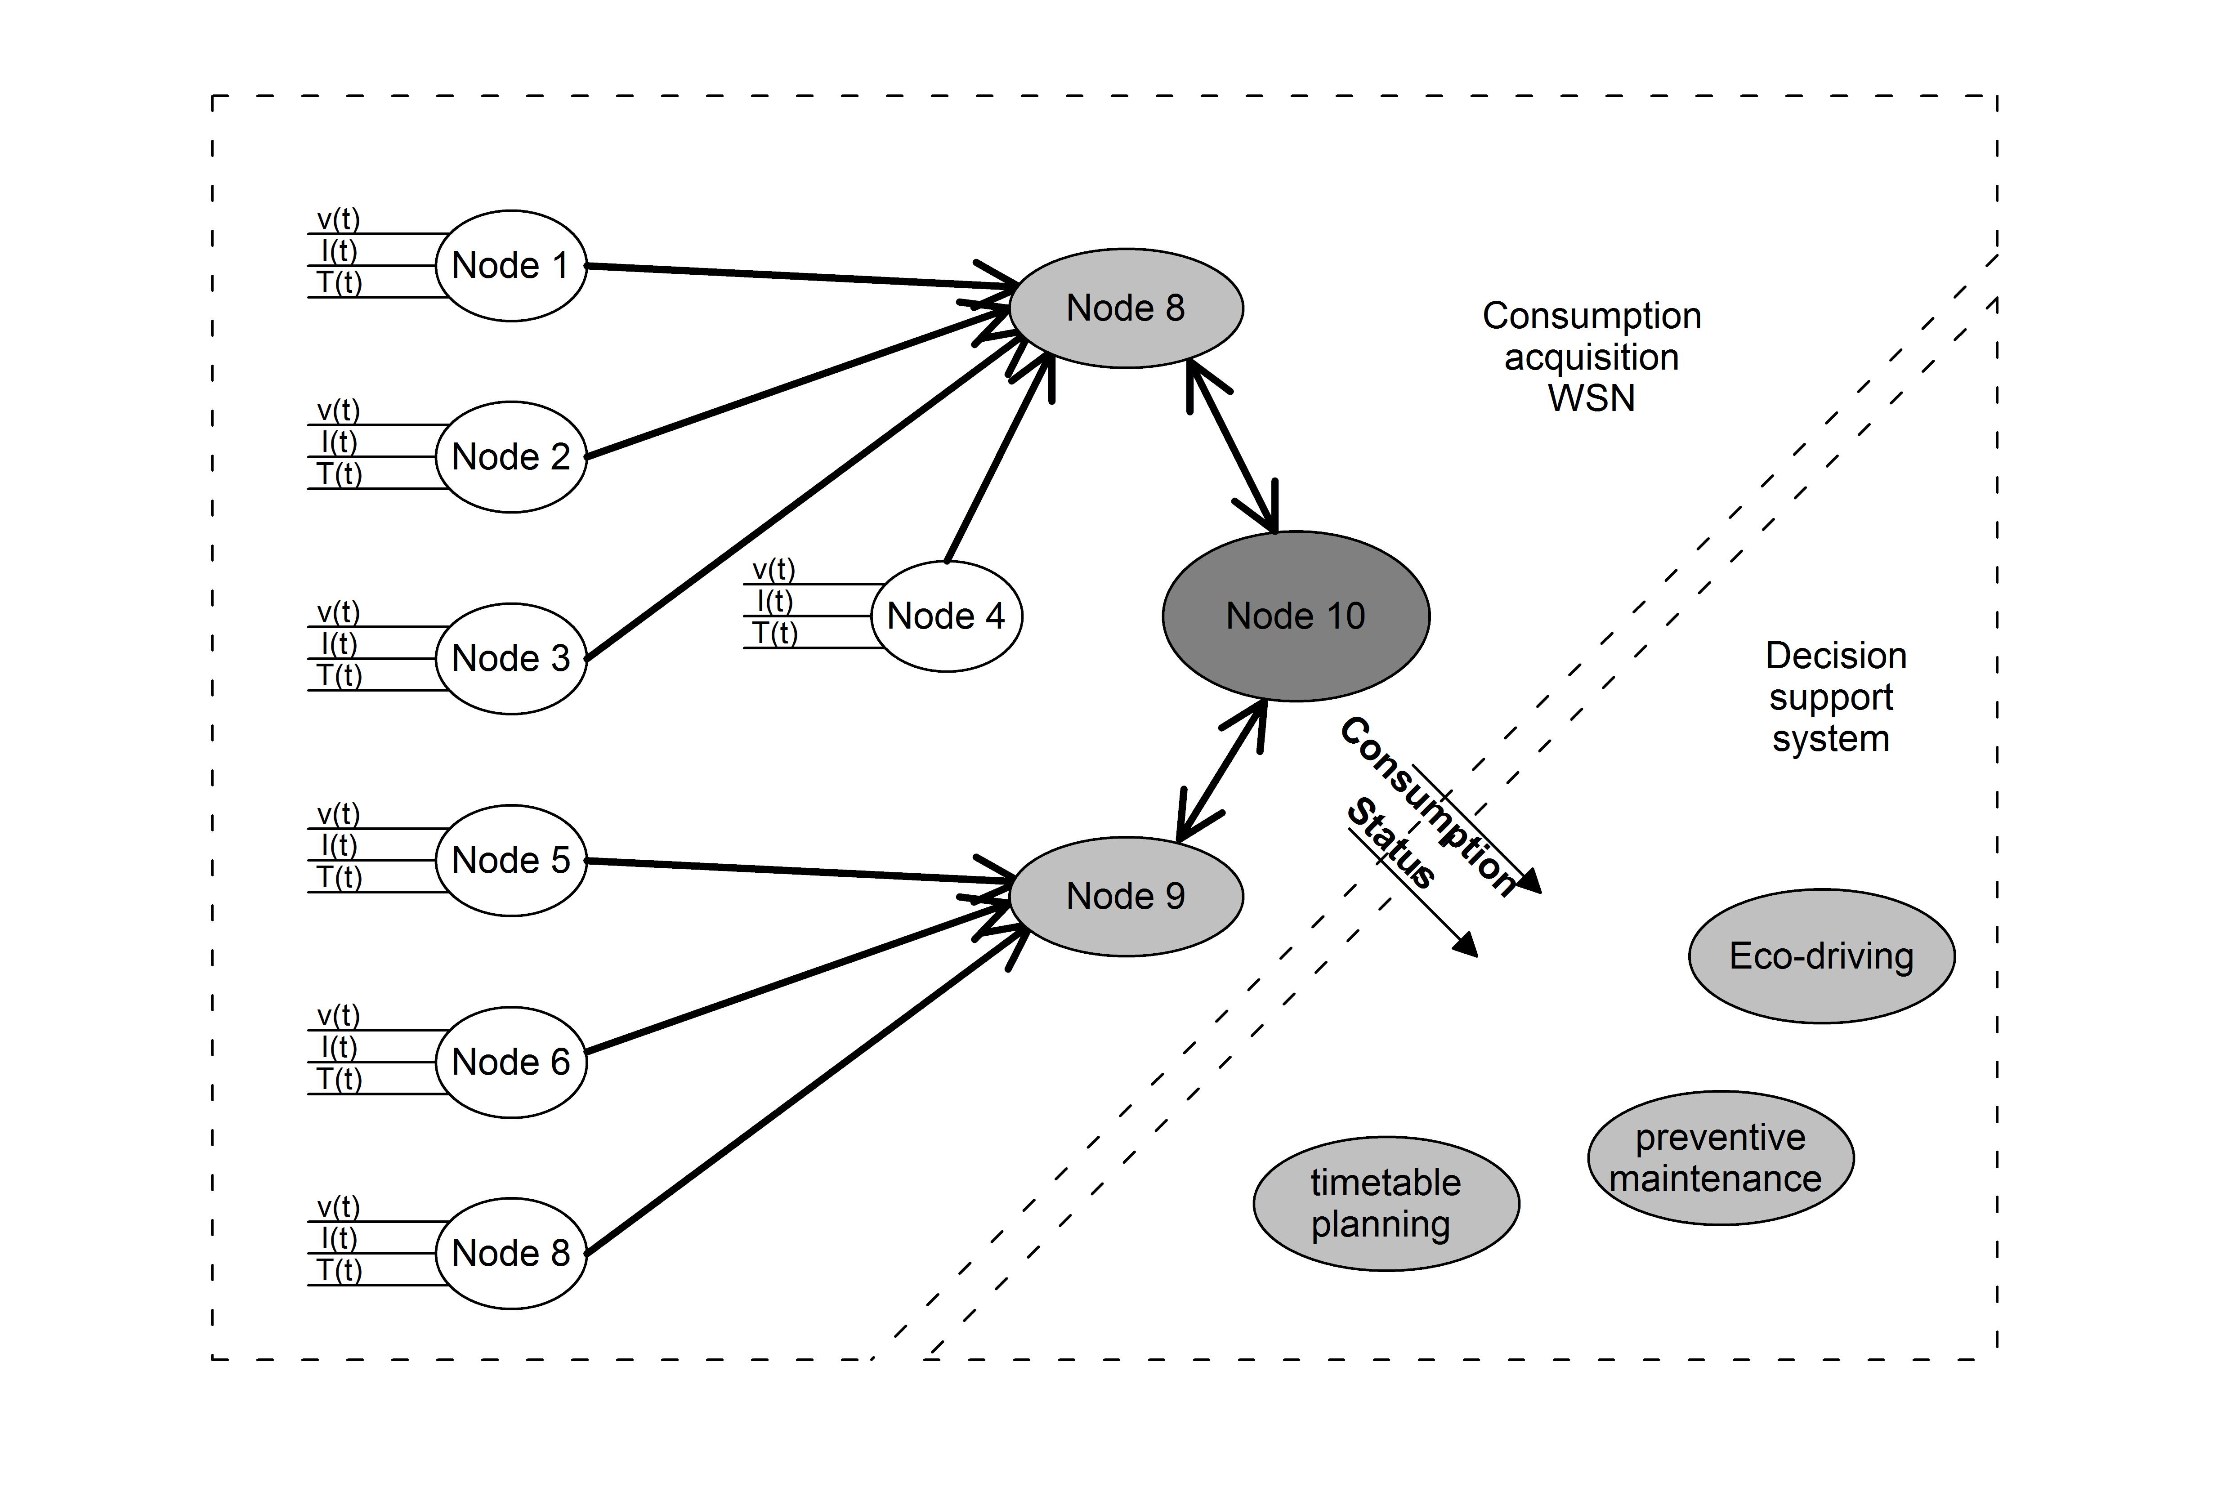

Figure 2.1: Integration of the WSN with a decision support system.

Without an outlier detection mechanism, the decision support subsystem may have the follow-ing outputs:

Input deviation from real value lower than a threshold The Decision Support Subsystem out-put is according to the real consumption conditions.

Input deviation from real value greater than a threshold The Decision Support Subsystem out-put is not according to the real consumption conditions.

The problem of taking decisions based on wrong considerations of the consumption status may lead to loss in desirable efficiency or increase of costs.

Let us consider a simple and hypothetical example where the DSS will provide an output towards suggesting an action in preventive maintenance based on the usage of a component. Con-sidering that the usage of the component is depending on the counting of situations that the com-ponent is working above the nominal conditions. Without an outlier detection mechanism, the outliers will induce the DSS to count situations of overcharge of the component where the mea-surement is not related to the working above the nominal conditions but is related to external influences such as EMI or temperature. The output of DSS may suggest a preventive maintenance on a component that is working in proper conditions.
To conclude, with an outlier detection mechanism in the consumption acquisition subsystem the decision support subsystem may know if the value of consumption is an outlier or not and, with that information, the DSS output will be more accurate with the real conditions of operation.
2.2 Outlier detection in WSNs | 7

2.2 Outlier detection in WSNs

Wireless sensor networks (WSNs) has been widely used in several applications in several domains such as industrial, scientific, medical and others. Those applications have been supported by the advances in wireless technologies as well as in the evolution of microcontroller technologies, with enhanced processing capabilities associated with reduced energy consumption.

2.2.1 Motivation

Rajasegarar et al. (2007) points an important motivation for the inclusion of computational algo-rithms, i.e. outlier detection algorithms, to reduce the transmission of erroneous data, since in WSNs, the majority of the energy consumption occurs in the radio communication. In particular, they present the case of Sensoria sensors and Berkeley motes where the energy consumption in communication exceeds in ranges from 1000 to 10000 the energy consumption of computation.
Thus, a research opportunity is raised to reduce the communication usage of mCs by adding processing features where the small increase in the computation will significantly reduce the en-ergy consumption in the transmission. These processing features are, among others, the outlier detection algorithms.

On the field of the quality of the data acquired by WSNs, the motivation of detecting outliers in data acquired from WSNs has been extensively presented in the literature. The need for acquire data from harsh or "highly dynamic" environments as well as the need to validate and extract knowledge from the acquired data are one of the main points in the motivation to study the outlier detection in WSNs, Zhang et al. (2010); Chandola et al. (2009); Ghorbel et al. (2015); Martins et al. (2015).

2.2.2 Research areas

Zhang et al. Zhang et al. (2010) identifies the outlier detection research areas in three domains:

Intrusion detection: Situation caused by malicious attacks, where the detection techniques are query-driven techniques;

Fault detection: Situation where the data suffer from noise and errors and where the detec-tion techniques are data-driven ones;

Event detection: Situation caused by the occurrence of one atomic or multiple events and where the majority of the research has been developed due to its complexity.

Based on the division of this three domains, the upcoming research is intended to be focused on the event detection and fault detection techniques. Specifically, the main goal for this research will be the event detection algorithms.
8 Outliers Detection

2.2.3 Challenges

The challenges of outlier detection in WSNs are related to the quality of the acquisition of the sensors, the reliability of the modules in terms of energy or environmental susceptibility, and the communication requirements and restrictions.

Zhang et al. Zhang et al. (2010) lists the challenges as the following:

Resource constraints;

High communication costs; Distributed streaming data; Dynamic network topology,

frequent communication failures, mobility and heterogeneity of nodes;

Large-scale deployment; Identifier outlier sources;

Branch et al. (2006) identifies an important challenge, where the probability of occurrence of outlier events are extremely small. Abid et al. (2016) as well as Sheng et al. (2007) identifies the large amount of data as the main challenge for outlier detection in WSN. Zhuang and Chen (2006) identifies the inexpensive and low fidelity sensors as the main reason for the error generation and, the main challenge are identified on the distributed streaming data among a large amount of sensors. Ghorbel et al. (2015) points a main challenge as the processing of data from sensors that generates continuously data that is uncertain and unreliable.
To conclude, and in the scope of the PhD, the main challenges will be the usage of inexpensive and low fidelity sensors that will be affected by the rush railway environment. Complementary, the main challenge of using outlier detection mechanisms in the railway WSN is the balance between the detection accuracy and the influence that undetected data-instances will induce in other sub-systems (in particular in decision support systems dependent on data from the WSN). In addition, the detection accuracy is directly related with the memory usage, computational requirements, communication overhead, etc.
2.3 Classification of outlier | 9

2.3 Classification of outlier

Zhang et al. (2010) presents aspects to be used as metrics to compare characteristics of different outlier detection techniques. In parallel, Chandola et al. (2009) presents a similar approach for the classification of outlier detection. In table 2.1 is present a comparison between two approaches to classify the nature of input sensor data.

Table 2.1: Classification of outlier techniques according to the nature of the input sensor data

 | Zhang et al. |  |  |  | Chandola et al.
 |  | univariate or |  | Described |  | different types
 | Attributes | univariate or |  | Described |  | (binary, categorical, continuous)
 | Attributes | multivariate |  | using |  | (binary, categorical, continuous)
 |  | multivariate |  | using |  | quantity:
 |  |  |  | attributes |  | quantity:
Input |  |  | Nature of | attributes |  | i) univariate;
sensor |  |  | input |  |  | ii) multivariate w/ same type;
data |  |  | data |  |  | iii) multivariate w/ different data types;
 |  | dependencies among |  |  |  | In sequence data, the data instances
 |  | dependencies among |  |  |  | are linearly ordered, for example,
 |  | the attributes of |  |  |  | are linearly ordered, for example,
 |  | the attributes of |  | Related to |  | time-series data, genome sequences,
 |  | sensor nodes |  | Related to |  | time-series data, genome sequences,
 |  | sensor nodes |  | each other |  | and protein sequences.
 | Correlations |  |  |  |  | In spatial data, each data instance
 |  |  |  |  |  | is related to its neighboring instances,
 |  |  |  |  |  | for example, vehicular traffic data,
 |  | dependency of sensor |  |  |  | and ecological data.
 |  | dependency of sensor |  |  |  | When the spatial data has a temporal
 |  | node readings on |  |  |  | When the spatial data has a temporal
 |  | node readings on |  |  |  | (sequential) component it is referred
 |  | history and |  |  |  | (sequential) component it is referred
 |  | history and |  |  |  | to as spatio-temporal data,
 |  | neighboring node |  |  |  | to as spatio-temporal data,
 |  | neighboring node |  |  |  | for example, climate data.
 |  | readings |  |  |  | for example, climate data.
 |  | readings |  |  |  | In graph data, data instances are
 |  |  |  |  |  | represented as vertices in a graph
 |  |  |  |  |  | and are connected to other vertices
 |  |  |  |  |  | with edges.
 |  |  |  |  |  | Can be categorized based on
 |  |  |  | Relationship |  | relationship present
 |  |  |  |  |  | among data instances
 |  |  |  | Applicability |  | for statistical techniques
 |  |  |  | Applicability |  | for nearest-neighbor-based techniques

Based on the work of Zhang et al. (2010) and Chandola et al. (2009), the table 2.2 identifies the different types of outliers. Those types differ on the objective of the outlier detection tech-niques: detect anomalies in individual data instances or in groups of data to detect irregularities, respectively, in local or in the global measuring system.
10 Outliers Detection

Table 2.2: Classification of the outlier techniques based on the type of the outlier/anomaly.

 |  | Zhang et al. |  |  | Chandola et al.
 |  | Variation 1:
 | Local | anomalous values detection |  | Point |  | An individual data instance
Type | outliers | only depends on its historical values | Type | anomalies |  | is considered anomalous,
Type |  | Variation 2; | Type |  |  | with respect to the others
of |  | Variation 2; | of |  |  | with respect to the others
of |  | anomalous values detection | of
outliers |  | anomalous values detection | anomaly
outliers |  | depends on historical values | anomaly
 |  | and on values of neighboring
 |  | Variation 1:
 |  | All data is transmitted |  |  |  | Contextual attributes:
 | Global | to a centralized architecture |  | Contextual |  | are used to determine
 | Global | where outlier detection |  | Contextual |  | the context for a given instance
 | outliers | where outlier detection |  | anomalies |  | the context for a given instance
 | outliers | techniques takes place |  | anomalies
 |  | Variation 2:
 |  | Data from a cluster of sensors
 |  | is used for outlier detection |  |  |  | Behavioral attributes:
 |  | in a aggregate/clustering |  |  |  | defines the noncontextual
 |  | based architecture |  |  |  | characteristics of a
 |  | Variation 3: |  |  |  | given instance.
 |  | Individual nodes can identify
 |  | global outliers if they have
 |  | a copy of global estimator model
 |  | obtained from the sink node
 |  |  |  |  |  | If a collection of related data
 |  |  |  | Collective |  | instances is anomalous
 |  |  |  | anomalies |  | with respect to the entire data set,
 |  |  |  |  |  | it is defined as a collective anomaly.

Table 2.3 continues the classification, focusing in three parts:

The need of pre-classified data (to implement supervised, semi-supervised or unsupervised outlier detection techniques);

The output of outlier detection techniques (binary labels for normal/abnormal data-set and a score for each data-set to evaluate the weight of being an anomaly)
The identity of the outliers (detect errors, events or malicious attacks)
2.4 Taxonomy of Outlier Detection Techniques | 11

Table 2.3: Classification of outlier detection techniques according to: i) need of pre-classified data; ii) output of detection techniques; iii) identity of outliers

 | Zhang et al. |  |  | Chandola et al.
 |  | Require pre-classified |  | Labels obtained by | Training data has labeled instances
Availability | Supervised | Require pre-classified | Data | Supervised | Training data has labeled instances
Availability | Supervised | normal and abnormal data | Data | Supervised | for normal and anomalous classes
of |  | normal and abnormal data | labels: | Anomaly Detection | for normal and anomalous classes
pre-defined |  |  | normal or | Labels obtained by | Training data has labeled instances
data |  | Require only pre-classified | anomalous | Labels obtained by | only for normal class.
data | Semi-supervised | Require only pre-classified | anomalous | Semi-supervised | only for normal class.
 | Semi-supervised | normal data |  | Semi-supervised | There is no labels for the
 |  | normal data |  | Anomaly Detection | There is no labels for the
 |  |  |  | Anomaly Detection | anomalous classes
 |  |  |  | Labels obtained by | Techniques that do not require
 | Unsupervised | Do not require pre-classified data |  | Unsupervised | Techniques that do not require
 | Unsupervised | Do not require pre-classified data |  | Unsupervised | training data
 |  |  |  | Anomaly Detection | training data
 |  | Zero-one classification:
Degree of | Scalar | Classifies a data measurement | Output | Scores | Degree of which a data instance
being an |  | into normal or outlier class | Output | Scores | is consider an anomaly
being an |  | into normal or outlier class | of |  | is consider an anomaly
outlier |  | Assign to each data measurements | of
outlier |  | Assign to each data measurements | Anomaly
 | Score | a outlier score; | Anomaly
 | Score | a outlier score; | detection
 |  | Display a ranked list of outliers | detection
Identity | Errors | Noise-related measurement
Identity | Errors | or data coming from a faulty sensor |  |  | Provide binary labels
of |  | or data coming from a faulty sensor |  | Labels | Provide binary labels
of |  | Particular phenomena |  | Labels | (normal/anomalous)
outliers | Events | Particular phenomena |  |  | (normal/anomalous)
outliers | Events | that changes the real-world state
 | Malicious | Outside of the scope
 | attacks | (In the scope of network security)

2.4 Taxonomy of Outlier Detection Techniques

The study of detection techniques requires a well-defined taxonomy framework that addresses the related work on the different areas. This taxonomy is well defined and solid in the literature, where the works of Zhang et al. (2010) and Chandola et al. (2009) reflect a similar approach on presenting a taxonomy for outlier detection techniques.

In the following sections a coverage in relevant techniques is presented:

Classification based techniques. Bayesian Networks Rule-based techniques

Support Vector Machines

Statistical based techniques. Parametric — Gaussian based Non-parametric — Histogram based

Non-parametric — Kernel function based

Nearest Neighbor-based techniques.

Using distance

Using relative density

Clustering based techniques.

Spectral Decomposition based techniques.
12 Outliers Detection

2.5 Classification based techniques

Classification based techniques are based on systematic learning approaches based on sets of data. The supervised approaches require knowledge to train a model (or classifier) from a set of data instances (or training data) and classifies a new data instance as normal or as outlier. The unsu-pervised approaches do not require knowledge and learn the boundary around normal instances, declaring the new instance as normal or as outlier depending if the data instance is outside of the boundary of the previous data sets.

The classification based techniques are listed as the following:

Neural Networks-based; Bayesian Networks-based; Rule-based;

Support Vector Machines-based.

Neural networks-based approaches are interesting strategies for outlier detection where a given neural network might be trained with only normal data-sets. At testing stage, the data instances that are similar to the training data-set are accepted by the neural network and then considered as normal. The remaining data-sets are rejected by the neural network due to their lack of similarity with normal data-sets. Thus, those data instances are considered as outliers. Based on the table 2.3, these techniques are classified as semi-supervised due to their need for normal data-sets for the training stage.

Bayesian networks-based approaches are identified as prominent techniques for outlier de-tection in WSNs, being the reason why they are extensively covered further on in 2.5.1. Those techniques use probabilistic graphical models to detect outliers based on the interdependencies of different variables.

Rule-based techniques, presented in 2.5.2, classifies an outlier based on a confidence value related to the number of the training instances correctly classified by a given rule and the total number of training instances covered by the same rule. For each test instance, all the rules are tested and the confidence value is ordered. The output of this outlier detection technique is given by the inverse of the confidence value of the rule that better captures the test instance.

Support Vector Machine (SVM) techniques are used for outlier detection to classify a given instance based on the fitness of a hyper-sphere to the data in a higher dimensional space. The hyper-sphere is obtained with a linear optimization algorithm where the objective function of this linear optimization problem is to minimize the radius R that cover the majority of the image vectors. The output of the SVM applied to OD is the classification of the image vectors as outliers if they are outside of the hyper-sphere. The SVM techniques are presented in 2.5.3.
2.5 Classification based techniques | 13

2.5.1 Bayesian Networks

Zhang et al. (2010) divide the bayesian network based techniques in three categories:

Naïve Bayesian Networks; Bayesian Belief Networks;
Dynamic Bayesian Network Models;

All those approaches uses probabilistic graphical models to represent a set of variables and their probabilistic interdependencies. This graphical model aggregates the information from dif-ferent variables and provides an estimate on the expectancy of an event to belong to the learned class.

Xiang et al. (2016) illustrates an application to measure the concentration of NO₂, CO and O₃ pollutants, using a bayesian network. All the three variables are all correlated and also depends on the temperature as presented in figure 2.2. The real measurements acquired by the microcontroller are represented with (s) and the representations in (t) refers to the real concentration of those pollutants.
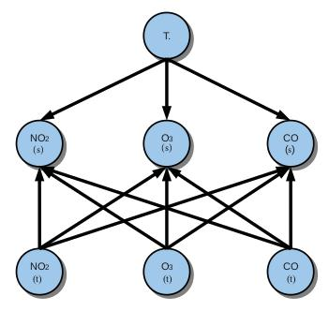

Figure 2.2: Application of a Bayesian Network to an atmospheric measurement system.

The three categories presented by Zhang et al. (2010) differs between them where the first cat-egory captures the sensor nodes correlations on spatio-temporal domain; The second one considers not only the spatio-temporal correlations but also the conditional dependence of sensor attributes; The third category proposes the measurement of state variables at a current time instance.

Janakiram et al. (2006) proposes the detection of outliers in sensor streamed data by capturing the conditional dependencies among the observation of it’s attributes. this is made in three phases:
14 Outliers Detection

Training Phase Phase where the Bayesian Belief Network is trained to capture the spatio-temporal correlations.
Testing Phase Phase where the trained BBN is tested on the level of accuracy and, if needed, the learned parameters are updated.
Inference Phase Phase where the missing values are inferred and the remaining streamed data are tested to detect if it is an outlier or not.

Janakiram et al. (2006) also defined the BBN, where the BBN is a directed graph, together with an associated set of probabilistic tables. The graph is divided in nodes and arcs, where the nodes represents the variables and the arcs are the representation of the casual/influential relationship among variables.

The main contribution of BBN is the possibility to have a model that, with the dependency between uncertain variables (by filling a node probability table), it is possible to describe complex probabilistic reasoning about uncertainty.
Janakiram et al. (2006) describes their process in three steps:

Constructing the Bayesian Belief Network

IF a few variables have direct dependencies

AND many of the variables are conditionally independent

THEN all the probabilities can be computed from the joint probability distribution.

Learning Bayesian Belief Networks IF the network structure is given

AND all variables are fully observable in the training examples THEN estimating the conditional probabilities is enough

IF the network structure is given

AND some of the variables are observable

THEN apply neural network using Gradient Ascent Procedure

IF the network structure is unknown

THEN Use heuristic search

OR Use constraint-based technique to search through potential structures

Inferring from Bayesian Belief Networks

THESIS The probability distribution of certain attributes might be inferred

PROOF Given the fact that the values that other attributes can take are known
2.5 Classification based techniques | 15

Paola et al. (2015) proposes an adaptive distributed Bayesian approach for detecting outliers in data collected by a WSN. The focus of the proposed algorithm is the optimization of outlier clas-sification accuracy, time and communication complexity and also considering externally imposed constraints on conflicting goals. The proposed algorithm is intended to run in each sensor node.
From the individual sensor node point of view, this algorithm consists in two phases:

Outlier detection Where, based on sensor readings and on the collaboration with neighbors, is made the probabilistic inference where the results are evaluated in three metrics: classifica-tion accuracy, time complexity and communication complexity.

Neighborhood selection Where the best neighbors are identified and selected to cooperate with, and, in addiction, to correspond to a reconfiguration of the Bayesian Network structure.

In the global point of view, if there is a high number of cooperating nodes, the classifica-tion is naturally higher with the drawback if increasing the processing time and communication complexity (thus resulting in increased detection delay and increase of energy consumption).
Xiang et al. (2016) proposes the addition of recover and recalibrate the drifted sensors simul-taneously based on the usage of a Bayesian network. The authors have applied their algorithm to the measurement of the variables in the sensor readings of the NO₂, CO and O₃ pollutants, as previously presented in figure 2.2. Based on the correlations of the sensor readings and on the tem-perature influence, the algorithm itself detects the outliers, recover valid information and adjust the BBN to automatically recalibrate the sensor.

2.5.2 Rule-based techniques

Rule based is another classification based technique for outlier detection. Similarly, this technique is based on a training stage from a data-set and a model generation to detect new data-instances based on history values.

Rule based techniques depends on two steps Chandola et al. (2009):

1. Learn rules from the training data-set

Using a learning algorithm (i.e. RIPPER, Decision Tree, etc.)

Where each rule has an associated confidence value proportional to the ratio:

Confidence Value = | number of training instances correctly classified by the rule
Confidence Value = | number of total training instances covered by the rule

2. Find for each test instance the rule That better capture the given test instance.

) The anomaly score is

The inverse of the confidence value for the rule that better capture the test instance.

Islam et al. (2016) proposes an algorithm for outlier detection inserted in rule-based taxonomy. They propose a new belief-rule-based association rule, with the focus on handling various types of uncertainties.
16 Outliers Detection

Due to the nature of the sensor data, a traditional inference mechanism cannot be used. There-fore, they propose a new inference mechanism for the rule-based algorithm that consists of an input transaction database that is converted into the following:

belief transaction database; support calculation;

belief matrix;

confidence calculation;

belief association rule discovery.

2.5.3 Support Vector Machines

Rather than performing outlier detection in the central node, Rajasegarar et al. (2007) proposes a distributed approach to:

performs detection on local data at each node

and communicates to the parent node only the summary information to perform at upper layer the global classification of the data.

Their proposal is based on a one-class quarter sphere SVM and is divided into 2 parts:

Anomaly detection algorithm

The OD is supported by previous works where, with the fitness approach of a hyper-sphere to the data in a higher dimensional space, and by applying a linear optimization to the problem of fitting the hypersphere with minimal radius R, having the center fixed at the origin and encompassing the majority of the image vectors.

The result of the linear optimization problem is the classification of the image vectors

as:
  - Support Vectors, if inside the sphere;

  - Outliers, otherwise.

Distributed anomaly detection

1st step: Each sensor node runs the entire AD algorithm on local data;

2nd step: The resulting radius is sent to the parent node;

3rd step: Each parent computes the global radius;

4th step: Parents sends the radius to children nodes;

5th step: Children compares global radius with local one and updates parameters.
2.5 Classification based techniques | 17

Xu et al. (2012) proposes a KNN-SVM which is a Support Vector Machine based on K-Nearest Neighbor Algorithm.

Despite KNN taxonomy is presented further on in section 3.7, in a synthesis the KNN is a distance-based approach that detect outliers in data-instances lying in the sparsest regions or lying in the outside of a given model boundary of the feature space.

Considering the Quarter sphere SVM technique proposed by Rajasegarar et al. (2007) the KNN-SVM combine the origin and the radius R that contain most of the samples and introduces kernel functions to make the optimization region more tighten.
18 Outliers Detection

2.6 Statistical based techniques

Chandola et al. (2009) identifies the statistical techniques for anomaly detection based on the assumption that, in a stochastic model, the most common data instances occur in high probability regions and the anomalies occur in low probability regions.

To detect anomalies, parametric techniques are suggested since those techniques assume the knowledge of the underlying distribution and estimate the parameters from a given data set. Non-parametric techniques differs from parametric ones without the need of assuming the knowledge of the distribution.
Andrade et al. (2016) lists some statistical parametric techniques:

Peirce’s Criterion Statistical parametric method for outlier detection based on a normal distribu-tion.

Chauvenet’s Criterion This criterion is based on the assumption a given measurement may be rejected if the probability of obtaining the deviation for this average value is less than the inverse of twice the number of measurements.

2.6.1 Parametric — Gaussian based

Zhang et al. (2010) summarizes parametric techniques as an anomaly detection strategy based on the following steps:

The available knowledge is generated from a known distribution; The distribution parameters is then estimated from the give data.

The usage of Gaussian models allows the spatial correlation of the readings towards distin-guishing between outlying sensors and event boundary.

2.6.2 Non-parametric — Histogram based

Sheng et al. (2007) proposes a histogram-based method to reduce the communication cost on sensor networks. The main objective of this proposal is to collect hints (in a form of histogram) about the data distribution and, with the knowledge from these hints, unnecessary data is filtered and potential outliers are detected
Complementary, Wang and Li (2013) introduces clusters on incremental histogram scheme based on a divide and conquer strategy:

The wireless network is divided in clusters (based on adjacent nodes and data correlated strategy);
The cluster head and cluster members updates the histogram incrementally and compares histograms in the form of Kullback-leibler divergence differentially (Kullback-leibler diver-gence is a convenient and robust method of measuring the difference between two data sets in a statistical sense.)
2.6 Statistical based techniques | 19

2.6.3 Non-parametric — Kernel function based

Zhang et al. (2010) synthesizes the concept of Kernel function non-parametric approaches as meth-ods for estimating the probability distribution function for normal instances (and a new instance that occurs on a low probability area is declared an outlier). Later on in section 2.9 is presented the Kernel Principal Component Analysis (KPCA) used by Ghorbel et al. (2014) for outlier detection in WSN’s.

Andrade et al. (2016) identify some kernel regression techniques:

Marzullo’s Fault Tolerant Sensor Averaging (FTA) Simple method for sensor fusion where the data assumed as anomalous is deleted.

Elmenreich’s Confidence-Weighted Averaging (CWA) The sensor’s confidence are correlated with the sensor’s variance.

CWA+FTA method This method combines both methods where the confidence-weighted aver-age is calculated and two-thirds of the anomalous data is removed.
20 Outliers Detection

2.7 Nearest Neighbor-based techniques

A promissory technique is extensively explored in the literature with the concept of neighbor-hoods, based on the key assumption that normal instances occurs in dense neighborhoods and anomalies occurs far from their closest neighbors.

2.7.1 Using distance

Branch et al. (2006) proposes algorithms that implements nearest neighbor-based techniques for outlier detection in WSN’s. The proposed unsupervised anomaly detection techniques uses the following different algorithms:

The distance to the k^{th} nearest neighbor;

The average distance to the k nearest neighbors;

the inverse of the number of neighbors, within a distance a.

Abid et al. (2016) bases the detection technique on the distance between the current measure-ment and its neighbors. A synthetic database is generated based on the insertion of random values into a real database (in particular the Intel Berkeley lab WSN database).

The procedure is divided in two steps:

Step 1a) For a given time-slot, the data values are sorted in a vector;

Step 1b) After that, for a given point in the vector, Euclidean distance between the prede-cessor and successor is calculated and stored in a second vector;

Step 1c) Based on the smallest distance between the current point and the predecessor or successor, the current point is linked;

Step 2 If the point in the vector is not linked (due to it’s distance between current point and predecessor/successor higher than a threshold?), is declared an outlier;

2.7.2 Using relative density

Chandola et al. (2009) defines the NN technique using relative density as a technique that estimates the density of the neighborhood of all data instances. Depending if the instance corresponds to a dense neighborhood or a low density one, the data is declared as outlier or normal.
2.8 Clustering based techniques | 21

2.8 Clustering based techniques

Chandola et al. (2009) synthesizes the clustering techniques in three categories based on three different assumptions:

The normal data instances are part of a cluster in the data and the outliers does not fit any cluster;

The normal data instances are present close to it’s closest cluster centroid and the outliers lies far way from their closest cluster centroid;

The normal data instances are part of large dense clusters and the outliers are part of small or sparse clusters.

Rajasegarar et al. (2006) uses a technique to minimize the communication overhead by using clusters among the sensor readings. In a further step, it merges the clusters before the data is sent to other nodes.

Andrade et al. (2016) presents a methodology to apply clustering and statistical techniques. The clusters are grouped according to the spatial position of the sensors and a k-means nearest-neighbor technique is used to provide a better understanding of the sensed environment. The proposed methodology follows a two-step procedure, starting with the usage of clustering in-formation and followed by a statistical-based method. The statistical method is Elmenreich’s Confidence-Weighted Averaging (CWA), where the sensor’s confidence are correlated with the sensor’s variance.

Cenedese et al. (2017) considers the network decomposition (i.e. the communication network topology) together with the data clustering measurements. They propose two algorithms: a cen-tralized clustering algorithm (CCA) and a distributed clustering algorithm (DCA).
22 Outliers Detection

2.9 Spectral Decomposition-based approach

The usage of Principal Component Analysis (PCA) technique is inherent to the spectral decomposition-based approach. Proposed by Chatzigiannakis et al. (2006), this technique efficiently models the spatio-temporal data correlations, in a distributed approach and, the local outliers are evaluated with the correlation among the sensor nodes.

Zhang et al. (2010) evaluates the Spectral Decomposition-based techniques in two outcomes:

The PCA-based techniques is of interesting usage where it captures the normal pattern of data;

However, it is computationally very expensive due to the need of selecting suitable principle components (needed to estimate a correlation matrix of normal patterns).

Gil et al. (2016) lists the steps of a PCA-based approach:

Robust recursive location estimator The PCA requires the estimation of the mean at each sam-pling time (the measurement vector x is centered).

Subspace tracking approach To avoid the need of extensive calculation of the eigendecomposi-tion, the authors takes advantage of subspace tracking (which recursively tracks the signal subspace spanned by the major principal components)

Recursive eigendecomposition computation The eigenstructure associated to an underlying space is recursively estimated;

Robust recursive detection criteria Two measures to compare the distance between a value and the remaining time-series are used

Robust subspace tracking Having an updating procedure to affect the signal subspace, if an out-lier is detected, this updating procedure is skipped.
2.10 Synthesis | 23

2.10 Synthesis

In this chapter was presented some of the literature review on outlier detection in WSN’s.

In an initial stage was presented the context of outlier detection applied to the railways moni-toring/sensing. Several authors try to define the outliers on sensor networks as the occurrence of an anomalous measurement, affected by an external event such as temperature variation or EMI effect. This way and framed with an railway sensor network, an outlier will be a disturbance in the sensing subsystem that will affect a subsystem dependent on the data provided by the sensing subsystem (such as a decision support system - DSS).
The challenges are presented to identify the main issues of WSN’s. In addition to the rush environment of the railway systems, challenges as the resource constraints, high communication cost (in terms of energy consumption) and others are identified. The main conclusion of this identification is the need for future work to evaluate the effect of undetected outliers on other subsystems (in particular, the DSS).

The literature present several works that covers the aspects that compare different outlier de-tection techniques. Those aspects can be considered as metrics to classify the characteristics of those techniques, as presented in section 2.3 of this work. Further on, a base taxonomy is presented to structure the relevant outlier detection techniques presented in the literature.
Starting with classification techniques, the main advantage is the result of well identified out-liers, based on building classification models to classify. A drawback is the computational com-plexity of those techniques. Another drawback is the need to choose a proper kernel function.
The statistical techniques presented are founded on the mathematical theory and depends on having a correctly acquired probability distribution model. The parametric functions depends on available knowledge and may be useless if the sensor data does not follow a given preset distribu-tion. On the other side, the non-parametric techniques does not require to make any assumption on the distribution characteristics. The interest of these techniques are the low computational requirements.

On the nearest neighbor-based techniques and on cluster techniques, the first technique pro-poses methodologies to evaluate how far is a given data instance from the neighbor (and the normal instances occurs in dense neighborhoods). The second technique are based on the assumption that the normal data can be grouped in clusters and the sparsest values are not presented in those clus-ters. (?? why different taxonomy division ??)
To conclude the literature review, the spectral decomposition approaches are slightly covered with particular emphasis on PCA technique.

In the following chapter, some lines of research are presented as future work.
24 Outliers Detection

Chapter 3

Future Research

In this chapter there are presented the future steps in research on outliers detection on railways WSN-based smart grid.

3.1 Evaluation of effect of undetected outliers in railway WSN

During the state of the art, the definition of "what is an outlier in railways WSN" was slightly covered, resulting in raising the research question:

What is the effect of an undetected outlier in an railways WSN?

A railways WSN is focused on acquiring the data (in forms of measurements) from the rail-ways environment with the purpose of providing that information to a subsystem (such as a deci-sion support system). Having this in mind, an assumption should be made to define the outlier as the effect of erroneous information retrieved from the DSS due to erroneous data from the mea-surement. A major contribution of an outlier detection mechanism is the validation of the quality of the output of the DSS. In particular, if a measurement or a set of measurements are detected as outliers, the DSS will have the information of the quality of his output, as is shown in figure 3.1.
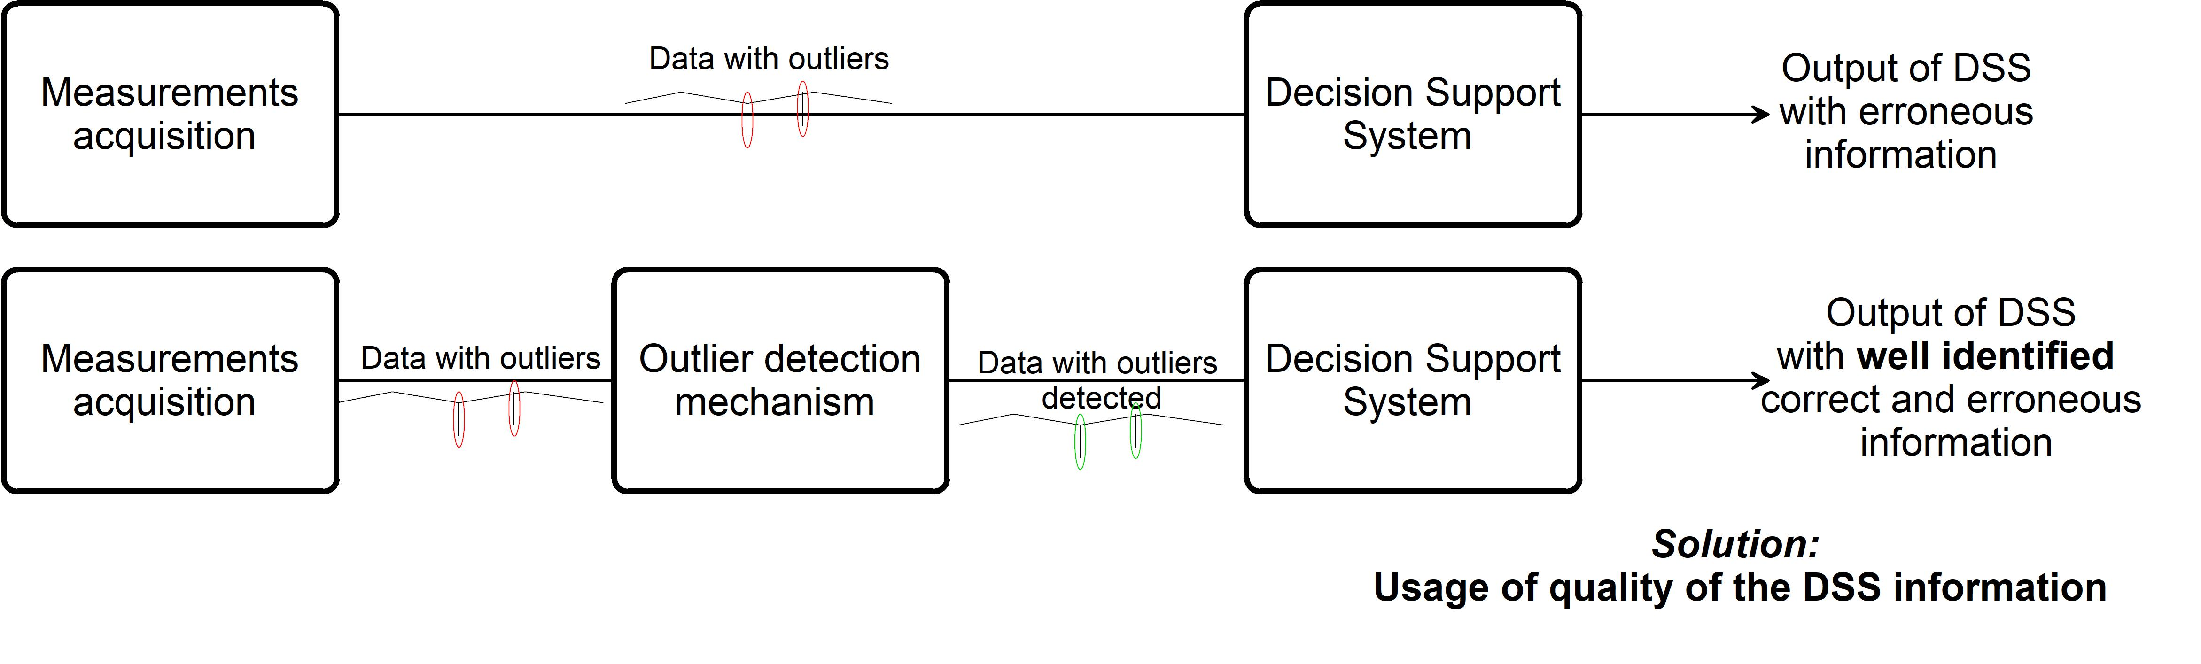

Figure 3.1: Comparison of the output of DSS with and without an outlier detection mechanism.

25

26 Future Research

It is important at this moment to present examples of DSS. Eco-driving strategies and timetable planning require conservative measurements of energy consumption in several points of the rail-way electrical system, where the situations of outliers should result, in example, in default outputs of DSS; On other side, preventive maintenance may find resourceful the presence of outliers con-sidering that those outliers reflect anomalous behavior due to unknown external effects (on the measurement).

The methodology will embrace the simulation of the railway WSN system. With a well defined simulation model that mimics the behavior of the DSS, the measurements acquisition system and the wireless network, the effect of undetected outlier can be evaluated before and after the DSS.

Considering the literature, two possibilities will be considered as a starting point for this rail-way WSN system simulator: the NS-3 and the contiki-cooja network simulators. However, for the future research, a higher analysis on the available simulators must be considered.

3.2 Selection of Outlier detection mechanism

On the previous section, the need of a simulation model was presented. However, based on real data from railway systems (or similar) can validate the implementation of an outlier detection mechanism.
In this way, a set of outlier detection mechanisms can be validated with a given test-bench.

The research question that can be raised is the following:

How to effectively detect an outlier in a railways WSN?

One main requirement of the energy consumption evaluation in a railway environment is the need to acquire AC measurements and extract, at the node, the RMS continuous values. Despite the continuous values are expected to be sent to a data concentrator at a periodic timestamp (much lower than the 50Hz/16,6Hz of the railways grid) the acquisition system must be constantly acquir-ing the variables and making the computational needed calculations to have an effective energy measurement. Therefore, the computational needs for such system should be considerable. In ad-dition, it is expected that such sensors have enough computational resources to implement certain outlier detection mechanisms that require extensive computational efforts.

This way, the computational requirements should not be considered in a initial approach, in the perspective of the node energy consumption. Complementarity, the literature has supported the usage of on-line outlier detection techniques that increases the computational effort towards the reduction of transmission energy consumption (avoiding the transmission of erroneous data).

The methodology expected to answer the raised research question is, at a first instance, a combination of the Xu et al. (2012) methodology (by using a KNN-SVM technique) and the Abid et al. (2016) methodology (that focuses the evaluation of the data values of a given time-slot by using a k^{th} nn procedure).

A first test-bench would be the data returned by a monitoring system developed in DEEC. In the figure 3.2 is presented the data that is monitoring a wind generator power converter.
3.2 Selection of Outlier detection mechanism | 27
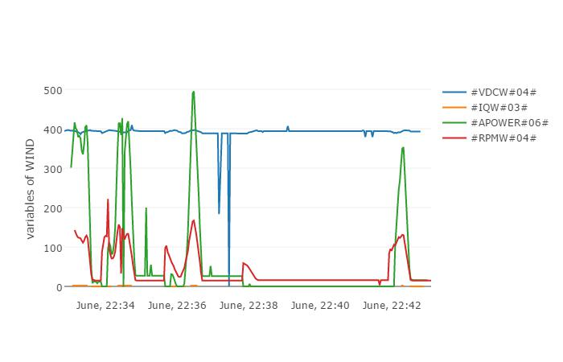

Figure 3.2: Website representation of ten minute log of wind generator variables.

The wind generator in question is designed to achieve 2kW at nominal power. However, the low and inconstant wind speed conditions are the cause of the viewed spikes in the power (green line) and in the rotor velocity (red line).

A major contribution of an oultier detection mechanism will be the pre-processing of the data before is transfered to the data-concentrator. An important note should be taken since this is a wired test-bench and the data is collected from the power converted with the spikes, showed in upper graph of figure 3.3, and then sent to the data concentrator.
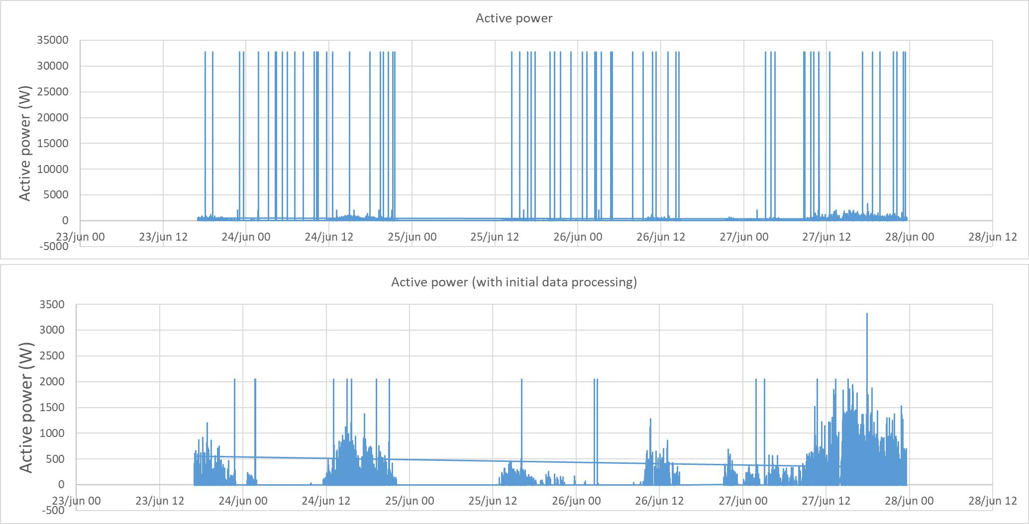

Figure 3.3: Data log of four days of wind generator variables.

28 Future Research

With the knowledge of the behavior of the wind turbine, it is known that the maximum power will not be greater than, at most 200% of the nominal power. An interesting outlier detection technique in this application will be a technique that does not require the apriori knowledge of the measurements. In the bottom graph is presented the graph that removes the erroneous data (based only on the knowledge that the power should be lower than 4kW).

Chapter 4

Conclusion

Lorem ipsum dolor sit amet, consectetuer adipiscing elit. Ut purus elit, vestibulum ut, placerat ac, adipiscing vitae, felis. Curabitur dictum gravida mauris. Nam arcu libero, nonummy eget, consectetuer id, vulputate a, magna. Donec vehicula augue eu neque. Pellentesque habitant morbi tristique senectus et netus et malesuada fames ac turpis egestas. Mauris ut leo. Cras viverra metus rhoncus sem. Nulla et lectus vestibulum urna fringilla ultrices. Phasellus eu tellus sit amet tortor gravida placerat. Integer sapien est, iaculis in, pretium quis, viverra ac, nunc. Praesent eget sem vel leo ultrices bibendum. Aenean faucibus. Morbi dolor nulla, malesuada eu, pulvinar at, mollis ac, nulla. Curabitur auctor semper nulla. Donec varius orci eget risus. Duis nibh mi, congue eu, accumsan eleifend, sagittis quis, diam. Duis eget orci sit amet orci dignissim rutrum.

29

30 Conclusion

Bibliography

Abid, A., A. Kachouri, and A. Mahfoudhi (2016, mar). Anomaly detection through outlier and neighborhood data in wireless sensor networks. In 2016 2nd International Conference on Ad-vanced Technologies for Signal and Image Processing (ATSIP). Institute of Electrical and Elec-tronics Engineers (IEEE).

Andrade, A. T. C., C. Montez, R. Moraes, A. R. Pinto, F. Vasques, and G. L. Da Silva (2016). Out-lier detection using k-means clustering and lightweight methods for wireless sensor networks. In IECON Proceedings (Industrial Electronics Conference), pp. 4683–4688.

Birol, F. and J.-P. Loubinoux (2016). 2016 edition of the uic-iea railway handbook on energy consumption and co2 emissions focuses on sustainability targets. Technical report, IEA - Inter-national Energy Agency; UIC - International Union of Railways.

Branch, J., B. Szymanski, C. Giannella, R. Wolff, and H. Kargupta (2006). In-network outlier detection in wireless sensor networks. In 26th IEEE International Conference on Distributed Computing Systems (ICDCS06). Institute of Electrical and Electronics Engineers (IEEE).

Cenedese, A., M. Luvisotto, and G. Michieletto (2017). Distributed clustering strategies in indus-trial wireless sensor networks. IEEE Transactions on Industrial Informatics 13(1), 228–237.

Chandola, V., A. Banerjee, and V. Kumar (2009, jul). Anomaly detection. ACM Computing Surveys 41(3), 1–58.

Chatzigiannakis, V., S. Papavassiliou, M. Grammatikou, and B. Maglaris (2006). Hierarchical anomaly detection in distributed large-scale sensor networks. In 11th IEEE Symposium on Computers and Communications (ISCC06). Institute of Electrical and Electronics Engineers (IEEE).

Ghorbel, O., M. Abid, and H. Snoussi (2014, may). Kernel principal subspace based outlier detec-tion method in wireless sensor networks. In 2014 28th International Conference on Advanced Information Networking and Applications Workshops, pp. 737–742. Institute of Electrical and Electronics Engineers (IEEE). cited By 0.

Ghorbel, O., W. Ayedi, H. Snoussi, and M. Abid (2015, jun). Fast and efficient outlier detection method in wireless sensor networks. IEEE Sensors Journal 15(6), 3403–3411.

31

32 BIBLIOGRAPHY

Gil, P., H. Martins, and F. Januário (2016, may). Detection and accommodation of outliers in wireless sensor networks within a multi-agent framework. Applied Soft Computing 42, 204– 214.

Islam, R. U., M. S. Hossain, and K. Andersson (2016, nov). A novel anomaly detection algorithm for sensor data under uncertainty. Soft Computing.

Janakiram, D., V. Reddy, and A. Kumar (2006). Outlier detection in wireless sensor networks us-ing bayesian belief networks. In 2006 1st International Conference on Communication Systems Software & Middleware. Institute of Electrical and Electronics Engineers (IEEE).

Martins, H., L. Palma, A. Cardoso, and P. Gil (2015, may). A support vector machine based technique for online detection of outliers in transient time series. In 2015 10th Asian Control Conference (ASCC). Institute of Electrical and Electronics Engineers (IEEE).

Paola, A. D., S. Gaglio, G. L. Re, F. Milazzo, and M. Ortolani (2015, may). Adaptive distributed outlier detection for WSNs. IEEE Transactions on Cybernetics 45(5), 902–913.

Rajasegarar, S., C. Leckie, M. Palaniswami, and J. Bezdek (2006). Distributed anomaly detec-tion in wireless sensor networks. In 2006 10th IEEE Singapore International Conference on Communication Systems. Institute of Electrical and Electronics Engineers (IEEE).

Rajasegarar, S., C. Leckie, M. Palaniswami, and J. C. Bezdek (2007, jun). Quarter sphere based distributed anomaly detection in wireless sensor networks. In 2007 IEEE International Confer-ence on Communications. Institute of Electrical and Electronics Engineers (IEEE).

Sheng, B., Q. Li, W. Mao, and W. Jin (2007). Outlier detection in sensor networks. In Proceed-ings of the 8th ACM international symposium on Mobile ad hoc networking and computing - MobiHoc 07. Association for Computing Machinery (ACM).

Shift2Rail Joint Undertaking (2015). Shift2rail joint undertaking multi-annual action plan. Tech-nical report, Shift2Rail.

Wang, Y. and G. Li (2013, aug). Incremental histogram based anomaly detection scheme in wire-less sensor networks. In 2013 IEEE International Conference on Signal Processing, Com-munication and Computing (ICSPCC 2013). Institute of Electrical and Electronics Engineers (IEEE).

Xiang, Y., Y. Tang, and W. Zhu (2016, feb). Mobile sensor network noise reduction and recalibra-tion using a bayesian network. Atmospheric Measurement Techniques 9(2), 347–357.

Xu, S., C. Hu, L. Wang, and G. Zhang (2012, sep). Support vector machines based on k near-est neighbor algorithm for outlier detection in WSNs. In 2012 8th International Conference on Wireless Communications, Networking and Mobile Computing. Institute of Electrical and Electronics Engineers (IEEE).
BIBLIOGRAPHY | 33

Zhang, Y., N. Meratnia, and P. Havinga (2010). Outlier detection techniques for wireless sensor networks: A survey. IEEE Communications Surveys & Tutorials 12(2), 159–170.

Zhuang, Y. and L. Chen (2006). In-network outlier cleaning for data collection in sensor networks.

In In CleanDB, Workshop in VLDB 2006, pp. 41–48. APPENDIX.

