07/11/2019 – Starting Cognex Vision System for APRS Brian Antonishek, x6033

2 Initial Setup Steps

1. Add Cognex and Point Grey paths to the DOS System Variable - 'Path'

(on System Properties -> Environment Variables)

C:\Program Files\Cognex\VisionPro\bin;

C:\Program Files\Point Grey Research\FlyCapture2\bin64;

C:\Program Files\Point Grey Research\FlyCapture2AIK\bin64;

Or as a single line (so you can cut-n-paste):

C:\Program Files\Cognex\VisionPro\bin;C:\Program Files\Point Grey Research\FlyCapture2\bin64;C:\Program Files\Point Grey Research\FlyCapture2AIK\bin64;

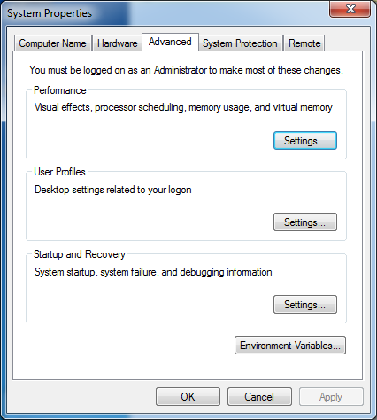 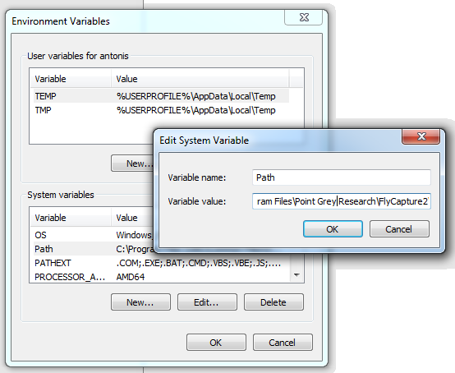

1. Set up Cognex executable to always run as administrator.

Find Cognex executable. Don’t start it, just bring up right-mouse menu and choose Properties -> Compatibility tab, and check the ‘run this program as an administrator’ box. (see image below).

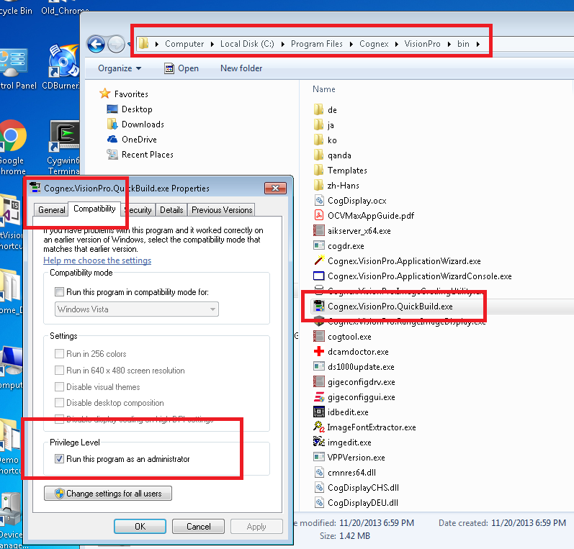

To run Cognex,

Load parameters on USB Cameras

This should always be done *before* starting any new Cognex session to make sure the camera’s parameters are set to those found to be most successful for connecting to the Cognex software. Mainly, that their frame rate is reduced to 3 frames per second. The default higher frame rates seem to freeze Cognex – Camera communications.

The program used to load camera parameters is called ‘Point Grey FlyCap2” and can be found here:

C:\Program Files\Point Grey Research\FlyCapture2\bin64\Point Grey FlyCap2.exe

Load parameters on USB Cameras (Continued)

I suggest ‘pinning’ the program’s icon to your bottom task bar for easy program launch. When the program is running, hover over the icon in the bottom tray (see circled image icon below) and use the right-mouse menu to pick ‘Pin to taskbar’. That way the icon will always be on the taskbar whether the programming is running or not and can be used to quickly launch the program.



The program should look like this when started:

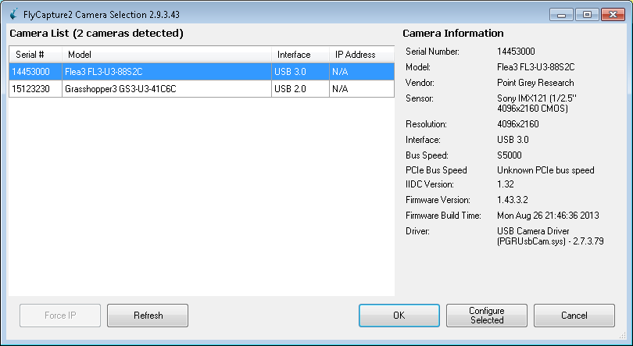

There should be two cameras listed. Ignore any USB speed warnings that may popup. Only disconnect / reconnect a camera from USB as a very last resort to try and get a camera seen by the FlyCap2 program or Cognex.

A ‘Flea’ and ‘Grasshopper’ camera should be shown on the Camera List.

Select the camera that you want to work with. Then click the ‘Configure Selected’ button. *Do not* hit ‘OK’ button. The OK button starts a live video stream from the camera and often times seems to interfere with Cognex then being able to talk to that camera later on.

The Configure screen will look like this:

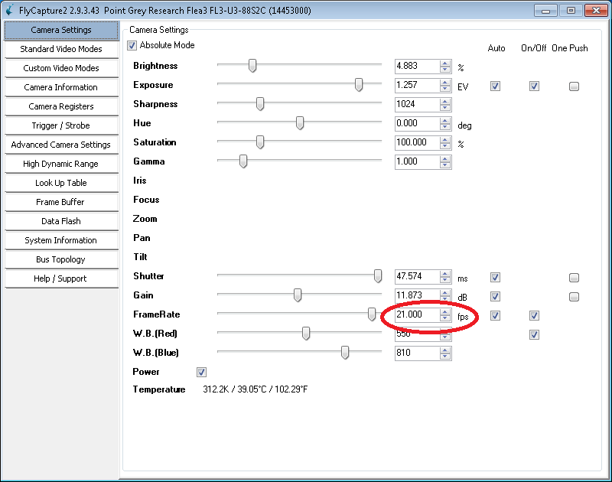

After you’ve correctly loaded the camera settings then the FrameRate will be at 3 frames per second (see red circle on Config picture). To load the settings, click on ‘Advanced Camera Settings’. Make sure the Channel number is on #1. Then Click the ‘Restore’ button.



Next, choose the “Camera Settings” tab and double-check that the frame rate is now set to 3 frames / second. If not, repeat the steps above to restore the same settings and check frame rate in ‘Camera Settings’ again.

Do the same procedure for the 2nd camera. When finished with the 2nd camera, click the ‘x’ in the upper-right corner to close the FlyCapture2 program. *Do not* click the ‘OK’ button.

Running Cognex executable

Run Cognex:

C:\Program Files\Cognex\VisionPro\bin\Cognex.VisionPro.QuickBuild.exe

If loading program for the 1st time, go under

File -> Open Quickbuild Application.... and choose this file --

\\mission.el.nist.gov\Programs\mfg_robotics\agility_performance\APRS_Demo\Cognex\KitBuilder_v_09_App.vpp

(or if have opened this application before, pick the file on the "Recent QuickBuild applications" list)

When it asks – “Do you want to save changes?” Always choose ‘No’.

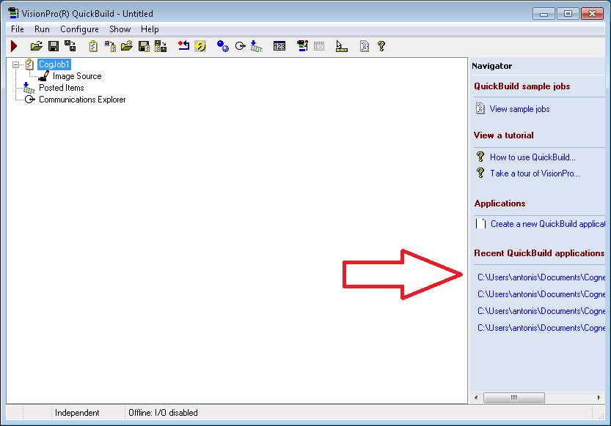

If the Cognex application loaded correctly, you should see the ‘CogJob1’ name should have changed to something like ‘Kitbuilder_v_09”.



If the application loaded correctly then hit the red triangle once to step the program through one iteration. Hopefully, the triangle will turn green which means everything ran correctly.



Next, turn on the network output (#1 below) then continuous run (#2 below). If all is good then you should see a green circle at position #3. Congrats! You did it!



Cognex should now be outputting position data on the agility PC on ports 5001 and 5002.