**HOME AUTOMATION SYSTEM**

W.S.H Boteju

(IT 14 0341 14)

B.Sc. Special Honours in Information Technology

Dissertation submitted in partial fulfillment of the requirements for the degree of Science

Department of Information Technology

Sri Lanka Institute of Information Technology

September 2018

# DECLARATION

“I declare that this is my own work and this dissertation1 does not incorporate without acknowledgement any material previously submitted for a Degree or Diploma in any other University or institute of higher learning and to the best of my knowledge and belief it does not contain any material previously published or written by another person except where the acknowledgement is made in the text.

Also, I hereby grant to Sri Lanka Institute of Information Technology the nonexclusive right to reproduce and distribute my dissertation, in whole or in part in print, electronic or other medium. I retain the right to use this content in whole or part in future works (such as articles or books).

Signature: Date:

(W.S.H Boteju)

The above candidate has carried out research for the B.Sc Dissertation under my supervision.

Signature of the supervisor: Date

# ABSTRACT

This project revolves around creating a home automation system prototype with the main focus of having the ability to lock or unlock a door, centralized control of lighting, controlling high tech appliances through the internet to provide improved convenience, comfort, energy, efficiency and safety. The system consists of a central device, a server, sensors, and an application. The popularity of home automation has been increasing greatly in recent years due to considerable affordability and simplicity through Smartphone and tablet connectivity. The techniques employed in home automation include those in building automation as well as the control of domestic activities, such as lighting control system, and the use of other electrical appliances. When Internet of Things also known as IoT, comes to our homes, it can be widely incorporated into making our castle smarter, safe and automated.

As home automation apps become more intelligent, their capabilities become almost endless, from controlling lights and locks to small appliances. Instead of having different apps for different functions, our app will be able to manage everything from one place.

And most importantly, due to the increase in energy consumption, increase population, and limited time frames, there is a grave need to conserve time, effort and energy in any way possible. Henceforth, this system will be cost effective, flexible, and have the capability to control and monitor the home environment, at your fingertips.

# ACKNOWLEDGEMENT

My heartfelt gratitude goes out to the CDAP group of SLIIT for the support and guidance given throughout the research period. I also extend these thanks to other members of the SLIIT staff that assisted in ways both small and large.

Big thanks go out to the industry experts that collaborated with me in providing their views and helping me come up with videos on the importance and relevance of the research.

Last but most certainly not least, an enormous amount of gratitude goes out to my supervisor, Mr. Yasas Mallawaarachchi for the immense support and guidance provided at all points during the research period. I truly would not have been able to complete the research to the extent that I have and to the standard of success that I have without your support.

# **TABLE OF CONTENTS**

DECLARATION 2

ABSTRACT 3

ACKNOWLEDGEMENT 4

TABLE OF CONTENTS 4

1 INTRODUCTION 6

1.1 Background 6

1.2 Literature Survey 7

1.2.1 Literature review 7

1.2.2 Existing Tools 9

1.3 Research Gap and Research Problem 11

1.4 Research Objectives 12

1.4.1 Main Objectives 12

1.4.2 Specific Individual Objectives 12

2 METHODOLOGY 13

2.1 System architecture 13

2.2 Functionality of the Project 14

2.2.1 Detecting flame and avoid circuit burnings 14

2.2.2 Monitoring and control high tech appliances. 15

2.2.3 Tools and Technologies 17

2.2.4 Product Constraints 17

3 RESULTS AND DISCUSSION 18

3.1 Research Findings 18

3.1.1 Pysher 18

3.1.2 Error handling 19

3.2 Discussion 20

4 CONCLUSION 21

5 REFERENCES 22

# 1 INTRODUCTION

## 1.1 Background

It’s the 21st Century; the world has witnessed a major advancement in the technology perspective; and along with these improvements, we as Humans have grown accustomed to having everything ready and available at our fingertips. People are constantly finding ways to make life easier, by reducing the time, effort, and energy; they put on daily routines and activities.

A couple of inventions made in this era that has impacted the lifestyle of millions of people are *Bluetooth, Mozilla Firefox, Skype, iPod, iPad, Facebook, Youtube, Iphone, BBC iPlayer, Amazon Kindle, Google Android, Spotify, and Google Driverless cars*.

Therefore with automated driving not too far behind, neither is the ability to have control over many aspects in our homes with just a few clicks. Home Automated Systems, are systems and devices than can control elements of your home environment – the lightings, high technical appliances, entry and exit systems, controlling garage gates, home security and many more. The Popularity of Smart Homes increased in the early 2000s, once people started to consider the actual benefits of Home Automation; it became a viable and affordable technology for customers. The main concepts that initiate the way families manage their lives and home is Interactivity and Connectivity. Due to business travels, Children’s school and extra-activates schedules as well as social or family activates, the latest smart systems provide a major contribution to the household, even if the family is far away.

Moving with the current trend, i.e. The Internet of Things also widely known as IOT a major contributing factor is involved in the designing and implementing Smart Home systems, which aims to make the lives of people and their homes easier, safer, more efficient and connected than ever before.

## 1.2 Literature Survey

### 1.2.1 Literature review

According to the conducted Literature Survey on pre-existing software platforms, functionalities and technologies that has been done prior to the proposal on our research, here are some of them,

1. Bluetooth based home automation system using cell phone [1]

This technology is using smartphones, Arduino board and Bluetooth technology. The hardware architecture of this consists of the Arduino board and a cell phone. The cell phone hosts the Python script which enables the user to access the home appliances and control commands for the appliances. The communication between the Arduino board and the cell phone is wireless and using Bluetooth technology. The cell phone use a software application which allows the user to control the home appliances. The main drawback of system is that it is limited to control the home appliances within the Bluetooth range.

2. A Comparative Analysis on Home Automation Techniques [2]

This is a GSM based home automation system. Global System for Mobile communication used to implement this home automation technology. The system used a GSM modem to control electric appliances through SMS request. Home appliances are connected with PIC16F887 microcontroller via relays. One of the advantages of this system is that users will get feedback status of household appliances via SMS on their smartphones.

3. E-mail interactive home automation system [3]

In this research, it was done to turn On/Off switches by sending an email. Used LED bulbs for prototype. After processing the mail, system identifies the command and precedes it. They require much more layout effort. Their architecture covers subsystems IR sensors, burglar alarm module and fire alarm module, into a single automated architecture for practical implementation in intelligent home environments. With this system you can preset or change the control parameters of several similar devices, for example, the thermostat of several air conditioners and their ON/OFF timings

4. Voice recognition based home automation for Paralyzed People [4]

Voice recognition based home automation system proposed by a researcher. Hardware architecture of this system consists of Arduino UNO and Smartphone. System comprises a DSP processor for the voice recognition function. Android OS has a built-in voice recognizing feature. This voice recognizing features is used to develop an app which control appliances from user voice command. This application converts the user voice command into text. Then it transmits that text message to Bluetooth module which is connected to Arduino. Advantage of voice controlled home automation system is that user only need to pronounce the application name and the command. A voice recognition application provided a user friendly interface to users and it has ability to add more appliances. Drawback is this system failed to work correctly in noisy environments.

5. Web Based ZigBee Enabled Home Automation System [5]

In summary this consists of three main modules, handheld microphone module, central controller module and appliance controller module. In this system, Microsoft speech API is used as a voice recognition application. The system recorded voice at a sampling frequency of 8 Khz. Differential pulse code modulation (DPCM) is used for compressed data from 12 bits to 6 bits. These data bits were sent from the microcontroller to the RF ZigBee module. This Automation system was tested using voice commands of 35 male and female with different English accents. Accuracy of this system is limited in the range of 40 meters.

6. An overview of home automation systems [6]

This is newly developing energy harvesting technology used in transportation, building and home automation systems. This system can be built up using internet, router, automation controller, duckbill 2 EnOcean and EnOcean devices. A smart phone application is used to control and monitor the home appliances using different type of communication techniques. In this paper the working principle of different type of wireless communication techniques such as ZigBee, Wi-Fi, Bluetooth, EnOcean and GSM are studied and run applications under Linux environment. This is also a kind of voice recognition based system. If voice signal is noisy then communication can highly effect and the system will fail to show accuracy. Data rate of EnOcean is approximately 125 kbps, which is high and it is self-power device.

7. Home Automation Using Internet of Things (IoT) [7]

IOT or internet of things is an upcoming technology that allows us to control hardware devices through the internet. This technology used for connecting, controlling and managing intelligent objects which are connected to Internet through an IP address. In this paper it discuss about IoT, how it can be used for realizing smart home automation and used two prototypes namely home automation using Bluetooth and home automation using Ethernet.

### 1.2.2 Existing Tools

|  |  |  |  |  |  |  |  |
| --- | --- | --- | --- | --- | --- | --- | --- |
| ***FEATURES*** | Bluetooth home automation | GSM | Email interactive | Voice recognition | ZigBee | EnOcean | **Home 365 AUTOMATION** |
| Garage Door Automated Control. |  |  |  | ✔ |  |  | ✔  *Opens and Close by monitoring the vehicle* |
| UV Light Detection and Switch on/off Light accordingly |  |  |  | ✔ |  |  | ✔ |
| Indoor Temperature Monitoring to operate AC or Fan. |  | ✔ |  | ✔ | ✔ | ✔ | ✔  *Depending on the people count, the AC and Fan is controlled.* |
| Detect Open Doors or Windows, and Control Locking them remotely. | ✔ | ✔ | ✔ | ✔ | ✔ | ✔ | ✔ |
| Detect On Lights and Off them accordingly, *vise versa.* | ✔ | ✔ | ✔ | ✔ | ✔ | ✔ | ✔ |
| Manage High tech appliance, during power failures and avoid circuit burns. |  |  |  |  |  |  | ✔ |
| Send Alert Notifications to the mobile app | ✔ | ✔ |  |  |  |  | ✔ |

## 1.3 Research Gap and Research Problem

In Today’s world, with the hassle of various activities in the household; Home Automation systems are used to make everyone lives simpler, more convenient, safer, by having the ability to control appliances at the tip of our fingers.

Even though there may be countless systems that are conventionally available around the globe, which are more advanced and covers a wider range of features like Front Door lock, Smart Locks, Home protection, climate control, Alarm Systems, there is always going to be even minor drawbacks in them, which we are hoping to fulfill with our Smart Home System.

The ones currently available are relatively expensive, and therefore our proposed system, would fit into the budget of many families, who want to have more independence and control over their home, and have their mind at ease when they travel for holidays, or even leave the house in a haste and suddenly experience the feeling of dread on whether they left any appliance on or left the door, window or garage open.

During Stormy weathers, service work or the random power cuts that suddenly occur, the power gets cut immediately and as soon as it goes, there are times that it comes back as well and along with it comes a very high voltage. When the power surges back on after an outage, it typically exceeds the maximum limit, and this could create high levels of heat and potentially damage the appliance. Our proposed system would ensure to protect these appliances by acting as a surge protector; which would keep the power at a safe level instead of letting all of it flow into the appliance & electronics. Hence, giving a peace of mind when there’s a storm or power outage.

And henceforth, taking the above facts into account and many more, our aim is to develop a smart, reliable, and most importantly affordable, smart home system which would make the life of many families easy and save ample time and effort, and also increase the home efficiency.

## 1.4 Research Objectives

### 1.4.1 Main Objectives

* Our goal is to develop a hardware component as well as a web application, which will give the user maximum control over their home appliances. The Hardware component will be a network of sensors and detectors that would emulate the devices in the home.
* The unique feature of our Home Automation system would be that, if the customer currently has existing sensors, then their devices will be able to synchronize with our very own Micro-controller, but that’s not all, once it synchronize, the user will have to ability to control it through our web application, from home or anywhere, as long as an internet connection is established.
* Our goal is to provide a convenient, reliable, easy to use, safe and most importantly cost effective Home automation system, and with the added flexibility of synchronizing and integrating with existing micro-controllers.

### 1.4.2 Specific Individual Objectives

* Implementation of a user interface allowing the user to control home high technical appliances.
* Maintain and help to reduce energy consumption via remote controlling.
* Develop a fully functional home automation system with low cost and high reliability which can affordable for any user.
* Detect flame and protect the system from circuit burnings.
* Able to control from anywhere in the world.

# 2 METHODOLOGY

This part of the document explains how the proposed system going to be designed and implemented. Functionalities and the flow will be explained clearly with the tools and technologies which are going to be used in order to achieve the objectives of the proposed system.

## 2.1 System architecture

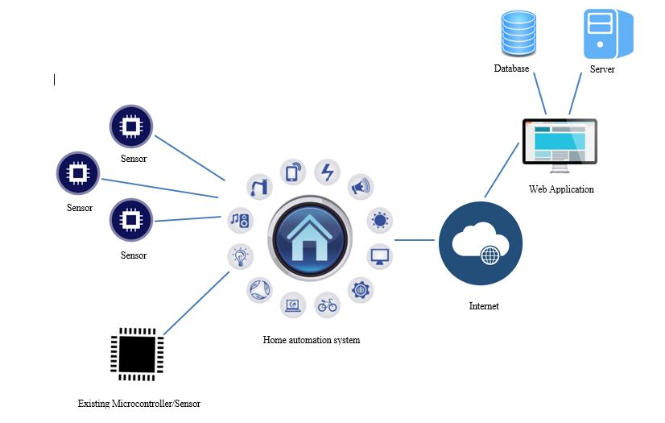

Figure 1: High-level Architecture Diagram

## Functionality of the Project

The app is developed as a web application with all the core functionality available. It allows users to automate garage & Exterior Lighting, Door and Windows Locking and Securing Network, Interior lighting and temperature control, Monitoring and control high technical appliances and detect circuit burns.

The core features of the web application regarding controlling the high tech appliances will be discussed here.

### Detecting flame and avoid circuit burnings

IR Flame detection sensor used to detect the flame within the circuit system and prevent system being damaged by circuit burnings. When sensor detected fire, notification will be send to the user.

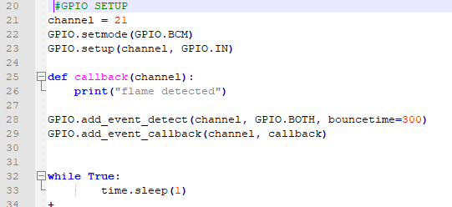

Figure 2.1 – Code snippet on detecting flame.

### Monitoring and control high tech appliances.

In this process, the system offers users an easy & effective means of controlling their various home high technical appliances from a remote location i.e. without physically being present at home. The system makes use of the internet to enable remote access to the various home appliances. It hence makes for a powerful & versatile system which expands the mobility of users by granting them total control over their home without the need of physical presence. IR flame sensor is also connected with the circuit to detect circuit burns.

Process layout is explained below along with the components.

1. A graphical user interface will be designed as a part of the web based application.

2. The user will access this interface and control the home high tech appliances.

3. The data from this application will be passed on to the server.

4. Then the signal will pass to the microcontroller.

5. The microcontroller is programmed in an appropriate way to understand this signal and convert it to an electrical signal and transmitted to the switch controlling the appliance.

6. The user will be able to monitor the status of the devices.

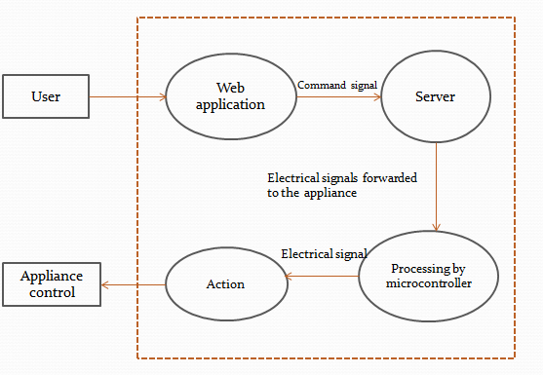

Figure 2.2: Data flow diagram to control high tech appliances.

Coded the raspberry pi to connect with the pysher and get the request from client to control the home appliances.

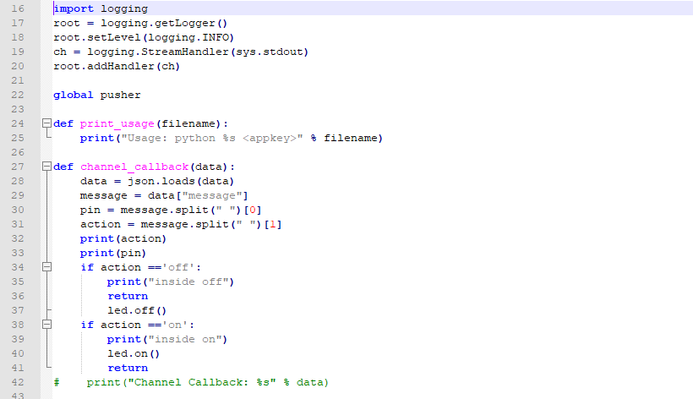

Figure: 2.3 Python code to control appliance

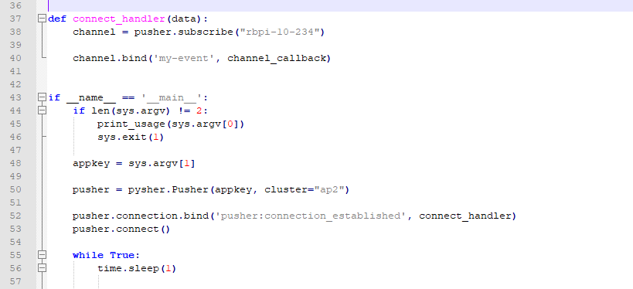

Figure : 2.4 Connect raspberry pi with pysher using the same channel and appkey.

### Tools and Technologies

**Tools:**

* Notepad++
* WebStorm

**Technologies:**

* HTML
* AngularJS
* NodeJS
* ExpressJS
* CSS
* Pysher

### Product Constraints

Home automation system experiences the following constraints,

1. Internet is mandatory in order to function the system.
2. The frontend of the application requires AngularJS and Node in order to function.
3. The home appliances must be connected to the main power supply at all times.

# RESULTS AND DISCUSSION

## Research Findings

This section will explore the results of the steps taken as detailed in the Methodology section (section 2). When comparing the proposed home automation system with existing complexity tools, drawbacks of existing systems are unable to control remotely, expensive, less functions etc. In our system it can control from anywhere in the world

### 3.1.1 Pysher

Here I‘ve used pysher to get the control from cloud. It has a Key, Secret, channel to communicate with the client through cloud.

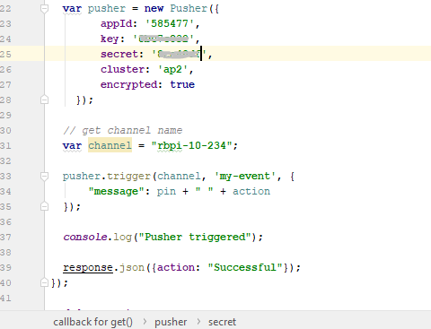

Figure 3.1: JavaScript code to connect the application with cloud.

### 3.1.2 Error handling

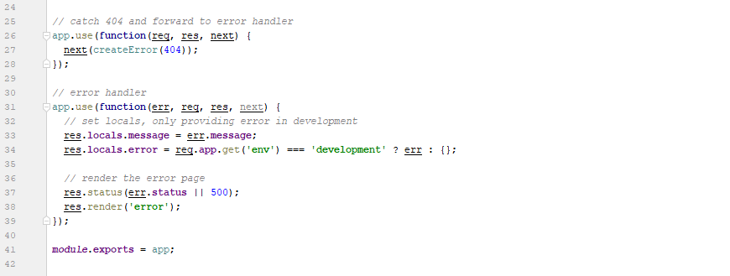

Figure 3.2 Error handling



Figure 3.3: Connect cloud and the pi

## Discussion

Home automation system is that in which the various appliances within the home are remotely controlled. There are different technologies exist which are used for home automation. By using Bluetooth or ZigBee we can remotely control all appliances within home but both of them having area limit. In our system we are using Wi-Fi based IoT (Internet of Things). So we can control home appliances from anywhere around the world. Due to IoT people and things to be connected any-time, anyplace, with anyone, ideally using any network and any service. Automation is an important application of IoT technologies. The Smart homes are known as Home automation, with the use of new technology, to make the housing activities more easy, accessible, secured and efficient. Home automation systems face some main challenges, these are high cost of ownership, inflexibility, difficulty in achieving security and poor manageability. The main intention of this research is to design and implement a home automation system using IoT that is able to controlling and automating most of the house appliances through an easy possible web interface. By using Wi-Fi technology to interconnect its distributed sensors to home automation server the proposed system has a great flexibility. This will decrease the deployment cost and will increase the ability of upgrading, and system reconfiguration. We have studied different techniques for home automation system. Various authors give various techniques with flowchart, block diagram and their explanation with proper layout of successful execution with adequate strengths and imperfection. Finally we built a low cost, effective, fully function home automation system.

# 4 CONCLUSION

Expectation is to provide marketable product to the industry by including automated devices that can be accessible remotely. Following the residential market and lead it by making the product easy to install by any person who have average knowledge of technology. Our Product has the added advantage of being relatively cheaper than the similar products that are already in the market and the security implemented into the system, is far more reliable that the current Home automation appliances. WPAN connected devices are accessible from anywhere virtually using web application, tablets or smart phones provided there is an internet connection. Ability of controlling lights from wherever the user wants, Controlling doors and windows locking system whenever wanted, Giving the access only to the white listed people, Save time and effort by controlling indoor and landscape lighting and having automated garage door functionality, Reduce electrical wastage and risk of fire by controlling the high tech appliances are major features of the IOT smart home system. The unique feature of this home Automation system, is the ability for the user to bring a new sensor into their home and configure and synchronize it with the web application, this will then give the user control of all the sensors and devices, old and new through a single application

# 5 REFERENCES

[1] Rajeev Piyare, M Tazil,"Bluetooth based home automation system using cell phone " *in IEEE Transactions on Consumer Electronics*,2011.

[2] Mirza Qutab Baig, Junaid Maqsood, Muhammad Haris Bin Tariq Alvi, “A Comparative Analysis on Home Automation Techniques” in *Artificial Intelligence, Modelling and Simulation (AIMS), 2014 2nd International Conference on,* Madrid, Spain,2015.

[3] Sirisilla Manohar, D. Mahesh Kumar,” E-mail interactive home automation system” *in International Journal of Computer Science and Mobile Computing,*2015.

[4] Mukesh Kumar, Shimi S.L,”Voice recognition based home automation for Paralyzed People” *in International Journal of Advanced Research in Electronics and Communication Engineering (IJARECE),*2015

[5] Ali Ziya Alkar, H.Selcuk Gecim, Muharrem Guney,“Web Based ZigBee Enabled Home Automation System” *in Network-Based Information Systems (NBiS), 2010 13th International Conference,* Takayama, Japan,2010.

[6] Muhammad Asadullah, Ahsan Raza,“An overview of home automation systems”*in Robotics and Artificial Intelligence (ICRAI), 2016 2nd International Conference,* Rawalpindi, Pakistan, 2016.

[7] Kumar Mandula, Ramu Parupalli, CH.A.S. Murty, E. Magesh,Rutul Lunagariya,”Mobile based home automation using Internet of Things(IoT)” *in Control, Instrumentation, Communication and Computational Technologies (ICCICCT), 2015 International Conference*, Kumaracoil, India.2015.