**HOME AUTOMATION**

## Project ID: 18-088

**Design Document** Halpe H.M.P.H IT15052902

# Bachelor of Science Special (Honors) in Information Technology

Department of Information Technology Sri Lanka Institute of Information Technology

Sri Lanka

May 2018

## Declaration

Author declare that this is author’s own work and this SRS does not incorporate without acknowledgement any material previously submitted for a degree or diploma in any other university or Institute of higher learning and to the best of author’s knowledge and belief it does not contain any material previously published or written by another person except where the acknowledgement is made in the text.

## Author:

|  |  |  |  |
| --- | --- | --- | --- |
| Name | Registration No | Signature | Date |
| H.M.P.H.Halpe | IT15052902 |  | 2018.05.15 |

The above candidate is carrying out research for the undergraduate Dissertation under my supervision.

Signature of the supervisor: ………………………… Date: …………………. Signature of the co-supervisor………………………. Date: ………………….

Table of Contents

Declaration i

Table of Contents ii

List of Figures iii

List of Tables iv

List of Appendices iv

1. Introduction 1
   1. Purpose 1
   2. Scope 1
   3. Definitions, Acronyms, and Abbreviations 2
   4. Overview 2
2. Overall Descriptions 3
   1. Product perspective 4
      1. System interfaces 5
      2. User interfaces 5
      3. Hardware interfaces 5
      4. Software interfaces 6
      5. Communication interfaces 6
      6. Memory constraints 6
      7. Operations 6
      8. Site adaptation requirements 6
   2. Product functions 7
   3. User characteristics 7
   4. Constraints 8
   5. Assumptions and dependencies 8
   6. Apportioning of requirements 8
3. Specific Requirements 9
   1. External interface requirements 9
      1. User interfaces 9
      2. Hardware interfaces 10
      3. Software interfaces 10
      4. Communication interfaces 10
   2. Architectural Design 10
      1. High level Architectural Design 10
      2. Hardware and software requirement with justification 11
      3. Risk Mitigation Plan with alternative solution identification 12
      4. Cost benefit analysis for the proposed solution 13
   3. Performance requirements 13
   4. Design constraints 13
   5. Software system attributes 14
      1. Reliability 14
      2. Availability 14
      3. Security 14
      4. Maintainability 14
   6. Other requirements 14
4. Supporting information 15
   1. Appendices 15
   2. References 16

## List of Figures

|  |  |
| --- | --- |
| *Figure 1* | Page  *Raspberry-pi block function 3*  *The Raspberry Pi 2B uses a 32-bit 900 MHz quad-core*  [*ARM Cortex-A7*](https://en.wikipedia.org/wiki/ARM_Cortex-A7) *processor 3*  *VIAIR 40 Amp Relay-93940 Amp Relay-93940 3*  *150px-Motion_detector 3*  *Interior light controlling system 9*  *Temperature controlling system 9*  *High level architectural diagram 16 10* |
| *Figure 2* |
| *Figure 3* |
| *Figure 4*  *Figure 5*  *Figure 6* |
| *Figure 7* |
| *Figure 8* | *Risk Management fundamental steps 11* |

***List of Tables***

|  |
| --- |
| Page |
| *Table 1 Definitions, Acronyms, and Abbreviations 2* |

*Table 2 Use case scenario Interior lighting control system 2*

# List of Appendices

|  |  |  |
| --- | --- | --- |
| Appendix | Description | Page |
| *Appendix – A Use case Diagrams 15* | | |

## Introduction

## Purpose

Purpose of this document is to specify and describe the approach of developing **Interior Lighting and Temperature Control** with web based automatic controlling system in home automation. In this document, complete system development of light and temperature detecting and controlling is described. This document mainly focused on how this Detection and control component interact with web application, information gathering, detecting and executing preventive actions. This document can be used by interested parties as a guideline or as a system specification of interior lighting and temperature controlling.

## Scope

Scope of this document is to give a basic idea about how the system is going to implement by using raspberry-pi, sensors, other hardware and a web based automatic controlling system. In this document, it covers the design criteria of interior light controlling and temperature controlling. Gathering environmental condition information from different sensor modules, thought that handling the system accordingly.

Expectation of implementing this component is to have a low-cost home automation system with a responsive web app. All the other components are connected through raspberry pi. This component will control all the hardware and check the current condition of all. Send notifications to the user via the responsive web app. According to the notifications received take the appropriate action.

## Definitions, Acronyms, and Abbreviations

|  |  |
| --- | --- |
| DD | Design Document |
| UI | User interface |
| API | Application Programming Interface |
|  |  |
|  |  |

* 1. **Overview**

**Table 1: Definitions, Acronyms and Abbreviations**

Home automation is referred to as “Internet of Things”. Gives access to control devices in your Home from a mobile device, from anywhere. With home automation, we can dictate how a device reacts, when it should react, and why it should react.

Basically, to the implementation of the home automation system we use the raspberry pi, relays sensors and some hardware components. Raspberry pi is a series of small [single-board computer.](https://en.wikipedia.org/wiki/Single-board_computer) Relay is an [electrically](https://en.wikipedia.org/wiki/Electric) operated [switch](https://en.wikipedia.org/wiki/Switch) which is used to control a circuit by a separate low-power signal.

Why we need a home automation system actually? Because to make easy our day today work another way makes tasks more convenient. When it comes to the busy time schedules forgetfulness happen, so we can control over devices remotely in this home automation system other benefits are increase home Security so that ensuring peace of mind. Power Failures/ Lighting resulting is can damaged appliances, this home automation system does the needful to notify the user to avoid that kind of situations.

By developing this kind of low cost base reliable home automation systems, we can have multiple advantages such as can automate multi-functional tasks simultaneously. Easily synchronize with existing sensors, Alert notification directly reserved to the mobile device. Most important thing is ensuring peace of mind.

There are many tasks controlling by the device. Control the Status of Indoor Lights. Control the Status of Fan / AC. Lock or Unlock Doors and Windows. Automating the Status of Outdoor Lights. Automating the Garage Door and Light, when the correct vehicle is approaching. Protecting high technical appliances from power outages or Lighting storms. Protecting the Home and the system application from any kind of attacks. This home automation system can be used by anyone who as internet connection /Wi-Fi in their house.

## Overall Descriptions

Raspberry pi is the main hardware of the system. Implementing the all functions by using this component. Raspberry Pi is a series of small [single-board computers](https://en.wikipedia.org/wiki/Single-board_computer). It has evolved through several versions that feature variations in memory capacity and peripheral-device support.

Other most important hardware is Relay. It is the link between low power digital electronics and high-power devices. They allow digital circuits and digital microcontrollers to switch high power devices on and off. For the sensors we are using motion detection sensors, temperature detection sensors etc.

To develop the responsive web application Technologies used to create the web application is; Bootstrap framework, HTML 5, JavaScript, PHP.

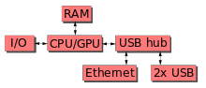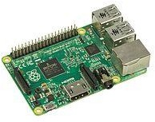

*Figure 2. Raspberry-pi block function Figure 2. The Raspberry Pi 2B uses a 32-bit 900 MHz*

*quad-core* [*ARM Cortex-A7*](https://en.wikipedia.org/wiki/ARM_Cortex-A7) *processor.*

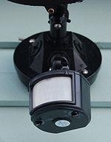

*Figure 3. VIAIR 40 Amp Relay-93940 Amp Relay-93940 Figure 4. 150px-Motion_detector*

## Product perspective

There are Bluetooth based home automation system using cell phone. Since our product is internet base we can have the ability to control the system far away from home. Which is not commercially available in the home automation systems.

In voice recognition based home automation system Hardware architecture consists of Arduino UNO and Smartphone. System comprises a DSP processor for the voice recognition function. Android OS has a built-in voice recognizing feature. This voice recognizing features is used to develop an app which control appliances from user voice command. This application converts the user voice command into text. Then it transmits that text message to Bluetooth module which is connected to Arduino. Advantage of voice controlled home automation system is that user only need to pronounce the application name and the command. A voice recognition application provided a user-friendly interface to users and it has ability to add more appliances. Drawback is this system failed to work correctly in noisy environments. That will be real disadvantage of this kind of system. Sometimes it’s only work with only one voice recognition. That will be another disadvantage. Its only work when we inside the home. Can’t remotely controlled when we are far away from home. But in our home automation system we don’t have those kinds of drawbacks since it is a web base remotely control system.

Since our automation system based on internet of things knowledge area, that allows us to control hardware devices through the internet. This technology used for connecting, controlling and managing intelligent objects which are connected to Internet through an IP address. Which is safer reliable and cost effective to the users of this system.

## System interfaces

The very first interface is Login form will be provided when the URL that can be access the web application type. House owner will be the one who has access to the web application or other users might have access regards to the master user’s requirements.

Web application will check with the MySQL database whether the user is registered with the system and allow entering the next interface only if authorized, otherwise rejects.

After login session 2nd interface will be shown. Here the house will separate into three main parts. User can be access any part as he/she wish. Appliances at the house are distributed among three main areas as Rooms, Garage and Living Area. Buttons showing the images of the three areas are redirecting to the next interface

Final interface has every detail about the appliances at the selected part of the house that user select from the previous interface. The appliances correspond to the selected area will be shown at a table with its status. Buttons are provided to each device to operate the status ON/OFF.

## User interfaces

This is the part where user get access to contact graphically with the home appliances. Web application will be developed with all the functionalities to fulfill the objectives of the proposed system.

## Hardware interfaces

Hardware requirements will need to run the developed application without having any problem. For the designing, implementation and testing purposes we have identified few hardware requirements such as,

Raspberry- pi

Mobile phones – Android OS 5.0 or later Desktop /Laptop

Tablet

This interface is the place where that redirects the requests to the home appliances which are made at the frontend of the system by the user. The appliances may act according to the responses that coming out of the hardware interface.

Raspberry pi microcontroller is the main device runs on the hardware interface. Many other electronic components and sensors are implementing at this part.

## Software interfaces

These software components, mainly target to use in creating applications, IDE for Raspberry pi. Responsive web app will be

## Communication interfaces

Mobile device or personal computer should connect with the Wi-Fi or mobile data to connect the application. Home appliances should connect with the Raspberry Pi to communicate with the application.

## Memory constraints

1 GB RAM or higher mobile phone/PC

Raspberry -pi with 1.4 [GHz](https://en.wikipedia.org/wiki/Hertz) [64](https://en.wikipedia.org/wiki/64-bit_computing)/32-bit [quad-core](https://en.wikipedia.org/wiki/Multi-core_processor) [ARM Cortex-A53](https://en.wikipedia.org/wiki/ARM_Cortex-A53) CUP,

1 [GB](https://en.wikipedia.org/wiki/Gibibyte) [LPDDR2](https://en.wikipedia.org/wiki/Mobile_DDR#LPDDR2) [RAM](https://en.wikipedia.org/wiki/Random-access_memory) at 900 MHz Memory and 1.5 W (average when idle) to 6.7 W Power

## Operations

There are two types of operations. Normal operations and Special operation. Normal operations are user can login to the application by using username and password. Will can select the controlling section of the home. Able to monitor and control home devices/appliances via the application. Special operations, Notify user when instant power failures. Determine which appliance needs to switch on back. Detect circuit burnings.

## Site adaptation requirements

To have the responsive web app a windows environment is needed and to gain the full functionality of the tool and active internet connection is needed. Need the knowledge of

Since we are using the raspberry pi official programming language of Raspberry Pi is Python, which comes preloaded with the Raspbian operating system.

## Product functions

There are four main functions in this home automation system. First one is Automated Garage Gate Controlling and Surrounding Light Control. In this function we do image processing to detect and capture the License plate number of the residence vehicles. Open the Garage gate when the vehicle is couple of meters away. Check if the vehicle is at a safe distance, once inside the garage, and close the garage gate. Automatically switch on the Home Porch Light, when nearing dusk. Switch on the garage light, if the light is limited, when the vehicle is approaching. Create and handle the Interface management of the house exterior (i.e. Garage Gate and Lights)

Interior Lighting and Temperature Control Machine learning to detect time and automate switching the status of the house lights. Monitor the temperate and count of people in a room, and operate the AC or Fan. Create and handle the Interface of the house Interior and Cooling System (i.e. Lights, AC, and Fan).

In Managing and Controlling High Technical Appliances when there is power failures, Detect the energy flow, monitor and handle the current flow of High Tech Appliances (refrigerator, routers, washing machines etc), once the power comes back. Manage which appliances need to be switched back on. Create and handle the Interface management of the house High Technical Appliances.

Remotely Controlling Doors and Windows implementing with sensor communication to detect open doors or windows in the house. Alert the owners via the server and application and lock the relevant doors and windows. Ensuring the security of the implemented system, securing the internet connection with firewall protection. Create and handle the interface management of the house Interior (i.e Doors and Windows)

## User characteristics

A user can be a novice or a computer related personal, whose intention is to use the home automation system. User can be getting notifications to the mobile and can control the system automatically even he or she is far away from home.

Raspberry pi is focused on simplicity, so any user can use this tool. The user does not need to have a sound knowledge about security or IT. Even to use the web application. One of the best thing about the home automation system is, the ability of our application to ***Synchronies* and *Integrate*** with existing Sensors, using NEST APIs. It provides more efficiency, maximum controlling of the user.

## Constraints

Web app handles notification receiving to the emails for user, under any circumstance notification should not forward or send to another parties.

## Assumptions and dependencies

Currently this system focused on for main four functions. In the feature version of this system will have more functions and more reliability and an optimizing system.

## Apportioning of requirements

This home automation system full fill the requirement of reliability, cost- effectiveness, multi-functionality, highly energy efficiency, easily synchronize with existing sensors, alert notifications mobile device.

## Specific requirements

* 1. **External interface requirements**
     1. **User interfaces**

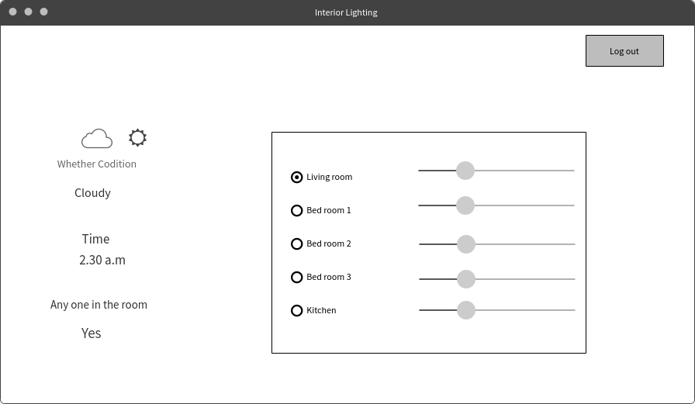

*Figure 5. Interior light controlling system*

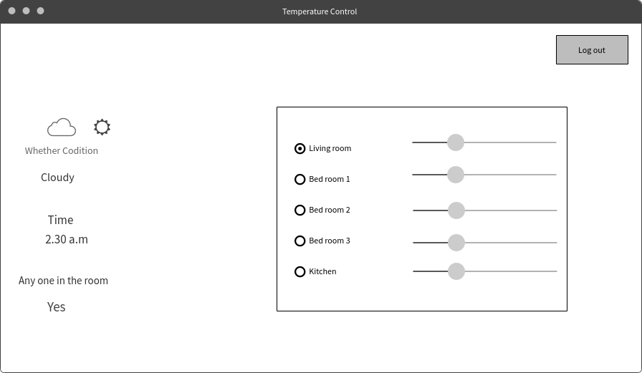

*Figure 6. Temperature controlling system*

## Hardware interfaces

Raspberry pi

Relays to control 120-240V devices Breadboard

Wires

Sensors (Motion diction, humidity checking)

## Software interfaces

Windows 10 Operating System

IDEs for Raspberry Pi

## Communication interfaces

Internet connection is the most required communication method. Because the entire home automation system is based on internet connection. If user wants to perform any activity that requires internet, there should be proper internet connection.

## Architectural Design

## High level Architectural Design

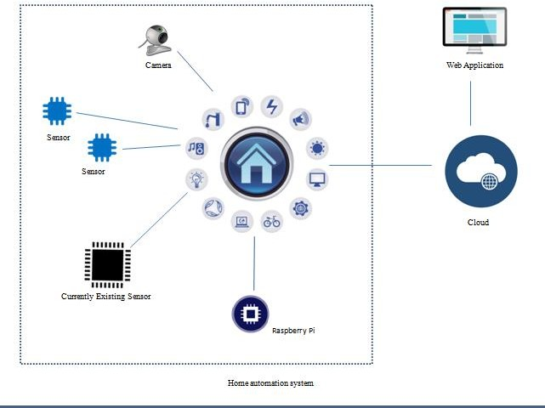

*Figure 7. High level architectural*

## Hardware and software requirements with justification

Basically, for hardware we use raspberry pi. Raspberry Pi is a low-cost, basic computer that runs entirely on open-source software and gives students the ability to mix and match software according to the work they wish to do. We are planning to use Raspberry pi as the development board except Arduino as the development board because we have image processing section. For image processing it is important to have OpenCV, Arduino does not support OpenCV.

A relay is an electrically operated switch. Relays are used where it is necessary to control a circuit by a separate low-power signal, or where several circuits must be controlled by one signal.

A breadboard is a solderless device for temporary prototype with electronics and test circuit designs. Most electronic components in electronic circuits can be interconnected by inserting their leads or terminals into the holes and then making connections through wires where appropriate.

For software requirement Raspberry Pi has a wide range of IDEs that provide programmers with good interfaces to develop source code, applications and system.

## Risk Mitigation Plan with alternative solution identification

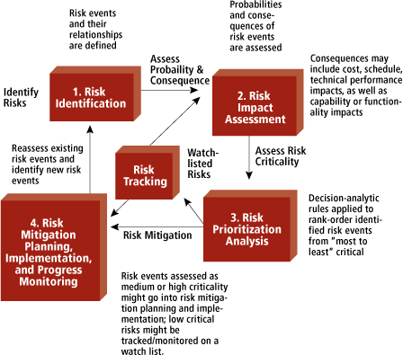

*Figure 8. Risk Management fundamental steps*

All ways have the backups of the codes. When it comes to the live testing monitor the environment for changes that affect the nature and/or the impact of the risk. Always have extra components like sensors as backup and extra hardware.

## Cost Benefit Analysis for the proposed solution

Raspberry -pi - 1700.00 LKR

UV Light Detection Sensor + Cable [8 - 1700.00 LKR Cameras - 8000.00 LKR

Other Sensors- 4000.00 LKR

Total cost- 14000.00 LKR

## Performance requirements

This application will be developed as a responsive application and therefore will be running on a mobile device or desktop computer. When compared with a desktop computer, the processing power of a mobile device is low. Due to this reason, the application should be developed in a way which it will consume minimum number of resources work efficiently.

The main target is to make the application to run smoothly and efficiently and provide the user an accurate and quick result making it a very reliable application to use in day to day activities.

## Design constraints

In system design, a design constraint refers to some limitation on the conditions, when the system is developed, or on the requirements of the system. During system design, it is as important to identify each design constraint as it is to elicit requirements since the design constraints place an overall boundary around the system design process.

Implementation constraints

Web responsive application is targeting to implement using HTML 5, JavaScript, and Python.

Time Factor

This will be done as a partial requirement to the degree under the guidance of SLIIT. Therefore, in dealing with projects artifacts it is strictly advised to follow the given schedules and deadlines.

Therefore, dealing with the time limitations has become one of the major concerns among the development team in the process of designing.

Human resource factor

This module will be done as a group project. Even though the sub modules have been divided among group members it’s very difficult to conclude when carrying out some work since there are many more ideas generated by the group members. Finding an appointment to have group meetings and to meet supervisor have become another problem with the busy schedules of everyone.

## Software system attributes

## Reliability

System should function well according to the specifications under normal operating environment without any crashes. System should be tested with multiple users accessing the application to ensure reliability. All ways should work with the required flow.

## Availability

Home automation applications should have been available at any time. User will be able to browse the application and control appliances any time. Ability to have the access for several uses simultaneously.

## Security

Users have done the authentication when using the web application. Mobile phone security plus application passwords can be used externally. All communications are open to internet so future modification should be done after integrating and launching of this version of the product.

## Maintainability

Maintainability is defined as the probability of performing a successful repair action within a given time. The proposed application will be easily maintained because application is developed according to the object-oriented principals and modularization. Also, the source code will be well commented and documented for any changes or modifications done in future.

## 3.6 Other requirements

Testing should be done during the implementations rather than waiting for fully completions of the system. Unit testing for test the Individual Components. Integration Testing and System Testing are also required.

## Supporting information

* 1. **Appendices** *Appendix A - Use Case Diagrams*

|  |  |
| --- | --- |
| **Use Case ID** | 001 |
| **Use Case** | Interior Lighting control |
|  |  |
| **Pre-Conditions** | Select whatever the place that you want to abject light |
|  |  |
| **Actor** | User |
|  |  |
| **Main Flow of events** | 1. Use case starts with once after the user clicks the lighting control button. 2. Application allow user to control light of the appropriate section/room 3. Use Case ends when the user closes light control of the place. |
| **Alternative Flows** | 2. a) If Application does not allow to control the Light control, reload the page again. |

*Table 2 Use case scenario Interior lighting control system*

|  |  |
| --- | --- |
| **Use Case ID** | 002 |
| **Use Case** | Temperature controlling |
|  |  |
| **Pre-Conditions** | User should select the room where you want to control the temperature |
|  |  |
| **Actor** | User |
|  |  |
| **Main Flow of events** | 1. Use case starts with once after the user clicks the temperature control button. 2. Application allow user to view status the room. 3. Application suggest the appropriate temperature to the room. 4. Do the needful and control the room temperature. 5. Use Case ends when the user closes the temperature application. |
| **Alternative Flows** | 2. a) If application does not allow user to view status, check whether the appliances connected with the system properly. |

*Table 3 Use case scenario for Temperature controlling system.*

## References

1. *Industries, A. (2018). Raspberry Pi: Adafruit Industries, Unique & fun DIY electronics and kits. [online] Adafruit.com. Available at:* [*https://w*](http://www.adafruit.com/index.php?main_page=category&amp;cPath=105)*ww*[*.adafr*](http://www.adafruit.com/index.php?main_page=category&amp;cPath=105)*uit*[*.com/index.php?main_page=category&cPath=105*](http://www.adafruit.com/index.php?main_page=category&amp;cPath=105) *[Accessed 13 May 2018].*
2. *En.wikipedia.org. (2018). Relay. [online] Available at: https://en.wikipedia.org/wiki/Relay [Accessed 13 May 2018].*
3. *Lightinglab.fi. (2018). [online] Available at:* [*http://www.lightinglab.fi/IEAAnnex45/guidebook/6_lighting%20control.pdf*](http://www.lightinglab.fi/IEAAnnex45/guidebook/6_lighting%20control.pdf) *[Accessed 14 May 2018].*
4. *Mdpi.com. (2018). [online] Available at:* [*http://www.mdpi.com/1424-*](http://www.mdpi.com/1424-) *8220/13/12/16915/pdf [Accessed 14 May 2018].*
5. *Anon, (2018). [ebook] Available at:* [*https://w*](http://www.omega.com/temperature/z/pdf/z110-114.pdf)*ww*[*.omega.com/tem*](http://www.omega.com/temperature/z/pdf/z110-114.pdf)*pe*[*ratur*](http://www.omega.com/temperature/z/pdf/z110-114.pdf)*e*[*/z/pdf/z110-114.pdf*](http://www.omega.com/temperature/z/pdf/z110-114.pdf) *[Accessed 14 May 2018].*
6. *Anon, (2018). [ebook] Available at:* [*http://www.ijsdr.org/papers/IJSDR1604038.pdf*](http://www.ijsdr.org/papers/IJSDR1604038.pdf) *[Accessed 15 May 2018].*
7. *Ayo, B. (2018). Development of a Home Automation System Using Wireless Sensor/Actuator Nodes. [online] Arxiv.org. Available at: https://arxiv.org/abs/1802.01955 [Accessed 15 May 2018].*