**A HOME AUTOMATION SYSTEM**

PROJECT ID

PROJECT PROPOSAL REPORT

O.Y.Navarathneraja IT15050786

A.R.J. Akwaththa IT15093660

W.S.H. Boteju IT14034114

H.M.P.H. Halpe IT15052902

Bsc. Special Honors Degree

Department of Information

Sri Lanka Institute of Information Technology

Sri Lanka

March 2018

# DECLARATION OF THE CANDIDATES AND SUPERVISOR

We declare that this is our own work and this proposal does not incorporate without acknowledgement any material previously submitted for a degree or diploma in any other university or Institute of higher learning and to the best of our knowledge and belief it does not contain any material previously published or written by another person except where the acknowledgement is made in the text.   
   
       

|  |  |  |
| --- | --- | --- |
| Name | Student ID | Signature |
| O.Y.Navarathneraja | IT15050786 |  |
| A.R.J. Akwaththa | IT15093660 |  |
| W.S.H Boteju | IT14034114 |  |
| H.M.P.H. Halpe | IT15052902 |  |

# The above candidates are carrying out research for the undergraduate Dissertation under my supervision. Name of the Supervisor: Signature of the supervisor: Date: Mr. Yashas Mallawarachchi

# ABSTRACT

This project revolves around creating a home automation system prototype with the main focus of having the ability to lock or unlock a door, centralized control of lighting, controlling high tech appliances through the internet to provide improved convenience, comfort, energy, efficiency and safety. The system consists of a central device, a server, sensors, and an application. The popularity of home automation has been increasing greatly in recent years due to considerable affordability and simplicity through smartphone and tablet connectivity. The techniques employed in home automation include those in building automation as well as the control of domestic activities, such as lighting control system, and the use of other electrical appliances. When Internet of Things also known as IOT, comes to our homes, it can be widely incorporated into making our castle smarter, safe and automated.

Once the System is implemented, Home automation system should be tested to find bugs and mismatches in the requirements. Prototype installation should be inspected and tested for bugs, functionality and ease of use. Fixing a bug or adding additional functionality to an automation system can have unforeseen consequences, which would lead to costly downfalls.

As home automation apps become more intelligent, their capabilities become almost endless, from controlling lights and locks to small appliances. Instead of having different apps for different functions, our app will be able to manage everything from one place.

And most importantly, due to the increase in energy consumption, increase population, and limited time frames, there is a grave need to conserve time, effort and energy in any way possible. Henceforth, this proposed system will be cost effective, flexible, and have the capability to control and monitor the home environment, at your fingertips.

*Table of Contents*

DECLARATION OF THE CANDIDATES AND SUPERVISOR II

ABSTRACT III

1. INTRODUCTION 1

1.1 Background Study 1

1.2 Literature Review 2

1.2.1 Existing Systems 2

1.3 Research Problem and Research Gap 6

2. OBJECTIVES 7

2.1 Main Objective 7

2.2 Specific Objectives 7

3. METHODOLOGY 8

3.1 System Overview 8

3.2 Functionalities i

3.2.1 Remote Controlling Doors and Windows i

3.2.2 Controlling high tech appliances. ii

3.2.3 Automated Garage gate Controlling and Surrounding Light Control ii

3.2.4 Lighting controlling and temperature controlling automation system iii

3.1 Flow of the Project iii

3.3 Gantt Chart viii

4. PERSONNEL AND FACILITIES ix

5. BUDGET xi

REFERENCES xii

***List of Figures***

Figure 1: High-level Architecture Diagram 8

Figure 2: Gantt Chart viii

***List of Tables***

Table 1: Description of Members Tasks and Functionality. x

Table 2: Estimate Budget xi

# INTRODUCTION

## Background Study

It’s the 21st Century; the world has witnessed a major advancement in the technology perspective; and along with these improvements, we as Humans have grown accustomed to having everything ready and available at our fingertips. People are constantly finding ways to make life easier, by reducing the time, effort, and energy; they put on daily routines and activities.

A couple of inventions made in this era that has impacted the lifestyle of millions of people are *Bluetooth, Mozilla Firefox, Skype, iPod, iPad, Facebook, Youtube, Iphone, BBC iPlayer, Amazon Kindle, Google Android, Spotify, and Google Driverless cars*.

Therefore with automated driving not too far behind, neither is the ability to have control over many aspects in our homes with just a few clicks. Home Automated Systems, are systems and devices than can control elements of your home environment – the lightings, high technical appliances, entry and exit systems, controlling garage gates, home security and many more. The Popularity of Smart Homes increased in the early 2000s, once people started to consider the actual benefits of Home Automation; it became a viable and affordable technology for customers. The main concepts that initiate the way families manage their lives and home is Interactivity and Connectivity. Due to business travels, Children’s school and extra-activates schedules as well as social or family activates, the latest smart systems provide a major contribution to the household, even if the family is far away.

Moving with the current trend, i.e The Internet of Things also widely known as IOT a major contributing factor is involved in the designing and implementing Smart Home systems, which aims to make the lives of people and their homes easier, safer, more efficient and connected than ever before.

## Literature Review

### Existing Systems

According to the conducted Literature Survey on pre-existing software platforms, functionalities and technologies that has been done prior to the proposal on our research, here are some of them,

1. Bluetooth based home automation system using cell phone[1]

This technology is using smartphones, Arduino board and Bluetooth technology. The hardware architecture of this consists of the Arduino board and a cell phone. The cell phone hosts the Python script which enables the user to access the home appliances and control commands for the appliances. The communication between the Arduino board and the cell phone is wireless and using Bluetooth technology. The cell phone use a software application which allows the user to control the home appliances. The main drawback of system is that it is limited to control the home appliances within the Bluetooth range.

2. A Comparative Analysis on Home Automation Techniques [2]

This is a GSM based home automation system. Global System for Mobile communication used to implement this home automation technology. The system used a GSM modem to control electric appliances through SMS request. Home appliances are connected with PIC16F887 microcontroller via relays. One of the advantages of this system is that users will get feedback status of household appliances via SMS on their smartphones.

3. E-mail interactive home automation system[3]

In this research , turn On/Off switches by sending an email. Used LED bulbs for prototype. After processing the mail, system identifies the command and proceed it. They require much more layout effort. Their architecture covers subsystems IR sensors, burglar alarm module and fire alarm module, into a single automated architecture for practical implementation in intelligent home environments. With this system you can preset or change the control parameters of several similar devices, for example, the thermostat of several air conditioners and their ON/OFF timings

4. Voice recognition based home automation for Paralyzed People [4]

A voice recognition based home automation system proposed by a researcher. Hardware architecture of this system consists of Arduino UNO and Smartphone. System comprises a DSP processor for the voice recognition function. Android OS has a built-in voice recognizing feature. This voice recognizing features is used to develop an app which control appliances from user voice command. This application converts the user voice command into text. Then it transmit that text message to Bluetooth module which is connected to Arduino. Advantage of voice controlled home automation system is that user only need to pronounce the application name and the command. A voice recognition application provided a user friendly interface to users and it has ability to add more appliances. Drawback is this system failed to work correctly in noisy environments.

5. Web Based ZigBee Enabled Home Automation System[5]

In summary this consist of three main modules, handheld microphone module, central controller module and appliance controller module. In this system, Microsoft speech API is used as a voice recognition application. The system recorded voice at a sampling frequency of 8 Khz. Differential pulse code modulation (DPCM) is used for compressed data from 12 bits to 6 bits. These data bits were sent from the microcontroller to the RF ZigBee module. This Automation system was tested using voice commands of 35 male and female with different English accents. Accuracy of this system is limited in the range of 40 meters.

6. An overview of home automation systems [6]

This is newly developing energy harvesting technology used in transportation, building and home automation systems. This system can be built up using internet, router, automation controller, duckbill 2 EnOcean and EnOcean devices. A smart phone application is used to control and monitor the home appliances using different type of communication techniques. In this paper the working principle of different type of wireless communication techniques such as ZigBee, Wi-Fi, Bluetooth, EnOcean and GSM are studied and run applications under Linux environment. This is also a kind of voice recognition based system. If voice signal is noisy then communication can highly effect and the system will fail to show accuracy. Data rate of EnOcean is approximately 125 kbps, which is high and it is self-power device.

7. Home Automation Using Internet of Things(IoT) [7]

IOT or internet of things is an upcoming technology that allows us to control hardware devices through the internet. This technology used for connecting, controlling and managing intelligent objects which are connected to Internet through an IP address. In this paper it discuss about IoT, how it can be used for realizing smart home automation and used two prototypes namely home automation using Bluetooth and home automation using Ethernet.

*Home 365 Automation System Comparison with existing systems*

|  |  |  |  |  |  |  |  |
| --- | --- | --- | --- | --- | --- | --- | --- |
| ***FEATURES*** | Bluetooth home automation | GSM | Email interactive | Voice recognition | ZigBee | EnOcean | **Home 365 AUTOMATION** |
| Garage Door Automated Control. |  |  |  | ✔ |  |  | ✔  *Opens and Close by monitoring the vehicle* |
| UV Light Detection and Switch on/off Light accordingly |  |  |  | ✔ |  |  | ✔ |
| Indoor Temperature Monitoring to operate AC or Fan. |  | ✔ |  | ✔ | ✔ | ✔ | ✔  *Depending on the people count, the AC and Fan is controlled.* |
| Detect Open Doors or Windows, and Control Locking them remotely. | ✔ | ✔ | ✔ | ✔ | ✔ | ✔ | ✔ |
| Detect On Lights and Off them accordingly, *vise versa.* | ✔ | ✔ | ✔ | ✔ | ✔ | ✔ | ✔ |
| Manage High tech appliance, during power failures and avoid circuit burns. |  |  |  |  |  |  | ✔ |
| Send Alert Notifications to the mobile app | ✔ | ✔ |  |  |  |  | ✔ |

## Research Problem and Research Gap

In Today’s world, with the hassle of various activities in the household; Home Automation systems are used to make everyone lives simpler, more convenient, safer, by having the ability to control appliances at the tip of our fingers.

Even though there may be countless systems that are conventionally available around the globe, which are more advanced and covers a wider range of features like Front Door lock, Smart Locks, Home protection, climate control, Alarm Systems, there is always going to be even minor drawbacks in them, which we are hoping to fulfill with our Smart Home System.

The ones currently available are relatively expensive, and therefore our proposed system, would fit into the budget of many families, who want to have more independence and control over their home, and have their mind at ease when they travel for holidays, or even leave the house in a haste and suddenly experience the feeling of dread on whether they left any appliance on or left the door, window or garage open.

During Stormy weathers, service work or the random power cuts that suddenly occur, the power gets cut immediately and as soon as it goes, there are times that it comes back as well and along with it comes a very high voltage. When the power surges back on after an outage, it typically exceeds the maximum limit, and this could create high levels of heat and potentially damage the appliance. Our proposed system would ensure to protect these appliances by acting as a surge protector; which would keep the power at a safe level instead of letting all of it flow into the appliance & electronics. Hence, giving a peace of mind when there’s a storm or power outage.

And henceforth, taking the above facts into account and many more, our aim is to develop a smart, reliable, and most importantly affordable, smart home system which would make the life of many families easy and save ample time and effort, and also increase the home efficiency.

# OBJECTIVES

## Main Objective

Our goal is to develop a hardware component as well as a web application, which will give the user maximum control over their home appliances. The Hardware component will be a network of sensors and detectors that would emulate the devices in the home.

The unique feature of our Home Automation system would be that, if the customer currently has existing sensors, then their devices will be able to synchronize with our very own Micro-controller, but that’s not all, once it synchronize, the user will have to ability to control it through our web application, from home or anywhere, as long as an internet connection is established.

Our goal is to provide a convenient, reliable, easy to use, safe and most importantly cost effective Home automation system, and with the added flexibility of synchronizing and integrating with existing micro-controllers.

## Specific Objectives

* To provide a single user interface to control door/windows, lightning systems, high tech appliances.
* Maintain and help to reduce energy consumption via remote controlling.
* Chronological time schedules to control the system.
* Time to time get security alerts (Images of specific places, get security alerts.)
* Protect the automation system by cyber-attacks which can happen and develop most secure, reliable and flexible Home Automation System.
* Develop a fully functional home automation system with low cost and high reliability which can affordable for any user.

# METHODOLOGY

This part of the document explains how the proposed system going to be designed and implemented. Functionalities and the flow will be explained clearly with the tools and technologies which are going to be used in order to achieve the objectives of the proposed system.

## System Overview

The entire proposed system consists of two main stages as Software and Hardware. Control center of the home appliances for the user is implementing as a web application which will be hosted in an online server. Web application has the interfaces to handle specific appliances within the house. The web server directs the request about the appliance that user need to handle towards the Arduino microcontroller via Internet. Arduino microcontroller will receive the request send by the server and sent it into the device that meant by the user.

The proposed home automation system can control the following appliances,

-Home lightning system

-Home door, window system

-High tech appliances (Fridge, washing machine etc)

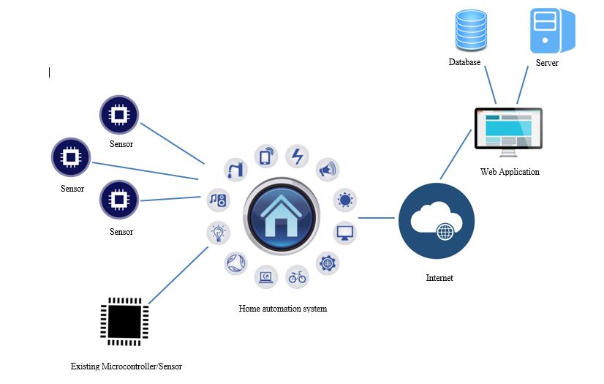-Garage (Door, lightning)

Figure 1: High-level Architecture Diagram

Development of the proposed system will be consisting of,

**User Interface:**

This is the part where user get access to contact graphically with the home appliances. Web application will be developed with all the functionalities to fulfill the objectives of the proposed system.

**Hardware Interface:**

This interface is the place where that redirects the requests to the home appliances which are made at the frontend of the system by the user. The appliances may act according to the responses that coming out of the hardware interface.

Arduino UNO microcontroller is the main device runs on the hardware interface. Many other electronic components and sensors are implementing at this part.

## Functionalities

### Remote Controlling Doors and Windows

People are forgetting to lock the doors and windows sometimes. And only remembers after they travel a distance that they can’t return home just to lock the doors and windows. Below shown features can be provided to cover up the above functionality by using the proposed web application,

- Interface to control doors

- Interface to control windows

To fulfill the above requirements in the web application, there has to be a circuit that connects app and the appliances. Circuit would be connected to the door lock with a servo motor device. Only one click in the web app would be needed in order to lock the door. A Wi-Fi module will handle the communication between android app and the Arduino.

### Controlling high tech appliances.

When people want to control their high tech appliances when they are far away from home, our app will provide a user friendly interface to control all the necessary appliances. User just needs to select the appliance name from the app and give the command to On or Off. This will helpful when the user can’t reach the home when thundering. For an example if meat or fish inside the refrigerator people can’t switch off the refrigerator when they are leaving home. There should be a way to control the refrigerator when they want to off.

So our proposed application will provide,

- Interface to select the home high tech appliance

- Interface to select the command.

### Automated Garage gate Controlling and Surrounding Light Control

**Image processing and IOT server communication**

Wireless Garage Gate Controllers may currently be available across the world, but with the latest IOT advancements; Our system through Image Processing, will detect the home resident’s license plate number and automatically open the garage gate when the vehicle is couple of meters from the garage. Furthermore, once the car has entered the garage, it will monitor the distance and once it’s in a safe distance, the gate sensor will close the Garage Gate. Hence saving ample time, and effort of the user.

That is not all that our system will handle, Through UV light sensor detection, a light outside the Home (Porch Light) will switch on when it gets closer to dusk (Evening). This light detection mechanism will also handle the lighting system inside the Garage, i.e if there is limited light supply inside the garage, and if a person or the vehicle is entering the garage, a light will be turned on; this would not only save the person some time from finding the light switch but also avoid causing any injury.

With so little time and so much errands to run, we as humans are always at haste with our routines, and we tend to forget to check if the garage door is closed or the light is left on; our Smart System will detect these minor details and send notifications via Server Communication to the residents, and henceforth have the ability to do the needful.

All this Communication will be handled between the app and the Arduino, through a secured Internet Connection, that is not easily penetrable for cyber attacks.

### Lighting controlling and temperature controlling automation system

Detect the time and environmental condition and automate the light controlling system by machine learning. Once the user of the system is away from house he or she must be able to control (ON/OFF/Dim) the lighting system of the house via the application.

Also detect the number of people in the room and environmental condition via sensors, by that controlling the temperature in the room by adjusting the fan or the AC. providing an interface to control system by user.

## Flow of the Project

It has come into conclusion as a team, that in order to achieve success in developing the proposed system, we as a team will be following the Agile Software development with Scrum as a framework for managing the process. [10]

Adapting to being a Scrum Team relies on a self –organizing and cross functional team. When being faced with challenges or conflicts, the team as a whole will decide on how to overcome such hurdles.

Within the Agile development, SCRUM teams are supported by two major roles, that is the Scrum Master and the Product Owner; for this Research Project, we would only be having guidance and coaching of the Supervisor as our Scrum master.

The typical Iterative Flow of the Project would be:

1. ***Requirements Phase***
2. ***Design Phase***
3. ***Development Phase***
4. ***Testing Phase***

***Requirements Gathering and Analysis***

When working on any kind of project or system or product, the gathering and analyzing of the requirements is one of the most important factors that can determine whether the product will be a success or failure.

In a Research, the area is unfamiliar, and hence it is vital to understand the research topic, and the system that is going to be implemented, the tools and technologies that are going to be used, and further more if various hardware components is involved, then how is it going to be to connected together and then connected the system, so on and so forth.

Therefore to have a guaranteed understanding of the requirements and research field, it is vital to look into previously developed and existing systems, their advantages and disadvantages, the challenges faced during the development, how the team overcame those challenges.

Since this system will be used by the public, it is important to receive their feedbacks and ideas and take them into consideration, by carrying out various surveys and interviews such as One-on-One interviews, Group-interviews, and Use cases, these must be carried with different research groups, and categorized accordingly, to help further analyze on how the system should function. It is difficult to develop a system that can satisfy each and every user, and therefore it is highly suggested to consider the Persona, rather than individuals when developing a system.

Researching on reading news paper articles, blogs, books, research papers, etc, will also give a better idea and a clear path on identifying the key points into developing a successfully system.

Once all the requirements are gathered and a thorough analysis is made on the system to be implemented, and ensuring there is no ambiguity, the next step in this phase is preparing the Software Requirement Specification also known as the SRS.

***Design***

In the Design Phase, the designs are developed by analyzing the requirements, the results from the surveys and interviews, the created SRS document. The Use-case Diagrams are created and reviewed to ensure that all the functionalities, the flow of the system are covered.

The primary achievement of drawing these diagrams is to ensure the client/ user has an understanding of how the system will function and what it will look like.

***Development***

This is the point where the Research project officially takes shape. During this period, the Construction of the system begins; the team will be occupied with coding and unit testing. As a Cross-function team, each team member will begin to implement their chosen feature. Furthermore, adapting to the Scrum Agile Methodology, each day, the team would meet and discuss on the working progress of the system, the meeting will be time-boxed and during thi time, the team will provide an update on what they worked on, what they will be working on and whether there are any impediments or blockers to their progress. This Flow will help in synchronizing the members, and help achieve a successful working product.

***Testing***

Software testing methodologies are different approaches of ensuring that the developing application and system is fully functional and tested. As we move further into the development, the system will have various sensors and interfaces that are going to be integrated together, this will make application get complex and intertwined; and therefore require the system to be fully tested.

To ensure our system is fully tested; we will be working on both Functional and Non-functional testing.

***Functional testing:***

1. ***Unit Testing:*** Testing the Individual Components or Modules that make up the application as a whole. Unit testing will be a test-driven development methodology, where the tests are written before the module is created.
2. ***Integration Testing:*** This testing is performed, once the modules or component of the team members has successfully completed their unit testing, and integrated together to perform a specific task.
3. ***System Testing:*** This Testing methodology involves testing the entire system as a whole for errors and bugs. System testing is considered as a Block-box testing method.

***Non-Functional Testing:***

This involves testing the system against the non-functional requirements, such as the *performance testing* is measuring how the system behaves under increasing data load, *Security testing* tests the system for confidentiality, authentication, this is done because of the increasing cyber-crimes and the awareness of software vulnerabilities. We will also be performing *Usability testing*, as this is vital for when the product goes into the market, it looks at how the user can easily access the system and product, with no assistance, it looks for the efficiency and satisfaction.

Our proposed system will consist of a Software and Hardware component that will be integrated into our Smart Home Application. The purpose of the web application is to monitor and control the home appliances remotely with interfaces provided. Proposed web application going to be user friendly and customized according to the user’s desire.

Web application is consisting of three main interfaces,

*1st interface:*

Login form will be provided when the URL that can be access the web application type. House owner will be the one who has access to the web application or other users might have access regards to the master user’s requirements. Web application will check with the MySQL database whether the user is registered with the system and allow entering the next interface only if authorized, otherwise rejects.

*2nd interface:*

After login session 2nd interface will be shown. Here the house will separate into three main parts. User can be access any part as he/she wish. Appliances at the house are distributed among three main areas as Rooms, Garage and Living Area. Buttons showing the images of the three areas are redirecting to the next interface.

*3rd interface:*

This interface has every detail about the appliances at the selected part of the house that user select from the previous interface. The appliances correspond to the selected area will be shown at a table with its status. Buttons are provided to each device to operate the status ON/OFF.

**Hardware Phase:**

Arduino UNO, along with connecting various Sensors will act as the core device of the hardware implementation phase.

**Tools and Technologies**

Languages used for the web application development: PHP, JavaScript, HTML 5

WAMP Server – Hosting the web application.

Cloud Server – To access it through public network.

MYSQL – Data Storage

## Gantt Chart

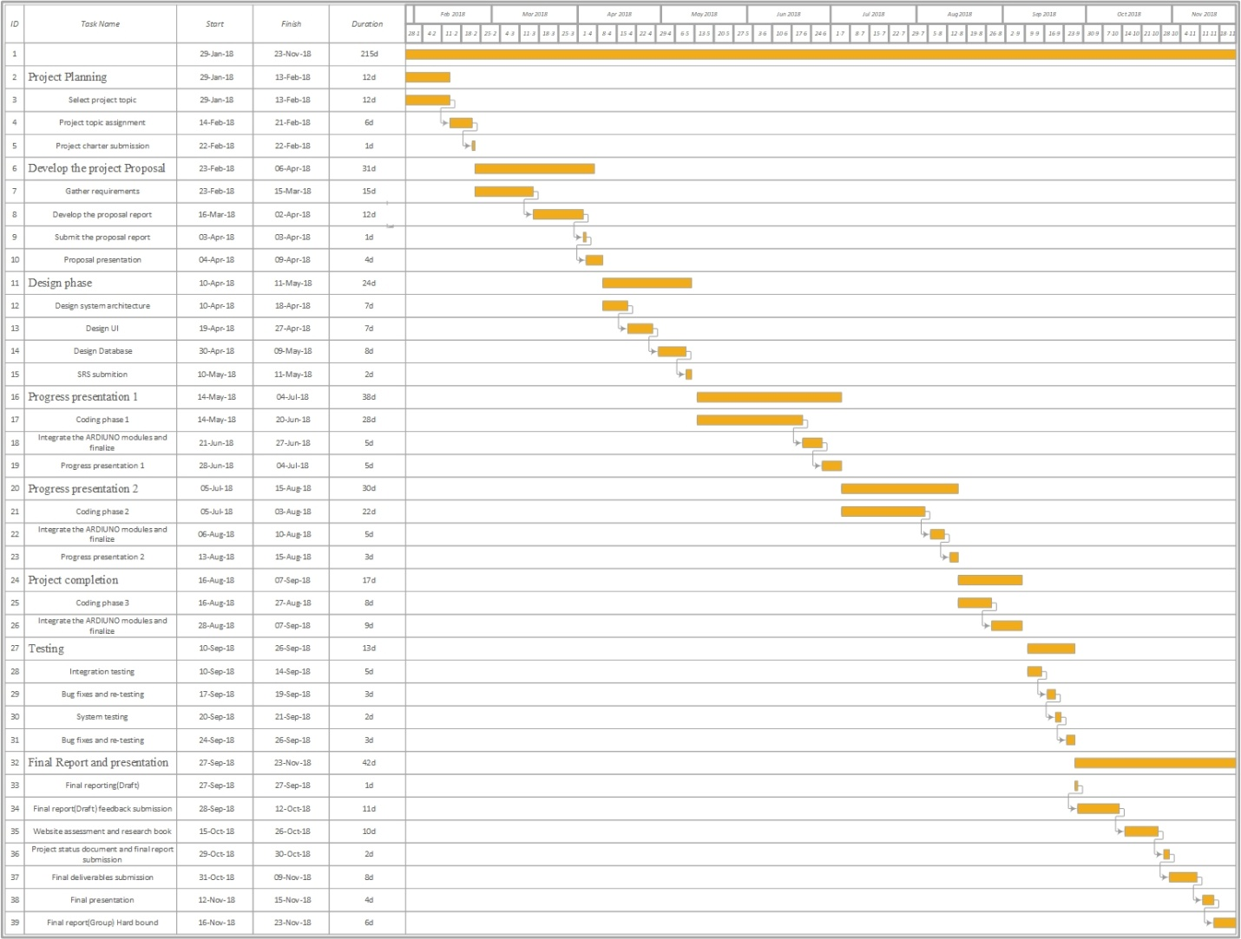

Figure 2: Gantt chart

# PERSONNEL AND FACILITIES

|  |  |
| --- | --- |
| **Member** | **Tasks /Functionalities** |
| **Onida Yolin Navarathneraja** | 1. Image processing to detect and capture the License plate number of the residence vehicles.  2. Open the Garage gate when the vehicle is couple of meters away.  Check if the vehicle is at a safe distance, once inside the garage, and close the garage gate.  3. Automatically switch on the Home Porch Light, when nearing dusk.  Switch on the garage light, if the light is limited, when the vehicle is approaching.  4. Create and handle the Interface management of the house exterior (i.e Garage Gate and Lights) |
| **A.R.J. Akwaththa** | 1. Sensor Communication to Detect Open Doors or Windows in the House.  2. Alert the Owners via the Server and Application and Lock the relevant Doors and windows.  3. Ensuring the Security of the Implemented System, securing the Internet connection with Firewall protection.  4. Create and handle the Interface management of the house Interior (i.e Doors and Windows) |
| **H.M.P.H. Halpe** | 1. Machine learning to detect time and automate switching the status of the house lights.  2. Monitor the temperate and count of people in a room, and operate the AC or Fan.  3. Create and handle the Interface of the house Interior and Cooling System (i.e Lights, AC, Fan) |
| **W.S.H. Boteju** | 1. When there is power failures, Detect the energy flow, Monitor and Handle the current flow of High Tech Appliances (refrigerator, routers, washing machines etc), once the power comes back. Manage which appliances need to be switched back on.  2. Create and handle the Interface management of the house High Technical Appliances. |

Table 1: Description of Members Tasks and Functionality.

# BUDGET

|  |  |  |  |  |
| --- | --- | --- | --- | --- |
| **Item** | **Description** | **Quantity** | **Cost Per Item** | **TOTAL** |
| Ardiuno [9] | · Microcontroller board based on the ATmega328 (datasheet)  ·14 digital input/output pins  ·16 MHz crystal oscillator  ·USB connection | 1 | 3500.00 | 3500.00 |
| Other Sensors | - | 2 | 2000.00 | 4000.00 |
| UV Light Detection Sensor + Cable [8] | ·Grove – UV Sensor  ·Spectral range of 200nm-400nm  ·Sensor GUVA-S12D  ·Low Power Consumption  ·Schotttky type Photodiode Sensor | 1 | 1700.00 | 1700.00 |
| Cameras | Home CCTV Cameras | 2 | 4000.00 | 8000.00 |
| ***Total*** | | | | **17200.00** |

Table 2: Estimate Budget

# 

# REFERENCES

[1] Rajeev Piyare, M Tazil,"Bluetooth based home automation system using cell phone " *in IEEE Transactions on Consumer Electronics*,2011.

[2] Mirza Qutab Baig, Junaid Maqsood, Muhammad Haris Bin Tariq Alvi, “A Comparative Analysis on Home Automation Techniques” in *Artificial Intelligence, Modelling and Simulation (AIMS), 2014 2nd International Conference on,* Madrid, Spain,2015.

[3] Sirisilla Manohar, D. Mahesh Kumar,” E-mail interactive home automation system” *in International Journal of Computer Science and Mobile Computing,*2015.

[4] Mukesh Kumar, Shimi S.L,”Voice recognition based home automation for Paralyzed People” *in International Journal of Advanced Research in Electronics and Communication Engineering (IJARECE),*2015

[5] Ali Ziya Alkar, H.Selcuk Gecim, Muharrem Guney,“Web Based ZigBee Enabled Home Automation System” *in Network-Based Information Systems (NBiS), 2010 13th International Conference,* Takayama, Japan,2010.

[6] Muhammad Asadullah, Ahsan Raza,“An overview of home automation systems”*in Robotics and Artificial Intelligence (ICRAI), 2016 2nd International Conference,* Rawalpindi, Pakistan, 2016.

[7] Kumar Mandula, Ramu Parupalli, CH.A.S. Murty, E. Magesh,Rutul Lunagariya,”Mobile based home automation using Internet of Things(IoT)” *in Control, Instrumentation, Communication and Computational Technologies (ICCICCT), 2015 International Conference*, Kumaracoil, India.2015.

[8] Grove – *UV Sensor – Seeed Wiki* [Online]

Available:  <https://www.seeedstudio.com/Grove-UV-Sensor-p-1540.html>

[9] Amazon - *Arduino Uno Microcontroller* [Online]

Available: [https://www.amazon.com/Arduino-Uno-R3-Microcontroller A000066/dp/B008GRTSV6](https://www.amazon.com/Arduino-Uno-R3-Microcontroller%20A000066/dp/B008GRTSV6)